**NAME OF THE PROJECT**

**Phase I internship report of**

**Final Year, Semester-IV**

**Submitted in the partial fulfilment of the requirements for the degree of**

**Master of Computer Application**

**(MCA)**

**By**

Mihir Sawant A048

**Name of the Company**

Kotak Securities

**Name of the Company Mentor**

Mr Vishal Puri

**Under the guidance of**

Prof Soni Sweta



**Department of Computer Engineering**

**Mukesh Patel School of Technology Management & Engineering**

**NMIMS (Deemed-to-be University), Mumbai**

**INDEX OF CONTENT**

|  |  |  |
| --- | --- | --- |
| **Sr. No.** | **Topic** | **Page No.** |
| 1 | Introduction | 3 |
| 2 | Company Overview | 4 |
| 3 | Training Phase | 5 |
| 4 | Project Overview   1. Fix protocol 2. pyautogui task in automation and batch scripting | 6-7 |
| 5 | Work Done | 8 |
| 6 | Key Learning and Challenges | 9 |
| 7 | Conclusion | 10 |

**Introduction**

In the early phase of my internship, I concentrated on learning trading fundamentals and understanding market dynamics. I engaged with diverse resources to gain insights into capital markets. Additionally, I delved into batch scripting to automate tasks and streamline processes, further enhancing my understanding of trading operations.

**Company Overview: Rite Technologies**

* **Establishment and Ownership:**

Kotak Securities was established in 1994 as a subsidiary of Kotak Mahindra Bank, a prominent financial institution in India.

* **History and Standing:**

Being one of India's oldest and largest brokerage firms, Kotak Securities holds a significant position in the financial market, boasting decades of experience and expertise.

* **Specialization:**

The company specializes in both institutional and retail equities, catering to a diverse clientele with varied investment needs and preferences.

* **Product and Service Offerings:**

Kotak Securities offers an extensive range of financial products and services, including equity research, sales trading, derivatives trading, prime brokerage, and market insights.

Key Offerings:

* Equity Research: Providing comprehensive research insights to assist clients in making informed investment decisions.
* Sales Trading: Facilitating seamless execution of trades for clients in the equities market.
* Derivatives Trading: Offering options for clients to hedge risks and speculate on market movements.
* Prime Brokerage: Providing specialized services catering to institutional clients and high-net-worth individuals.
* Market Insights: Delivering timely analysis and commentary on market trends and developments.

**Training Phase**

During my training phase of the internship, I engaged with essential documents like the Zerodha Trading Book, Trading for Beginners Book, and studied NISM Module 8. Under the guidance of my mentor, Mr. Vishal Puri, I delved into concepts such as the basics of Futures and Options (F&O) and gained an overview of trading systems. This phase served as a foundational period for my understanding of the stock market and trading dynamics.

**Project Overview**

**Fix Protocol:**

**Overview:**

Enables real-time trade information exchange.

**Features:**

* Standardized Format: Ensures compatibility.
* Widespread Adoption: Industry-wide acceptance.
* Asset Support: Covers various asset classes.
* Scalability: Efficient handling of transactions.

**Components:**

* Session Layer: Manages connections.
* Application Layer: Facilitates message exchange.
* Infrastructure: Provides communication framework.

Benefits:

* Efficiency: Reduces latency.
* Transparency: Real-time data access.
* Operational Risk Reduction: Minimizes errors.

` ‘

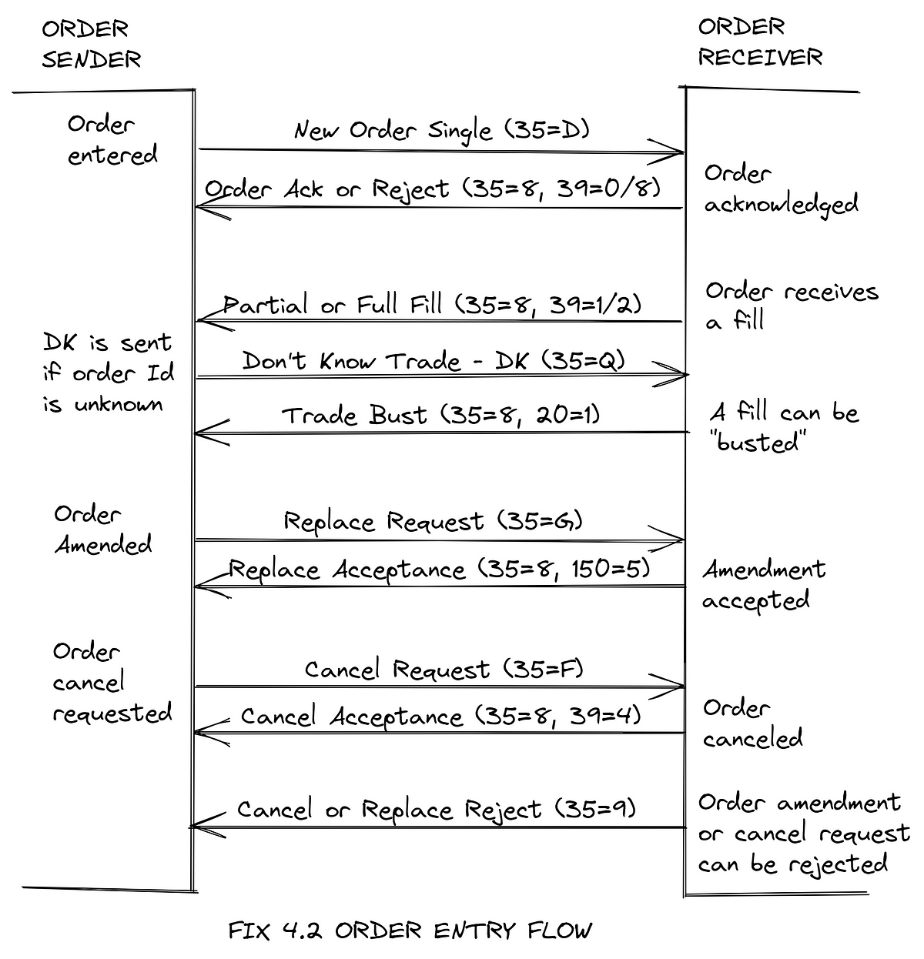

**Python:**

**PyAutoGUI: python package used for automating mouse and keyboards commands and control in software.**

***A very basic hello world of pyautgui, we can directly get the mouse position by inbuilt function.***

import pyautogui

x, y = pyautogui.position()

print("Mouse pointer position - X:", x, " Y:", y)

pyautogui.moveTo(1920 / 2, 1080 / 2)

pyautogui.click()

pyautogui.typewrite("Hello, World!")

**Work Done**

* •Understanding the bloomberg system.
* •Understanding different types of orders and how to place them in bloomberg system
* •Placed some test orders using FIX and bloomberg system during mock.
* •Basic Testing work for some internal software, like finding bugs and reporting them.

**Key Learning and Challenges**

During my internship, I gained comprehensive insights into various aspects of trading systems, including derivatives (FNO), the FIX protocol, and batch scripting. Additionally, I developed basic automation scripts using PyAutoGUI for software tasks. I delved into the dynamics of the stock market, including market sentiments and indices, while also learning about internal testing software and the Bloomberg system. Throughout, I navigated challenges with determination, enhancing my understanding of trading intricacies and software automation.

**Conclusion**

In conclusion, my internship immersed me in diverse tasks such as exploring derivatives, mastering the FIX protocol, and developing automation scripts with PyAutoGUI. Understanding the stock market dynamics and delving into market sentiments expanded my knowledge. Despite facing challenges, I emerged with a fortified skill set, ready for future ventures in finance and technology.