**Juice Shop Documentation**

1. **What is Juice Shop?**

Juice Shop is a website created for testing security problems. Its interface is made to resemble an online shop for selling fruit products. Juice Shop helps customers get their wanted fruit products from all around the world. The website provides a user-friendly interface that can be translated to every existing language. This way everybody can shop from Juice Shop, despite their origin. The website provides the options to create an account, use it for placing orders and to leave comments for the products, both anonymous and not.

1. **How to use Juice Shop?**
2. **Create an account**
   1. Go to the *Account* option that is on the top right corner of the screen.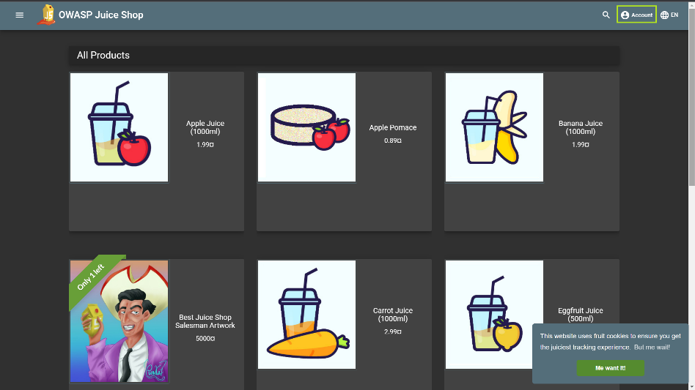
   2. There you will see only the option to login. To see the full login form, click on this option. At the bottom of the form you will see the option to join as a new customer, choose it. 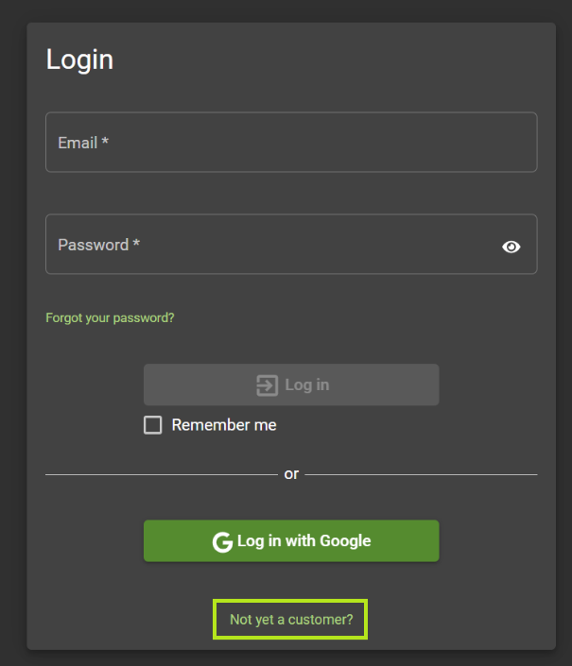
   3. Fill out the form you see, following the example below. If you meet any difficulties coming up with a password, consult with the password advisor, given in the form.

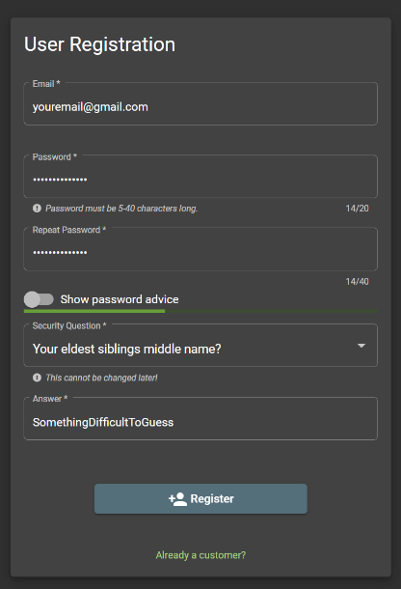

* 1. To create your account, click *Register*.
  2. After clicking *Register*, your registration will be completed. The only thing you need to do to enter your profile is to fill out the form that will show up after clicking *Register*.

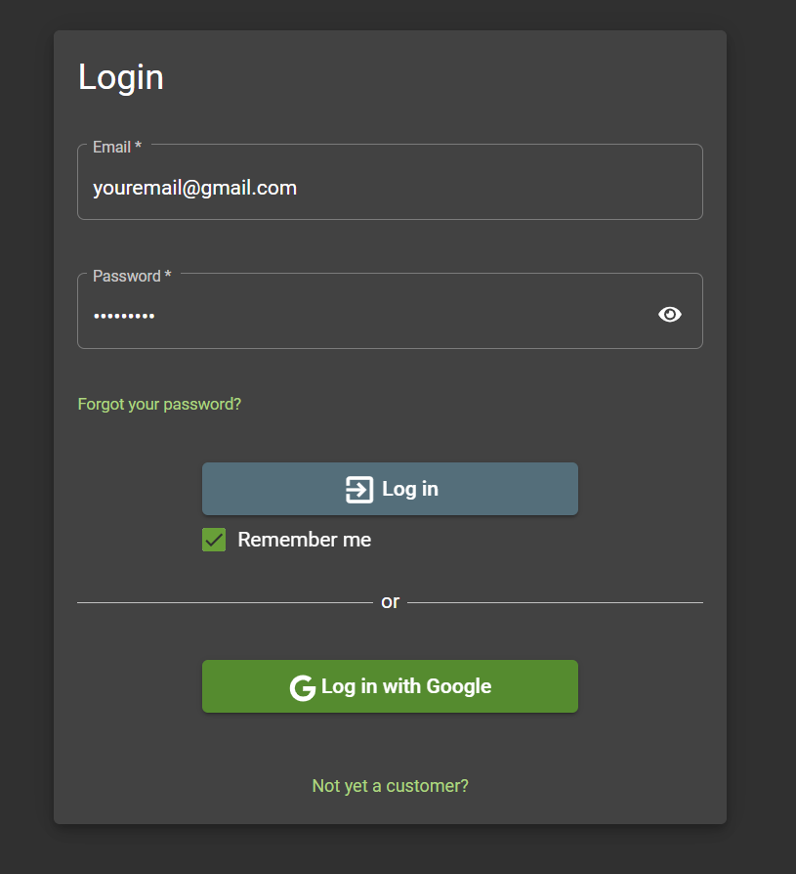

* 1. If you want to enter your account by default every time after that, check the box *Remember me*.
  2. You can use your account freely after clicking the *Log in* button.

1. **Login into your account**
   1. Go to the *Account* option that is on the top right corner of the screen.
   2. There you will see only the option to login. To see the full login form, click on this option. Fill it out with your account information as shown below. 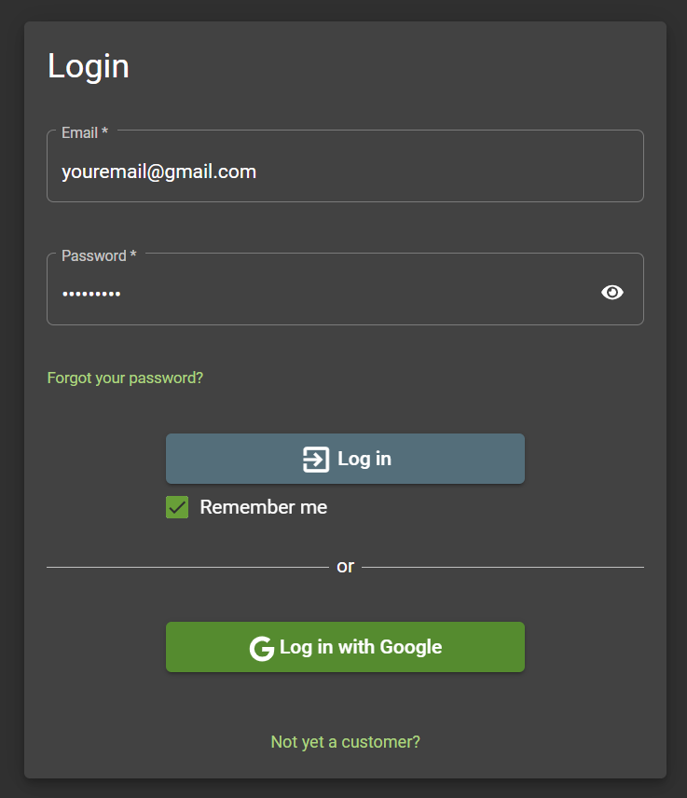
   3. If you want to enter your account by default every time after that, check the box *Remember me*.
   4. You can use your account freely after clicking the *Log in* button.
   5. If you want to log in with Google, then simply click the *Log in with Google* button. You will be redirected to a page where you can choose your Google account. 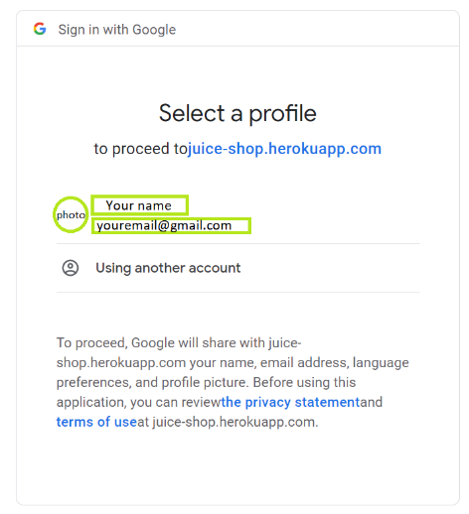
   6. Choose the account you want to proceed with by clicking on it. You will be then redirected to the website’s main page, logged in your account.
   7. You should see the Juice Shop website like shown below, no matter what login option you have chosen.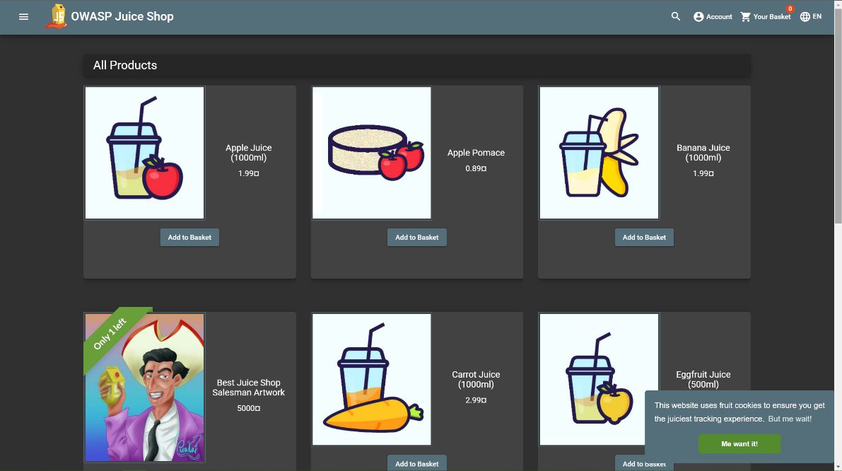
2. **Add items to your basket**
   1. Select which item you want to buy and click on *Add to Basket* bellow your wanted item. 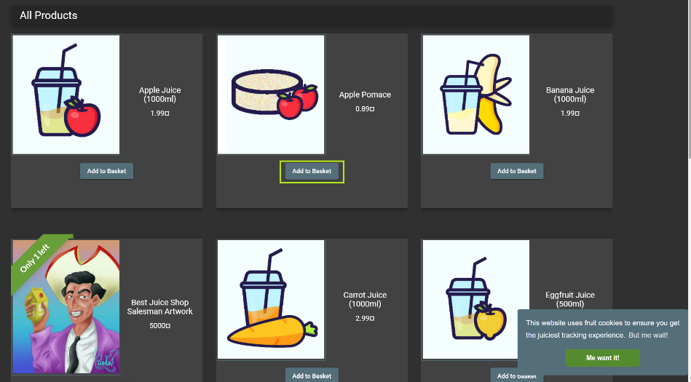
   2. You can change the quantity of the selected item in the basket. To do so, just click on *Your Basket*.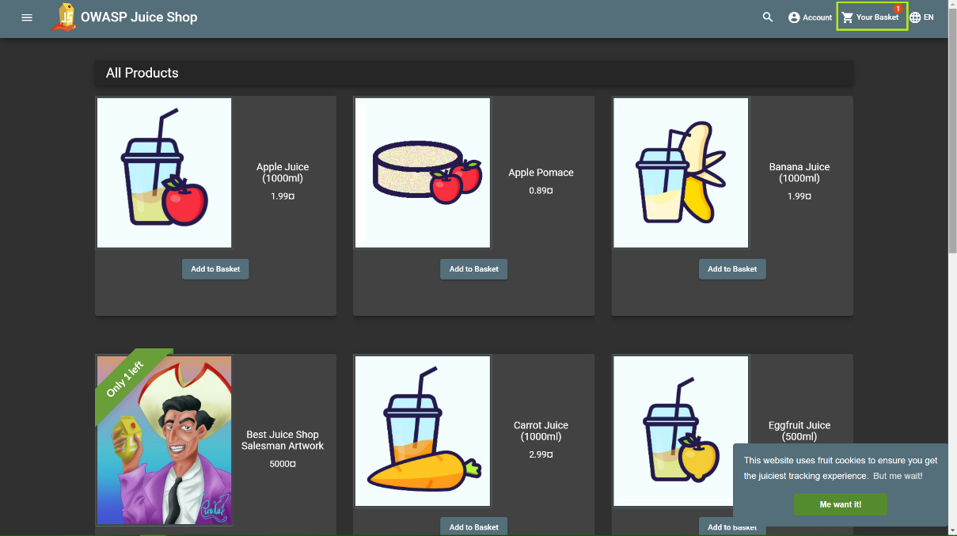
   3. You can increase the quantity by clicking the plus sign icon and decrease it by clicking the minus sign icon. You can also remove it from your basket by clicking on the bin icon.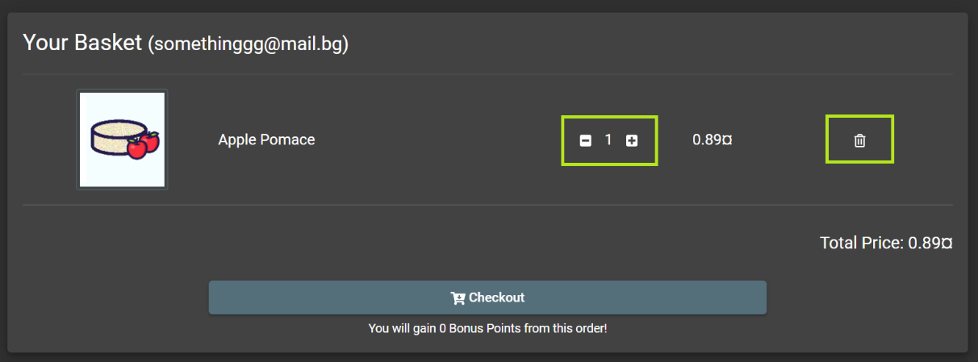
3. **Shop from the website**
   1. After you have added everything you want to your basket, to place an order, click the *Checkout* button in the basket section.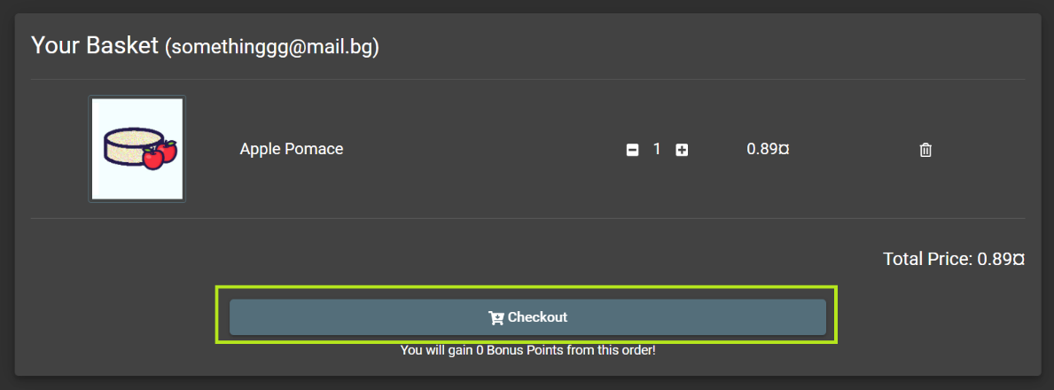
   2. Once you have clicked the *Checkout* button, you will see this address option list. 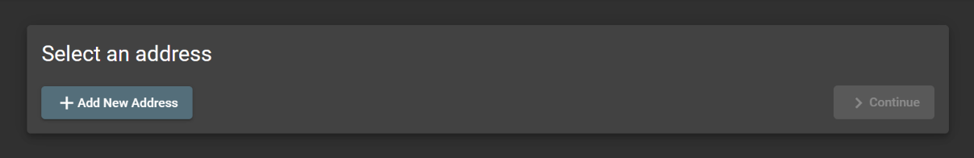
   3. If you have not shopped from Juice Shop before, it will be empty. In this case, click on *Add New Address*.

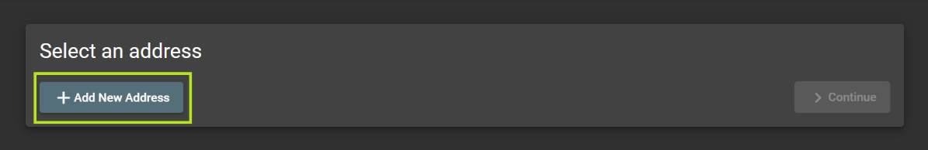

* 1. You will see the following form that you have to fill up with your personal information and then click the *Submit* button to save this address. 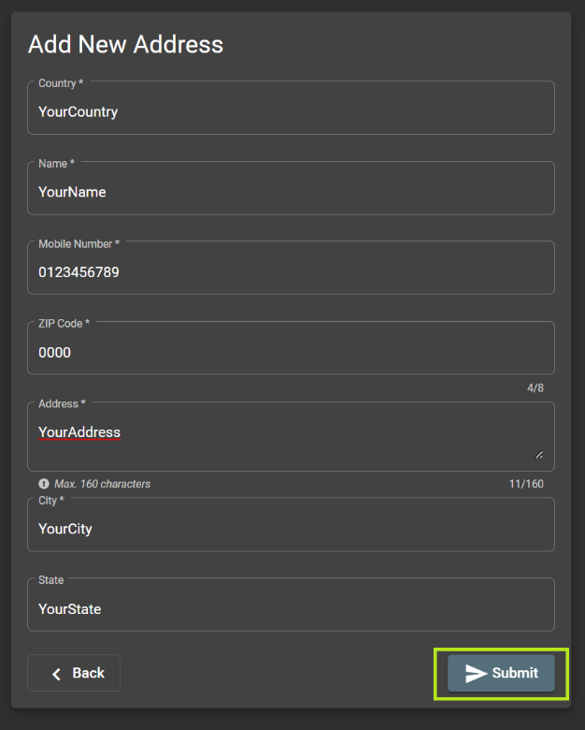
  2. Now you will be able to choose your address so you can continue with placing the order. For this, click the *Continue* button.

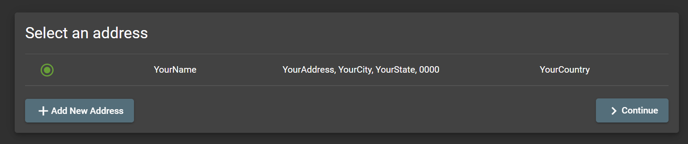

* 1. The next thing you will see is the delivery options menu. You have to choose between the three possible options and again click the *Continue* button when ready.

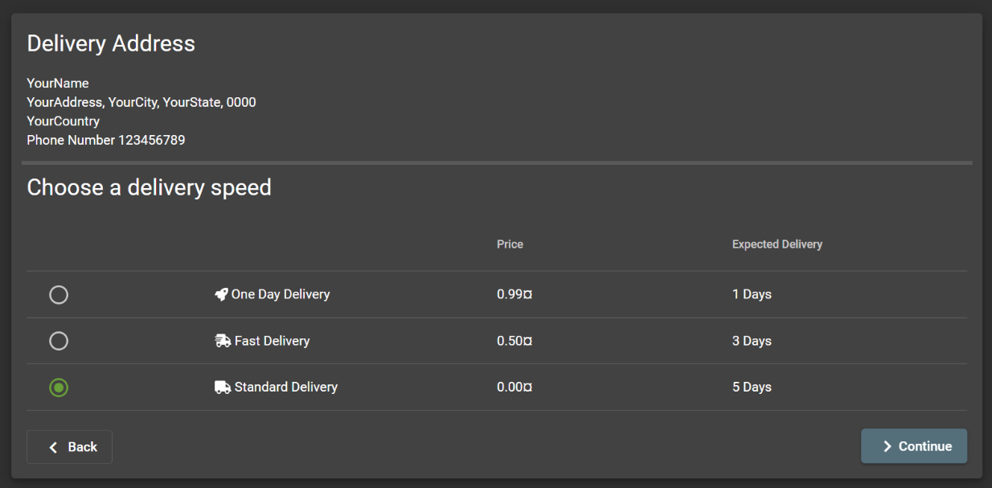

* 1. The next step is to add a payment method. For this step you have to put in your billing details by choosing *Add new card*. If you have a discount code, make sure to add it through the *Add a coupon* option. You can choose other payment options as well by clicking on *Other payment options*.

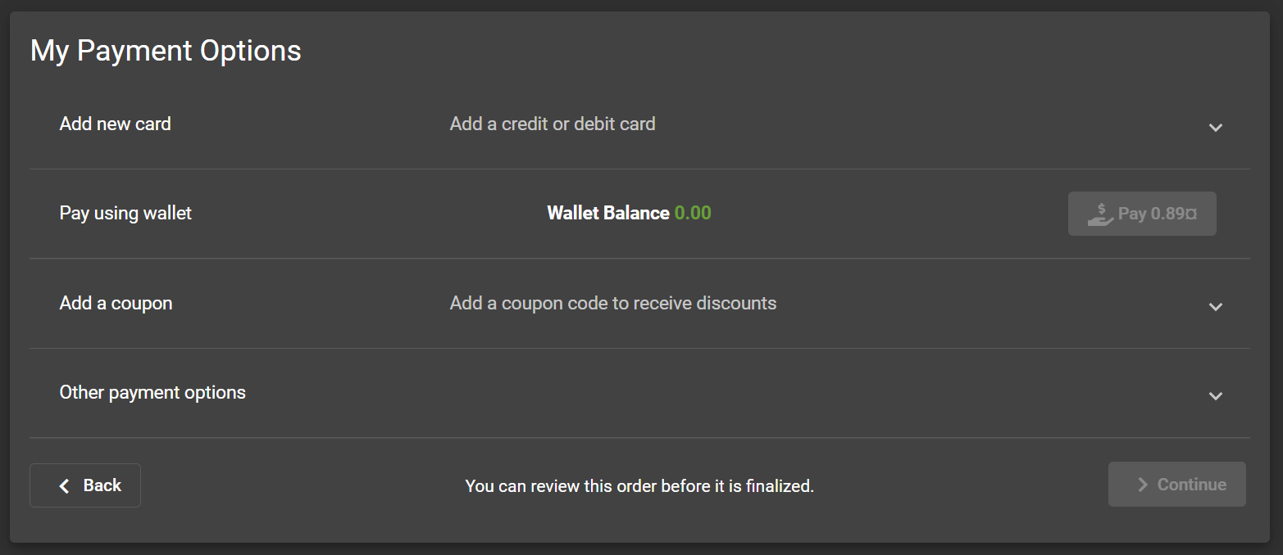

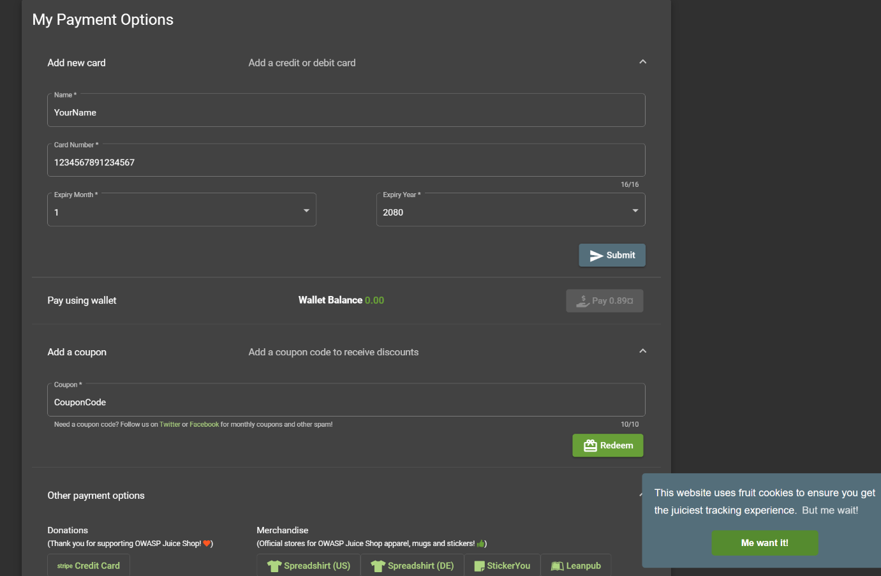

* 1. Once you have added your card information, save it by clicking on the *Submit* button. You will now be able to choose it as a payment option.
  2. For saving your coupon code, just click on the *Redeem* button.
  3. After filling everything needed, to continue with your order choose a card and click *Continue*. 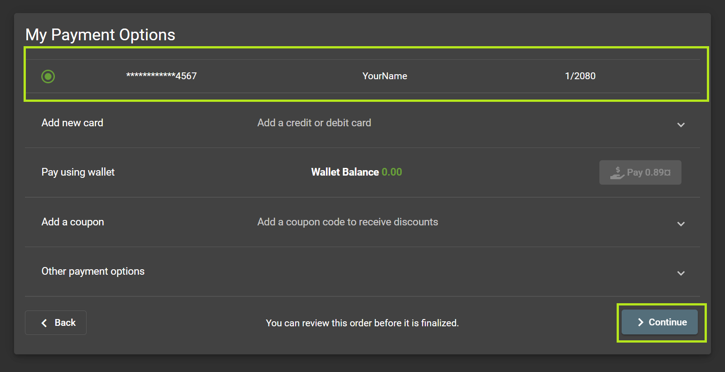
  4. The final step is to check if your information is correct and if you are still sure about placing the order, then click on *Place your order and pay*.

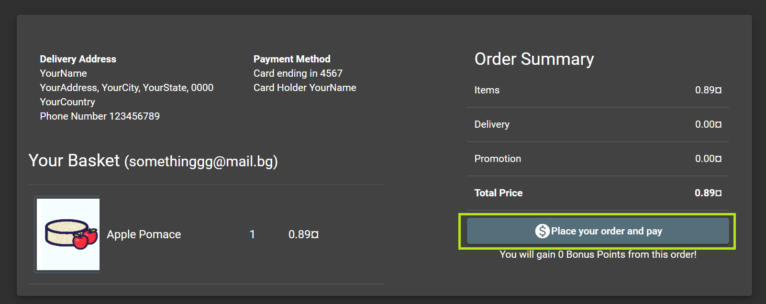

* 1. Now all you have to do is wait for your order to arrive to you.

1. **Leave feedback**
   1. If you want to leave feedback for a specific product, then click on its picture and you will see this form.

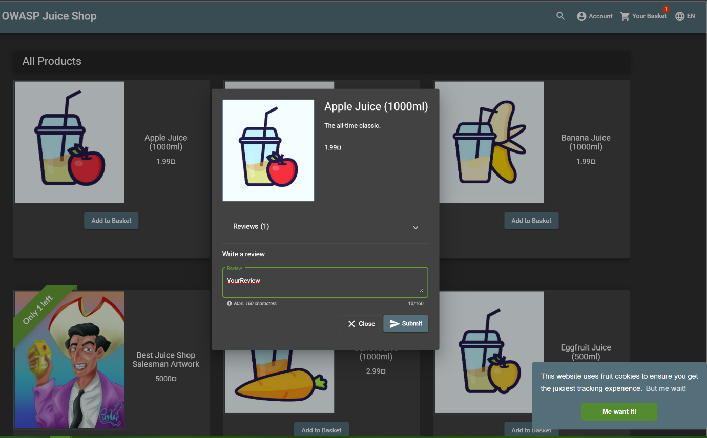

* 1. Fill out what you want to say about this product. To send your feedback, click *Submit*.
  2. If you want to leave feedback for Juice Shop then click the side menu bar. Then choose the *Customer Feedback* option.

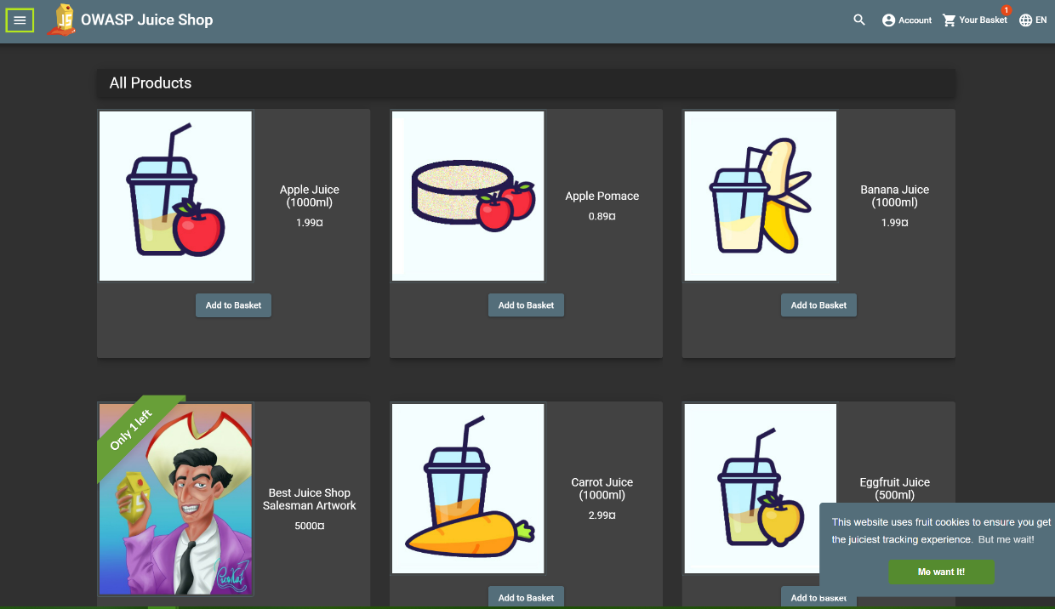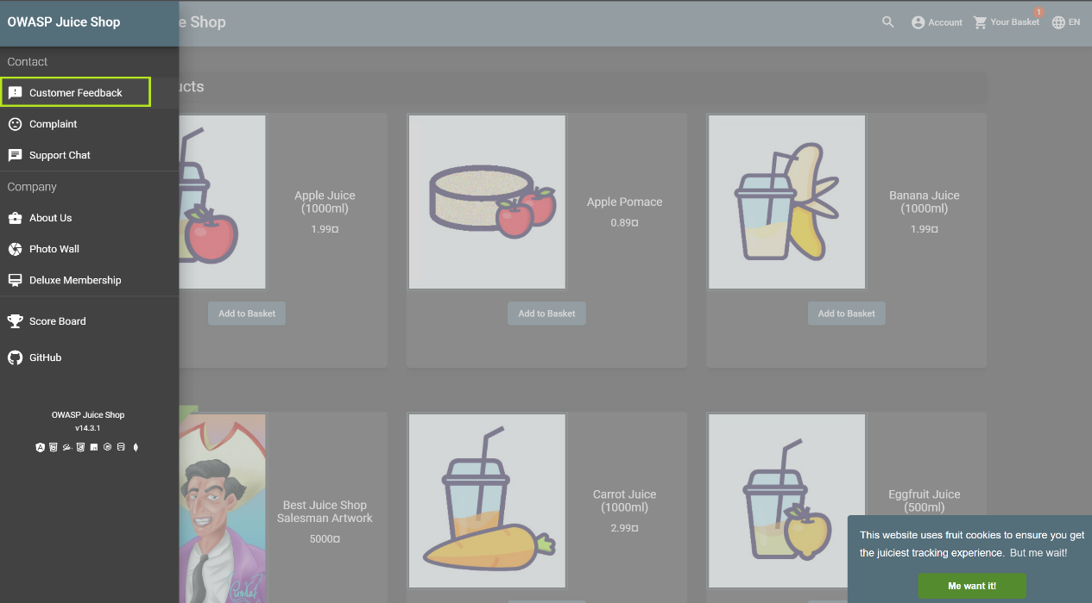

* 1. You will have to fill out a form with your feedback, looking like the one shown below, and when you are ready with your feedback, click *Submit*.

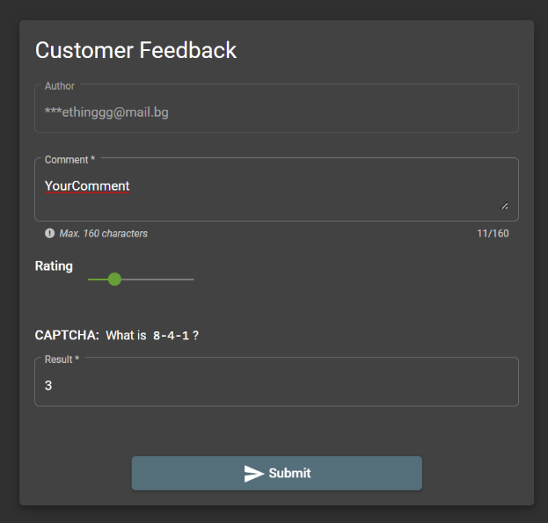

* 1. If you want your feedback to be anonymous, then log out of your account and leave your feedback the same way as above. The only difference you will see is that the author in the form will be anonymous.

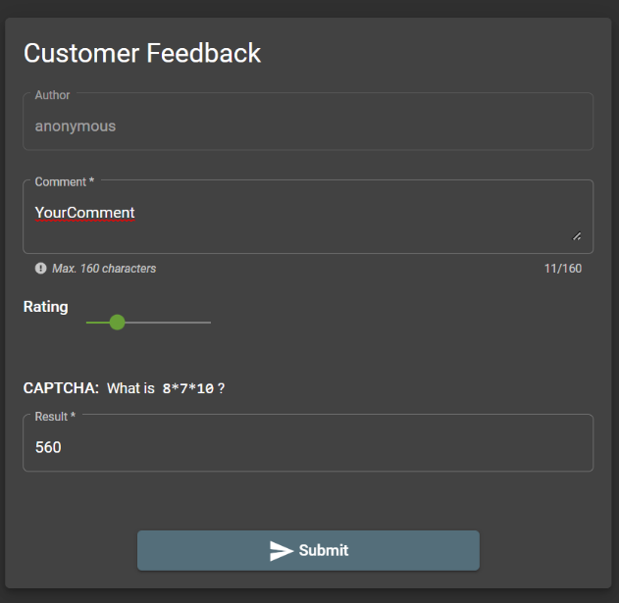

1. **Leave feedback about this documentation**

Give us your feedback here: mihaelavi1@uni-sofia.bg