**MALM Documentation**

**FOR CLIENTS**

**What is MALM?**

MALM is a compact chest of drawers designed specifically for your needs. It is easy to assemble and therefore it should not take more than half an hour from your time.

**What will you need before starting the assembly?**

* Slotted screwdriver
* Cross slot/Phillips screwdriver
* A pencil
* A hammer
* Soft and smooth surface
* A person to help you (If possible)

**What to do if some of the instructions are unclear?**

Call IKEA call center – there is always someone ready to help you on the other side of the line.

**What will you find in the set?**

You will find four thin planks, three thicker pieces of wood for the sides and the top of the chest of drawers, eight medium pieces of wood for the drawers and three extremely thin pieces of darker wood. The set also includes the following parts, that will be named by their serial numbers from now on.

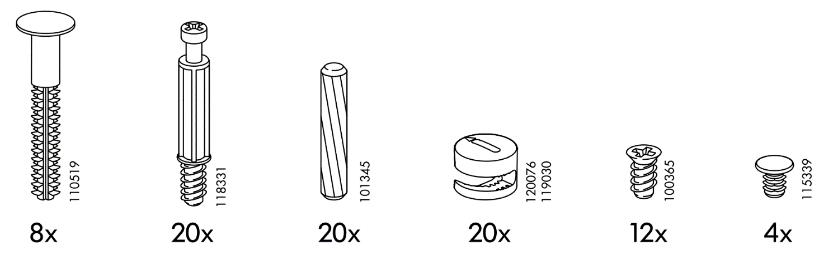

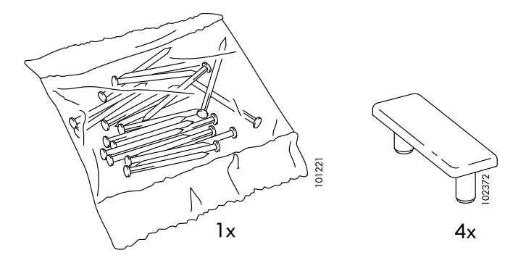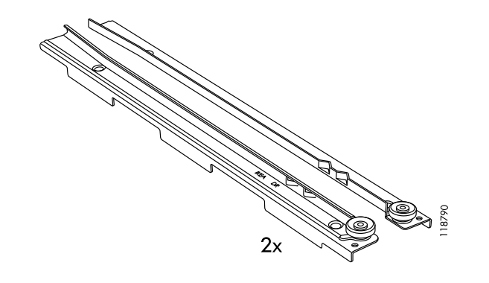

**How to build the MALM?**

1. The first step is to get the two thickest pieces of wood and place them with the smooth side down. On the upper side you will see eight holes. You have to place one of the eight 110519 parts inside each one of them and then fixate them there with the Cross slot/Phillips screwdriver, as shown:

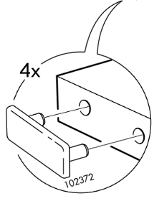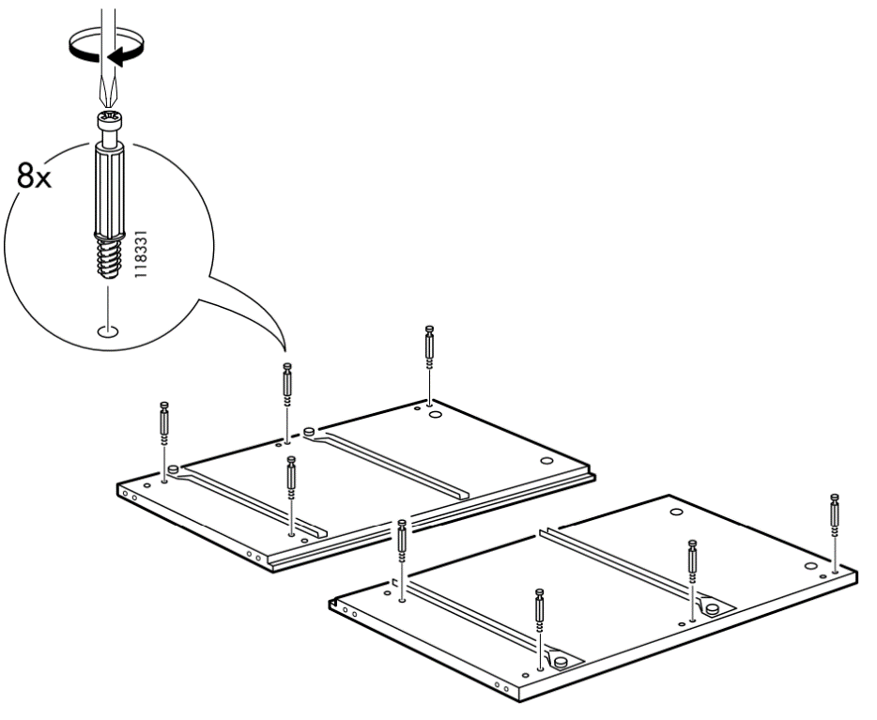

1. When you are ready with that step, you should put the four 102372 parts in the side holes on the thin side of the same wooden pieces, as shown in the bubble right over this text.
2. 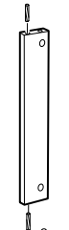The third step is to get the four identical thin planks and place on each side of the plank one of the 101345 parts as shown:

After that you have to place them on one of the thicker wooden pieces that you worked with

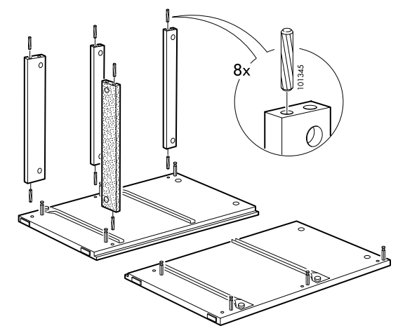 before like this:

1. The fourth step is to fixate the four 120076-119030 parts on the bottom holes of those planks with a Slotted screwdriver like that:
2. 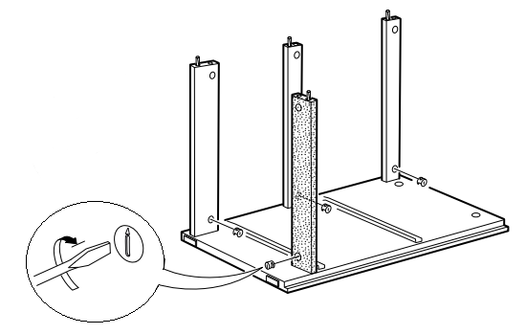What you have to do next is to get the other thicker piece of wood and put it on top of the planks so that the 101345 parts can fit in its holes and the 118331 elements that are attached to it can fit in the planks’ holes.
3. After that you have to flip your assembly to the right so the three planks can be on top. You have to do that in order to secure the bottom of your chest of drawers – the differently colored plank on the illustration

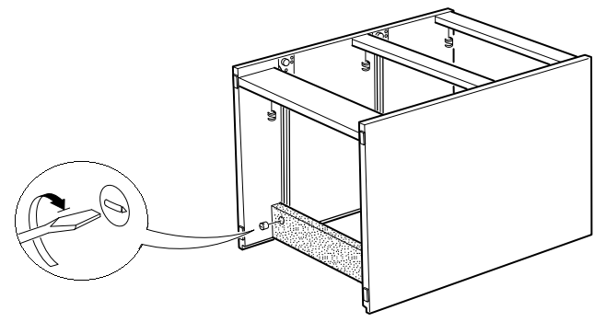

1. The seventh step is to grab the thick square piece of wood and place it on the ground with the holes facing you. In the outer four of those holes you have to put four 118331 elements. After that you should flip the assembly with the three planks facing you and the two bigger pieces of wood should be perpendicular to the ground. Then you put the square piece of wood on top of your assembly but do not forget to put four 101345 parts to the base of your assembly as shown in the illustration:

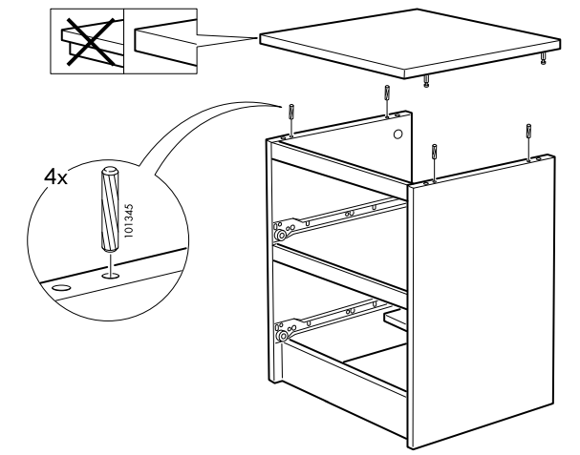

1. The next step is to put four 120076-119030 elements in the thicker pieces of wood’s holes and to fixate them with a Slotted screwdriver like this:
2. 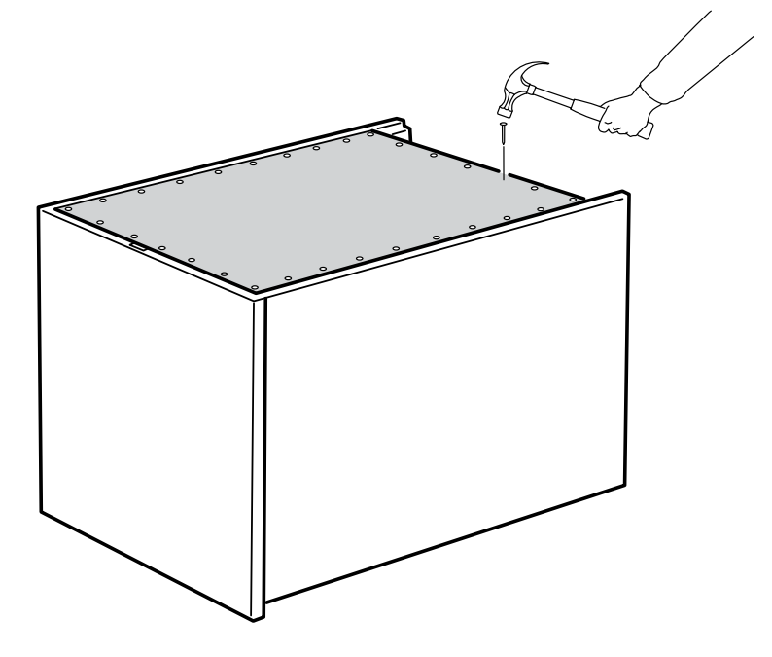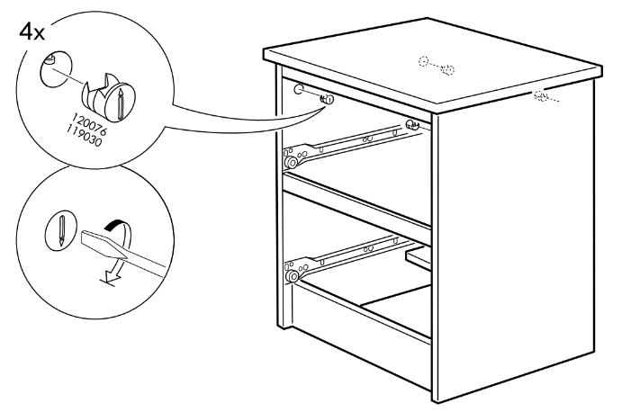After this you have to place the assembly with the part you see facing the ground. Then grab the biggest thin piece of wood and place it on top. Then use the nails from 101221 to secure it – this is the back of your chest of drawers:
3. All you have to do now is to build the drawers. You should be left with ten unused pieces of wood – eight of them are identical to each other, two of the others are thinner and the other two are the drawers’ front-facing parts. Grab one of the last two and put it with the holes facing up. Then place four 118331 parts in the holes shown and fill the other four holes with 101345 parts. Then get two of those eight identical pieces and put them perpendicular so the 118331 and 101345 elements can fit in their holes.

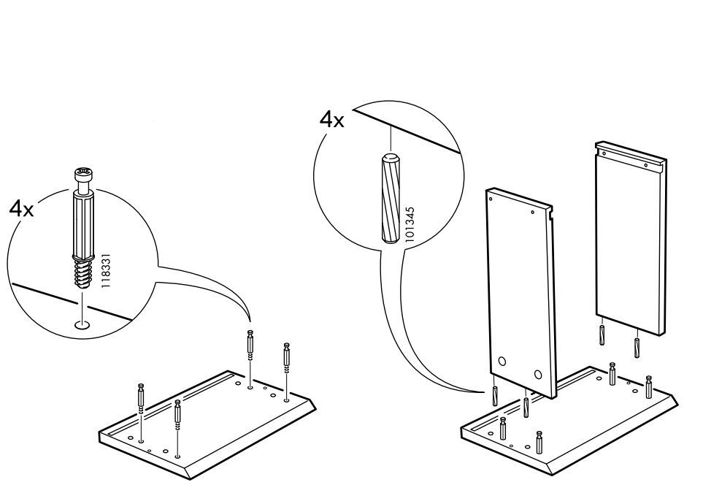

1. The next step is to put four 120076-119030 elements in those two identical pieces’ side holes and fixate them with a Slotted screwdriver. Then slide one of the thin pieces behind those two and fixate it by placing another wooden plank perpendicularly to it.

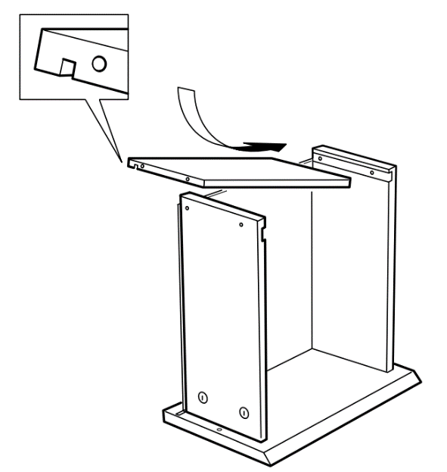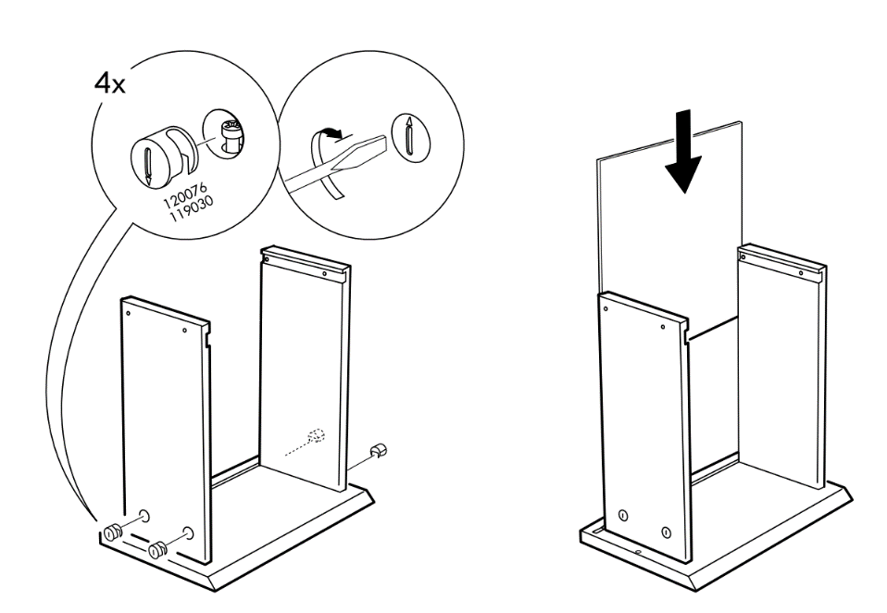

1. Now you need to put four 110519 elements in the upper holes of the side planks (you will need the hammer for those ones) and two 115339 parts in the front-facing plank as shown in the illustration:

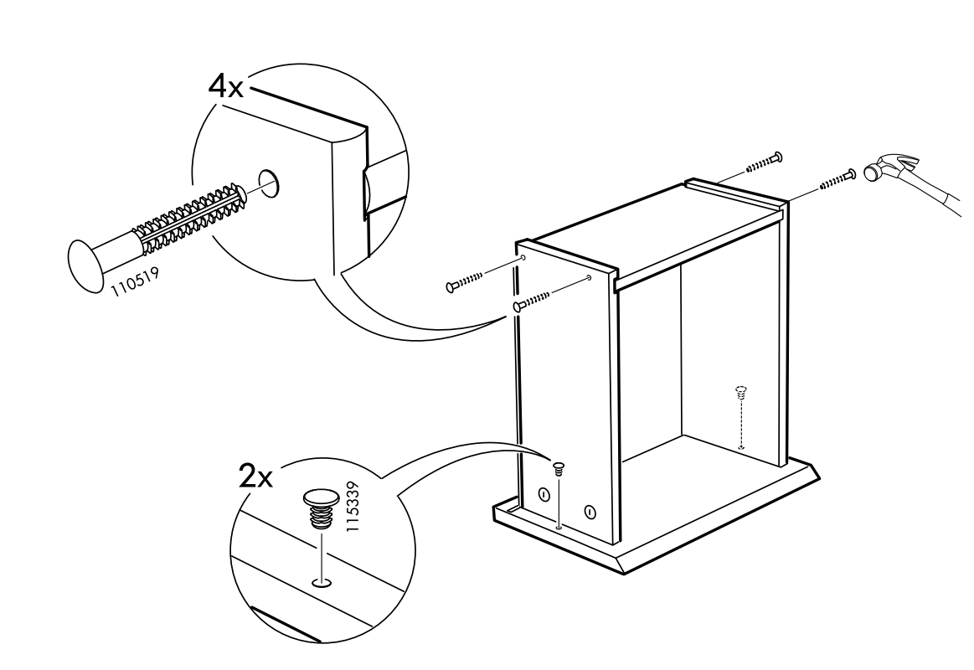

1. Then flip the drawer with the bottom facing up and place two 118790 parts on the sides that you will have to fixate with three 100365 elements on a side as shown: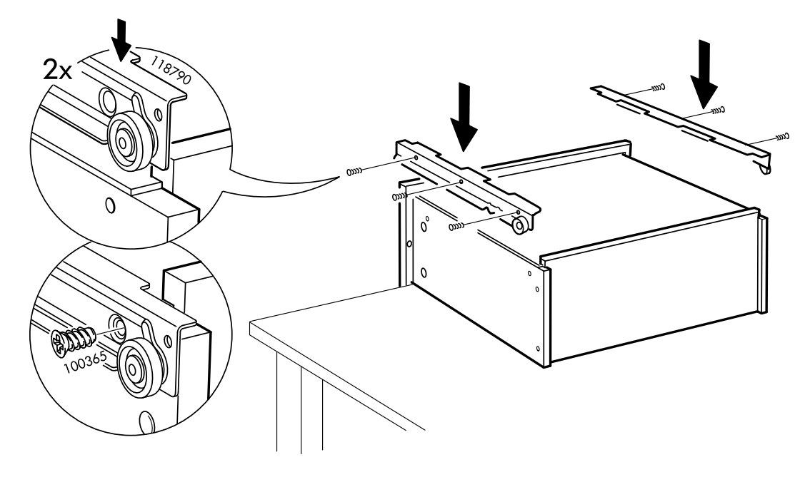
2. 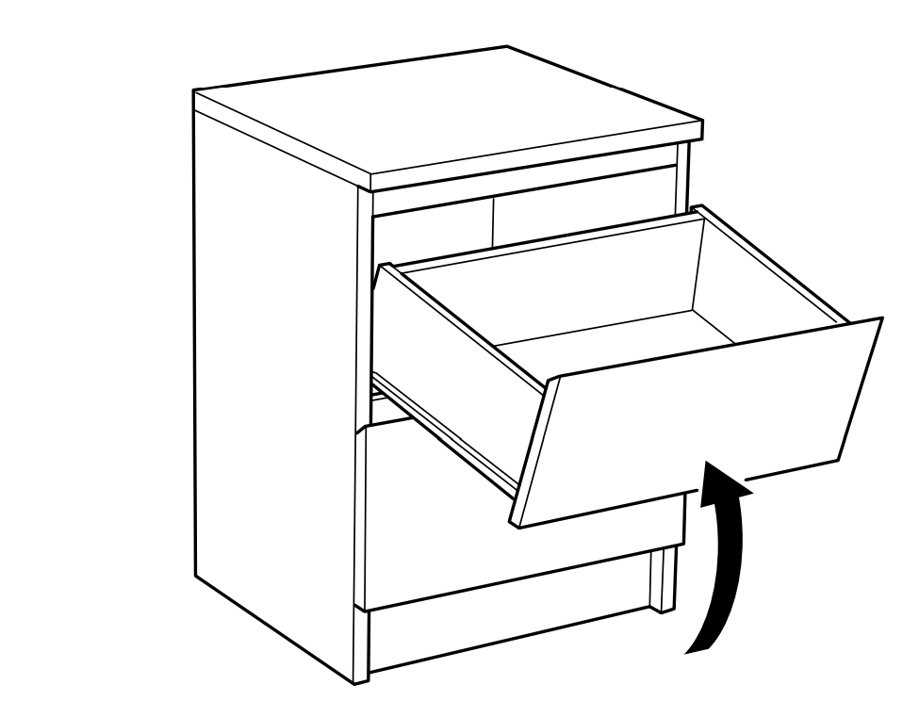After you repeat the same for your other drawer, you have to put them in your base and the MALM chest of drawers will be finished.

**How did you find this documentation?**

Give us your feedback here: mihaelavi1@uni-sofia.bg