Gestiunea

unei

Aplicatii de fitness

Popescu Mihaela-Maria

An II – Grupa 241

1. ***Prezentați pe scurt baza de date (utilitatea ei).***

In scopul realizarii proiectului final la materia Sisteme de Gestiune a Bazelor de Date, am construit baza de date a unei aplicatii de fitness.

In cadrul acesteia retinem informatii despre toti userii aplicatiei, atat membrii cat si instructorii salilor. Membrii detin un anumit tip de abonament, carora li se atribuie un program de antrenament cu un instructor personal la unul dintre cluburi. Fiecare antrenament este format din mai multe exercitii. Toti membrii achita o taxa lunara, tinandu-se evidenta platilor. Instructorul actualizeaza prin intermediul aplicatiei antrenamentele membrilor. Un membru poate avea mai multe tipuri de antrenamente, cu diferiti instructori si la diferite sali. Exista optiunea de antrenamente online, astfel un membru poate sa achizitioneze un antrenament online.

De asemenea, retinem date si despre angajatii fiecarei sali. Orice sala poate avea unul sau mai multi receptionisti, paznici sau personal de curatenie, insa fiecare angajat poate lucra la o singura sala.

Pentru o organizare eficienta, am utilizat doua tabele asociative ce ne ajuta in gestionarea relatiilor many-to-many: “workout_plan” ce face legatura intre 4 entitati(Gym, Instructor, Workout, Member) si “books” intre Member si Online_Class.

1. ***Realizați diagrama entitate-relație(ERD).***

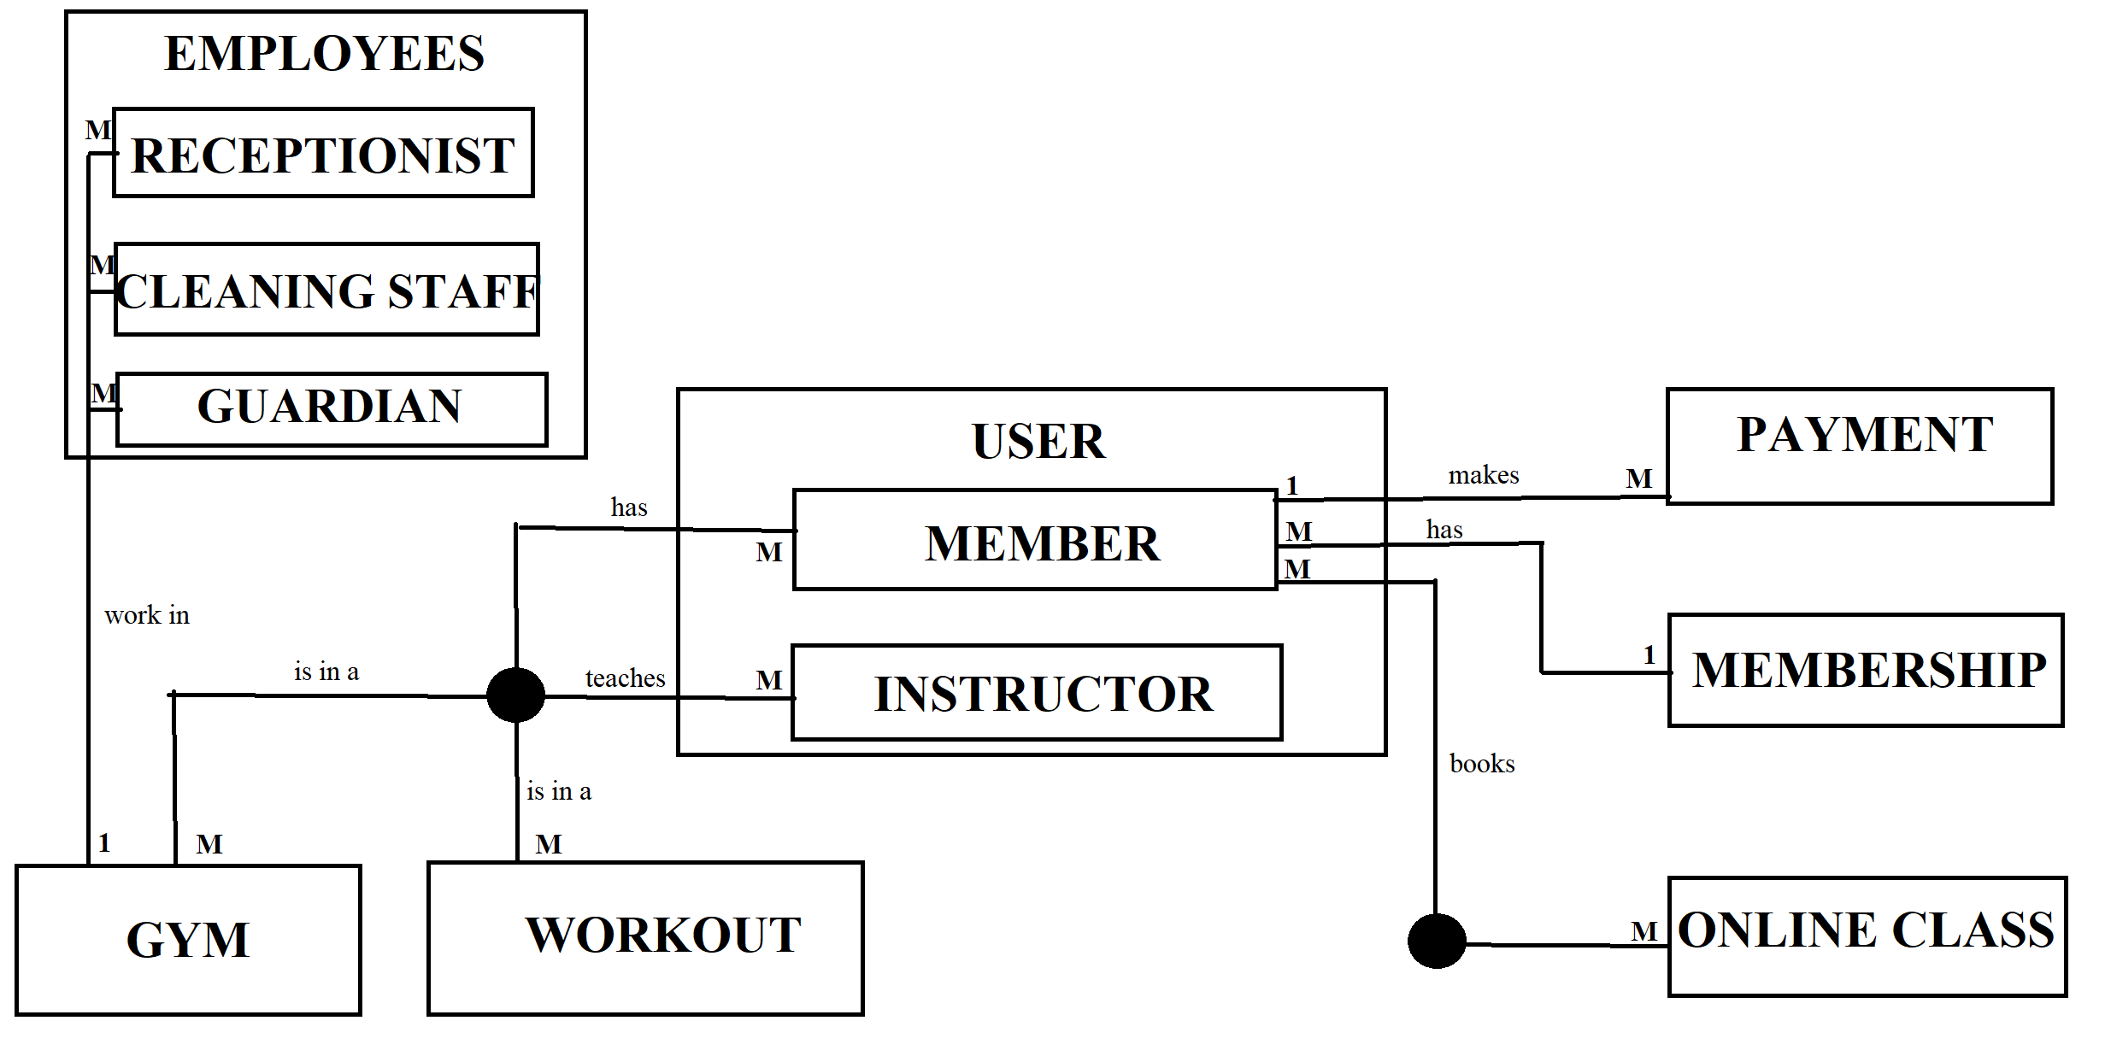

1. ***Pornind de la diagrama entitate-relație realizați diagrama conceptuală a modelului propus, integrând toate atributele necesare.***

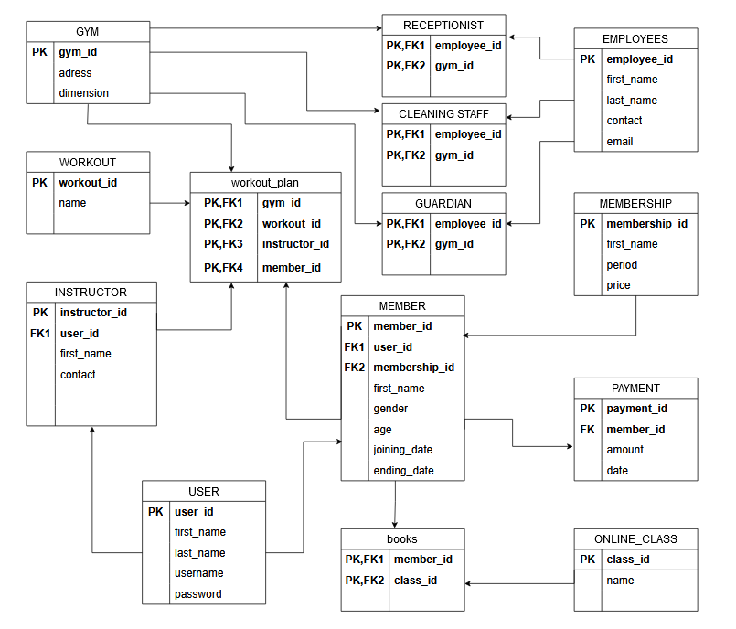

1. ***Implementați în Oracle diagrama conceptuală realizată: definiți toate tabelele, implementând toate constrângerile de integritate necesare (chei primare, cheile externe etc).***

CREATE TABLE GYM

(GYM_ID NUMBER(10) PRIMARY KEY, ADRESS VARCHAR(20), DIMENSION NUMBER(10));

CREATE TABLE WORKOUT

(WORKOUT_ID NUMBER(10) PRIMARY KEY, NAME VARCHAR(20) NOT NULL);

CREATE TABLE USERS

(USER_ID NUMBER(10) PRIMARY KEY, FIRST_NAME VARCHAR(20) NOT NULL, LAST_NAME VARCHAR(20) NOT NULL,USERNAME VARCHAR(20), PASSWORD VARCHAR(20) NOT NULL);

CREATE TABLE ONLINE_CLASS

(CLASS_ID NUMBER(10) PRIMARY KEY , NAME VARCHAR(20) NOT NULL);

CREATE TABLE MEMBERSHIP

(MEMBERSHIP_ID NUMBER(10) PRIMARY KEY , NAME VARCHAR(20) NOT NULL, PERIOD VARCHAR(20)NOT NULL, PRICE NUMBER(10)NOT NULL);

CREATE TABLE MEMBERS

(MEMBER_ID NUMBER(10) PRIMARY KEY , FIRST_NAME VARCHAR(20), GENDER VARCHAR(20), AGE NUMBER(10), JOINING_DATE DATE NOT NULL, ENDING_DATE DATE,

MEMBERSHIP_ID REFERENCES MEMBERSHIP(MEMBERSHIP_ID), USER_ID REFERENCES USER1(USER_ID));

CREATE TABLE INSTRUCTOR

(INSTRUCTOR_ID NUMBER(10) PRIMARY KEY, FIRST_NAME VARCHAR(20) NOT NULL, CONTACT VARCHAR(20), USER_ID REFERENCES USER1(USER_ID));

CREATE TABLE PAYMENT

(PAYMENT_ID NUMBER(10) PRIMARY KEY, AMOUNT NUMBER(10) NOT NULL,DATE_TIME DATE, MEMBER_ID REFERENCES MEMBER1(MEMBER_ID));

CREATE TABLE WORKOUT_PLAN

(GYM_ID NUMBER(10) REFERENCES GYM(GYM_ID), WORKOUT_ID NUMBER(10) REFERENCES WORKOUT(WORKOUT_ID),INSTRUCTOR_ID NUMBER(10) REFERENCES INSTRUCTOR(INSTRUCTOR_ID),MEMBER_ID NUMBER(10) REFERENCES MEMBER1(MEMBER_ID),

PRIMARY KEY(GYM_ID,WORKOUT_ID,INSTRUCTOR_ID,MEMBER_ID));

CREATE TABLE BOOKS

(MEMBER_ID NUMBER(10) REFERENCES MEMBERS(MEMBER_ID), CLASS_ID NUMBER(10) REFERENCES ONLINE_CLASS(CLASS_ID),

PRIMARY KEY(MEMBER_ID,CLASS_ID));

CREATE TABLE EMPLOYEES

(EMPLOYEE_ID NUMBER(10) PRIMARY KEY , FIRST_NAME VARCHAR(20) NOT NULL, LAST_NAME VARCHAR(20) NOT NULL,CONTACT VARCHAR(20), EMAIL VARCHAR(20));

CREATE TABLE RECEPTIONISTS

(EMPLOYEE_ID NUMBER(10) REFERENCES EMPLOYEES(EMPLOYEE_ID), GYM_ID NUMBER(10) REFERENCES GYMS(GYM_ID),

PRIMARY KEY (EMPLOYEE_ID,GYM_ID));

CREATE TABLE CLEANING_STAFF

(EMPLOYEE_ID NUMBER(10) REFERENCES EMPLOYEES(EMPLOYEE_ID), GYM_ID NUMBER(10) REFERENCES GYMS(GYM_ID),

PRIMARY KEY (EMPLOYEE_ID,GYM_ID));

CREATE TABLE GUARDIANS

(EMPLOYEE_ID NUMBER(10) REFERENCES EMPLOYEES(EMPLOYEE_ID), GYM_ID NUMBER(10) REFERENCES GYMS(GYM_ID),

PRIMARY KEY (EMPLOYEE_ID,GYM_ID));

COMMIT;

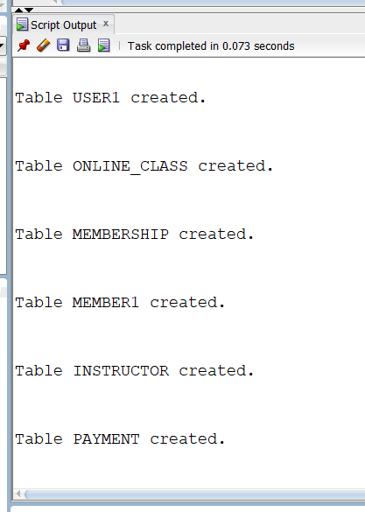 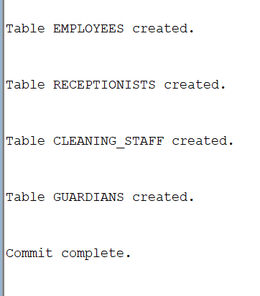

1. ***Adăugați informații coerente în tabelele create (minim 5 înregistrări pentru fiecare entitate independentă; minim 10 înregistrări pentru tabela asociativă).***

*TABELA GYMS:*

INSERT INTO GYMS

VALUES (1, 'STR SOLDAT IOSIF ION', 10);

INSERT INTO GYMS

VALUES (2, 'STR ISTRIEI', 10);

INSERT INTO GYMS

VALUES (3, 'STR LUNCA', 100);

INSERT INTO GYMS

VALUES (4, 'STR LALOSU', 80);

INSERT INTO GYMS

VALUES (5, 'STR PADESU', 120);

INSERT INTO GYMS

VALUES (6, 'CALEA VITAN', 150);

INSERT INTO GYMS

VALUES (7, 'STR GRIVITEI', 90);

SELECT * FROM GYMS;

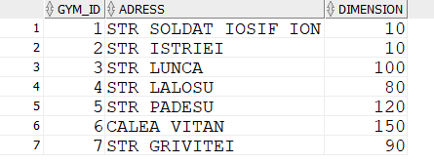

*--TABELA WORKOUT*

INSERT INTO WORKOUT

VALUES (1, 'CARDIO');

INSERT INTO WORKOUT

VALUES (2, 'CROSS-FIT');

INSERT INTO WORKOUT

VALUES (3, 'SWIMMING');

INSERT INTO WORKOUT

VALUES (4, 'POWERLIFTING');

INSERT INTO WORKOUT

VALUES (5, 'BODYBUILDING');

INSERT INTO WORKOUT

VALUES (6, 'ZUMBA');

INSERT INTO WORKOUT

VALUES (7, 'STRENGTH TRAINING');

INSERT INTO WORKOUT

VALUES (8, 'CALISTHENICS');

INSERT INTO WORKOUT

VALUES (9, 'CORE WORKOUTS');

INSERT INTO WORKOUT

VALUES (10, 'BOXING CIRCUIT');

SELECT * FROM WORKOUT;

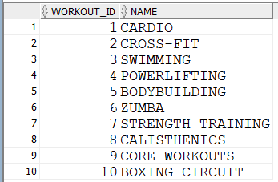

*--TABELA EMPLOYEES*

INSERT INTO EMPLOYEES

VALUES (100, 'MARIA','GEORGESCU','0722513230','MARIA@GMAIL.COM');

INSERT INTO EMPLOYEES

VALUES (101, 'IOANA','TRANDAFIR','0722518830','IOANA@GMAIL.COM');

INSERT INTO EMPLOYEES

VALUES (102, 'CORNEL','PROTOPOPESCU','0729513230','POPESCU@GMAIL.COM');

INSERT INTO EMPLOYEES

VALUES (103, 'ALEX','MIHAIL','0722763230','ALEX@GMAIL.COM');

INSERT INTO EMPLOYEES

VALUES (104, 'IUSTINA','MARGINEANU','072876530','MARGINEANU@GMAIL.COM');

INSERT INTO EMPLOYEES

VALUES (105, 'ROBERT','IONESCU','0722777230','ROB@GMAIL.COM');

INSERT INTO EMPLOYEES

VALUES (106, 'DAVID','BRANZOVENESCU','0733313230','BRANZICA@GMAIL.COM');

INSERT INTO EMPLOYEES

VALUES (107, 'IULIANA','POPESCU','078899550','POPESCU32@GMAIL.COM');

INSERT INTO EMPLOYEES

VALUES (108, 'CRISTIAN','IOAN','0722444230','IOAN@GMAIL.COM');

INSERT INTO EMPLOYEES

VALUES (109, 'GABRIEL','BADEA','0797613230','GB@GMAIL.COM');

INSERT INTO EMPLOYEES

VALUES (110, 'AURORA','IANCU','0722777290','IANCU_A@GMAIL.COM');

INSERT INTO EMPLOYEES

VALUES (111, 'BOGDAN','DELAP','079088765','DLP@GMAIL.COM');

INSERT INTO EMPLOYEES

VALUES (112, 'KARINA','LUCULET','074443230','KARINA@GMAIL.COM');

INSERT INTO EMPLOYEES

VALUES (113, 'VALENTIN','ALAFIN','0711113230','VFIN@GMAIL.COM');

INSERT INTO EMPLOYEES

VALUES (114, 'DRAGOS','CONSTANTIN','079123430','CONSTANTIN@GMAIL.COM');

INSERT INTO EMPLOYEES

VALUES (115, 'CASSANDRA','MARTIN','071556730','CASSI@GMAIL.COM');

INSERT INTO EMPLOYEES

VALUES (116, 'GEORGIANA','ANDU','0717789230','GEORGIA@GMAIL.COM');

INSERT INTO EMPLOYEES

VALUES (117, 'RALUCA','LEON','0745564330','RALEO@GMAIL.COM');

INSERT INTO EMPLOYEES

VALUES (118, 'MARIANA','ANGHEL','0785497860','ANGHEL@GMAIL.COM');

INSERT INTO EMPLOYEES

VALUES (119, 'BIANCA','OANCEA','079875550','BIBI@GMAIL.COM');

INSERT INTO EMPLOYEES

VALUES (120, 'DANA','EPU','0776865231','EPU_DI@GMAIL.COM');

INSERT INTO EMPLOYEES

VALUES (121, 'MARA','MOCANU','0722213230','MARA@GMAIL.COM');

SELECT * FROM EMPLOYEES;

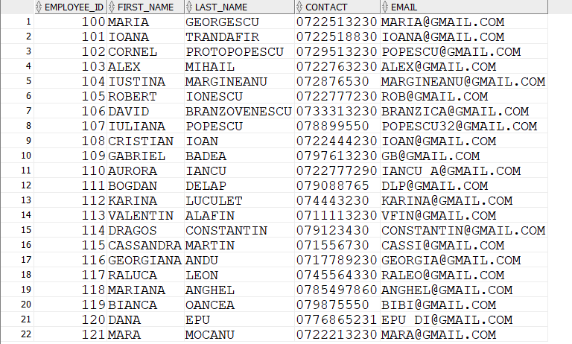

*--TABELA RECEPTIONISTS*

INSERT INTO RECEPTIONISTS

VALUES(100,1);

INSERT INTO RECEPTIONISTS

VALUES(101,2);

INSERT INTO RECEPTIONISTS

VALUES(102,3);

INSERT INTO RECEPTIONISTS

VALUES(103,4);

INSERT INTO RECEPTIONISTS

VALUES(104,5);

INSERT INTO RECEPTIONISTS

VALUES(105,6);

INSERT INTO RECEPTIONISTS

VALUES(106,7);

SELECT * FROM RECEPTIONISTS;

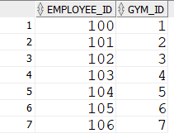

*--TABELA GUARDIANS*

INSERT INTO GUARDIANS

VALUES(107,1);

INSERT INTO GUARDIANS

VALUES(108,2);

INSERT INTO GUARDIANS

VALUES(109,3);

INSERT INTO GUARDIANS

VALUES(110,4);

INSERT INTO GUARDIANS

VALUES(111,5);

INSERT INTO GUARDIANS

VALUES(112,6);

INSERT INTO GUARDIANS

VALUES(113,7);

SELECT * FROM GUARDIANS;

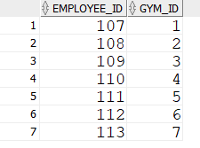

*--TABELA CLEANING_STAFF*

INSERT INTO CLEANING_STAFF

VALUES(114,1);

INSERT INTO CLEANING_STAFF

VALUES(115,2);

INSERT INTO CLEANING_STAFF

VALUES(116,3);

INSERT INTO CLEANING_STAFF

VALUES(117,4);

INSERT INTO CLEANING_STAFF

VALUES(118,5);

INSERT INTO CLEANING_STAFF

VALUES(119,6);

INSERT INTO CLEANING_STAFF

VALUES(120,7);

INSERT INTO CLEANING_STAFF

VALUES(121,6);

SELECT * FROM CLEANING_STAFF;

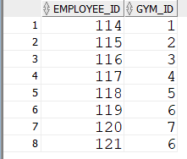

*--TABELA USERS*

INSERT INTO USERS

VALUES (1, 'MIHAELA','POPESCU','mica','cefef!2dA');

INSERT INTO USERS

VALUES (2, 'DIANA','IORDACHE','didi_iord','jncUBB');

INSERT INTO USERS

VALUES (3, 'MARIA','MARIN','MM36','LKLjh');

INSERT INTO USERS

VALUES (4, 'COSMIN','TEODOR','cosmit','kfkw!233dA');

INSERT INTO USERS

VALUES (5, 'ALEXANDRU','RUS','777_MONEY','lajdeb@AX');

INSERT INTO USERS

VALUES (6, 'MATEI','RUS','forex_mr','mxrcars*');

INSERT INTO USERS

VALUES (7, 'CORINA','NITULESCU','cory','asdd!sgbd');

INSERT INTO USERS

VALUES (8, 'NATALIA','IONESCU','nationescu','mvsjhd!#@');

INSERT INTO USERS

VALUES (9, 'EUGEN','POPESCU','popyeug','ddvvw22');

INSERT INTO USERS

VALUES (10, 'LILIANA','LUCULET','lilyluk','fb!fe31w3');

INSERT INTO USERS

VALUES (11, 'RADU','RUS','valer_rus','cnjskme');

INSERT INTO USERS

VALUES (12, 'MIRELA','RUS','t_mirela','vgdbrgr');

INSERT INTO USERS

VALUES (13, 'IONEL','OCO','oko_ion','wq32213');

INSERT INTO USERS

VALUES (14, 'ALEXANDRA','GHEORGHE','alxg','wr3r3f');

INSERT INTO USERS

VALUES (15, 'MARA','MALUTAN','maruca','sdrg222');

INSERT INTO USERS

VALUES (16, 'PATRICIA','TRANDAFIR','floricica','erfcwv332');

INSERT INTO USERS

VALUES (17, 'MARIA','DUMITRU','mariuca','fvrgrwf');

INSERT INTO USERS

VALUES (18, 'VLAD','PARASCHIV','vllladd','asdefe');

INSERT INTO USERS

VALUES (19, 'LUCA','DITA','luked','ceffkjwefn');

INSERT INTO USERS

VALUES (20, 'CLAUDIA','ERIN','clauclau','vwefqe');

INSERT INTO USERS

VALUES (21, 'TUDOR','OPRISAN','tud_oop','ecdvreg3');

INSERT INTO USERS

VALUES (22, 'SERGIU','ARIN','sssergiu','lmnbhj');

INSERT INTO USERS

VALUES (23, 'ADRIAN','ZAMIN','ADIZZZ','ffvdaqqq');

INSERT INTO USERS

VALUES (24, 'LAURENTIU','FLORENTIN','florentiu','xscvvvds');

INSERT INTO USERS

VALUES (25, 'LORENA','NEAGU','lolo_nnn','lolkcnjsd');

INSERT INTO USERS

VALUES (26, 'GABRIELA','GLONT','GG_WP','dnkjsndjn');

INSERT INTO USERS

VALUES (27, 'RAUL','GHEORGHIU','raul_gs','DFwdcf');

INSERT INTO USERS

VALUES (28, 'FLORIN','MIHAI','florinmihai','cofkiebf');

INSERT INTO USERS

VALUES (29, 'MARIUS','BOCOV','mariusb','ddvvrfwef');

INSERT INTO USERS

VALUES (30, 'ELISA','IANCU','elya','dcefef');

select * from users;

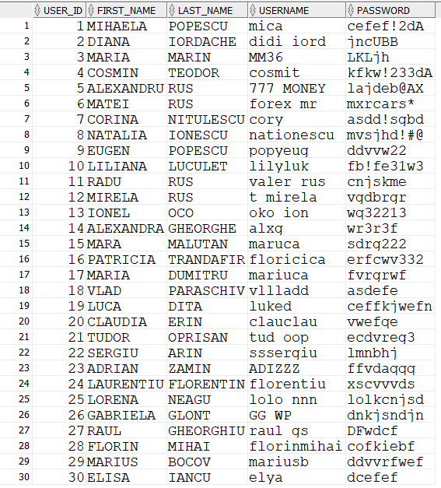

*--TABELA INSTRUCTORS*

INSERT INTO INSTRUCTORS

VALUES(1,'MIHAELA','072662512',1);

INSERT INTO INSTRUCTORS

VALUES(2,'ALEX','073451512',5);

INSERT INTO INSTRUCTORS

VALUES(3,'MATEI','077876251',6);

INSERT INTO INSTRUCTORS

VALUES(4,'NATY','071982611',8);

INSERT INTO INSTRUCTORS

VALUES(5,'FLO','07578912',29);

INSERT INTO INSTRUCTORS

VALUES(6,'SERGIU','079875123',22);

INSERT INTO INSTRUCTORS

VALUES(7,'GABI','0789007611',26);

INSERT INTO INSTRUCTORS

VALUES(8,'PATY','079876112',16);

INSERT INTO INSTRUCTORS

VALUES(9,'DI','071123432',2);

INSERT INTO INSTRUCTORS

VALUES(10,'RAUL','072999811',27);

select * from instructors;

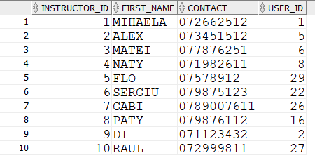

*--TABLE ONLINE_CLASS*

INSERT INTO ONLINE_CLASS

VALUES(1001,'CYCLING');

INSERT INTO ONLINE_CLASS

VALUES(1002,'TRAIN ABS!');

INSERT INTO ONLINE_CLASS

VALUES(1003,'PILATES');

INSERT INTO ONLINE_CLASS

VALUES(1004,'YOGA');

INSERT INTO ONLINE_CLASS

VALUES(1005,'DUMP TRUCK');

INSERT INTO ONLINE_CLASS

VALUES(1006,'DANCE IT OUT');

INSERT INTO ONLINE_CLASS

VALUES(1007,'SWEATY SWEAT');

INSERT INTO ONLINE_CLASS

VALUES(1008,'MUSCLE DESTROYER');

INSERT INTO ONLINE_CLASS

VALUES(1009,'FULL BODY TONING');

INSERT INTO ONLINE_CLASS

VALUES(1010,'BEGINNERS CIRCUIT');

INSERT INTO ONLINE_CLASS

VALUES(1011,'10-MIN-SQUAT');

INSERT INTO ONLINE_CLASS

VALUES(1012,'UPPER BODY POWER');

SELECT * FROM ONLINE_CLASS;

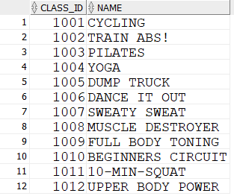

*--TABELA MEMBERSHIP*

INSERT INTO MEMBERSHIP

VALUES(1,'BRONZE','1 MONTH',199);

INSERT INTO MEMBERSHIP

VALUES(2,'SILVER','1 MONTH',239);

INSERT INTO MEMBERSHIP

VALUES(3,'GOLD','1 MONTH',279);

INSERT INTO MEMBERSHIP

VALUES(4,'PLATINUM','1 MONTH',299);

INSERT INTO MEMBERSHIP

VALUES(5,'BRONZE','3 MONTHS',559);

INSERT INTO MEMBERSHIP

VALUES(6,'SILVER','3 MONTHS',699);

INSERT INTO MEMBERSHIP

VALUES(7,'GOLD','3 MONTH',799);

INSERT INTO MEMBERSHIP

VALUES(8,'PLATINUM','3 MONTH',899);

INSERT INTO MEMBERSHIP

VALUES(9,'BRONZE','12 MONTHS',1990);

INSERT INTO MEMBERSHIP

VALUES(10,'SILVER','12 MONTHS',2590);

INSERT INTO MEMBERSHIP

VALUES(11,'GOLD','12 MONTHS',2990);

INSERT INTO MEMBERSHIP

VALUES(12,'PLATINUM','12 MONTHS',3199);

SELECT * FROM MEMBERSHIP;

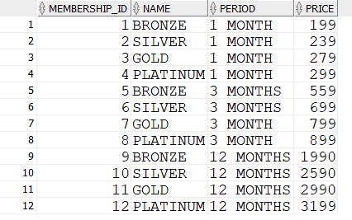

--TABELA MEMBERS

INSERT INTO MEMBERS

VALUES(2001,'MARIA','F',19,SYSDATE,DATE '2023-02-12',1,3);

INSERT INTO MEMBERS

VALUES(2002,'COSMIN','M',23,SYSDATE,DATE'2023-04-12',5,4);

INSERT INTO MEMBERS

VALUES(2003,'CORINA','F',25,SYSDATE,DATE'2023-02-12',3,7);

INSERT INTO MEMBERS

VALUES(2004,'EUGEN','M',54,SYSDATE,DATE'2023-02-12',1,9);

INSERT INTO MEMBERS

VALUES(2005,'LILIANA','F',55,SYSDATE,DATE'2024-01-12',12,10);

INSERT INTO MEMBERS

VALUES(2006,'RADU','M',48,SYSDATE,DATE'2023-02-12',3,11);

INSERT INTO MEMBERS

VALUES(2007,'MIRELA','F',49,SYSDATE,DATE'2023-04-12',7,12);

INSERT INTO MEMBERS

VALUES(2008,'IONEL','M',40,SYSDATE,DATE'2024-01-12',9,13);

INSERT INTO MEMBERS

VALUES(2009,'ELISA','F',19,SYSDATE,DATE'2023-04-12',6,30);

INSERT INTO MEMBERS

VALUES(2010,'FLORIN','M',22,SYSDATE,DATE'2023-02-12',1,28);

INSERT INTO MEMBERS

VALUES(2011,'LORENA','F',17,SYSDATE,DATE'2023-02-12',2,25);

INSERT INTO MEMBERS

VALUES(2012,'LAURENTIU','M',21,SYSDATE,DATE'2023-02-12',3,24);

INSERT INTO MEMBERS

VALUES(2013,'ALEXANDRA','F',18,SYSDATE,DATE'2023-02-12',1,14);

INSERT INTO MEMBERS

VALUES(2014,'MARIA','F',24,SYSDATE,DATE'2023-02-12',4,17);

INSERT INTO MEMBERS

VALUES(2015,'TUDOR','M',30,SYSDATE,DATE '2023-02-12',3,21);

INSERT INTO MEMBERS

VALUES(2016,'ADRIAN','M',39,SYSDATE,DATE'2023-04-12',6,23);

INSERT INTO MEMBERS

VALUES(2017,'MARA','F',27,SYSDATE,DATE'2023-02-12',1,15);

INSERT INTO MEMBERS

VALUES(2018,'VLAD','M',29,SYSDATE,DATE'2024-01-12',11,18);

INSERT INTO MEMBERS

VALUES(2019,'CLAUDIA','F',58,SYSDATE,DATE'2023-02-12',1,20);

INSERT INTO MEMBERS

VALUES(2020,'LUCA','M',31,SYSDATE,DATE '2023-02-12',3,19);

SELECT * FROM MEMBERS;

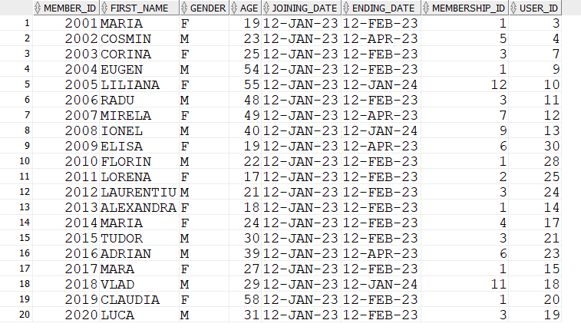

--TABELA ASOCIATIVA WORKOUT_PLAN

INSERT INTO WORKOUT_PLAN

VALUES(1,9,10,2020);

INSERT INTO WORKOUT_PLAN

VALUES(2,10,3,2002);

INSERT INTO WORKOUT_PLAN

VALUES(3,2,4,2007);

INSERT INTO WORKOUT_PLAN

VALUES(1,6,2,2005);

INSERT INTO WORKOUT_PLAN

VALUES(1,7,2,2005);

INSERT INTO WORKOUT_PLAN

VALUES(1,3,2,2005);

INSERT INTO WORKOUT_PLAN

VALUES(5,4,6,2015);

INSERT INTO WORKOUT_PLAN

VALUES(7,3,8,2009);

INSERT INTO WORKOUT_PLAN

VALUES(7,5,5,2018);

INSERT INTO WORKOUT_PLAN

VALUES(6,1,1,2006);

INSERT INTO WORKOUT_PLAN

VALUES(6,1,1,2007);

INSERT INTO WORKOUT_PLAN

VALUES(6,1,2,2008);

INSERT INTO WORKOUT_PLAN

VALUES(6,1,2,2005);

INSERT INTO WORKOUT_PLAN

VALUES(6,3,2,2004);

INSERT INTO WORKOUT_PLAN

VALUES(2,7,3,2013);

INSERT INTO WORKOUT_PLAN

VALUES(7,5,4,2016);

INSERT INTO WORKOUT_PLAN

VALUES(4,1,1,2011);

INSERT INTO WORKOUT_PLAN

VALUES(4,2,1,2011);

INSERT INTO WORKOUT_PLAN

VALUES(4,3,1,2011);

INSERT INTO WORKOUT_PLAN

VALUES(4,4,1,2011);

INSERT INTO WORKOUT_PLAN

VALUES(2,8,2,2003);

INSERT INTO WORKOUT_PLAN

VALUES(5,7,3,2001);

INSERT INTO WORKOUT_PLAN

VALUES(5,6,6,2012);

INSERT INTO WORKOUT_PLAN

VALUES(7,9,5,2006);

INSERT INTO WORKOUT_PLAN

VALUES(3,10,7,2009);

INSERT INTO WORKOUT_PLAN

VALUES(6,5,10,2004);

INSERT INTO WORKOUT_PLAN

VALUES(6,8,10,2020);

INSERT INTO WORKOUT_PLAN

VALUES(6,9,2,2017);

SELECT * FROM WORKOUT_PLAN;

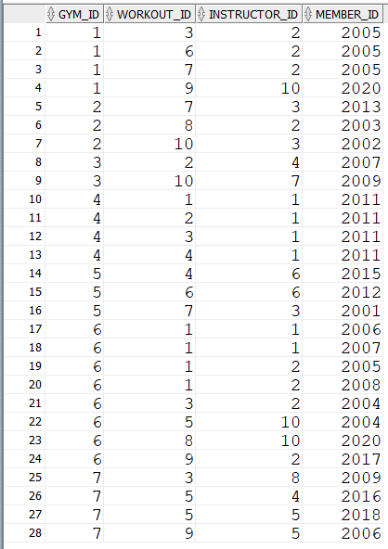

--TABELA ASOCIATIVA BOOKS

INSERT INTO BOOKS

VALUES(2003,1001);

INSERT INTO BOOKS

VALUES(2010,1011);

INSERT INTO BOOKS

VALUES(2004,1002);

INSERT INTO BOOKS

VALUES(2019,1007);

INSERT INTO BOOKS

VALUES(2007,1006);

INSERT INTO BOOKS

VALUES(2020,1005);

INSERT INTO BOOKS

VALUES(2020,1009);

INSERT INTO BOOKS

VALUES(2018,1003);

INSERT INTO BOOKS

VALUES(2012,1010);

INSERT INTO BOOKS

VALUES(2011,1011);

INSERT INTO BOOKS

VALUES(2001,1004);

INSERT INTO BOOKS

VALUES(2008,1012);

INSERT INTO BOOKS

VALUES(2016,1004);

INSERT INTO BOOKS

VALUES(2017,1007);

INSERT INTO BOOKS

VALUES(2015,1012);

INSERT INTO BOOKS

VALUES(2010,1002);

INSERT INTO BOOKS

VALUES(2005,1010);

INSERT INTO BOOKS

VALUES(2010,1001);

INSERT INTO BOOKS

VALUES(2002,1007);

INSERT INTO BOOKS

VALUES(2012,1008);

INSERT INTO BOOKS

VALUES(2018,1003);

INSERT INTO BOOKS

VALUES(2020,1009);

INSERT INTO BOOKS

VALUES(2013,1011);

INSERT INTO BOOKS

VALUES(2019,1006);

INSERT INTO BOOKS

VALUES(2011,1003);

INSERT INTO BOOKS

VALUES(2018,1008);

INSERT INTO BOOKS

VALUES(2015,1010);

INSERT INTO BOOKS

VALUES(2002,1001);

SELECT * FROM BOOKS;

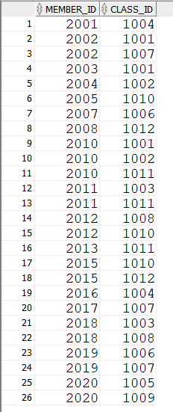

--TABELA PAYMENTS

INSERT INTO PAYMENTS

VALUES(9001,199,SYSDATE,2001);

INSERT INTO PAYMENTS

VALUES(9002,299,SYSDATE,2002);

INSERT INTO PAYMENTS

VALUES(9003,259,SYSDATE,2003);

INSERT INTO PAYMENTS

VALUES(9004,1990,SYSDATE,2004);

INSERT INTO PAYMENTS

VALUES(9005,2990,SYSDATE,2005);

INSERT INTO PAYMENTS

VALUES(9006,199,SYSDATE,2006);

INSERT INTO PAYMENTS

VALUES(9007,199,SYSDATE,2007);

INSERT INTO PAYMENTS

VALUES(9008,3199,SYSDATE,2008);

INSERT INTO PAYMENTS

VALUES(9009,299,SYSDATE,2009);

INSERT INTO PAYMENTS

VALUES(9010,259,SYSDATE,2010);

INSERT INTO PAYMENTS

VALUES(9011,199,SYSDATE,2011);

INSERT INTO PAYMENTS

VALUES(9012,199,SYSDATE,2012);

SELECT * FROM PAYMENTS;

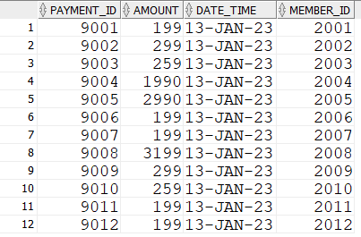

1. ***Formulați în limbaj natural o problemă pe care să o rezolvați folosind un subprogram stocat independent care să utilizeze două tipuri diferite de colecții studiate. Apelați subprogramul.***

--Definiti un subprogram prin care sa obtineti nr de membrii antrenati de un instructor

--dat de la tasatura. Tratati toate exceptiile

--folosim functie stocata,un vector si un tablou imbricat

CREATE OR REPLACE type tablou_imbricat is TABLE OF NUMBER(10);

/

CREATE OR REPLACE type vector1 AS VARRAY(10) OF NUMBER(10);

/

CREATE OR REPLACE FUNCTION f1(iid instructors.instructor_id%TYPE)

RETURN number

IS t tablou_imbricat := tablou_imbricat();

v_id vector1:=vector1();

x NUMBER(10);

rez number(10);

j number(10):=0;

BEGIN

FOR i in 1..5 LOOP

v_id.extend;

SELECT instructor_id into x

from INSTRUCTORS

where instructor_id=i;

v_id(i):=x;

END LOOP;

t.extend;

SELECT DISTINCT member_id bulk collect into t

FROM WORKOUT_PLAN

WHERE instructor_id=iid;

rez:=t.count();

if rez=0 then

RAISE NO_DATA_FOUND;

ELSE

RETURN rez;

END IF;

EXCEPTION

WHEN NO_DATA_FOUND THEN RAISE_APPLICATION_ERROR(-20000,'Nu exista membrii antrenati de instructorul dat');

END f1;

/

BEGIN

DBMS_OUTPUT.PUT_LINE('INSTRUCTORUL DAT ANTRENEAZA '|| f1('&p_id') || ' MEMBRII');

END;

/

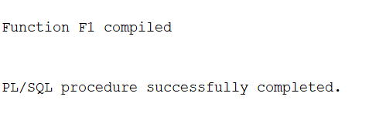

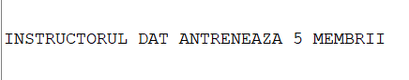

Input: 2

Output: 5

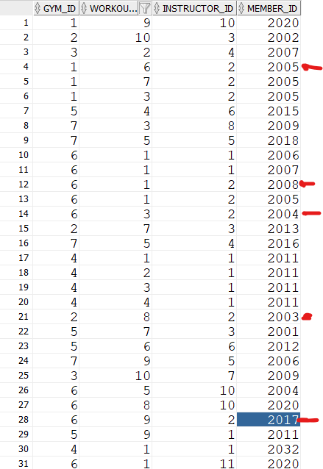

1. ***Formulați în limbaj natural o problemă pe care să o rezolvați folosind un subprogram stocat independent care să utilizeze 2 tipuri diferite de cursoare studiate, unul dintre acestea fiind cursor parametrizat. Apelați subprogramul.***

*--Pentru fiecare sala(id dat de la tastatura) sa se afiseze lista antrenamentelor ce au loc in acea sala*

*--folosim o procedura stocata, un ciclu cursor cu subcereri si un cursor parametrizat*

CREATE OR REPLACE PROCEDURE p1

is

CURSOR C (parametru gyms.gym_id%TYPE)IS

SELECT WORKOUT_NAME,INSTRUCTOR_NAME,MEMBER_NAME

FROM WORKOUT W, INSTRUCTORS p, MEMBERS M, WORKOUT_PLAN WP

WHERE WP.GYM_ID=parametru AND W.WORKOUT_ID=WP.WORKOUT_ID AND P.INSTRUCTOR_ID=WP.INSTRUCTOR_ID AND M.MEMBER_ID=WP.MEMBER_ID;

BEGIN

FOR I IN (SELECT GYM_ID FROM GYMS)LOOP

DBMS_OUTPUT.PUT_LINE('-------------------------------------');

DBMS_OUTPUT.PUT_LINE ('GYM '||i.GYM_ID);

DBMS_OUTPUT.PUT_LINE('-------------------------------------');

FOR J IN C(i.gym_id) LOOP

DBMS_OUTPUT.PUT_LINE ('MEMBRUL '|| j.MEMBER_NAME ||' ARE WORKOUT-UL ' || j.WORKOUT_NAME ||' CU INSTRUCTORUL ' || j.INSTRUCTOR_NAME);

END LOOP;

END LOOP;

END p1;

/

BEGIN

p1;

END;

/

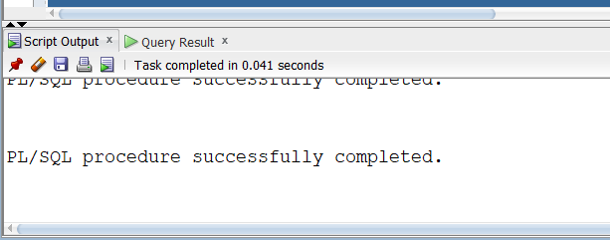

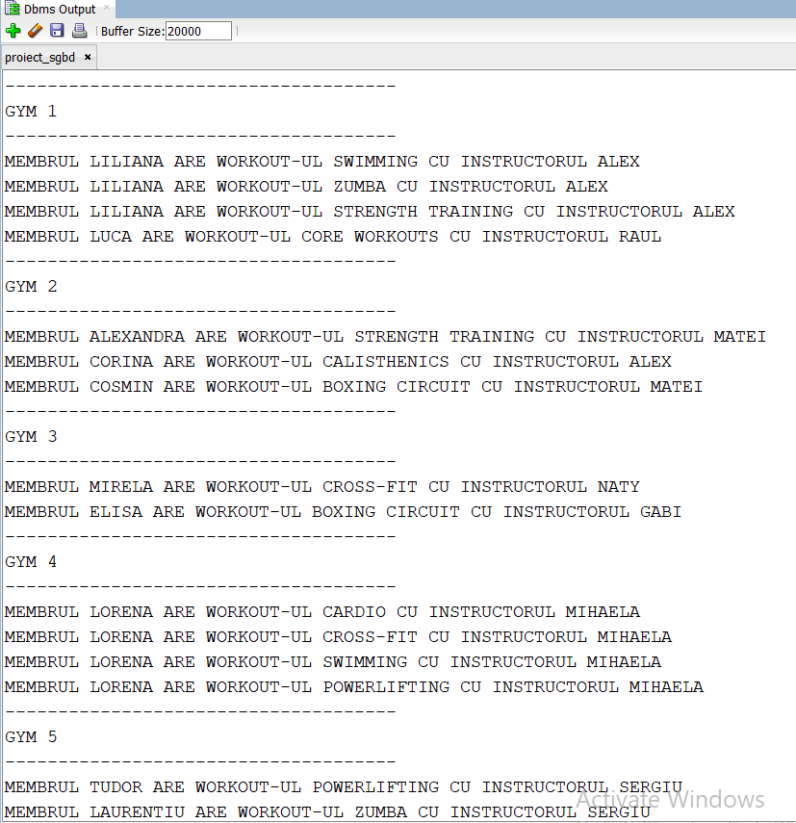

1. ***Formulați în limbaj natural o problemă pe care să o rezolvați folosind un subprogram stocat independent de tip funcție care să utilizeze într-o singură comandă SQL 3 dintre tabelele definite. Definiți minim 2 excepții. Apelați subprogramul astfel încât să evidențiați toate cazurile tratate.***

*--sa se afiseze numarul de angajati dintr-o sala data de la tastatura*

*--folosim o functie stocata*

CREATE OR REPLACE FUNCTION F2(v_id gyms.gym_id%TYPE)

RETURN NUMBER

is A NUMBER;

B NUMBER;

C NUMBER;

rez NUMBER;

begin

SELECT COUNT(distinct G.EMPLOYEE_ID), COUNT(distinct c.EMPLOYEE_ID),COUNT(distinct r.EMPLOYEE_ID)

into A,B,C

FROM GUARDIANS G, CLEANING_STAFF C, RECEPTIONISTS R

WHERE G.GYM_ID=C.GYM_ID AND G.GYM_ID=R.GYM_ID AND G.GYM_ID=V_ID

group by g.gym_id

ORDER BY G.GYM_ID ASC;

rez:=a+b+c;

return rez;

EXCEPTION

WHEN NO_DATA_FOUND THEN RAISE_APPLICATION_ERROR(-20000,'Nu exista aceasta sala');

WHEN TOO_MANY_ROWS THEN RAISE_APPLICATION_ERROR(-20001,'Exista mai multe sali cu acest id');

WHEN OTHERS THEN RAISE_APPLICATION_ERROR(-20002,'Alta eroare!');

end f2;

/

DROP FUNCTION F2;

BEGIN

DBMS_OUTPUT.PUT_LINE('NR DE ANGAJATI ESTE ' || f2('&P'));

END;



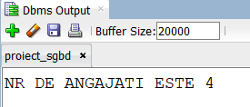

--8 refacut

--sa se calculeze numarul de angajati ai unei sali cu dimensiunea data de la tastatura

--si sa se stearga aceasta sala

CREATE OR REPLACE FUNCTION f2_pmm(dim gyms.dimension%TYPE)

RETURN VARCHAR IS MSG VARCHAR(40);

A NUMBER;

B NUMBER;

C NUMBER;

txt VARCHAR(40):='SALA A FOST STEARSA CU SUCCES';

copie gyms.dimension%TYPE;

NR_ANG NUMBER;

nd NUMBER;

exista_ang EXCEPTION;

PRAGMA EXCEPTION_INIT(exista_ang,-2292); --EXCEPTIE INTERNA NEPREDEFINITA

exc1 EXCEPTION;

exc2 EXCEPTION;

BEGIN

SELECT COUNT(DIMENSION) INTO nd

from gyms

where dimension=dim;

if nd=0 then

RAISE EXC1;

ELSIF nd>1 then

RAISE EXC2;

end if;

BEGIN

SELECT COUNT(distinct G.EMPLOYEE_ID), COUNT(distinct c.EMPLOYEE_ID),COUNT(distinct r.EMPLOYEE_ID)

into A,B,C

FROM GUARDIANS G, CLEANING_STAFF C, RECEPTIONISTS R, GYMS GM

WHERE G.GYM_ID=C.GYM_ID AND G.GYM_ID=R.GYM_ID AND GM.GYM_ID=G.GYM_ID AND GM.DIMENSION=DIM

group by g.gym_id

ORDER BY G.GYM_ID ASC;

NR_ANG:=a+b+c;

MSG:=CONCAT('NUMARUL DE ANGAJATI ESTE ', TO_CHAR(NR_ANG));

EXCEPTION

WHEN NO_DATA_FOUND THEN DBMS_OUTPUT.PUT_LINE('NU EXISTA ANGAJATI LA ACEASTA SALA');

END;

DELETE FROM GYMS WHERE DIMENSION=dim;

RETURN txt;

EXCEPTION

WHEN EXC1 THEN DBMS_OUTPUT.PUT_LINE('NU AVEM O SALA CU DIMENSIUNEA DATA');

RETURN MSG;

WHEN EXC2 THEN DBMS_OUTPUT.PUT_LINE('EXISTA MAI MULTE SALI CU DIMENSIUNEA DATA');

RETURN MSG;

WHEN exista_ang THEN DBMS_OUTPUT.PUT_LINE('NU PUTETI STERGE ABONAMENTUL DEOARECE EXISTA MEMBRII CE AU ACEASTA SUBSCRIPTIE');

RETURN MSG;

END F2_PMM;

/

--TOO MANY ROWS: 10

--NO DATA FOUND: 35

--FOREIGN KEY RESTRICTION : 80

--SUCCES:70

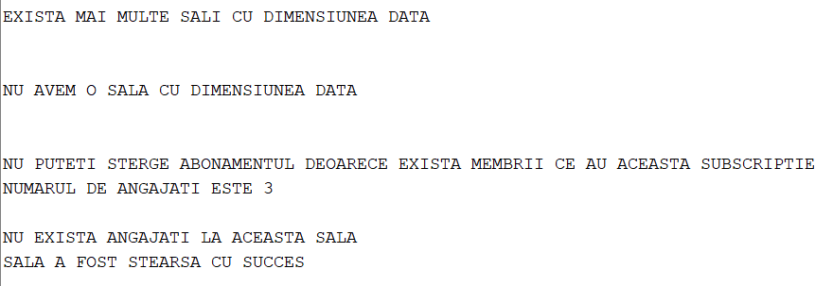

1. ***Formulați în limbaj natural o problemă pe care să o rezolvați folosind un subprogram stocat independent de tip procedură care să utilizeze într-o singură comandă SQL 5 dintre tabelele definite. Tratați toate excepțiile care pot apărea, incluzând excepțiile NO_DATA_FOUND și TOO_MANY_ROWS. Apelați subprogramul astfel încât să evidențiați toate cazurile tratate.***

*--sa se afiseze numarul de antrenamente pe care il are un membru dat de la tastatura(NUMELE SAU)*

*--cu un anumit instructor dat de la tastatura(numele sau)*

*--la o sala data de la tastatura*

*-- si cu abonament de tip SILVER 1 luna*

*--folosim procedura stocata SI CURSOR EXPLICIT*

CREATE OR REPLACE PROCEDURE P2(m_nume members.member_name%TYPE,

i_nume instructors.instructor_name%TYPE,

g_id gyms.gym_id%TYPE,

ms_nume membership.membership_name%TYPE,

ms_id membership.membership_id%TYPE)

is

rez NUMBER;

a_nume members.member_name%TYPE;

b_nume instructors.instructor_name%TYPE;

c_id gyms.gym_id%TYPE;

CURSOR C IS

SELECT COUNT(*)

FROM WORKOUT_PLAN WK,MEMBERS M ,INSTRUCTORS I, GYMS G , MEMBERSHIP MS

WHERE upper(M.MEMBER_NAME)=upper(m_nume) AND WK.MEMBER_ID=M.MEMBER_ID and

upper(I.instructor_name)=upper(i_nume) AND WK.INSTRUCTOR_ID=I.INSTRUCTOR_ID AND

WK.GYM_ID=g_id AND WK.GYM_ID=G.GYM_ID AND

upper(MS.MEMBERSHIP_NAME)=upper(ms_nume) AND MS.MEMBERSHIP_ID=ms_id;

BEGIN

select member_name

into a_nume

from members

where member_name=m_nume;

OPEN C;

LOOP

FETCH C INTO REZ;

EXIT WHEN C%NOTFOUND;

DBMS_OUTPUT.PUT_LINE('NR DE ANTRENAMENTE FACUTE DE ' || M_NUME ||' CU ' || I_NUME || ' IN SALA ' || G_ID|| ' ESTE ' || REZ);

END LOOP;

EXCEPTION

WHEN NO_DATA_FOUND THEN RAISE_APPLICATION_ERROR(-20000,'Nu exista acest membru/instructor/sala/abonament');

WHEN TOO_MANY_ROWS THEN RAISE_APPLICATION_ERROR(-20001,'Exista mai multi membri/instructori/sali/memberships cu acest nume');

WHEN OTHERS THEN RAISE_APPLICATION_ERROR(-20002,'Alta eroare!');

END P2;

/

BEGIN

P2('&P_NUME_MEMBRU','&P_NUME_INSTRUCTOR','&P_ID_SALA','SILVER',2);

END;

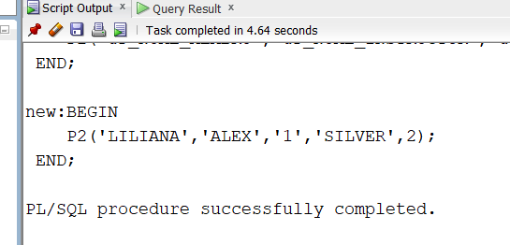

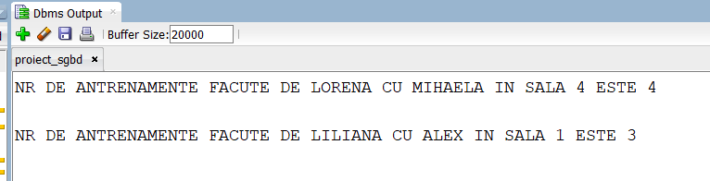

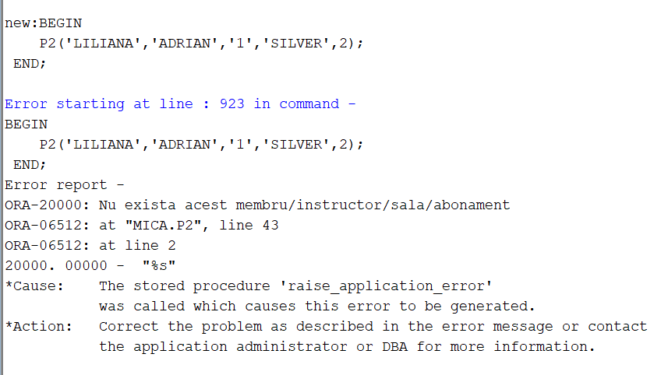

--9 refacut

--EX9

--sa se afiseze numarul de antrenamente pe care il are un membru dat de la tastatura(NUMELE SAU)

--cu un anumit instructor dat de la tastatura(numele sau)

--la o sala data de la tastatura

-- si cu abonament de tip SILVER 1 luna (membership cod 2)

--folosim procedura stocata SI CURSOR EXPLICIT

CREATE OR REPLACE PROCEDURE P2 (m_nume members.member_name%TYPE,

i_nume instructors.instructor_name%TYPE,

g_id gyms.gym_id%TYPE,

ms_id membership.membership_id%TYPE)

is

rez NUMBER;

a NUMBER;

b NUMBER;

c_id NUMBER;

d number;

exc1 exception;

exc2 exception;

exc3 exception;

exc4 exception;

CURSOR C IS

SELECT COUNT(*)

FROM WORKOUT_PLAN WK,MEMBERS M ,INSTRUCTORS I, GYMS G , MEMBERSHIP MS

WHERE

upper(M.MEMBER_NAME)=upper(m_nume) AND

WK.MEMBER_ID=M.MEMBER_ID and

upper(I.instructor_name)=upper(i_nume) AND

WK.INSTRUCTOR_ID=I.INSTRUCTOR_ID AND

WK.GYM_ID=g_id AND WK.GYM_ID=G.GYM_ID AND

MS.MEMBERSHIP_ID=ms_id;

BEGIN

select count(member_id )

into a

from members

where UPPER(member_name)=UPPER(m_nume);

if a = 0 then

RAISE exc1;

elsif a>1 then

RAISE TOO_MANY_ROWS;

END IF;

select count(INSTRUCTOR_ID )

into b

from INSTRUCTORS

where UPPER(INSTRUCTOR_NAME)=UPPER(I_NUME);

if b = 0 then

RAISE exc2;

ELSIF B>1 THEN

RAISE TOO_MANY_ROWS;

END IF;

select count(gym_id)

into c_id

from gyms

where gym_id=g_id;

if c_id = 0 then

RAISE exc3;

END IF;

select membership_id

into d

from membership

where membership_id=ms_id;

if d != 2 then

RAISE EXC4;

END IF;

OPEN C;

LOOP

FETCH C INTO REZ;

if REZ = 0 THEN

RAISE NO_DATA_FOUND;

END IF;

EXIT WHEN C%NOTFOUND;

DBMS_OUTPUT.PUT_LINE('NR DE ANTRENAMENTE FACUTE DE ' || M_NUME ||' CU ' || I_NUME || ' IN SALA ' || G_ID|| ' ESTE ' || REZ);

END LOOP;

EXCEPTION

WHEN exc1 THEN RAISE_APPLICATION_ERROR(-20003,'Nu exista acest membru');

WHEN exc2 THEN RAISE_APPLICATION_ERROR(-20010,'Nu exista acest instructor');

WHEN exc3 THEN RAISE_APPLICATION_ERROR(-20100,'Nu exista aceasta sala');

WHEN exc4 THEN RAISE_APPLICATION_ERROR(-20104,'Abonamentul nu este de tip SILVER 1 MONTH');

WHEN NO_DATA_FOUND THEN RAISE_APPLICATION_ERROR(-20000,'Nu exista acest plan de antrenament');

WHEN TOO_MANY_ROWS THEN RAISE_APPLICATION_ERROR(-20001,'Exista mai multi membri/instructori cu acest nume');

END P2;

/

BEGIN

P2('&P_NUME_MEMBRU','&P_NUME_INSTRUCTOR','&P_ID_SALA','&p_id_membership');

END;

-- NO DATA FOUND MEMBRU : CORNEL, MIHAELA , 2 ,2

--TOO MANY ROWS MEMBRU : LORENA, MIHAELA, 4, 2

--NO DATA FOUND INSTRUCTOR: ADRIAN, CORNEL, 3, 2

--TOO MANY ROWS INSTRUCTOR: LUCA, RAUL, 2 2

--ABONAMENT GRESIT : LILIANA MIHAELA 4 1

--NO DATA FOUND PLAN: LILIANA ALEX 5 2

--SUCCES : LILIANA ALEX 1 2

1. ***Definiți un trigger de tip LMD la nivel de comandă. Declanșați trigger-ul.***

--Definiti un declansator care sa nu permita inserarea unui gardian care nu exista in tabela employees sau care exista deja in tabela cleaning_staff sau receptionists.

--Definiti un declansator care sa nu permita modificarea tabelei workout_plan de altcineva inafara de instructor

*--Definiti un declansator care sa nu permita modificarea tabelei workout_plan in afara intervalului 10:00-16:00*

CREATE OR REPLACE TRIGGER trig_lmd1

BEFORE INSERT OR DELETE OR UPDATE on WORKOUT_PLAN

BEGIN

IF (TO_CHAR(SYSDATE,'D') = 1) OR (TO_CHAR(SYSDATE,'HH24') NOT BETWEEN 10 AND 16)THEN

IF INSERTING THEN RAISE_APPLICATION_ERROR(-20001,'Inserarea in WORKOUT_PLAN este permisa doar in timpul programului de lucru!');

ELSIF DELETING THEN RAISE_APPLICATION_ERROR(-20002,'Stergerea din WORKOUT_PLAN este permisa doar in timpul programului de lucru!');

ELSE RAISE_APPLICATION_ERROR(-20003,'Actualizarile in WORKOUT_PLAN sunt permise doar in timpul programului de lucru!');

END IF;

END IF;

END;

/

DROP TRIGGER trig_lmd1;

INSERT INTO WORKOUT_PLAN

VALUES(1,4,1,2001);

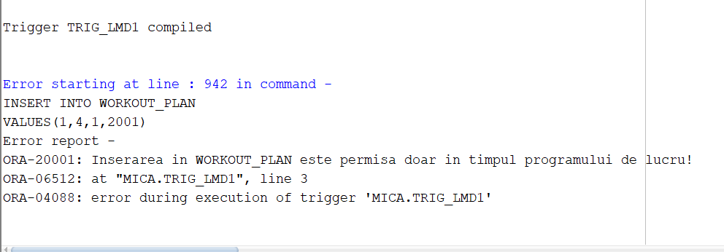

1. ***Definiți un trigger de tip LMD la nivel de linie. Declanșați trigger-ul.***

*--Definiti un declansator care sa nu permita inserarea unui membru a carui varsta este mai mica sau egala cu 15 ani si a carui data de incheiere a abonamentului este inaintea inregistrarii sale*

CREATE OR REPLACE TRIGGER trig_lmd2

BEFORE INSERT ON MEMBERS

FOR EACH ROW

BEGIN

if :NEW.AGE<=15 THEN

RAISE_APPLICATION_ERROR(-20910, 'Eroare: Varsta trebuie sa fie peste 15 ani!');

elsif :NEW.ending_date<:NEW.joining_date THEN

RAISE_APPLICATION_ERROR(-20900, 'Eroare: ENDING_DATE nu poate fi inaintea JOINING_DATE!');

Else

DBMS_OUTPUT.PUT_LINE('INSERARE REUSITA!');

END IF;

END;

/

insert into members

VALUES(2030,'ALINA','F',20,DATE '2025-01-12', DATE'2024-02-12',3,30);

DELETE FROM MEMBERS WHERE MEMBER_NAME='ALINA';

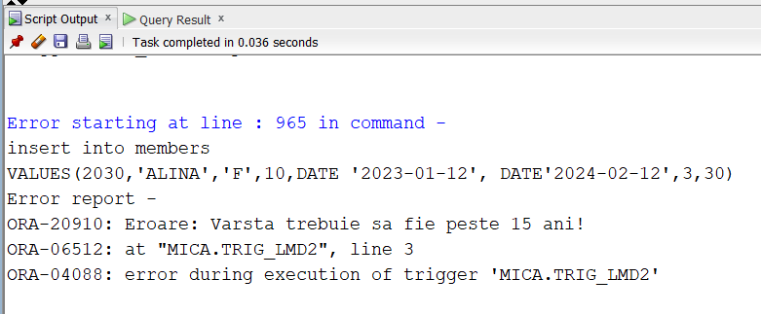

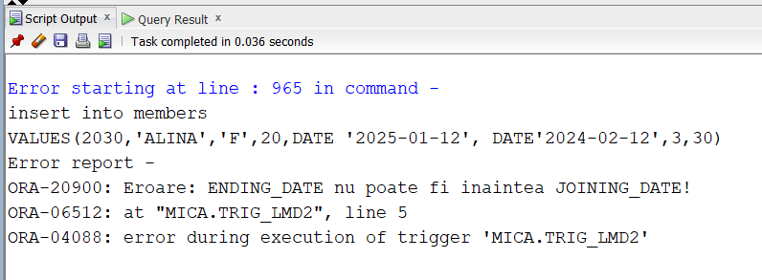

1. *Definiți un trigger de tip LDD. Declanșați trigger-ul.*

*----Definiti un declansator LDD care sa nu permita crearea, stergerea sau modificarea tabelelor pana la dezactivarea acestuia*

CREATE OR REPLACE TRIGGER trig_ldd

BEFORE CREATE OR ALTER OR DROP ON DATABASE

BEGIN

RAISE_APPLICATION_ERROR(-20000, 'PENTRU A CREA/MODIFICA/STERGE UN TABEL, TREBUIE SA DEZACTIVATI DECLANSATORUL trig_ldd!');

END;

/

CREATE TABLE EMP AS ( SELECT * FROM EMPLOYEES);

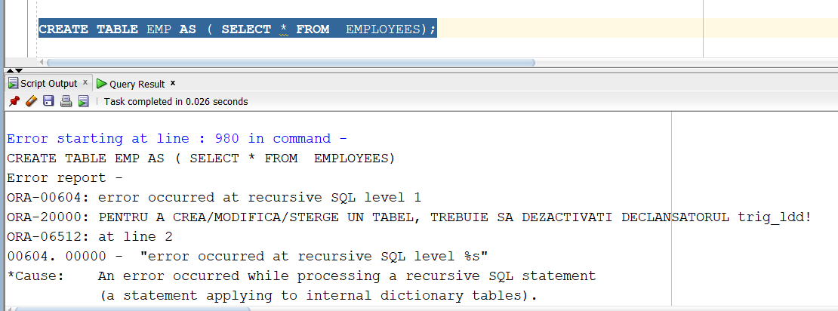

1. ***Definiți un pachet care să conțină toate obiectele definite în cadrul proiectului.***

CREATE OR REPLACE PACKAGE pachet1 AS

FUNCTION F1

RETURN NUMBER;

FUNCTION F2(v_id gyms.gym_id%TYPE)

RETURN NUMBER;

PROCEDURE P1;

PROCEDURE P2(m_nume members.member_name%TYPE,

i_nume instructors.instructor_name%TYPE,

g_id gyms.gym_id%TYPE,

ms_nume membership.membership_name%TYPE,

ms_id membership.membership_id%TYPE);

END pachet1;

/

CREATE OR REPLACE PACKAGE BODY pachet1 AS

FUNCTION F1

RETURN number

IS t tablou_imbricat := tablou_imbricat();

v_id vector1:=vector1();

x NUMBER(10);

rez number(10);

j number(10):=0;

BEGIN

FOR i in 1..5 LOOP

v_id.extend;

SELECT instructor_id into x

from INSTRUCTORS

where instructor_id=i;

v_id(i):=x;

END LOOP;

j:=v_id(3);

t.extend;

SELECT member_id bulk collect into t

FROM WORKOUT_PLAN

WHERE instructor_id=j;

rez:=t.count();

RETURN rez;

EXCEPTION

WHEN NO_DATA_FOUND THEN RAISE_APPLICATION_ERROR(-20000,'Nu exista membrii antrenati de instructorul dat');

WHEN TOO_MANY_ROWS THEN RAISE_APPLICATION_ERROR(-20001,'Exista mai multi membrii antrenati de mai multi instructori!');

WHEN OTHERS THEN RAISE_APPLICATION_ERROR(-20002,'Alta eroare!');

End;

FUNCTION F2(v_id gyms.gym_id%TYPE)

RETURN NUMBER

is A NUMBER;

B NUMBER;

C NUMBER;

rez NUMBER;

begin

SELECT COUNT(distinct G.EMPLOYEE_ID), COUNT(distinct c.EMPLOYEE_ID),COUNT(distinct r.EMPLOYEE_ID)

into A,B,C

FROM GUARDIANS G, CLEANING_STAFF C, RECEPTIONISTS R

WHERE G.GYM_ID=C.GYM_ID AND G.GYM_ID=R.GYM_ID AND G.GYM_ID=V_ID

group by g.gym_id

ORDER BY G.GYM_ID ASC;

rez:=a+b+c;

return rez;

EXCEPTION

WHEN NO_DATA_FOUND THEN RAISE_APPLICATION_ERROR(-20000,'Nu exista aceasta sala');

WHEN TOO_MANY_ROWS THEN RAISE_APPLICATION_ERROR(-20001,'Exista mai multe sali cu acest id');

WHEN OTHERS THEN RAISE_APPLICATION_ERROR(-20002,'Alta eroare!');

end;

PROCEDURE P1

is

CURSOR C (parametru gyms.gym_id%TYPE)IS

SELECT WORKOUT_NAME,INSTRUCTOR_NAME,MEMBER_NAME

FROM WORKOUT W, INSTRUCTORS p, MEMBERS M, WORKOUT_PLAN WP

WHERE WP.GYM_ID=parametru AND W.WORKOUT_ID=WP.WORKOUT_ID AND P.INSTRUCTOR_ID=WP.INSTRUCTOR_ID AND M.MEMBER_ID=WP.MEMBER_ID;

BEGIN

FOR I IN (SELECT GYM_ID FROM GYMS)LOOP

DBMS_OUTPUT.PUT_LINE('-------------------------------------');

DBMS_OUTPUT.PUT_LINE ('GYM '||i.GYM_ID);

DBMS_OUTPUT.PUT_LINE('-------------------------------------');

FOR J IN C(i.gym_id) LOOP

DBMS_OUTPUT.PUT_LINE ('MEMBRUL '|| j.MEMBER_NAME ||' ARE WORKOUT-UL ' || j.WORKOUT_NAME ||' CU INSTRUCTORUL ' || j.INSTRUCTOR_NAME);

END LOOP;

END LOOP;

END ;

PROCEDURE P2(m_nume members.member_name%TYPE,

i_nume instructors.instructor_name%TYPE,

g_id gyms.gym_id%TYPE,

ms_nume membership.membership_name%TYPE,

ms_id membership.membership_id%TYPE)

is

rez NUMBER;

a_nume members.member_name%TYPE;

b_nume instructors.instructor_name%TYPE;

c_id gyms.gym_id%TYPE;

CURSOR C IS

SELECT COUNT(*)

FROM WORKOUT_PLAN WK,MEMBERS M ,INSTRUCTORS I, GYMS G , MEMBERSHIP MS

WHERE upper(M.MEMBER_NAME)=upper(m_nume) AND WK.MEMBER_ID=M.MEMBER_ID and

upper(I.instructor_name)=upper(i_nume) AND WK.INSTRUCTOR_ID=I.INSTRUCTOR_ID AND

WK.GYM_ID=g_id AND WK.GYM_ID=G.GYM_ID AND

upper(MS.MEMBERSHIP_NAME)=upper(ms_nume) AND MS.MEMBERSHIP_ID=ms_id;

BEGIN

select member_name

into a_nume

from members

where member_name=m_nume;

OPEN C;

LOOP

FETCH C INTO REZ;

EXIT WHEN C%NOTFOUND;

DBMS_OUTPUT.PUT_LINE('NR DE ANTRENAMENTE FACUTE DE ' || M_NUME ||' CU ' || I_NUME || ' IN SALA ' || G_ID|| ' ESTE ' || REZ);

END LOOP;

EXCEPTION

WHEN NO_DATA_FOUND THEN RAISE_APPLICATION_ERROR(-20000,'Nu exista acest membru/instructor/sala/abonament');

WHEN TOO_MANY_ROWS THEN RAISE_APPLICATION_ERROR(-20001,'Exista mai multi membri/instructori/sali/memberships cu acest nume');

WHEN OTHERS THEN RAISE_APPLICATION_ERROR(-20002,'Alta eroare!');

END ;

end pachet1;

/

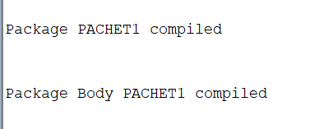

select pachet1.f1 from dual;

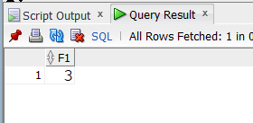

select pachet1.f2(6) from dual;

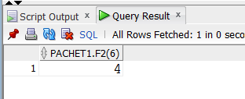

EXECUTE pachet1.p1;

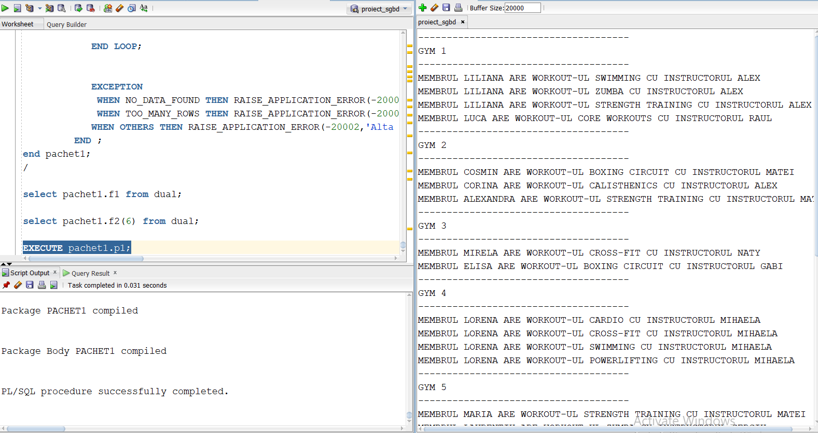

EXECUTE pachet1.p2('&P_NUME_MEMBRU','&P_NUME_INSTRUCTOR','&P_ID_SALA','SILVER',2);

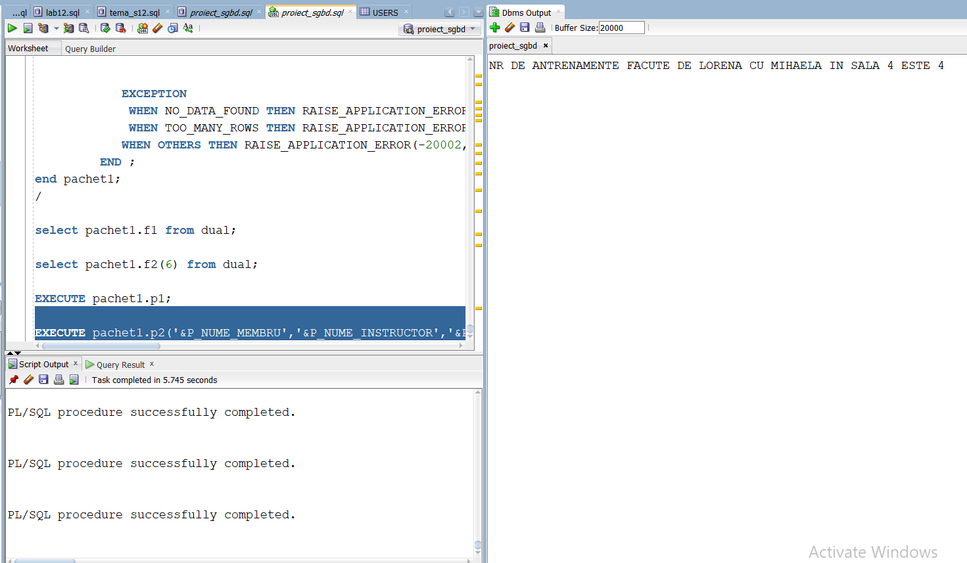

--13 refacut

CREATE OR REPLACE PACKAGE ex13 AS

FUNCTION F1(iid instructors.instructor_id%TYPE)

RETURN NUMBER;

FUNCTION f2_pmm(dim gyms.dimension%TYPE)

RETURN VARCHAR;

PROCEDURE P1;

PROCEDURE P2 (m_nume members.member_name%TYPE,

i_nume instructors.instructor_name%TYPE,

g_id gyms.gym_id%TYPE,

ms_id membership.membership_id%TYPE);

END ex13;

/

CREATE OR REPLACE PACKAGE BODY EX13 AS

FUNCTION F1(iid instructors.instructor_id%TYPE)

RETURN number

IS t tablou_imbricat := tablou_imbricat();

v_id vector1:=vector1();

x NUMBER(10);

rez number(10);

j number(10):=0;

BEGIN

FOR i in 1..5 LOOP

v_id.extend;

SELECT instructor_id into x

from INSTRUCTORS

where instructor_id=i;

v_id(i):=x;

END LOOP;

t.extend;

SELECT DISTINCT member_id bulk collect into t

FROM WORKOUT_PLAN

WHERE instructor_id=iid;

rez:=t.count();

if rez=0 then

RAISE NO_DATA_FOUND;

ELSE

RETURN rez;

END IF;

EXCEPTION

WHEN NO_DATA_FOUND THEN RAISE_APPLICATION_ERROR(-20000,'Nu exista membrii antrenati de instructorul dat');

END f1;

FUNCTION f2_pmm(dim gyms.dimension%TYPE)

RETURN VARCHAR IS MSG VARCHAR(40);

A NUMBER;

B NUMBER;

C NUMBER;

txt VARCHAR(40):='SALA A FOST STEARSA CU SUCCES';

copie gyms.dimension%TYPE;

NR_ANG NUMBER;

nd NUMBER;

exista_ang EXCEPTION;

PRAGMA EXCEPTION_INIT(exista_ang,-2292);

exc1 EXCEPTION;

exc2 EXCEPTION;

BEGIN

SELECT COUNT(DIMENSION) INTO nd

from gyms

where dimension=dim;

if nd=0 then

RAISE EXC1;

ELSIF nd>1 then

RAISE EXC2;

end if;

BEGIN

SELECT COUNT(distinct G.EMPLOYEE_ID), COUNT(distinct c.EMPLOYEE_ID),COUNT(distinct r.EMPLOYEE_ID)

into A,B,C

FROM GUARDIANS G, CLEANING_STAFF C, RECEPTIONISTS R, GYMS GM

WHERE G.GYM_ID=C.GYM_ID AND G.GYM_ID=R.GYM_ID AND GM.GYM_ID=G.GYM_ID AND GM.DIMENSION=DIM

group by g.gym_id

ORDER BY G.GYM_ID ASC;

NR_ANG:=a+b+c;

MSG:=CONCAT('NUMARUL DE ANGAJATI ESTE ', TO_CHAR(NR_ANG));

EXCEPTION

WHEN NO_DATA_FOUND THEN DBMS_OUTPUT.PUT_LINE('NU EXISTA ANGAJATI LA ACEASTA SALA');

END;

--DELETE FROM GYMS WHERE DIMENSION=dim;

RETURN msg;

EXCEPTION

WHEN EXC1 THEN DBMS_OUTPUT.PUT_LINE('NU AVEM O SALA CU DIMENSIUNEA DATA');

msg:='NU AVEM O SALA CU DIMENSIUNEA DATA';

RETURN MSG;

WHEN EXC2 THEN DBMS_OUTPUT.PUT_LINE('EXISTA MAI MULTE SALI CU DIMENSIUNEA DATA');

msg:='EXISTA MAI MULTE SALI CU DIMENSIUNEA DATA';

RETURN MSG;

WHEN exista_ang THEN DBMS_OUTPUT.PUT_LINE('NU PUTETI STERGE ABONAMENTUL DEOARECE EXISTA MEMBRII CE AU ACEASTA SUBSCRIPTIE');

msg:='NU PUTETI STERGE ABONAMENTUL DEOARECE EXISTA MEMBRII CE AU ACEASTA SUBSCRIPTIE';

RETURN MSG;

END F2_PMM;

PROCEDURE P1

is

CURSOR C (parametru gyms.gym_id%TYPE)IS

SELECT WORKOUT_NAME,INSTRUCTOR_NAME,MEMBER_NAME

FROM WORKOUT W, INSTRUCTORS p, MEMBERS M, WORKOUT_PLAN WP

WHERE WP.GYM_ID=parametru AND W.WORKOUT_ID=WP.WORKOUT_ID AND P.INSTRUCTOR_ID=WP.INSTRUCTOR_ID AND M.MEMBER_ID=WP.MEMBER_ID;

BEGIN

FOR I IN (SELECT GYM_ID FROM GYMS)LOOP

DBMS_OUTPUT.PUT_LINE('-------------------------------------');

DBMS_OUTPUT.PUT_LINE ('GYM '||i.GYM_ID);

DBMS_OUTPUT.PUT_LINE('-------------------------------------');

FOR J IN C(i.gym_id) LOOP

DBMS_OUTPUT.PUT_LINE ('MEMBRUL '|| j.MEMBER_NAME ||' ARE WORKOUT-UL ' || j.WORKOUT_NAME ||' CU INSTRUCTORUL ' || j.INSTRUCTOR_NAME);

END LOOP;

END LOOP;

END ;

PROCEDURE P2 (m_nume members.member_name%TYPE,

i_nume instructors.instructor_name%TYPE,

g_id gyms.gym_id%TYPE,

ms_id membership.membership_id%TYPE)

is

rez NUMBER;

a NUMBER;

b NUMBER;

c_id NUMBER;

d number;

exc1 exception;

exc2 exception;

exc3 exception;

exc4 exception;

CURSOR C IS

SELECT COUNT(*)

FROM WORKOUT_PLAN WK,MEMBERS M ,INSTRUCTORS I, GYMS G , MEMBERSHIP MS

WHERE

upper(M.MEMBER_NAME)=upper(m_nume) AND

WK.MEMBER_ID=M.MEMBER_ID and

upper(I.instructor_name)=upper(i_nume) AND

WK.INSTRUCTOR_ID=I.INSTRUCTOR_ID AND

WK.GYM_ID=g_id AND WK.GYM_ID=G.GYM_ID AND

MS.MEMBERSHIP_ID=ms_id;

BEGIN

select count(member_id )

into a

from members

where UPPER(member_name)=UPPER(m_nume);

if a = 0 then

RAISE exc1;

elsif a>1 then

RAISE TOO_MANY_ROWS;

END IF;

select count(INSTRUCTOR_ID )

into b

from INSTRUCTORS

where UPPER(INSTRUCTOR_NAME)=UPPER(I_NUME);

if b = 0 then

RAISE exc2;

ELSIF B>1 THEN

RAISE TOO_MANY_ROWS;

END IF;

select count(gym_id)

into c_id

from gyms

where gym_id=g_id;

if c_id = 0 then

RAISE exc3;

END IF;

select membership_id

into d

from membership

where membership_id=ms_id;

if d != 2 then

RAISE EXC4;

END IF;

OPEN C;

LOOP

FETCH C INTO REZ;

if REZ = 0 THEN

RAISE NO_DATA_FOUND;

END IF;

EXIT WHEN C%NOTFOUND;

DBMS_OUTPUT.PUT_LINE('NR DE ANTRENAMENTE FACUTE DE ' || M_NUME ||' CU ' || I_NUME || ' IN SALA ' || G_ID|| ' ESTE ' || REZ);

END LOOP;

EXCEPTION

WHEN exc1 THEN RAISE_APPLICATION_ERROR(-20003,'Nu exista acest membru');

WHEN exc2 THEN RAISE_APPLICATION_ERROR(-20010,'Nu exista acest instructor');

WHEN exc3 THEN RAISE_APPLICATION_ERROR(-20100,'Nu exista aceasta sala');

WHEN exc4 THEN RAISE_APPLICATION_ERROR(-20104,'Abonamentul nu este de tip SILVER 1 MONTH');

WHEN NO_DATA_FOUND THEN RAISE_APPLICATION_ERROR(-20000,'Nu exista acest plan de antrenament');

WHEN TOO_MANY_ROWS THEN RAISE_APPLICATION_ERROR(-20001,'Exista mai multi membri/instructori cu acest nume');

END P2;

end EX13;

/

select ex13.f1('&p_id') from dual;

begin

dbms_output.put_line(ex13.f2_pmm('&p_dim'));

end;

EXECUTE ex13.p1;

EXECUTE ex13.p2('&P_NUME_MEMBRU','&P_NUME_INSTRUCTOR','&P_ID_SALA','&p_id_membership');

drop package ex13;

1. ***Definiți un pachet care să includă tipuri de date complexe și obiecte necesare unui flux de acțiuni integrate, specifice bazei de date definite (minim 2 tipuri de date, minim 2 funcții, minim 2 proceduri).***

CREATE OR REPLACE PACKAGE pachet2 is

type user_details is record(

u_id users.user_id%TYPE,

f_name users.first_name%TYPE,

m_id members.member_id%TYPE);

type workouts is record(

m_name members.member_name%TYPE,

w_name workout.workout_name%TYPE,

i_name instructors.instructor_name%TYPE,

g_id NUMBER(10));

FUNCTION get_member_name (mid members.member_id%TYPE)

return VARCHAR;

FUNCTION get_instructor_name (iid instructors.instructor_name%TYPE)

return VARCHAR;

FUNCTION get_workout_name (wid workout.workout_name%TYPE)

return VARCHAR;

PROCEDURE add_workout_plan(gid gyms.gym_id%TYPE,

wid workout.workout_id%TYPE,

iid instructors.instructor_id%TYPE,

mid members.member_id%TYPE);

PROCEDURE modify_payment(pid payments.payment_id%TYPE,

am payments.amount%TYPE,

m_id members.member_id%TYPE,

new_am payments.amount%TYPE

);

END pachet2;

/

DROP PACKAGE pachet2;

CREATE OR REPLACE PACKAGE BODY pachet2 IS

vu user_details;

vw workouts;

FUNCTION get_member_name (mid members.member_id%TYPE)

return VARCHAR is nume varchar(20);

BEGIN

SELECT MEMBER_NAME INTO nume

FROM MEMBERS

WHERE MEMBER_ID=mid;

return nume;

end;

FUNCTION get_instructor_name (iid instructors.instructor_name%TYPE)

return VARCHAR is nume varchar(20);

BEGIN

SELECT instructor_name INTO nume

FROM INSTRUCTORS

WHERE INSTRUCTOR_ID=iid;

return nume;

end;

FUNCTION get_workout_name (wid workout.workout_name%TYPE)

return VARCHAR is nume varchar(20);

BEGIN

SELECT workout_name INTO nume

FROM WORKOUT

WHERE WORKOUT_ID=wid;

return nume;

end;

PROCEDURE add_workout_plan(gid gyms.gym_id%TYPE,

wid workout.workout_id%TYPE,

iid instructors.instructor_id%TYPE,

mid members.member_id%TYPE) is

BEGIN

vw.m_name:=get_member_name(2001);

vw.w_name:=get_workout_name(4);

vw.i_name:=get_instructor_name(10);

vw.g_id:=6;

DBMS_OUTPUT.PUT_LINE('PLANUL DE ANTRENAMENT A FOST ADAUGAT');

DBMS_OUTPUT.PUT_LINE(vw.m_name || ' FACE ' || vw.w_name ||' CU INSTRUCTORUL ' || vw.i_name|| ' IN SALA '|| vw.g_id);

END add_workout_plan;

PROCEDURE modify_payment(pid payments.payment_id%TYPE,

am payments.amount%TYPE,

m_id members.member_id%TYPE,

new_am payments.amount%TYPE) IS

BEGIN

update payments

set

amount=new_am

where payment_id=pid;

DBMS_OUTPUT.PUT_LINE('plata cu id-ul ' || pid ||' cu valoarea ' || am|| ' a fost modficata');

END modify_payment;

END pachet2;

/

drop package body pachet2;

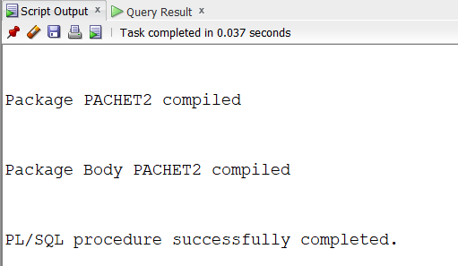

execute pachet2.add_workout_plan(6,7,10,2001);

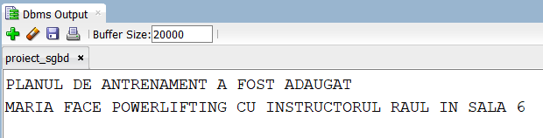

execute pachet2.modify_payment(9001,199,2001,250);



inainte

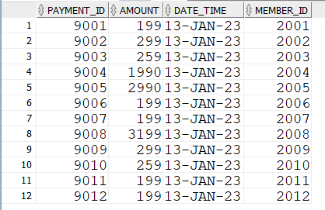

Dupa

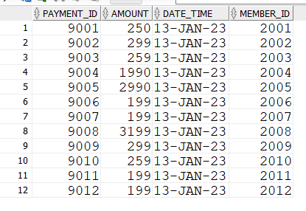

--ex14 refacut

-- facem un pachet care sa afiseze adresele salilor de fitness in care

-- se antreneaza membrii clubului

-- input : nume membru, nume instructor

-- tabel indexat pt a tine evidenta antrenamentelor (workout_plan)

-- tabel imbricat pt a tine evidenta salilor (gyms)

-- 3 functii : get_member_id, get_instructor_id , get_workout_id

-- 2 proceduri : get_workout_plan, show_gym

CREATE OR REPLACE PACKAGE pachet as

TYPE tip_tabel_workout_plan IS TABLE OF workout_plan%ROWTYPE INDEX BY PLS_INTEGER;

tabel_wk tip_tabel_workout_plan;

TYPE tip_tabel_sali IS TABLE OF gyms.gym_id%TYPE;

tabel_gym tip_tabel_sali := tip_tabel_sali();

FUNCTION get_member_id (m_name members.member_name%TYPE)

RETURN members.member_id%TYPE;

FUNCTION get_instructor_id (i_name instructors.instructor_name%TYPE)

RETURN instructors.instructor_id%TYPE;

FUNCTION get_workout_id (wk_name workout.workout_name%TYPE)

RETURN workout.workout_id%TYPE;

PROCEDURE get_workout_plan ( m_name members.member_name%TYPE,

i_name instructors.instructor_name%TYPE,

wk_name workout.workout_name%TYPE);

PROCEDURE show_gym (g_id gyms.gym_id%TYPE);

end pachet;

/

CREATE OR REPLACE PACKAGE BODY pachet as

FUNCTION get_member_id (m_name members.member_name%TYPE)

RETURN members.member_id%TYPE AS

v_id members.member_id%TYPE;

nr NUMBER(10):=0;

BEGIN

SELECT COUNT(MEMBER_ID)

INTO NR

FROM MEMBERS

WHERE UPPER(MEMBER_NAME)=UPPER(M_NAME);

IF NR=0 THEN

DBMS_OUTPUT.PUT_LINE('NU EXISTA MEMBRII CU NUMELE DAT');

ELSIF NR>1 THEN

DBMS_OUTPUT.PUT_LINE('EXISTA MAI MULTI MEMBRII CU NUMELE DAT');

ELSE

SELECT MEMBER_ID

INTO V_ID

FROM MEMBERS

WHERE UPPER(MEMBER_NAME)=UPPER(M_NAME);

RETURN V_ID;

END IF;

END get_member_id;

FUNCTION get_instructor_id (i_name instructors.instructor_name%TYPE)

RETURN instructors.instructor_ID%TYPE AS

v_id instructors.instructor_ID%TYPE;

nr NUMBER(10):=0;

BEGIN

SELECT COUNT(instructor_id)

INTO NR

FROM instructors

WHERE UPPER(instructor_name)=UPPER(i_name);

IF NR=0 THEN

DBMS_OUTPUT.PUT_LINE('NU EXISTA INSTRUCTORI CU NUMELE DAT');

ELSIF NR>1 THEN

DBMS_OUTPUT.PUT_LINE('EXISTA MAI MULTI INSTRUCTORI CU NUMELE DAT');

ELSE

SELECT instructor_id

INTO V_ID

FROM instructors

WHERE UPPER(instructor_name)=UPPER(i_name);

RETURN V_ID;

END IF;

END get_instructor_id;

FUNCTION get_workout_id (wk_name workout.workout_name%TYPE)

RETURN workout.workout_id%TYPE AS

v_id workout.workout_ID%TYPE;

nr NUMBER(10):=0;

BEGIN

SELECT COUNT(workout_id)

INTO NR

FROM WORKOUT

WHERE UPPER(workout_name)=UPPER(wk_name);

IF NR=0 THEN

DBMS_OUTPUT.PUT_LINE('NU EXISTA WORKOUT CU NUMELE DAT');

ELSIF NR>1 THEN

DBMS_OUTPUT.PUT_LINE('EXISTA MAI MULTE WORKOUT-URI CU NUMELE DAT');

ELSE

SELECT workout_id

INTO V_ID

FROM workout

WHERE UPPER(workout_name)=UPPER(wk_name);

RETURN V_ID;

END IF;

END GET_WORKOUT_ID;

PROCEDURE show_gym (g_id gyms.gym_id%TYPE) AS

adresa gyms.adress%TYPE;

nr NUMBER(10):=0;

BEGIN

SELECT COUNT(*)

INTO NR

FROM GYMS

WHERE GYM_ID=G_ID;

IF NR=0 THEN

DBMS_OUTPUT.PUT_LINE('NU EXISTA SALA');

ELSIF NR>1 THEN

DBMS_OUTPUT.PUT_LINE('EXISTA MAI MULTE SALI');

ELSE

SELECT ADRESS

INTO ADRESA

FROM GYMS

WHERE GYM_ID=G_ID;

DBMS_OUTPUT.PUT_LINE(ADRESA);

END IF;

END show_gym;

PROCEDURE get_workout_plan ( m_name members.member_name%TYPE,

i_name instructors.instructor_name%TYPE,

wk_name workout.workout_name%TYPE) as

mid members.member_id%TYPE;

iid instructors.instructor_id%TYPE;

wkid workout.workout_id%TYPE;

gid gyms.gym_id%TYPE;

v_wk workout_plan%ROWTYPE;

BEGIN

mid:=get_member_id(m_name);

IF mid!=0 then

iid:= get_instructor_id(i_name);

wkid:=get_workout_id(wk_name);

if iid!=0 and wkid!=0 then

SELECT * BULK COLLECT INTO tabel_wk

FROM workout_plan

where instructor_id=iid and workout_id=wkid;

IF tabel_wk.count>0 THEN

FOR i in tabel_wk.FIRST..tabel_wk.LAST LOOP

GID:=tabel_wk(i).gym_id;

tabel_gym.extend;

tabel_gym(i):=gid;

END LOOP;

IF tabel_gym.count>0 THEN

FOR I IN tabel_gym.FIRST..tabel_gym.LAST LOOP

show_gym(tabel_gym(i));

END LOOP;

end if;

ELSE

DBMS_OUTPUT.PUT_LINE('NU SE POATE');

END IF;

ELSE

DBMS_OUTPUT.PUT_LINE('NU SE POATE');

END IF;

ELSE

DBMS_OUTPUT.PUT_LINE('NU SE POATE');

END IF;

END GET_WORKOUT_PLAN;

end pachet;

/

drop package pachet;

--NO DATA FOUND MEMBRU : CORNEL MIHAELA SWIMMING

-- TOO MANY ROWS - MEMBRU : LORENA MIHAELA BODYBUILDING

--NO DATA FOUND -- INSTRUCTORI 'LUCA','IOANA','BODYBUILDING'

-- TOO MANY ROWS - INSTRUCTORI 'LUCA','RAUL','BODYBUILDING'

--NO DATA FOUND -- WORKOUT 'LILIANA','MIHAELA','JUMP'

-- TOO MANY ROWS - WORKOUT'LILIANA','MIHAELA','CARDIO'

--NU EXISTA PLANUL DE ANTRENAMENT 'LILIANA','ALEX','BODYBUILDING'

--SUCCESS 'LILIANA','ALEX','SWIMMING'

EXECUTE PACHET.GET_WORKOUT_PLAN('&P_NUME_MEMBRU','&P_NUME_INSTRUCTOR','&P_NUME_WORKOUT');