**TEST REPORT**

**Project:** <https://www.dasha.ro/>

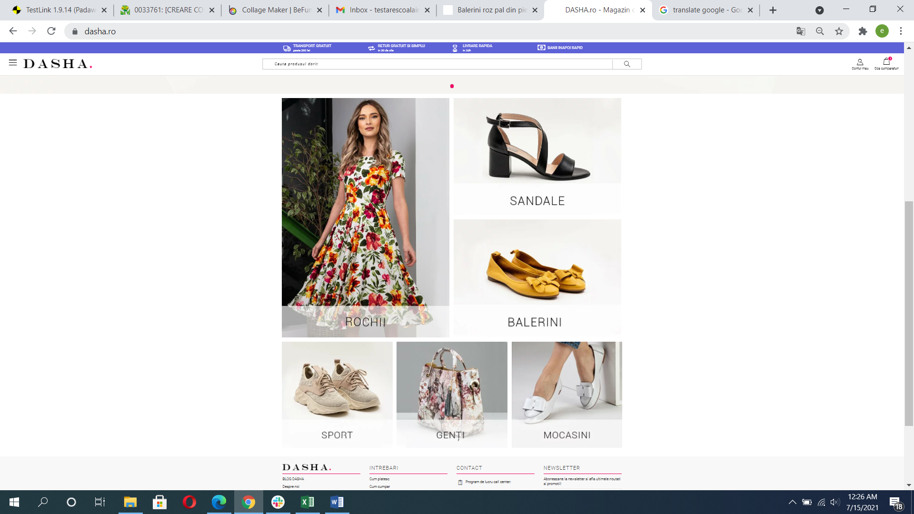

Date: 30.07.2021

**Table of contents**

Objective………………………………………………………………...3

Product Description……………………………………………………...3

Testing Period…………………………………………………………... 3

Features/ Functionalities Tested…………………………………………3

Test Environment………………………………………………………..4

Testing Tools…………………………………………………………….4

Testing Types Used…………………………………………...…………4

Smoke Tests……………………………………………………………..5

Test Results…………………………………………………...…………6

Test Metrics per Feature/ Functionality…………………………………7

Test Rate per Feature/ Functionality…………………………………….7

Overall Metrics…………………………………………………………..8

Defect Metrics…………………………………………………………...9

Proposed Features and Improvements ………………………………...11

Conclusions…………………………………………………………….12

**Objective**

Main objective of this testing session was to validate that the website can be used properly, efficiently and safe by customers in order to purchase clothes, shoes, bags, cosmetics and jewelry. The main functionalities were tested using various testing types and techniques.

**Product Description**

The focus of the testing effort was a romanian e-commerce website that has the purpose of facilitating the process of buying a wide variety of clothes, shoes, bags, cosmetics and jewelry by regular customers.

The website can be accessed via <https://www.dasha.ro/>

**Testing Period**

The site was tested between 01.06.2021 – 30.07.2021.

**Features/Functionalities/Test Suite tested**

|  |  |  |
| --- | --- | --- |
| Main Page | Ordonare | UX Usability Testing |
| CONT NOU | Pagina Produs | Connectivity Testing |
| INTRA IN CONT | Adauga in cos | Security Testing |
| Log Out | Cos Cumparaturi | Compatibility Testing |
| Contul meu | Update Cart | Smoke Testing |
| Cautare | Stergere din cos |  |
| Listare Produse | Checkout |  |
| Filtrare | Retur |  |

**Test Environment**

* This testing session was performed on:
* a laptop running Windows 10 Pro and using mostly Chrome 91 browser
* a laptop running MacOS Mojave and using mostly Safari Version 13.1
* a Samsung A6 mobile running Android 8 and using Chrome Version 81
* a iPhone X running iOS (using Toggle Device Toolbar provided by Chrome browser)
* The following browsers were used for cross browser testing:
* Chrome
* Mozilla Firefox
* Microsoft Edge
* Safari

**Test Tools**

The following tools were use in this testing session:

* TestLink
* Mantis Bug Tracker
* Snipping Tool, Paint, VLC Media Player
* Microsoft Office

**Testing Types Used**

Alte tipuri de testare utilizate: Black-box, Manual, Dynamic, Integration Testing, System Testing, Systems Integration Testing.

**Smoke Tests**

In order to assure product capacity to endure a complete testing procedure, the assessment of main functionalities degree of stability was top priority at the beginning of the testing period.

In the absence of a requirements list, testing was performed based on previous experience and common sense.

**Smoke tests** were also selected based on tester experience.

**Smoke suite includes 8 test cases that were executed with a pass rate of 100%.**

Main tested functionalities:

* CONT NOU
* INTRA IN CONT
* Listare Produse
* Filtrare
* Pagina Produs
* Adauga in cos
* Checkout

**Test Results**

A total of 150 test cases have been designed for this session and 149 (99%) were executed (1 test case is not run).

**Test metrics per category**

|  |  |  |  |  |  |
| --- | --- | --- | --- | --- | --- |
| **CATEGORY** | **Total No of Tests** | **NOT RUN** | **PASSED** | **FAILED** | **BLOCKED** |
| Main Page | 23 | 0 | 11 | 12 | 0 |
| CONT NOU | 9 | 0 | 7 | 2 | 0 |
| INTRA IN CONT | 6 | 0 | 6 | 0 | 0 |
| Log out | 1 | 0 | 1 | 0 | 0 |
| Contul meu | 6 | 0 | 5 | 1 | 0 |
| Cautare | 3 | 0 | 2 | 1 | 0 |
| Listare Produse | 6 | 0 | 4 | 2 |  |
| Filtrare | 12 | 0 | 8 | 4 | 0 |
| Ordonare | 8 | 0 | 6 | 0 | 2 |
| Pagina Produs | 12 | 0 | 12 | 0 | 0 |
| Adauga in cos | 8 | 0 | 8 | 0 | 0 |
| Cos cumparaturi | 7 | 0 | 5 | 2 | 0 |
| Update Cart | 13 | 0 | 11 | 2 | 0 |
| Stergere din cos | 3 | 1 | 0 | 2 | 0 |
| Checkout | 13 | 0 | 12 | 1 | 0 |
| Retur | 5 | 0 | 4 | 1 | 0 |
| UX Usability Testing | 3 | 0 | 1 | 2 | 0 |
| Connectivity Testing | 3 | 0 | 0 | 3 | 0 |
| Security Testing | 6 | 0 | 3 | 3 | 0 |
| Compatibility Testing | 3 | 0 | 2 | 1 | 0 |
| **TOTAL** | **150** | **1** | **108** | **39** | **2** |
| **% out of TOTAL** | | **1%** | **72%** | **26%** | **1%** |

**Test rate per category**

|  |  |  |  |  |
| --- | --- | --- | --- | --- |
| **CATEGORY** | **% NOT RUN** | **% PASSED** | **% FAILED** | **% BLOCKED** |
| Main Page | 0% | 48% | 52% | 0% |
| CONT NOU | 0% | 78% | 22% | 0% |
| INTRA IN CONT | 0% | 100% | 0% | 0% |
| Log out | 0% | 100% | 0% | 0% |
| Contul meu | 0% | 83% | 17% | 0% |
| Cautare | 0% | 67% | 33% | 0% |
| Listare Produse | 0% | 67% | 33% | 0% |
| Filtrare | 0% | 67% | 33% | 0% |
| Ordonare | 0% | 75% | 0% | 25% |
| Pagina Produs | 0% | 100% | 0% | 0% |
| Adauga in cos | 0% | 100% | 0% | 0% |
| Cos cumparaturi | 0% | 71% | 29% | 0% |
| Update Cart | 0% | 85% | 15% | 0% |
| Stergere din cos | 33% |  | 67% | 0% |
| Checkout | 0% | 92% | 8% | 0% |
| Retur | 0% | 80% | 20% | 0% |
| UX Usability Testing | 0% | 33% | 67% | 0% |
| Connectivity Testing | 0% | 0% | 100% | 0% |
| Security Testing | 0% | 50% | 50% | 0% |
| Compatibility Testing | 0% | 67% | 33% | 0% |
| **TOTAL** | **1%** | **72%** | **26%** | **1%** |

**Overall Metrics**

**Defect metrics**

|  |  |  |  |
| --- | --- | --- | --- |
| **No. crt.** | **ID** | **Severity** | **Summary** |
| 1 | [33444](https://bugs.scoalainformala.ro/view.php?id=33444) | blocker | [Filtrare] The filter is lost when user goes to next page |
| 2 | [33814](https://bugs.scoalainformala.ro/view.php?id=33814) | critical | [Main Page] User cannot subscribe to Newsletter due to server error |
| 3 | [33486](https://bugs.scoalainformala.ro/view.php?id=33486) | major | [Security Testing] A non-administrator user should not find the link to Dasha admin account |
| 4 | [33761](https://bugs.scoalainformala.ro/view.php?id=33761) | major | [Security Testing] Lack of CAPTCHA functionality on registering a new account |
| 5 | [33763](https://bugs.scoalainformala.ro/view.php?id=33763) | normal | [CONT NOU] User should not register an account using an invalid structure of "Email" |
| 6 | [34113](https://bugs.scoalainformala.ro/view.php?id=34113) | normal | [Contul meu] The password should not be changed filling 2 characters in "Noua Parolă" |
| 7 | [33497](https://bugs.scoalainformala.ro/view.php?id=33497) | normal | [Cautare] A part of search results are not relevant to searched keyword |
| 8 | [33500](https://bugs.scoalainformala.ro/view.php?id=33500) | normal | [Listare Produse] If user chooses NOUTATI/Imbracaminte, the results list does not include only clothes |
| 9 | [33443](https://bugs.scoalainformala.ro/view.php?id=33443) | normal | [Filtrare] User cannot filter discounted items |
| 10 | [34112](https://bugs.scoalainformala.ro/view.php?id=34112) | normal | [Filtrare] If user chooses INCALTAMINTE/MATERIAL/Piele naturala, items list does not include only leather items |
| 11 | [33823](https://bugs.scoalainformala.ro/view.php?id=33823) | normal | [Connectivity Testing] If internet connection drops, the page remains indefinitely in loading state |
| 12 | [33825](https://bugs.scoalainformala.ro/view.php?id=33825) | normal | [Security Testing] The website did not enforce a policy for creating account with a complex password |
| 13 | [33832](https://bugs.scoalainformala.ro/view.php?id=33832) | normal | [Compatibility Testing] On Safari, the item image cannot be viewed in certain places after user moves the mouse over item image |
| 14 | [33442](https://bugs.scoalainformala.ro/view.php?id=33442) | normal | [Update Cart] Missing proper validation for “Cantitate” on “DETALII COS”: user can update a quantity not in stock |
| 15 | [33697](https://bugs.scoalainformala.ro/view.php?id=33697) | normal | [Update Cart] Missing proper validation for “Cantitate” on “DETALII COS”: user can update quantity to a negative number |
| 16 | [33432](https://bugs.scoalainformala.ro/view.php?id=33432) | normal | [Stergere din cos] Multiple issues after deleting items from "DETALII COS" page |
| 17 | [33499](https://bugs.scoalainformala.ro/view.php?id=33499) | minor | [Filtrare] UI issue: the size filter must not appear 2 times on the Outlet/Incaltaminte Outlet page |
| 18 | [33492](https://bugs.scoalainformala.ro/view.php?id=33492) | minor | [Main Page] UI issue: For all sections of "Cookie Settings" window, the text has no proper alignment |
| 19 | [33491](https://bugs.scoalainformala.ro/view.php?id=33491) | minor | [Main Page] UI issue: no space between 2 words (Siteulwww.dasha.ro), on "Politica de utilizare Cookie-uri" page |
| 20 | [33490](https://bugs.scoalainformala.ro/view.php?id=33490) | minor | [Main Page] UI issue: the link to "Politica de utilizare Cookie-uri" is not unique |
| 21 | [33485](https://bugs.scoalainformala.ro/view.php?id=33485) | minor | [Main Page] UI issue for the "TRANSPORT GRATUIT peste 200 lei" page: 2 images overlap the text |
| 22 | [33501](https://bugs.scoalainformala.ro/view.php?id=33501) | minor | [Listare Produse] UI issue: Alpha sizes are not displayed with uppercase on item image |
| 23 | [33679](https://bugs.scoalainformala.ro/view.php?id=33679) | minor | [Cos cumparaturi] UI issue: User should not see "VEZI DETALII COS" button in "CONTINUTUL COSULUI" if no item was added |
| 24 | [33503](https://bugs.scoalainformala.ro/view.php?id=33503) | minor | [Listare Produse] UI issue: if user selects INCALTAMINTE/Pantofi, title page must not be "Pantofi de dama din piele naturala" |
| 25 | [33712](https://bugs.scoalainformala.ro/view.php?id=33712) | minor | [Stergere din cos] UI issues: "VEZI DETALII COS" button from "CONTINUTUL COSULUI" should not be visible after removing items |
| 26 | [33489](https://bugs.scoalainformala.ro/view.php?id=33489) | minor | [Main Page] UI issue: webpage links are mentioned on "Politica de confidentialitate" page, but hyperlinks are not working |
| 27 | [33820](https://bugs.scoalainformala.ro/view.php?id=33820) | minor | [UX Usability Testing] After adding item in bag, there is not a reasonable number of steps until Checkout page |
| 28 | [33749](https://bugs.scoalainformala.ro/view.php?id=33749) | minor | [Checkout] UI issue: On "Checkout" page, there are 2 buttons named "ADAUGA O ADRESA NOUA" |

**Proposed Features and Improvements**

|  |  |  |
| --- | --- | --- |
| **FEATURE/IMPROVEMENT** | **FUNCTIONALITY** | **PROPOSALS** |
| FEATURE | FAVORITE | It would be nice for user to be able to save items in FAVORITE |
| FEATURE | Cos cumparaturi | The items added in "Cos cumparaturi" to be viewed only if user is logged |
| IMPROVEMENT | CONT NOU | A new account to be registered only after email confirmation |
| IMPROVEMENT | Stergere din cos | the text and box for discount voucher should not be visible after user removes all the items from "DETALII COS" page |
| IMPROVEMENT | Checkout | 1) the comment box from "Checkout" page should have a limited number of characters |
| 2) On "Sumar comanda" form, the Subtotal value should be aligned with the other values |
| 3) now if user has previously added at least 1 invoice address, user has no possibility to indicate in Checkout page that delivery address is identical to invoice address |
| In this case it would be helpful for user to be asked if delivery address and invoice address are identical: |
| * if not, the existing invoice addresses & "ADAUGA O NOUA ADRESA DE FACTURARE" button to be displayed |
| * user to be able to add a new invoice address |
| IMPROVEMENT | UX Usability Testing | "CONTINUTUL COSULUI" section and "DETALII COS" page could be merged into a single page On merged page, user should have 2 buttons: - "Vezi si alte produse" - "Catre Checkout" |
| IMPROVEMENT | Connectivity Testing | For the moment if the internet connection is down or up, the page remains indefinitely in loading state. A better handle would be: - if server does not send an answer to user request, the application should display a clear error message (“Please check your internet connection”) - a "Retry" button |
| IMPROVEMENT | CONTINUTUL COSULUI | a tooltip for deleting item from "CONTINUL COSULUI" section |
| IMPROVEMENT | DETALII COS | a tooltip for deleting item from "DETALII COS" page |

**Conclusions**

**1) The current status of application**

* **Bugs found:**
* A significant number of bugs were identified for “Main Page” and “Filtrare” functionalities. However most of them are not major defects, therefore do not interfere with the correct functionality of the website.
* A special attention should be paid to the Security aspects: to enforce policy for a complex password, to implement the CAPTCHA functionality on registering a new account, confidentiality of the Dasha admin account link.

Conclusion: immediate fixing is recommended for blocker, critical and major defects

* **User perspective**:
* The website can be used for its intended purpose – user is able to create account, login, navigate the website, search for products, add items to cart and place an order.
* User experience could be improved according to *Proposed Features and Improvements* chapter.

Conclusion: I would recommend this website to be used as its major functions work good enough for user to fulfill the need of buying fashion items online.

2) **The current status of testing**

* Estimated test coverage of functional and non-functional requirements: 80%
* Dasha.ro is a website dedicated to romanian users so the main functionalities were tested mostly on a laptop running Windows 10, on Chrome browser (used by over 73% of romanian users).
* Also the main flows were tested using different browsers (Chrome, Safari, Mozilla Firefox, Microsoft Edge), devices (laptops, mobiles), operating systems (Windows 10, MacOS Mojave 10, Android 8)

