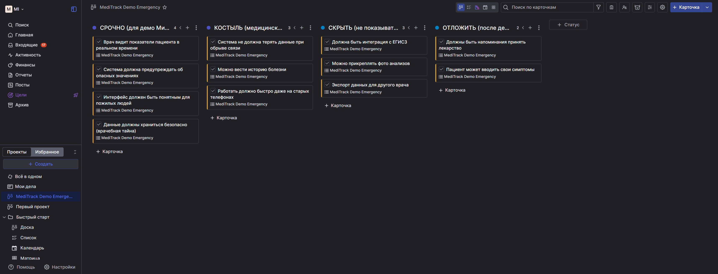
https://github.com/Mihai-San-1/medtrack-demo-rescue.git

