# Usability Aspect Report Template Instructions

The following page contains a Usability Aspect Report form template. You will need to fill in one of these forms for every usability good or bad aspect you identify. The easiest method is to copy/paste the template however many times you need. Please put a horizontal line between all the reports, and preferably also put each report on a new page so that we can easily see where each report starts and ends. For this coursework, we expect to see at least 5 of these filled out by every individual.

The template contains **bold titles** which are part of the template and need to be present on every report. It also contains <instructions> which are put inside of greater and less than symbols. You can delete the instructions, they are only there to provide guidance on what to put in the individual boxes.

You can also keep or delete this instructions page.

Severity ratings [1, p49]:

* 0 – Not a problem - Rater thinks that this is not a usability problem at all.
* 1 – Cosmetic problem only – Need not be fixed unless extra time is available on project
* 2 – Minor usability problem – Fixing this should be given low priority
* 3 – Major usability problem – Important to fix, so should be given high priority
* 4 – Usability catastrophe – imperative to fix this before product can be released

[1] J. Nielsen and R. L. Mack, Usability Inspection Methods, 1994

**HE Number**: <your initials>-<number>

**Problem/Good Aspect**: <State if this is a good or bad aspect>

**Name**: <Short but descriptive and distinctive name for the problem or good aspect.>

**Heuristic:** <Name and number of the heuristic>

**Interface Aspect**: <Describe what part of the interface you are talking about along with any other relevant facts to help describe the aspect. Pictures or screenshots are almost always necessary unless you are a very good writer. >

**Explanation**: <Your explanation of how the heuristic is met or violated. If applying the heuristic involves making claims about the user (i.e. what the user will or will not be familiar with), include your reasoning/evidence to support those claims. Statements like “A novice user will *probably* …. *because ….*” Or “users will be *unlikely* to … *because* …” are appropriate here. >

**Severity Rating**: <Numeric rating. If this is a good aspect, put “NA” here. Give a very short description of why you selected this rating. >

**Justification (Frequency, Impact, Persistence):**

* **Frequency**: <Common or rare? Why? How many users, and what type, are likely to experience the aspect? Is this something that most users, some users, or hardly any users, will want to do?>
* **Impact**: <Easy or difficult to overcome? Why? If it is difficult to overcome and if the user unlikely to be able to achieve their goals, are they likely to waste allot of time?>
* **Persistence**: <Is it a problem that is one-time? In other words, once they know about it and how to overcome it, will they be repeatedly bothered by it? Why?>
* **How I weighed the factors**: <Justify your numerical rating by providing your assessment and reasoning about all the following: frequency, impact, and persistence and how you weighed these factors in your severity rating. For example: a relatively rare problem, easy to overcome, and low persistence could justify rating as a minor problem. A low frequency problem that is critical when it occurs (e.g. unable to save) would be grounds for giving it a high severity rating despite the low frequency. If this is a good aspect, then describe the benefits to the user from this aspect, also considering things like frequency and impact. >

**Possible solution and/or trade-offs**: <For problems, propose at least one possible solution. For both problems and good aspects, briefly mention some trade-offs.>

**Relationships**: <Optional. List the HE number of any other reports that this report relates to. Not all reports will have a relationship.>

**HE Number**: MC-1

**Problem/Good Aspect**: Good

**Name**: Finding the lectures for a particular week is extremely intuitive.

**Heuristic:** 6. Recognition rather than recall

**Interface Aspect**: The aspects in question are the side navigation menu (which shows the major sections of the course’s Learn website), the top bar which shows what week is currently selected, and the content box, which shows information about the lectures which ran in the selected week.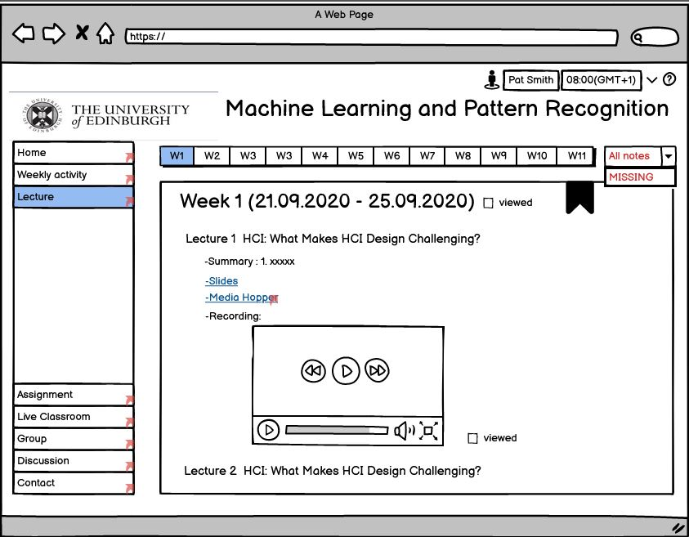

**Explanation**: The interface should make it very easy for a user to find the lectures he is interested in. The reason for this is that this design is consistent (or at least should be in theory) with the expectations a student might have on how to find a particular lecture. To elaborate on this let us assume that a student is on the home page of the course and wants to find lecture 2 of week 2. His expectation when seeing the navigation bar on the left is that he should find under the “Lecture” section, which is true. After selecting it, the top navigation bar and the title of the content box make it clear that the week 1 lectures are currently the ones shown. The highlighting in the top navigation bar may prompt the user to try to select Week 2, which would be the correct thing to do.

**Severity Rating**: NA. The aspect is useful for the user, allowing him to find the lecture he is interested in in an effective manner.

**Justification (Frequency, Impact, Persistence):**

* **Frequency**: Common. Most students will probably interact with these aspects several times per week, whenever they search for a lecture.
* **Impact**: High. Finding lectures is one of the most important features of any Learn course page. These aspects make it easy for a student to do so.
* **Persistence**: High. If a student searches a lecture, he will have to interact with these aspects.
* **How I weighed the factors**: These aspects are very important for the user experience since a typical student will probably search for lectures several times per week (frequency and impact). A student might also reasonably expect for the lectures to be easy to find. The two mentioned aspects allow a student to reach any lecture in a couple of clicks, starting from the home page of the course. The two aspects must be used every time a user searches for a lecture. (persistence).
* **Possible solution and/or trade-offs**: The main trade-off of this design is that lectures are more easily accessible at the cost of duplication. Lectures can be found either in the “Lectures” section or in the “Weekly Activity” section. If only the latter were available, then the user would also likely need to scroll down in addition to the two clicks when searching for a lecture, or may even miss the second lecture of a particular week (since the “Weekly Activity” section has the week events ordered presumably in the order they were added, hence the second lecture in a week can be at the bottom of the page and not visible at a first glance). This trade-off is justified in my opinion.

**Relationships**: -

**HE Number**: MC-2

**Problem/Good Aspect**: Problem

**Name**: It is not clear that clicking on “Semester Timetable” will take the user off the Learn course page.

**Heuristic:** 4. Consistency and standards

**Interface Aspect**: Clicking on the Semester Timetable link will take the user off the Learn page.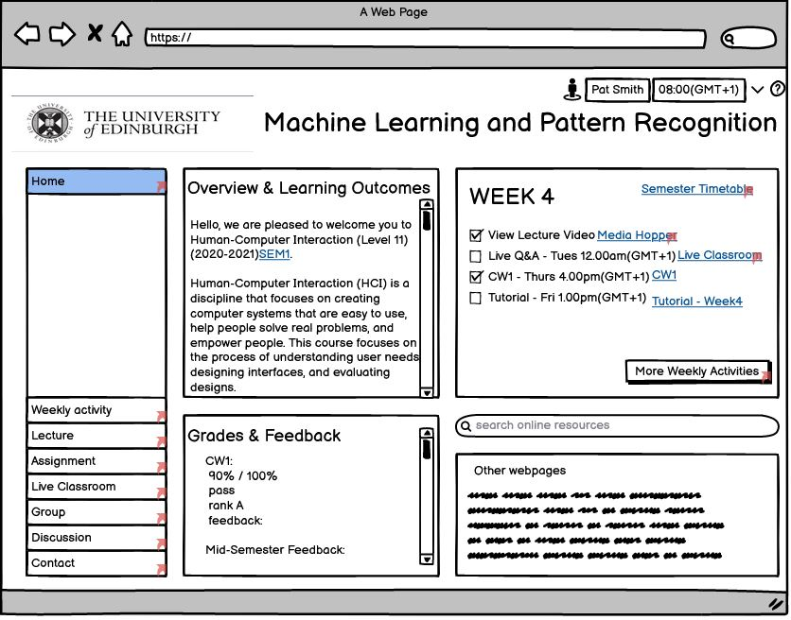

**Explanation**: Every other link except the Media Hopper one will redirect the user to another page of this course’s Learn website. The Media Hopper link is properly labeled as such, so the user will probably not be surprised when he is redirected to the Media Hopper website after clicking the link. However, the Semester Timetable link is not properly labeled, so a student might assume that he will be redirected to another Learn page.

**Severity Rating**: 2/10. This aspect will probably only mildly annoy the user the first time he interacts with it.

**Justification (Frequency, Impact, Persistence):**

* **Frequency**: Common. A student checks his timetable often, especially at the beginning of the semester.
* **Impact**: Low. The user will probably waste some time the first time he learns that the link redirects to another website, since he will need to load the Learn site again.
* **Persistence**: Low. Once the user learns about this issue, he will likely open the link in another tab so that he will not need to reload the Learn page after seeing his timetable.
* **How I weighed the factors**: This issue is only a mild annoyance to a student: he will be surprised by the fact that the semester timetable is on another website only the first few times he clicks the link. Then, he is likely to adapt and open the timetable in another tab (since most browsers provide this functionality and most students in a Computer Science course are probably aware of this feature). The “error” (if it can even be called that) is easily recoverable: the student simply goes back to the Learn page once he is done with viewing the timetable.  
  I gave this issue a low severity rating, because it does not prevent the user from doing what he set out to do, it just causes him an inconvenience.

**Possible solution and/or trade-offs**: I can see two solutions: the first is embedding the timetable in a Learn page on the course website and making the link redirect to it (thus the user will not leave Learn at all). The second solution is labelling the link properly, making it clear that it will redirect to a non-Learn website: e.g: “Semester Timetable – open in Path”. I can see no trade-off for the second solution, it is a straightforward thing to implement. If the first solution were to be implemented instead, one might have to add another entry on the navigation bar on the left and it would require more dev work, as embedding the timetable in a Learn page might not be trivial from a backend perspective.

**Relationships**: -

**HE Number**: MC-3

**Problem/Good Aspect**: Problem

**Name**: Not clear if an activity is complete (in the “Weekly Activity” section)

**Heuristic:** 1. Visibility of system status.

**Interface Aspect**: In the screenshot included in MC-2, it can be seen that on the home page, a user can mark certain activities (e.g: tutorials) as completed. In the “Weekly Activity” section, there is no indication whether an activity has been completed or not.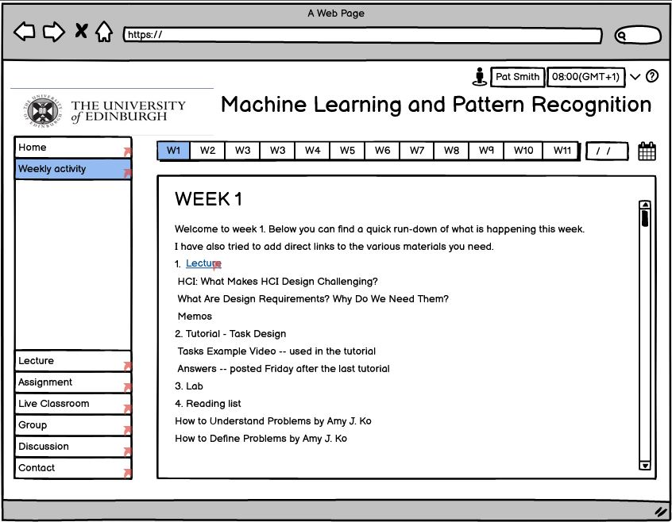

**Explanation**: Assuming that the user marks this week’s tutorial as “complete” on the home page and then clicks on “More weekly activities”, he will be seeing the same tutorial, but with no indication on whether the system considers it to be completed or not, thus casting doubt whether his action on the home page had any effect.

**Severity Rating**: 7/10, it impacts a main feature of the design.

**Justification (Frequency, Impact, Persistence):**

* **Frequency**: Very common. A student is very likely to use the “Weekly Activity” page quite often, since this page is used to access a week’s readings, tutorials, and labs. Every time a student sees the activities in a given week, he will not be able to discern whether he has completed a certain activity by only looking at the page.
* **Impact**: High. For the personas chosen by this group (personas 2 and 6), the ability to track their progress was extremely important. This design fails to address this requirement. A student can only track their progress in a given week. Had they missed doing an activity in a previous week, the website would not bring this to their attention.
* **Persistence**: High. If a student wants to monitor his progress across multiple weeks, the design does not allow him to do so.
* **How I weighed the factors**: I weighed the factors relative to the personas chosen by the group. To a student that performs his weekly activities in time, having a to-do list only for the current week suffices. For such a person, this problem aspect has a low impact. Although, such a student might want to review his progress in the past weeks in order to make sure that he didn’t miss anything. In that case, the issue might affect him too!  
  For a person such as persona 6 (Niki Ivanov), monitoring his progress across weeks seems to be important and the current design does not allow him to do that.

**Possible solution and/or trade-offs**: A solution might be to highlight the items which were completed. Doing so would also require the inclusion of a way to mark an item as completed or not, in the “Weekly activity” section. The trade-off is that this might make this section more cluttered and that it will require a lot more development effort to implement. Having more customizability is never a bad thing though, and from a pure design perspective, I do not see many cons to adding such a feature.

**Relationships**: -

**HE Number**: MC-4

**Problem/Good Aspect**: Problem aspect

**Name**: User cannot access the course timetable from any other page but “Home”

**Heuristic:** 7. Flexibility and efficiency of use. / 6. Recognition rather than recall.

**Interface Aspect**: The only way to access the semester timetable is through the link present on the “Home” page (as can be seen in the screenshot in MC-2).

**Explanation**: Accessing the timetable was an important requirement for the personas. It is quite reasonable for a student to miss the link to the course timetable since it does not even have a box of its own and it is not highlighted in accordance with its importance. In order to access the timetable, a student must first remember that a link for it exists only on the home page, which violates heuristic 6. Therefore, it should make sense for it to be accessible from the navigation bar on the left. Also, in order to get to the course timetable from another Learn page, the user would have to first go to the home page and then to the timetable, which is not as efficient as it should be.

**Severity Rating**: 3/10 The timetable is still accessible, at least it will take slightly longer for a student to access it.

**Justification (Frequency, Impact, Persistence):**

* **Frequency**: Common. I would imagine that most students would like to see their timetable.
* **Impact**: Low. To overcome this issue, the user must remember that a link to the timetable is on the course home page, then go there and click it.
* **Persistence**: Low. Once a user has accessed the timetable a few times, they will remember where the link is.
* **How I weighed the factors**: I gave this issue a low severity rating because it does not prevent the user from accessing the timetable. This low rating is also justified from the fact that quite often the user will be on the home page when he decides to check out the semester timetable. In that case, the issue does not impact the user. However, when the user is on another page of the website and wants to access the timetable, he first needs to remember that the link for it is on the home page, then he needs to visit the home page and click it. This is not efficient and would waste the student’s time.

**Possible solution and/or trade-offs**: The simple solution to this problem is to include the link to the timetable on the navigation bar on the left. The trade-off is that adding one more option to this navigation bar may make the user take more time when trying to find the page he is interested in.

**Relationships**: MC-2 (somewhat).

**HE Number**: MC-5

**Problem/Good Aspect**: Problem

**Name**: The home page has too much information.

**Heuristic:** 8. Aesthetics and minimalist design.

**Interface Aspect**: The home page contains too much clutter (with reference to the screenshot in MC-2).

**Explanation**: The home page should contain some information about the course and perhaps some useful links. Currently, it contains several different things which do not have a lot to do with each other: some information about the course, a to-do list for the current week, grades and feedback and a list of other webpages, as well as a search bar whose functionality is not immediately apparent nor explained. This is not minimalist design, as a user would probably be overwhelmed by the amount of information on the page. It is also aesthetically unpleasing, as the “Overview and Learning Outcomes” and the “grades & Feedback” boxes are too small for the content they contain. Interacting with those boxes would be awkward.

**Severity Rating**: 4/10

**Justification (Frequency, Impact, Persistence):**

* **Frequency**: Extremely common. The home page is the first page a student sees when accessing a course’s Learn page.
* **Impact**: Medium. It does not impact the functionality of the Learn course website, but it might negatively impact a student’s experience.
* **Persistence**: High. The users will see this page extremely often.
* **How I weighed the factors**: I gave this issue a low rating because it does not impact the functionality of the course website. However, I gave it a slightly higher rating compared to the other cosmetic problem-aspects because it has the chance of negatively affecting a student’s engagement with the course. If a student got a low mark in the previous assignment, he does not need to be reminded that every time he opens the course from MyED. At the very least, he should opt out of his grades being shown there.  
  I can see the merit of having the weekly to-do list on the home page (for ease of access) though, but I cannot see any reason for including the search bar and the “Other webpages” box there (especially since their purpose is not well-defined).

**Possible solution and/or trade-offs**: Aside from the general course information, the content should be replaced with links to other pages containing the content, perhaps even a site map. The trade-off is that there might be some students who actually like the current design, and wouldn’t mind their current grades being shown on the home page.

**Relationships**: -