Food Panda

Project Documentation



Teacher: Mihaela Dinsoreanu

Teacher Assistant: Alexandru Frasie

Student: Blagu Alexandru Mihai

Group: 30431

Contents

Project Specification 3

Database Diagram 3

Use case diagram 4

Class Diagram 5

# Project Specification

The aim of this project is to design and implement a web application for managing a restaurant as an admin, or ordering food from different restaurants as a customer

# Database Diagram

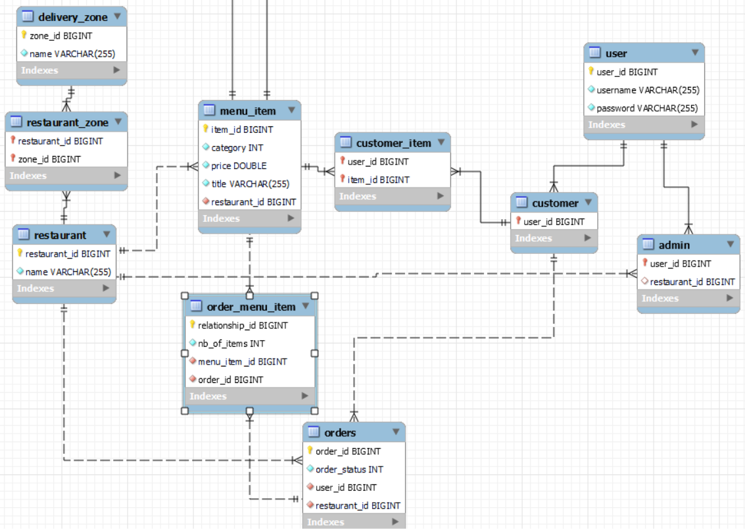

Fig. 1 – Database diagram

# Use case diagram

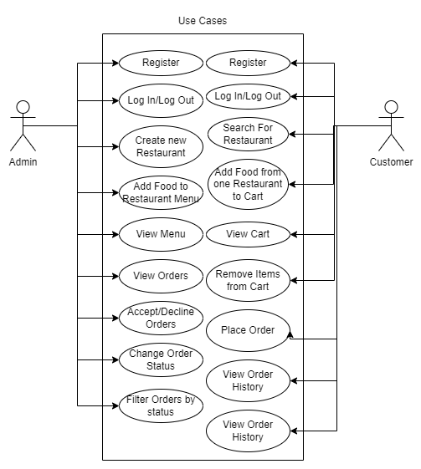There are 2 users: The Admin and the Customer.

Fig. 2 – Use Case Diagram

# Class Diagram

The Architecture of the application is structured in layers. The user interacts with the user interface which than passes information downwards trough the layers, down to the database and then back up again.

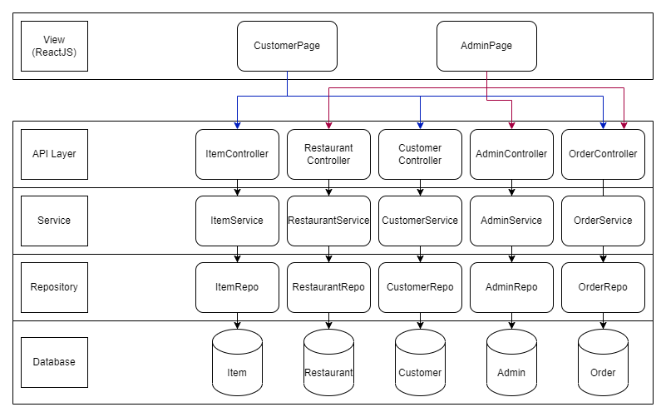

Fig. 3 – Class Diagram