



Solution Design
Document
Table of Contents
I. Purpose 3
II. Automated process details 4
3 Runtime guide 5
3.1 Architectural structure of the Master Project 5
3.2 Master Project Runtime Details 5
3.3 Project name 1 6
3.4 Project(s) workflows 6
3.5 Packages 7
3.6 Architectural structure of the Master Project 7
4 Other Details 8
Future Improvements 8
Other Remarks 8
5 Glossary 9

Purpose

Outlines the major components of the Master Project (the overall output of the development, containing one or multiple projects that together cover the scope of the robotic process automation) taking into account all the business restrictions (scheduling, peaks, future increases in volume etc.). The focus of the Solution Architect will be on:
- Robustness;
- Scalability;
- Efficiency;
- Replicability;
- Reusability of component
The information herein is targeted primarily at the developers that will initially implement the solution and subsequently at the support developers in case of change requests.

Automated process details

Item | Description
Master Project Name | = Translator Evaluator
Robot Type | FOR and Mix
Orchestrator used? | Optional/Partial – REFramework supports Orchestrator (assets + queue), but the current implementation retrieves transaction data from a local hardcoded list of URLs
Scalable | No (current implementation) – transaction source is a fixed in-workflow list of 5 URLs  Yes (design) – can be made scalable by switching to an Orchestrator Queue
UiPath version used | Studio 22.10.13.0

Runtime guide

Architectural structure of the Master Project

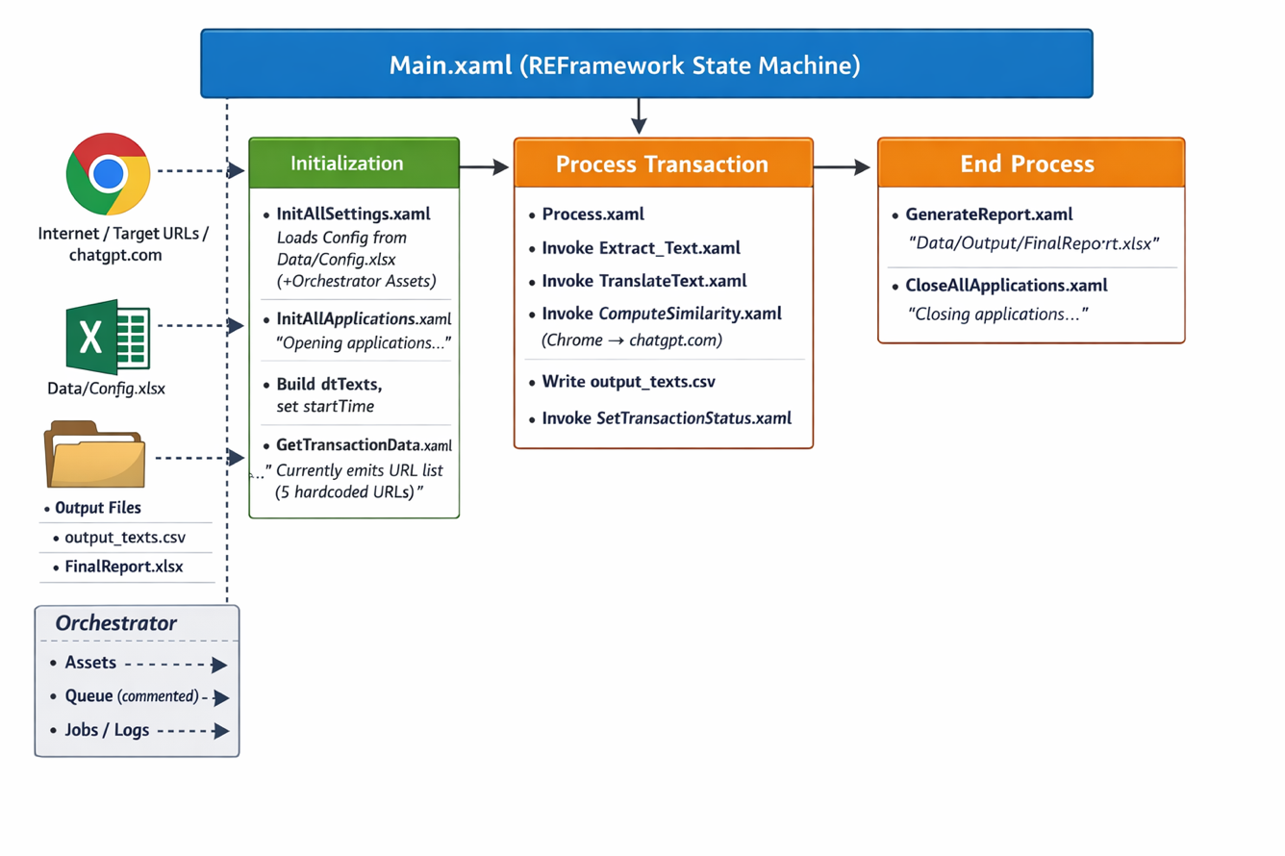

Master Project Runtime Details

ITEM NAME | DESCRIPTION
Production environment details | Windows robot machine / VM – running UIPath Robot. Requires interactive desktop session because the process uses browser UI automation to navigate to ‘chatgpt.com’.
Prerequisites to run | Google Chrome installed – and accessible to UIPath UIAutomation Next  Internet access – to target URLs and ‘chatgpt.com’  User is authenticated – into ChatGPT in Chrome profile used by the robot  Excel available
Input Data | Transaction URLs: fixed list of 5 URLs
Expected output | ‘DetailedData’ sheet: per-item data  ‘Summary’ sheet: totals/average score/execution time
How to start the automated process | The process will be run locally from UIPath Studio by executing ‘Main.xaml’
Reporting  (queues reporting, Kibana or another platform) | UIPath Logs: Output artifacts
How is Orchestrator used? | Optional
Password policies  (mention any specific compliance requests) | n/a
Stored credentials  (Never use hardcoded credentials in the workflow!) | n/a
List of queues names  (Naming convention: ProcessName_QueueName) | n/a
Schedule Details | n/a
Multiple Resolutions Supported?  (in case of image automation / Citrix and VDI) | n/a
Recommended Resolution | n/a

Project name – Translator Evaluator
ITEM NAME | DESCRIPTION
Environment used for development  (name, location, configuration details etc) | UiPath Studio 22.10.13 (Windows Project)
Environment prerequisites  (OS details, libraries, required apps) | - Windows Machine with UiPath Robot/Studio compatible runtime  - Google Chrome  - Excel  - Internet connectivity to the target websites and ‘chatgpt.com’  - Permissions to write to project output folders/files
Repository for project  (where is the developed project stored) | https://github.com/MihaiCiorascu/RPA_TeamProject
Configuration method  (assets, excel file, Json file) | Orchestrator Assets cand overwrite config keys when present.  ‘Data/Config.xlsx’
List of reused components | UiPath REFrameworks: base workflows (‘Framework/*’) and state machine pattern
List of new reusable components | - ‘Workflows/Extract_text.xaml’  - ‘Workflows/Translate_text.xaml’  - ‘Workflows/ComputeSimilarity.xaml’  - ‘Workflows/GenerateReport.xaml’

Project(s) workflows
Workflows specific to: Translator Evaluator
For the workflow files defined below please specify the input and output parameters.
Workflow Name | Description
Main.xaml | REFramework state machine entry point orchestrating Initialize -> Get Transaction Data -> Process Transaction -> End Process. Also builds the ‘dtTexts’ DataTable schema and captures ‘startTime’
Framework/InitAllSettings.xaml | Reads Data/Config.xslx sheets into ‘Config’ dictionary; then tries to load assets from Orchestrator ‘Assets’ sheet and overwrite matching keys.
Framework/InitAllApplications.xaml | Initializes applications
Framework/GetTransactionData.xaml | Retrieves next transaction data
Framework/Process.xaml | Runs the business steps for a single transaction URL: extract text -> translate -> compute similarity; writes CSV snapshot
Workflows/Extract_Text.xaml | For each URL, extracts relevant text and appends a new row to ‘dtTexts’. Cleans whitespaces and caps length.
Workflows/TranslateText.xaml | Takes the last row’s “Original Text (RO)”, translates to English, then retranslates back to Romanian; stores results into “Translated Text (EN)” and “Retransalted Text (RO)”
Workflows/ComputeSimilarity.xaml | Opens Chrome, navigates to ‘chatgpt.com’, submits a prompt comparing original vs retranslated text, parses “Score: 0.XX Reason: …”, writes “Similarity Score” + “Reasoning” into last row.
Workflows/GenerateReport.xaml | Computes summary metrics (count, average similarity, total execution time). Writes ‘Detailed Data’ and ‘Summary’ sheets to ‘Data/Output/FinalReport.xlsx’ and applies formatting/autofit.
Framework/SetTransactionStatus.xaml | Standard REFramework status update & retry logic. Captures screenshot on system exceptions.
Framework/TakeScreensot.xaml | Takes full-screen screenshot and saves ‘.png’ to configured folder.

Packages
Include the list of packages and high-level description for each of them, to explain their purpose
Package Name | Description
UiPath.Excel.Activities [2.16.1] | Excel file read/write, formatting, autofit
UiPath.MicrosoftOffice365.Activities [3.5.10] | Office 365 activities
UiPath.System.Activities [22.10.4] | Core system activities: logging, file ops, data tables, retries, etc.
UiPath.Testing.Activities [22.10.1] | Test cases
UiPath.UIAutomation.Activities [25.10.22] | UI automation used for browser automation in translation/similarity workflows

Architectural structure of the Master Project

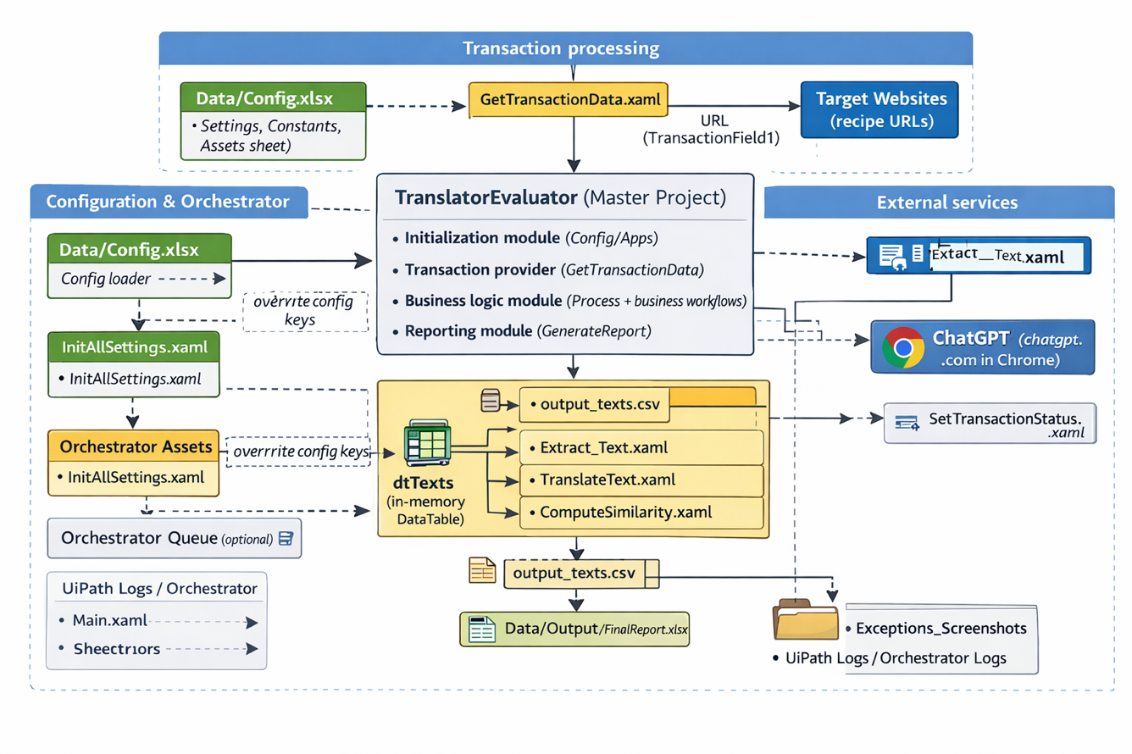

Other Details

Future Improvements
• Replace hardcoded URL list with an external source:
- Orchestrator Queue
- CSV input
- API endpoint
• Add explicit ChatGPT authentication handling (login detection, retry, error messaging)
• Add stronger validation:
- Ensure extracted text exists before translation
- Ensure translated/retranslated text fields are populated before similarity step
• Improve observability:
- Persist per-transaction timing
- Add distinct log fields for URL / step durations
• Improve resilience to UI changes on ‘chatgpt.com’ (selectors, timeouts, fallback parsing)

Other Remarks
- Current ‘InitAllApplications.xaml’ and ‘CloseAllApplications.xaml’ are logging-only stubs. If additional applications are introduced, implement open/close/login/logout steps here.
- ‘ComputeSimilarity.xaml’ uses browser automation to send prompts to ‘chatgpt.com’. This is sensitive to UI changes and requires an interactive session.

Glossary

The main terms used in the Solution Architecture Document are defined below:
Master project - the overall output of the development, containing one or multiple projects that together cover the scope of the robotic process automation. There is a 1 to 1 connection between the Master Project and the Process to be automated (As presented in the PDD).
Project - an UiPath Studio project containing one or multiple workflow files. A project can be converted to a package and run independently, covering a particular scope within the master project. Or multiple projects can be converted into one package depending on the aims and restrictions of the automation. The project is used when defining the development and support phase of the automation.
Package - the output of compiling one or multiple projects. A package can be deployed on the robot machine and be executed by the robot service. Only one package can be executed at a given time by a robot. The package is used when defining the running phase of the automation.
Workflow - a component of the package, the workflow encapsulates a part of the project logic. The workflow can be of type: sequence, flowchart or state machine. A workflow is saved as an .xaml file inside the project folder. A workflow file can be invoked from another workflow and by default there is an initial workflow file that will run when executing the package.
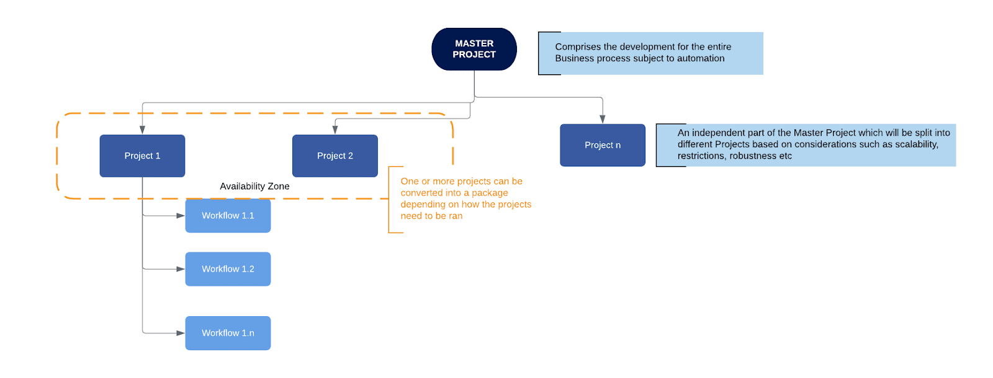
Activity - an action that the robot executes.
Sequence - a workflow where activities are executed one after another, in a sequential order
Flowchart - a workflow where activities are connected by arrows and the logic of the workflow can be easily followed in a visual manner. The flowchart can also be exported as an image from UiPath studio.
State machine - a more advanced way of organizing a workflow, similar to a flowchart.
FOR – Front office robot
Orchestrator – Enterprise architecture server platform supporting: release management, centralized logging, reporting, auditing and monitoring tools, remote control, centralized scheduling, queue/robot workload management, assets management.

