**VIA Board Games**

**Mihai Mihaila, 331432**

**Cristian Josan, 331958**

**Tomáš Mäsiar, 331956**

**Dominika Krullová, 331879**

**Software Technology Engineering**

**Semester 1**

**10.03.2022**

Version: October, 2022

**Table of content**

Preface iii

List of figures and tables iv

1. Background Description 1

2. Problem Statement 2

4. Definition of purpose 4

4. Delimitation 5

5. Methodology 6

6. Time schedule 7

7. Risk assessment 8

8. Sources of Information 9

# Background Description

It is well known that studying at any university mainly requires loads of academic work and dedication. However, there are many other factors which can directly affect the outcome of your study efforts, more often than not hidden in plain sight.

The one most commonly overlooked by many is taking care of your mental well-being and creating a social network of potentially important future contacts. And what better way of socializing is out there than simply going out and meeting a couple of unfamiliar faces? A simple extracurricular activity, such as board games, can improve mental health of any undergraduate by quite a significant bit.

In an article from Harvard Health Publishing titled The Health Benefits of Strong Relationships, the author expresses the idea that social connections not only give us pleasure, they also influence our long-term health in ways every bit as powerful as adequate sleep, a good diet, and not smoking. Dozens of studies have shown that people who have social support from family, friends, and their community are happier, have fewer health problems, and live longer.

We understand the importance of the social aspect of studying at a university and have been lucky enough to be approached by a client by the name of Bob, who has a vision of founding a student association, which is, among helping student socialize, going to be lending board games. Being invited to an interview, Bob’s ideas and hardships about creating such an association have been expressed.

Bob is positive that the creation of this organization will benefit the students’ ability to connect with their peers and be more socially engaged overall. Judging by the ideas communicated throughout the interview, some of the underlying motives include the exchange of board games, creating a rather informal setting for students to connect in and cooperate with each other, and hosting various events on VIA University College’s grounds.

Based on Bob’s model of the aforementioned association, membership is going to be split into two following options: a paid membership (later referred to as “members”) and a free membership (later referred to as “guests”). Guests will have the freedom to attend any of the hosted events, play any board games available at the event, and rate board games under the condition that they have played them.

On top of this, members will also have the right to vote for which new board games are to be bought, borrow and bring them home for a fixed period of time, and lastly reserve them to make sure they are available at the event they are about to attend.

The association will have a catalog made, which is going to store information such as a list of all board games, their availability, and if one is not available, details of the person currently in hold of it. Similarly, it will need a recommendation system based on ratings for board games that members and guests have provided.

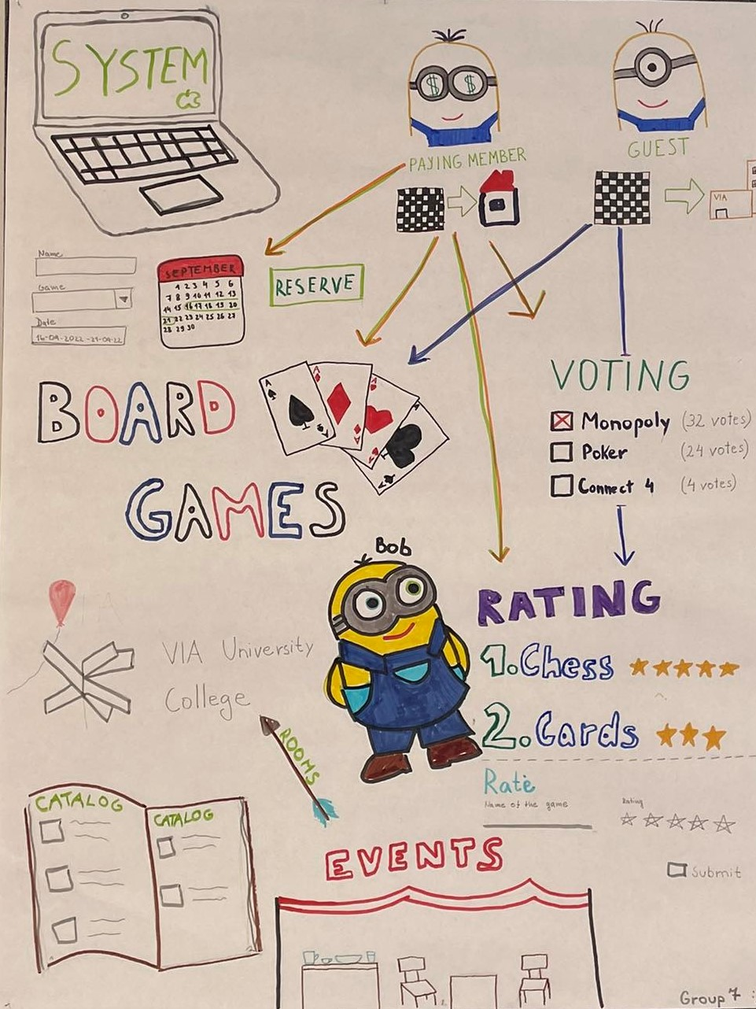

**Pic. 1 Rich picture**

# Problem Statement

**Students have difficulties finding a board game that they would like to borrow based on their preferences. (Main problem)**

1. What details need to be included in order to make it easier for the students to find their desired board game?
2. How are the board games going to be displayed?

**Students have difficulties reporting lost or damaged board games.**

1. What data needs to be collected in order to know every thing about the lost/damages board game?
2. What is going to happen after a damaged/lost board game is reported?
3. Who are relevant recipients of the reports?
4. How are the lost items going to be found?

**Students have difficulties paying for a membership.**

1. What data needs to be collected in order to fulfill the payment?
2. Who is going to receive the money?

**Students have difficulties finding events with their favorite board games.**

1. What details need to be announced in order to make it easier for the students to find the event?
2. What is the method that is going to be used in order to announce the students about the events?

**Students have difficulties voting for the next game.**

1. What are going to be the parameters for the voting process?
2. Which data needs to be collected when someone votes?

**Students have problem rating a game.**

1. What are going to be the parameters for the rating process?
2. Which data needs to be collected when someone rates a game?

# Definition of purpose

The purpose is to create a platform, which is going to help Bob with managing events, tracking the status of all board games, managing members, and make it simple for members to borrow games and look up events.

# Delimitation

The project will not contain:

1. a payment system
2. a lost item tracking system

# 

# Methodology

* UML – Astah (Project description part - UX description)

**Front end:**

* Web Design – Figma ( Designing of the web page)
* Web Development – HTML / CSS / JS / JQuery

**Back end:**

* UML – Astah Professional ( Design of the classes and the software )
* JAVA – Software development

# Time schedule

Development FrontEnd: 200 hours

Development BackEnd: 400 hours

Documentation: 220 hours

Testing + Polishing: 300 hours

**Hours in total: 1120**

**280 hours per student**

Obrázok, na ktorom je text, krížovka, skladací meter

Automaticky generovaný popis

**Pic. 2 Time schedule**

# Risk assessment

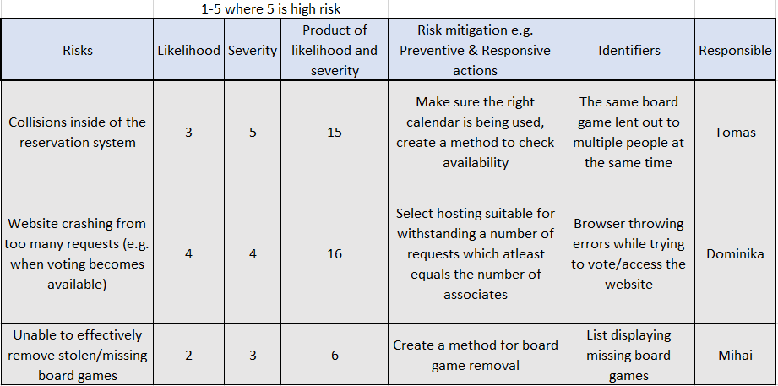

**Pic. 3 Risk assessment**

# Sources of Information

**Appendices**

* Appendix K – Group Contract