Car Renting Application

Analysis and Design Document

Student:Meciu Mihai

**Group:30238**

Revision History

|  |  |  |  |
| --- | --- | --- | --- |
| **Date** | **Version** | **Description** | **Author** |
| 8/apr/2016 | 0.1 | Begin | Meciu Maihai |
|  |  |  |  |
|  |  |  |  |
|  |  |  |  |

Table of Contents

I. Project Specification 4

II. Elaboration – Iteration 1.1 4

1. Domain Model 4

2. Architectural Design 4

2.1 Conceptual Architecture 4

2.2 Package Design 4

2.3 Component and Deployment Diagrams 4

III. Elaboration – Iteration 1.2 4

1. Design Model 4

1.1 Dynamic Behavior 4

1.2 Class Design 4

2. Data Model 4

3. Unit Testing 4

IV. Elaboration – Iteration 2 4

1. Architectural Design Refinement 4

2. Design Model Refinement 4

V. Construction and Transition 5

1. System Testing 5

2. Future improvements 5

VI. Bibliography 5

# Project Specification

Creatii si implementati o aplicatie de tip client-server pentru serviciu de inchiriere de masini care poate fi utilizata atat de client cat si de angajatii complaniei. Aplicatia va permite clientilor sa caute si sa vizioneze masinile valabile.

# Elaboration – Iteration 1.1

# Domain Model

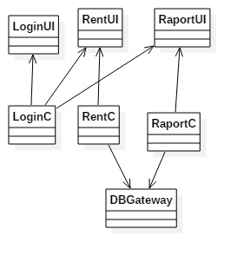

# Architectural Design

## Conceptual Architecture

Voi folosi aritectura Layers pentru a aranja aplicatia.

## Package Design

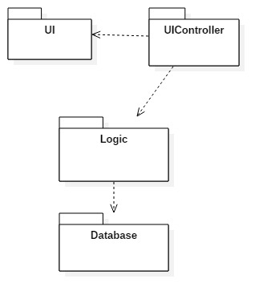

## Component and Deployment Diagrams

# 

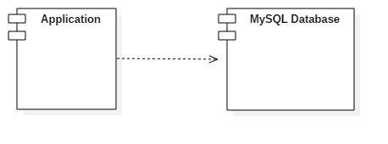

# Elaboration – Iteration 1.2

# Design Model

## Class Design

Server Class Diagram:

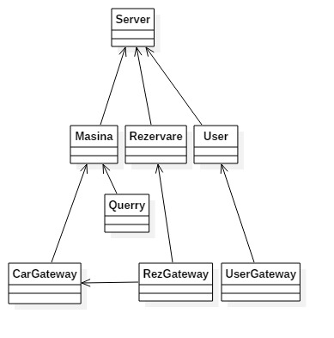

Clietn Class Diagram:

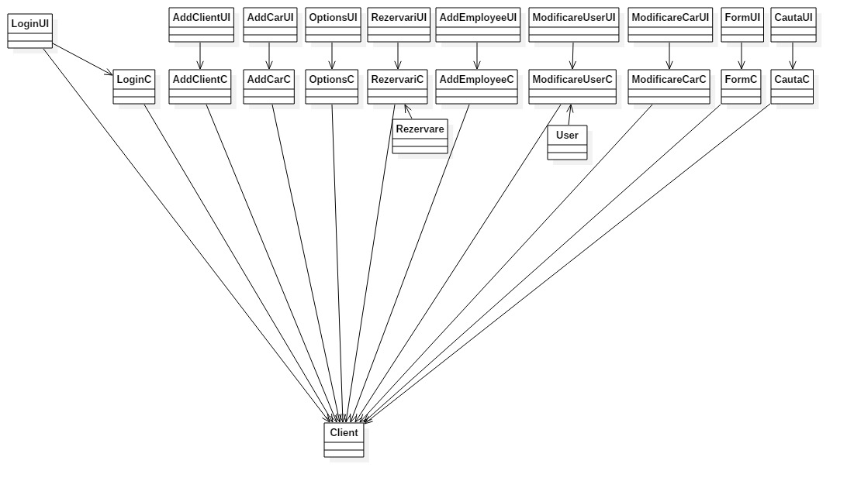

# Elaboration – Iteration 2

# Architectural Design Refinement

Am folosit arhitectura Client-Server , avand doua aplicati, una pentru client si una pentru server. Pentru aplicatia client am folosit arhitectura Layers pentru a stabili o ierarhie intre pachete.

# Construction and Transition

# System Testing

Nu am avut module specializate pe testare.

# Future improvements

Posibilitatea de a adauga poze pentru masini.

# Bibliography