PlayWorthy

Analysis and Design Document : Assignment 1

Student: Mihai Sabadis
Group: 30431

Table of Contents
Table of Contents
1. Requirements Analysis 3
1.1 Assignment Specification 3
1.2 Functional Requirements 3
1.3 Non-functional Requirements 3
2. Use-Case Model 4
3. System Architectural Design 4
3.1 Architectural Pattern Description 4
3.2 Diagrams 5
4. Class Design 6
4.1 Package + Class Diagram 6
5. Data Model 6

1. Requirements Analysis

Assignment Specification
The objective of this project is to build a full-stack web application named "PlayWorth" that allows users to manage a video game library and write reviews. This assignment serves as a foundational CRUD system demonstrating REST API principles, relational database mapping, and client-server architecture.

Functional Requirements
The application has the following functional requirements:
- Allow users to register and manage profiles containing their name, email, age, password, and system role (Customer or Admin).
- Allow users to add video games to their personal library (establishing a Many-to-Many relationship).
- Allow users to write, edit (Patch/Put), and delete reviews for specific video games.
- Provide a bare-bones admin panel (frontend) where all users can be viewed in a table, created, selected, updated, or deleted.
- Enforce edge-case business logic, such as preventing duplicate emails upon user creation and preventing a user from adding the same game to their library twice.

Non-functional Requirements

The application has the following non-functional requirements:
- Implement robust backend validations (e.g., @StrongPassword custom validator, @NotBlank) to ensure that all inputs adhere to the specified format.
- Use Spring Data JPA (Hibernate) as the ORM to handle database interactions and automatically generate the database schema.
- Use the Spring Inversion of Control (IoC) container for dependency injection.
- Use a layered architecture (Controllers, Services, Repositories) for better organization and separation of concerns.
- Use a PostgreSQL relational database to store all the data.
- Implement a Global Exception Handler to intercept validation errors and custom exceptions, returning standardized JSON error messages to the frontend.

Use-Case Model
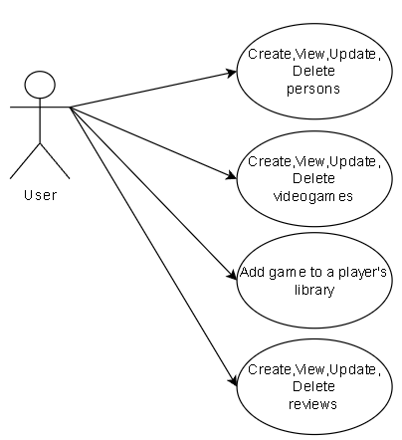
Description of the “Add game to library” use-case:
- Use case goal: Linking a specific video game to a user's personal library.
- Primary actor: The Customer/User of the application.
- Main success scenario: The database connection succeeds. The system receives the personId and gameId via an HTTP POST request and verifies the user does not already own the game. The game is successfully added to the user's ownedGames list, and the player_library database table is updated.
- Extensions (Alternate scenario of success): The user views their library and the newly added game is fetched and displayed correctly.
- Failure: The user attempts to add a game they already own. The system intercepts the Many-to-Many duplicate edge case and throws a ValidationException. The frontend displays a SnackBar notification stating: "This person already owns this game!".

System Architectural Design

Architectural Pattern Description

The application utilizes a classic 3-tier architecture:
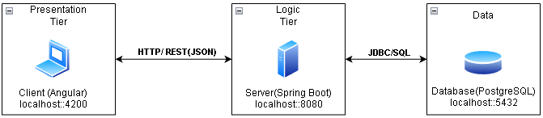
- Presentation Tier (Client): An Angular SPA (Single Page Application) using TypeScript, Angular Material for UI components, and Signal Stores for state management.
- Logic Tier (Server): A Spring Boot Java application exposing RESTful API endpoints. It contains the business logic, security validations, and DTO mappings.
- Data Tier (Database): A PostgreSQL relational database.

Diagrams

The backend strictly follows an architecture where each layer has separate concerns:

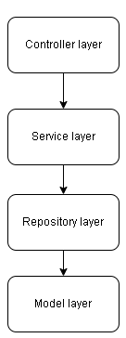

- Controller: This is the entry point of the application. It handles HTTP requests and responses (REST API).
- Service: This represents the "brain" of the application. It contains all the business logic, processes data received from the Controller, enforces application rules, and throws custom exceptions if the business rules are violated.
- Repository: This layer is strictly responsible for database interaction. It uses Spring Data JPA to execute standard CRUD operations and custom queries.
- Model: This represents the data structure of the application. It contains the Java classes (e.g.,Player, Team, Manager) that are mapped directly to tables in the relational database using the ORM (Hibernate).

Class Design

Package + Class Diagram
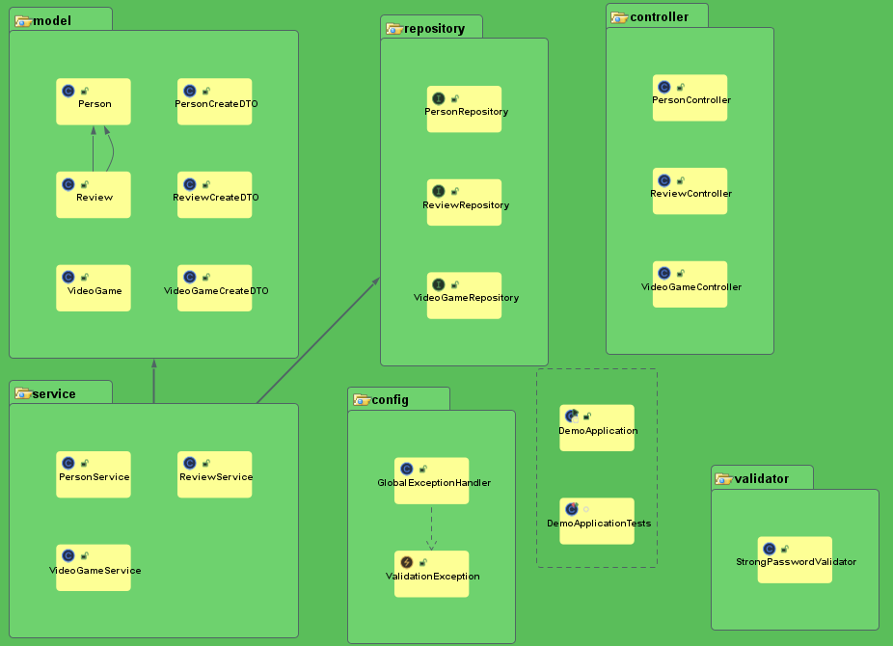

Package Structure Description:
- model: Contains the JPA Entities (Person, VideoGame, Review) and Data Transfer Objects (PersonCreateDTO, ReviewCreateDTO) used to secure API payloads.
- controller: Contains the REST controllers (PersonController, VideoGameController, ReviewController).
- service: Contains the business logic services.
- repository: Contains the Spring Data JPA interfaces.
- validator: Contains custom validation annotations (@StrongPassword).
- config: Contains global configurations, including the GlobalExceptionHandler.

Data Model
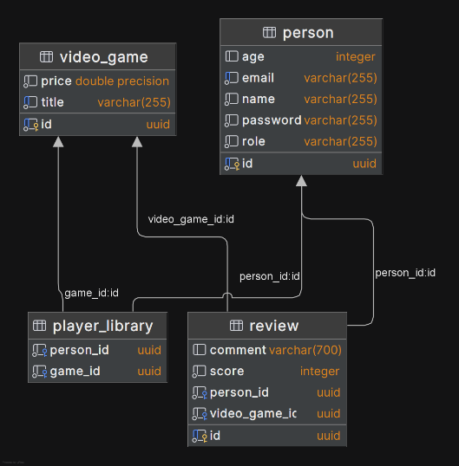
Entity Descriptions:
- Person: Represents a user. Fields include id (UUID), name, email (Unique), age, password, and role. It has a 1:n relationship with Review.
- VideoGame: Represents a game in the catalog. Fields include id (UUID), title, and price. It has a 1:n relationship with Review.
- Review: Represents a user's opinion on a game. Fields include id (UUID), score, comment, author_id (Foreign Key to Person), and game_id (Foreign Key to VideoGame).
- player_library: This is the Many-to-Many (n:m) join table automatically generated by Hibernate to connect the Person and VideoGame entities. It consists of person_id and game_id.

