PlayWorthy

Analysis and Design Document : Assignment 3

Student: Mihai Sabadis
Group: 30431

Table of Contents
Table of Contents
1. Requirements Analysis 3
1.1 Assignment Specification 3
1.2 Functional Requirements 3
1.3 Non-functional Requirements 3
2. Use-Case Model 4
3. System Architectural Design 5
3.1 Architectural Pattern Description 5
3.2 Diagrams 5
4. Class Design 6
4.1 Package + Class Diagram 7
5. Data Model 8
6. Security & Authentification 9
6.1 JWT Authentification & Route Guards 9
6.2 JWT Authentification & Route Guards 9
6.3 Cryptography & Password Management 9
6.4 Password Recovery via SMTP Email 9

1. Requirements Analysis

Assignment Specification
The objective of this project is to build a full-stack web application named "PlayWorthy" that allows users to manage a video game library and write reviews. This assignment serves as a foundational CRUD system demonstrating REST API principles, relational database mapping, and client-server architecture.

Functional Requirements
The application has the following functional requirements:
- Allow users to register and manage profiles containing their name, email, age, password, and system role (Customer or Admin).
- Allow users to add video games to their personal library (establishing a Many-to-Many relationship).
- Allow users to write, edit (Patch/Put), and delete reviews for specific video games.
- Provide a bare-bones admin panel (frontend) where all users can be viewed in a table, created, selected, updated, or deleted.
- Enforce edge-case business logic, such as preventing duplicate emails upon user creation and preventing a user from adding the same game to their library twice.
- Preventing a user from writing more than one review for video game, and also if the game is not present in the user’s library
- Secure Authentication: The system must authenticate users using JSON Web Tokens (JWT). The frontend must store the token in the session and attach it to outgoing requests via an interceptor.
- Role-Based Authorization & Ownership: The backend must restrict endpoints based on the user's role (ADMIN vs. PLAYER). Players are strictly confined to modifying only their own properties and reviews, while Admins have global access. The frontend must enforce route guards to separate Admin and Player dashboards.
- Password Security: Passwords must be hashed using BCrypt before being stored in the database. Users must not be allowed to update their password via standard profile editing forms.
- Password Recovery: The system must provide a secure password reset flow via Email. Users must receive a temporary, time-bound 6-digit code to authorize a password change, followed by an automatic confirmation email upon success.

Non-functional Requirements

The application has the following non-functional requirements:
- Implement robust backend validations (e.g., @StrongPassword custom validator, @NotBlank) to ensure that all inputs adhere to the specified format.
- Use Spring Data JPA (Hibernate) as the ORM to handle database interactions and automatically generate the database schema.
- Use the Spring Inversion of Control (IoC) container for dependency injection.
- Use a layered architecture (Controllers, Services, Repositories) for better organization and separation of concerns.
- Use a PostgreSQL relational database to store all the data.
- Implement a Global Exception Handler to intercept validation errors and custom exceptions, returning standardized JSON error messages to the frontend.
- Implement comprehensive Unit and Integration testing using JUnit 5 and Mockito, utilizing an in-memory H2 database to verify REST endpoints, complex flows, and database interactions without affecting the production PostgreSQL database.

Use-Case Model

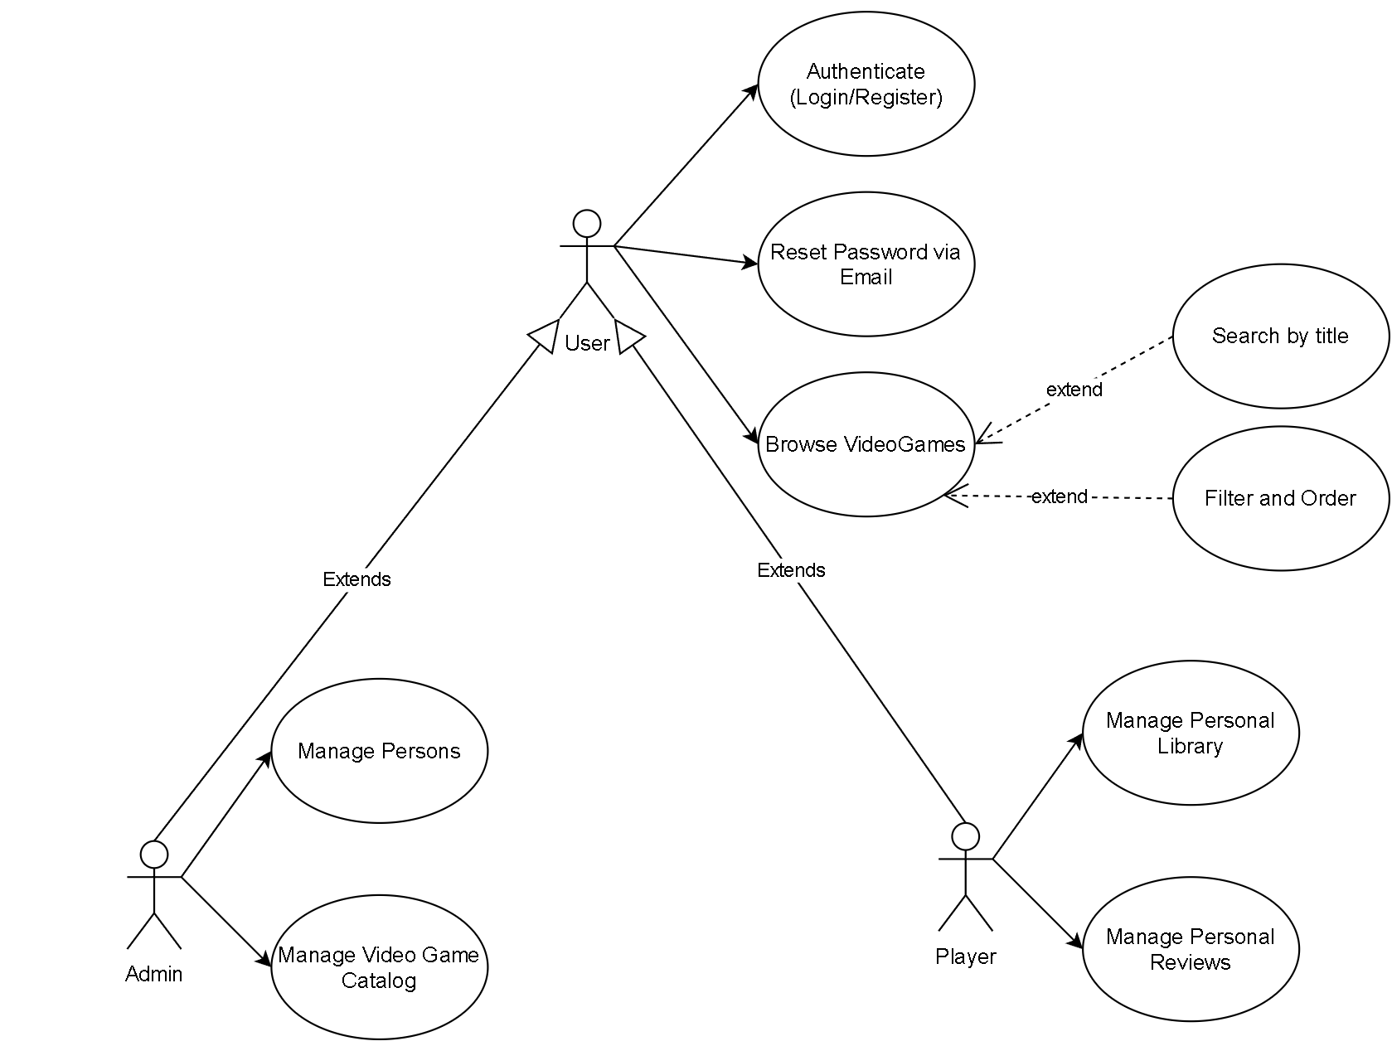

Note on Terminology: In the use case diagram, the term "Manage" refers to the ability to execute full CRUD operations (Create, View/Read, Update, Delete) on a specific resource, restricted by the user's role and ownership.

Use Case: Manage Personal Library (Add Game)
- Use case goal: Linking a specific video game to a user's personal library.
- Primary actor: Player
- Main success scenario: The database connection succeeds. The system receives the personId and gameId via an HTTP POST request and verifies the user does not already own the game. The game is successfully added to the user's owned games list, establishing a Many-to-Many relationship, and the player_library database table is updated.
- Extensions (Alternate scenario of success): The user views their library and the newly added game is fetched and displayed correctly.
- Failure: The user attempts to add a game they already own. The system intercepts the Many-to-Many duplicate edge case and throws a ValidationException.

Use Case: Manage Personal Reviews
- Use case goal: Allow a player to write, view, edit (Patch/Put), or delete their own review for a specific video game.
- Primary actor: Player
- Main success scenario: The player submits a review payload (score and comment) for a game. The system validates the JWT and checks the database to confirm the player owns the game and has not already reviewed it. The review is successfully saved.
- Extensions (Alternate scenario of success): The player modifies an existing review. The backend enforces the "Ownership Pattern" by ensuring the user's ID in the JWT matches the review's author ID before applying the update.
- Failure: The player attempts to review a game not present in their library, or attempts to write more than one review for the same game. The system enforces business logic and throws an exception, returning a JSON error message.

Use Case: Manage Persons (Admin Panel)
- Use case goal: Allow an Admin to view, create, update, or delete any user in the system.
- Primary actor: Admin
- Main success scenario: The Admin accesses the frontend admin panel, where users are viewed in a table. The Admin selects a user to update or delete. The backend intercepts the HTTP request, verifies that the JWT contains the ADMIN role, bypasses standard ownership checks, and successfully executes the database operation.

Use Case: Password Recovery via Email
- Use case goal: Allow a user to securely reset a forgotten password using a time-bound verification code.
- Primary actor: User (Base Actor)
- Main success scenario: The user requests a password reset via email. The backend generates a secure 6-digit code, saves it to the database with a 15-minute expiration timestamp, and dispatches an email to the user. The user inputs the correct code and a new password. The system verifies the code, hashes the new password using BCrypt, nullifies the temporary code, and sends a final confirmation email.
- Failure: The user submits an incorrect code or attempts to use it after the time-bound window has expired. The system rejects the request and no password update occurs

Use Case: Browse Video Games (Search, Filter, Order)
- Use case goal: Allow users to explore the video game catalog by searching for specific titles, filtering by developer, or ordering results by price.
- Primary actor: User (Base Actor)
- Main success scenario: The user navigates to the video game catalog. The system retrieves and displays a list of available games. To find specific content, the user inputs a search term (e.g., a game title), selects a developer to filter by, or chooses a sorting parameter (e.g., price ascending/descending). The frontend sends these parameters via an HTTP request to the backend, which dynamically queries the database and returns the refined, sorted list of games for the user to view.
- Extensions (Alternate scenario of success): If the user enters a search term or applies a filter that does not match any games in the database, the system successfully returns an empty list and the frontend displays a friendly "No games found" message.

System Architectural Design

Architectural Pattern Description

The application utilizes a classic 3-tier architecture:
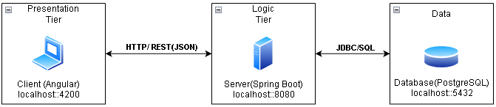

- Presentation Tier (Client): An Angular SPA (Single Page Application) using TypeScript and Angular Material for UI components. The frontend is modularly organized into distinct features (e.g., login, person-list, video-game-details) representing routable pages, and shared components (e.g., person-form-dialog, video-game-card) representing reusable UI elements. State management is handled dynamically using Signal Stores (e.g., login.store.ts), while HTTP interceptors and route guards handle token attachment and navigation security.

- Logic Tier (Server): A Spring Boot Java application exposing RESTful API endpoints. It strictly follows a layered architecture (Controllers, Services, Repositories) to separate concerns. The server acts as the authoritative source for the application, handling all business logic, custom input validation (e.g., the @StrongPassword validator), and stateless JWT security to ensure the client only receives sanitized DTOs rather than raw database entities.

- Data Tier (Database): A PostgreSQL relational database. The schema design, including complex relationships like the Many-to-Many player_library join table, is entirely managed and generated by Spring Data JPA (Hibernate). This allows the logic tier to interact with the database using object-oriented Java entities rather than raw SQL.

Diagrams

The backend strictly follows an architecture where each layer has separate concerns:

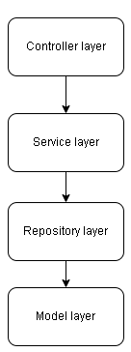

- Controller: This is the entry point of the application. It handles HTTP requests and responses (REST API).
- Service: This represents the "brain" of the application. It contains all the business logic, processes data received from the Controller, enforces application rules, and throws custom exceptions if the business rules are violated.
- Repository: This layer is strictly responsible for database interaction. It uses Spring Data JPA to execute standard CRUD operations and custom queries.
- Model: This represents the data structure of the application. It contains the Java classes (e.g.,Person, Review, VideoGame) that are mapped directly to tables in the relational database using the ORM (Hibernate).

Class Design

Package + Class Diagram
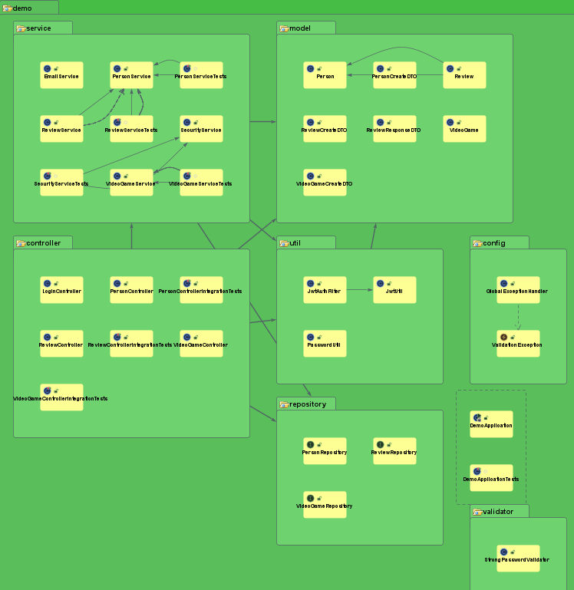

Package Structure Description:
- model: Contains the JPA Entities (Person, VideoGame, Review); Data Transfer Objects (PersonCreateDTO, ReviewCreateDTO, ReviewResponseDTO) used to secure API payloads; Records( LoginRequest,LoginResponse).
- controller: Contains the REST controllers: PersonController, VideoGameController, ReviewController and LoginController.
- service: Contains the business logic services and includes.
- repository: Contains the Spring Data JPA interfaces.
- validator: Contains custom validation annotations (@StrongPassword).
- util / security: Contains the security configurations, including JwtUtil (for generating and parsing tokens), JwtAuthFilter (to intercept and validate requests), and PasswordUtil (for BCrypt hashing
- config: Contains global configurations, including the GlobalExceptionHandler.
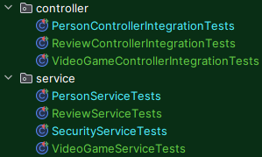
- Besides the java directory, we also have the unit and integration tests present in the test directory

Data Model
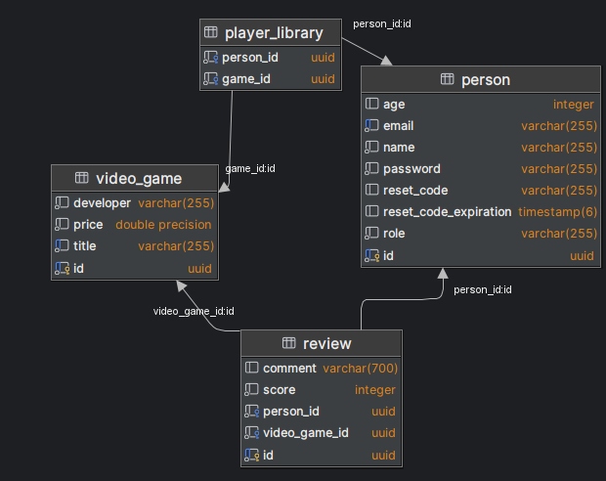

Entity Descriptions:
- Person: Represents a user. Fields include id (UUID), name, email (Unique), age, password, role and reset_code (String) to store the temporary 6-digit recovery code, and reset_code_expiration (LocalDateTime) to enforce a 15-minute validity window for the code. It has a 1:n relationship with Review.
- VideoGame: Represents a game in the catalog. Fields include id (UUID), title, and price. It has a 1:n relationship with Review.
- Review: Represents a user's opinion on a game. Fields include id (UUID), score, comment, author_id (Foreign Key to Person), and game_id (Foreign Key to VideoGame).
- player_library: This is the Many-to-Many (n:m) join table automatically generated by Hibernate to connect the Person and VideoGame entities. It consists of person_id and game_id.

Security & Authentication

JWT Authentication & Route Guards

The application implements stateless authentication using JSON Web Tokens. Upon successful login, the backend issues a JWT containing the user's ID and Role (ADMIN or PLAYER).
- Frontend: The token is stored in sessionStorage. An Angular HttpInterceptor automatically attaches this token as a Bearer header to all outgoing requests (except public endpoints like /login and /person/forgot-password). Route guards (adminGuard, guestGuard and authGuard) prevent unauthorized users from accessing specific dashboard URLs.
- Backend: A JwtAuthFilter intercepts incoming HTTP requests, validates the token signature, and verifies expiration.

Role-based Authorization & Ownership
The backend enforces strict access control directly in the REST Controllers. Using the token's claims, the system checks the user's role and ID. A PLAYER token is heavily restricted using an "Ownership Pattern"—a player can only fetch, update, or delete a Person or Review entity if the ID of the resource matches the ID extracted from their JWT. ADMIN tokens bypass these ownership checks.

Cryptography & Password Management
Plaintext passwords are never stored in the relational database. The backend utilizes BCryptPasswordEncoder to hash passwords upon user registration and password resets. To prevent accidental overwrites or security vulnerabilities, password fields have been entirely removed from standard "Edit Profile" DTOs and frontend forms.

Password Recovery via SMTP Email
A secure password recovery workflow is integrated using spring-boot-starter-mail.
- The user requests a reset via their email address.
- The backend generates a secure 6-digit code, hashes it, and saves it to the Person entity with a 10-minute expiration timestamp.
- The system acts as an SMTP client to dispatch a real email containing the code to the user.
- Once the user submits the correct code and a new password, the system updates the BCrypt hash, nullifies the temporary code, and automatically dispatches a final "Password Changed Successfully" confirmation email to ensure account security.

