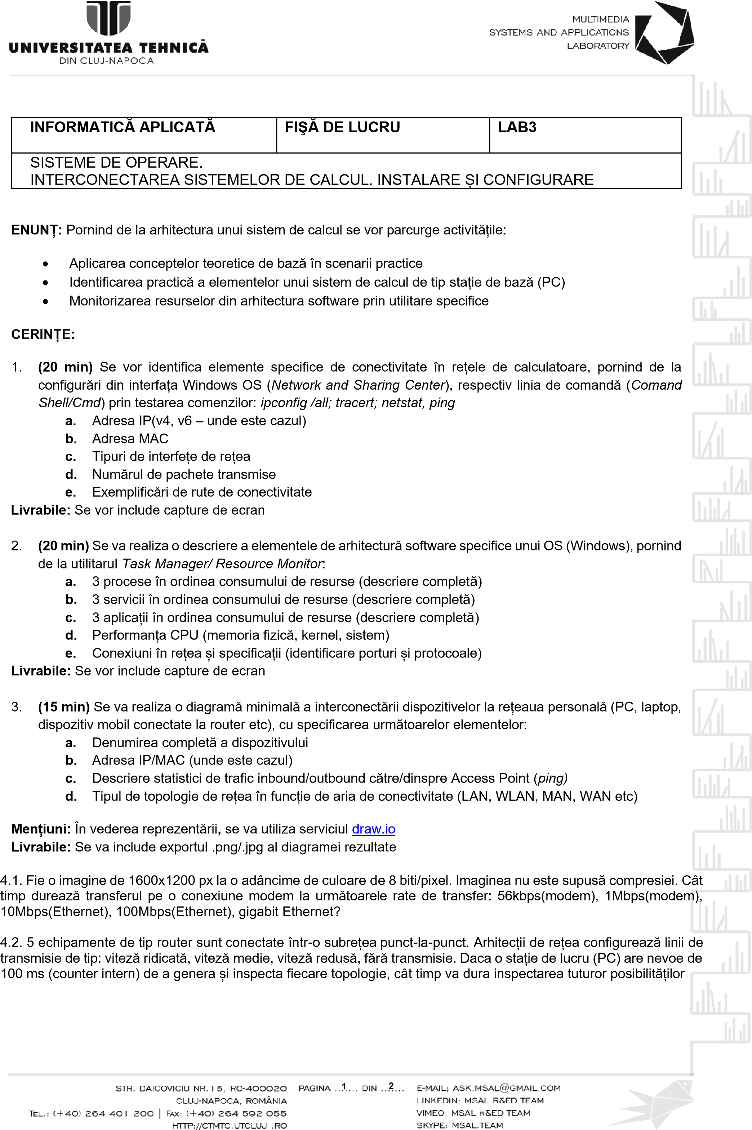

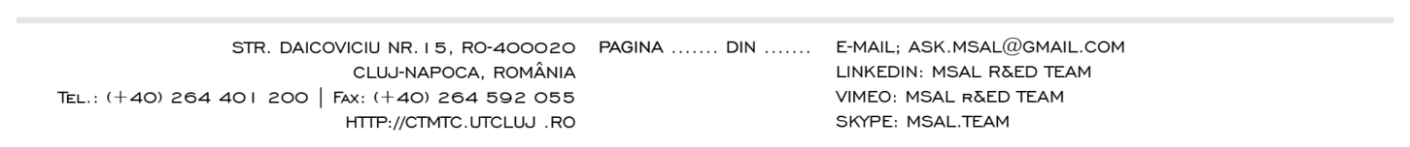

**2**

**2**

**LIVRABILE:**

1

document .docx /.pdf ce conține rezolvările exercițiilor

1

-

4

, încărcat prin intermediul funcționalității

**MS FORMS.**

TERMEN: Ziua desfășurării laboratorului (conform orar semi

-

grupă),

**11.45**

**PM**

FISA DE LUCRU

Ex 1:

a.)IP v4: 10.150.1.61

IP v6: 2001:b30:1802:6:7d4d:a5ff:ef6b:ef8a

2001:b30:5000:6:c48f:5eaa:10b1:4a80

b.)MAC Adress: 6C-4B-90-BE-8F-35

c.)Ethernet 2: Realtek PCIe GbE Family Controller

d.)4 pana la [www.google.com](http://www.google.com)

e.)Routa de conectivitate pana la [www.google.com](http://www.google.com)

d.)

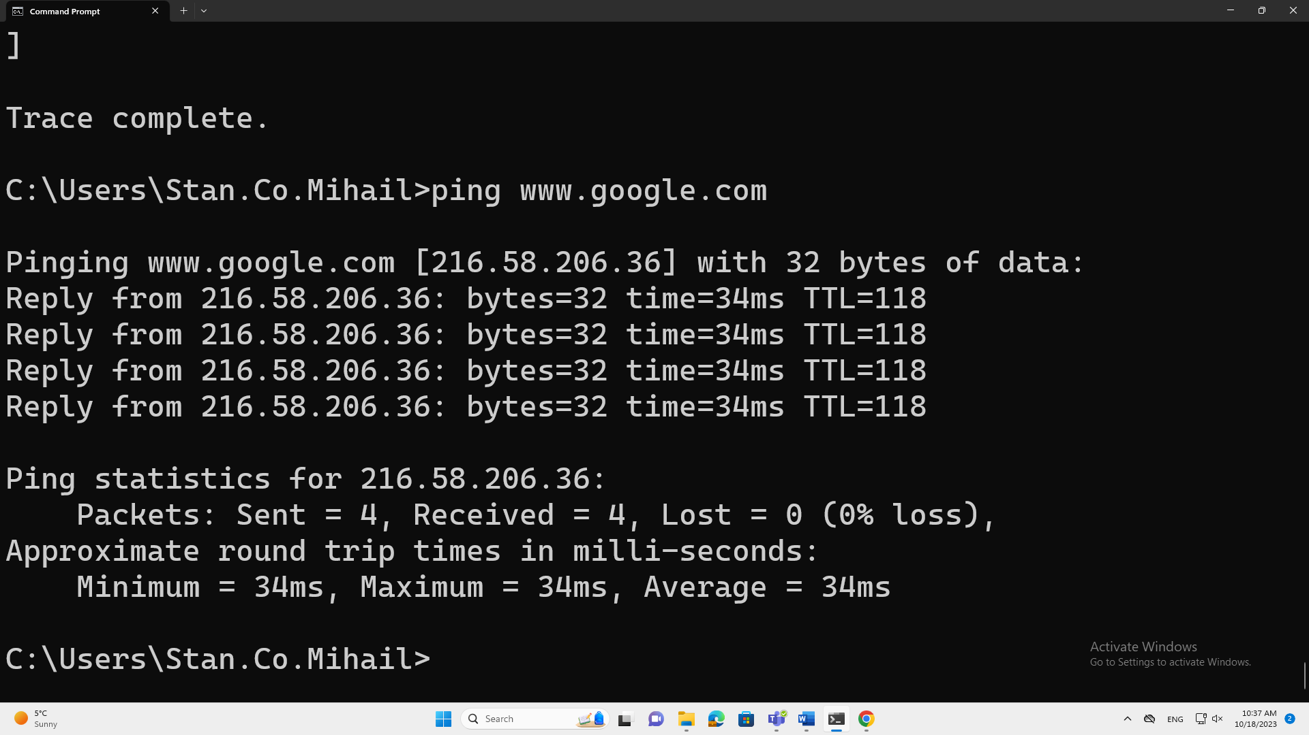

e.)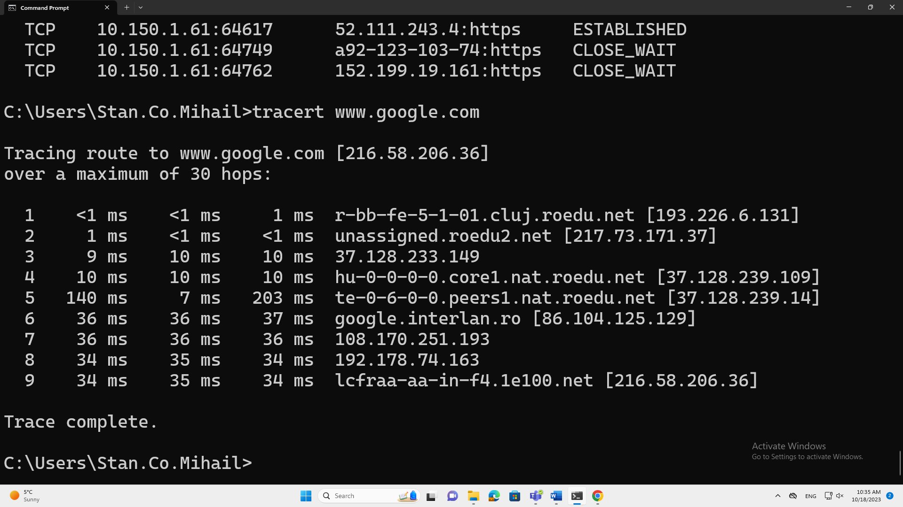

Ex 2:

a.)3 procese:

1.Antimalware Service Executeable 146.4 MB

2.Start 26.3 MB

3.Widgets 19.4 MB

b.)3 Servicii:

1.Service Host:DCOM Server Process Laucher (5) 22.6 MB

2.Microsoft.Management.Services.IntuneWindowsAgent 18.9 MB

3.appmodel 18.1 MB

c.)3 aplicatii:

1.Microsoft Teams 253.6 MB

2.Google Chrome 141.1 MB

3.Microsoft Word 120.2 MB

d.)INTEL® CORE™ i3-8100 CPU @ 3.60 GHz

Memorie fizica:2.27Ghz

e.)Protocol TCP si UDP

Porturi:135,445,5040,7070….

Ex 4.1:

a.)56kbps(Modem): 4.571 min

b.)1Mbps(Modem):15.36 s

c.)10Mbps(Ethernet):1.536 s

d.)100Mbps(Ethernet):0.15 s

e.)Gigabit(Ethernet):0.014 s

Ex 4.2: