SQL Database( **MySQL [relational database, port – 3306]**, PostgreSQL, Microsoft SQL Server) = stores data in **tables**, rows and columns (changes in a row or column may affect others)

> Query in MySQL: **SELECT * from persons where AGE > 10**

> Log in a MySQL Database: **mysql –u [user] –p[password – initial from /var/log/mysqld.log]**

> Change default password: **ALTER USER ’[root]’@’[localhost]’ IDENTIFIED BY ’[NEWPASSWORD]’;**

There is also a script used for changing the default password – **mysql_secure_installation** – but the script is not run within the SQL prompt, as it is a shell script/

> Create other users: **CREATE USER ’[user]’@’[localhost]’ IDENTIFIED BY ’[NEWPASSWORD]’;**

-- ’[user]’@’[localhost]’ – this means that the user can connect to the DB only from the localhost, can be replaced with other IPs from external, or if you use % instead of localhost/IP, it means that users can connect from everywhere

> Grant permissions: GRANT **<PERMISSIONS> ON <DB.TABLE> TO <’user’@’%’;**

**Example: GRANT SELECT ON school.persons TO ’john’@’%’;**

It can be used to grant multiple permissions on all tables from a database, as for:

**GRANT SELECT, UPDATE ON school.* TO ’john’@’%’;**

To grant all privileges to all tables in all databases: **GRANT ALL PRIVILEGES ON *.* TO ’john’@’%’;**

To list permissions for a user: **SHOW GRANTS FOR ’john’@’%’;**

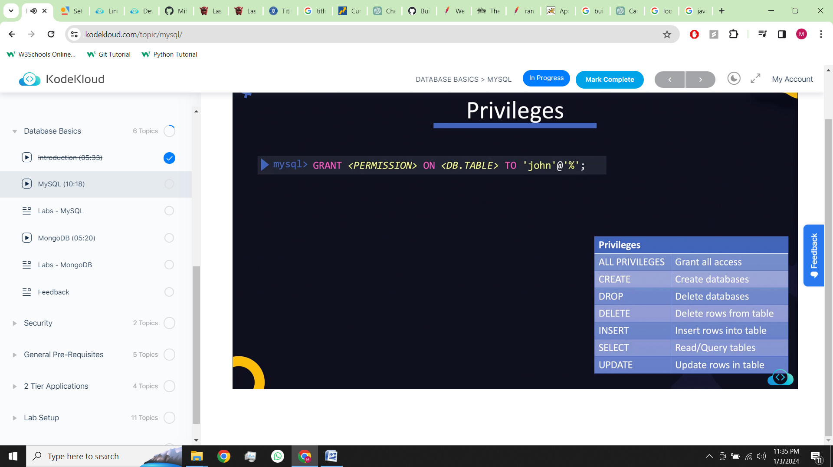

> Show all databases: **SHOW DATABASES;**

> Create database: **CREATE DATABASE [database name];**

> To select a database which you want to work on (you can only use one database at a time): **USE [databse name];**

> Create a table: **CREATE TABLE [table name]**

**(**

**Name varchar(255),**

**Age int,**

**Location varchar(255)**

**);**

> See a list of tables: **SHOW TABLES;**

> To insert data into a table:

**INSERT INTO [tablename] values**

**( ”John Doe”, 45, ”New York”);**

To view the data in the table: **SELECT * FROM [table];**

**LAB EXAMPLE:**

But if you have installed MariaDB server you might have noticed that there is no password set for MySQL root user. If you have installed MariaDB server then set password P@ssw0rd123 for root user.

i. Login to mysql database server: - mysql -u root

and then run the following queries in it.

ii. USE mysql;

iii. UPDATE user SET password=PASSWORD('P@ssw0rd123') WHERE User='root' AND Host = 'localhost';

iv. FLUSH PRIVILEGES;

NoSQL (**MongoDB [document database, port- 27017]**, Cassandra, Amazon DynamoDB) – store data in **collection**, store information in the form of documents or pages (changes in a file does not affect others)

Multiple documents form a collection and multiple collections form a database and you can have more than one databases in a MongoDB server

The mongo shell is a Java Script interface.

> Query in NoSQL: db.persons.find( { age: { $gt: 10 } } )

> The **logs** are stored in: **/var/log/mongodb/mongod.log**

**> Configuration** file**: /etc/mongod.conf**

**> Connect** to the database command**: mongo**

**> Display** a list of databases**: show dbs**

**> Create** a new database or **switch** to an existing database**: use [database]**

**>** To find out to **which db** you are into**: db**

> To create a collection: **db.createCollection(„dbname”)**

> To list collections**: show collections**

> To add data to the database**: db.[databasename].insert and insert the data in JSON format:**

Example to create a new document within the collection in the database:

db.persons.insert({

„name”: „John Doe”,

„age” : 45,

„location”: „New York”,

„salary”: 5000

})

**>** To retrieve data from the database: **db.[database].find()**

**>** Filter output example**: db.[database].find({„name”: „John Doe”})**