Generating Surveys with Ask Language

Ankorins, Edgars,¹ Ivanov, Martin Vladkov,¹ Stentsøe, Daniel¹ and Vlăsceanu, Mihai+Marius¹
¹ IT University of Copenhagen, Rued Langgaards Vej 7, DK-2300 Copenhagen S, Denmark

Abstract.

- Introduction
The demand for web-based survey services or feedback forms for mobile applications increased in the recent years. The demand is also reflected into the progress in the socially-oriented technology, such as mobile technology and social media. With this progress the design complexity of surveys increased. Survey creators want to express surveys that interact with the users in complicated ways, such as forking. However, the available Domain-Specific Languages (DSLs), such as SuML and QPL offer limited possibilities regarding survey design flexibility [1].
The domain of survey research has a broad coverage and it can be employed by almost any discipline or field [2]. Therefore, it is beneficial to design a tool, such as a language, that can generate surveys for different environments as easy as possible.
The objective of this project is to define and implement a textual DSL for generating surveys to be used on two different platforms. This project will target the Android Platform and web applications and use e-mail as an electronic data reporting method. Moreover, in this report we present the development and implementation workflow of the DSL.

- Domain Analysis
A common type of social science and quantitative research method is represented by surveys. In a survey research, the researcher defines a relevant collection of individuals as a sample, that represents the target population as a whole [3]. The surveys can be presented in different formats and environments such as a written document, an online survey, a face-to-face interview, electronic data reporting or a telephone interview [4]. Our DSL should allow the survey creators to express surveys in a clear and fast way, while not having to write code that is not specific to the domain of surveys [1].
Surveys include two types of questions; open questions represents questions where the respondent is not provided with possible response categories and the respondent has to input his/her own answer. The closed question type is the type of question where the possible response categories are presented to the respondent along with the question. Moreover, the closed questions type is also divided into several sub-types, most commonly used being Dichotomous, Multiple Choice, Constant Sum, Rank Order Scaling, Rating, and Staple Scale [1, 4]. Furthermore, every particular question type previously stated has the feature to be set either optional or mandatory to be answered by the respondent.
In order to address the survey design complexity highlighted in the previous chapter, an important feature of the domain is forking [5].
- Ask Language
Ask is the language we have designed, that enables the user to write surveys that can be exported to web applications and Android Platform. In this section we will cover the Ask DSL.
  - Language requirements
From our domain analysis we found a range of question types most commonly used in surveys and decided that the language should support these.
A considerable number of online surveys also have optional questions and allows for forking questions. This lead us to the following language requirements:
- Full support for all question types found during language analysis
- A question can be mandatory or optional in a survey
- Where possible a question can lead to different questions depending on the answer
  - Language Design
The meta-model of our language was realized iteratively, refining it at each iteration step. The changes made through the iterations and the reasons why are described in 3.3 Design principles.
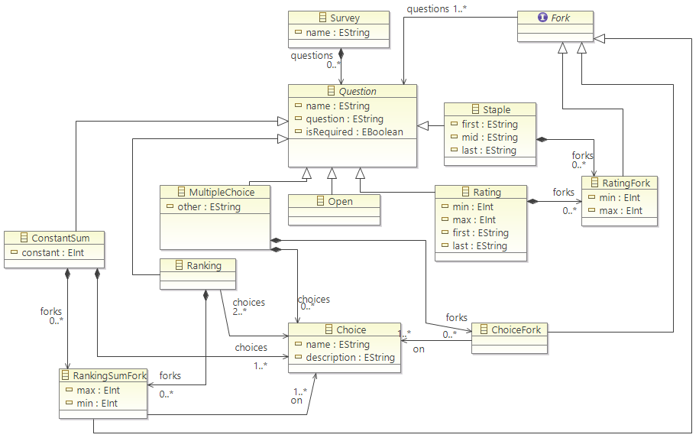
Fig. 1. Meta-model of our language
The attributes of each question type are explained in Appendix: Question Types Model Implementation.
The question types our language needs to support are Open Ended, Multiple Choice, Ranking, Ranking Sum, Staple and Rating. They all share some common attributes; An identifier, the question they ask and whether it is required or not. All questions are therefore subclasses of the Question class that defines these three attributes for them, name, question and isRequired. Instances of Question is contained by a Survey class, to be able to create a series of questions of different types.
Each question type, except Open, contains an attribute named Fork. Each of these attributes is a subclass of the Fork class. The purpose of using forks is to allow branching into different paths of questions, depending on the answer. So each Fork subclass, models one or more possible answers to the question they are contained in. If one of these modelled answers is the answer, the survey will continue along the path of the questions defined in the questions attribute of Fork. For example, as depicted in figure 2 for a Rating question a RatingFork can be specified; if the question is answered with a number within the range stated in min and max of RatingFork, the survey will continue with the questions specified in the questions of RatingFork. Once the forked questions have been answered, the survey will continue with the normal questions in the survey.

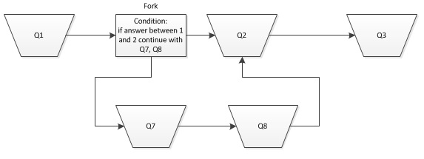
Fig. 2. Question flow diagram with the use of a fork
  - Design principles
The final meta-model and grammar was created over a couple of iterations, each time refining the meta-model. Each iteration was started when we noticed that our design was violating a design guideline, a what-not-to-do (WNTD) or if we found an error.
On our first iteration of the grammar we tried applying a guideline [6] to make our language consistent. For us, this meant making the internal keywords, grammar keywords and grammar layout consistent; Making the non-terminals, terminals and the language structure the same, e.g. using the non-terminal “if” in all of the forks.
After our first iteration of the meta-model and grammar, our DSL was “Duplicating the concepts and semantics of traditional programming languages” [7] which is a WNTD. At that time, the Fork class contained Question instead of referencing it. The effect was that the user would have to nest all the questions inside a fork. At the next iteration we modified it to reference Question creating a more flat structure in the grammar.
In the first iterations of the meta-model the Dichotomous question type was still present. However, in order to avoid conceptual redundancy [6], we decided to remove it. It is possible to create a Dichotomous question by using a Multiple Choice question instead.
  - Grammar and Concrete Syntax
We decided to use Xtext as our framework to write our grammar. Xtext also provides us with an IDE to write the concrete syntax. With Xtext we were able to create our DSL, Ask, as an external DSL. Creating Ask as an external DSL allowed us to have full control over the implementation, syntax and logic of the language, as opposed to an internal DSL. Furthermore, internal DSLs have various limitations like code completion being polluted by noise from the host language, error messages being produced in terms of the host language and increased difficulty in separation between language design and implementation [3].

Concrete Syntax shows an example of a survey written in Ask.
Concrete Syntax
Survey1
MultipleChoice Q1:
the user
is required
to answer "Did you find the Ask language useful?"
picking 1 of these A : "Yes", B : "No"
if A then continue with Q2, Q3
Rating Q2:
rate "Ask ease of use"
1 and 10 "Awful" "Amazing"
Ranking Q3:
is required
rank "Favorite Features"
these A : "Code Generation", B : "Editor", C : "Forking"
We only allow a single survey for each file, to reduce the complexity both on the back-end as well as for the survey creator. The survey will be declared with a name, followed by the declaration of the questions. Each question will be declared by choosing the desired type, such as MultipleChoice displayed in Concrete Syntax as well as assigning an identifier. Inside the body of a question we have a number of optional terminals to increase the readability of the grammar. It is possible to use keywords such as the user and may, but these can be omitted. The actual question string can be prefixed with answer, rate, or rank depending on the question type. A question can be marked as mandatory by using the is required keyword.
MultipleChoice and ConstantSum will contain a comma separated list of Choice instances. Each instance of Choice is defined by an identifier, followed by a colon, as well as the Choice description. Each instance of a Choice can be referenced in a Fork of the parenting question. Instances of Fork are declared with the terminal if, followed by the choice identifiers and a comma separated list of the Question identifiers. The fork can reference several choices and can lead to one or more questions. If the answers are within an integer range, such as in Rating questions, the fork will be declared with an integer range instead of choices.
  - Use of models
When the design was changed from Question being contained by Fork, to being referenced, a couple challenges arose. One challenge was the default implementation of the identifiers in Xtext, which allows the same identifier for choices in the same scope. With this ambiguity, a choice in a fork will be referenced to the first occurrence of that identifier. To circumvent the ambiguity of identifiers we implement a Model-to-Model transformation. This transformation replaces the choices in the forks with the choices of the parenting question, if they match.
  - Constraints
We have to introduce a number of constraints that will help in avoiding both user introduced pitfalls, as well as the language's shortcomings. These constraints include:
- checking that each question has an unique identifier
- checking that forks does not reference either the same choice or question twice
- checking for loops in the forks, by disallowing a fork to reference a previously defined question
- checking for empty questions or choice strings
  - Code Generation
We decided to use code generation to create the applications for each platform. Code generation has various advantages, as opposed to DSL interpretation that convinced us that it is the best choice for this project. Among the most important ones are code reuse, system verification and maintainability. The automation process ensures correctness of the generated code, saves a lot of development hours, allows for faster time to market and lowers the overall cost of the architecture in the long run [8].
A crucial point before producing the code generators was to implement a hardcoded back-end for each platform. This allowed us to consider different ways to generate the code, before starting to code the actual code generators. Furthermore, it pointed us in the right direction of an easy and clean implementation of the generators due to the already gained back-end knowledge. We used our hardcoded back-ends code to create templates for the code to be outputted by the code generators. The code generators were written in Xtend, utilizing Xtend’s templates. The first generates a Java class for Android and the second generates HTML and Java Script (JS) for a web application. In both cases our main focus was to ensure efficiency of the code generators and readability of the produced back-end code.
After completing the model transformation and passing the constraints, the parsed model will be put through the code generators, in a Model-to-Text (M2T) transformation. Assuming that the second question from Concrete Syntax, is run through the code generator, the Rating question template would be applied on the question. The output would look like the Generated code snippet.

Rating question template
'''
RatingQuestion «it.name» =
new RatingQuestion ("«it.name»","«it.question» ",«it.isRequired», «it.min», «it.max», "«it.first»"," «it.last»");
questions.add(«it.name»);
'''
Generated code
RatingQuestion Q2 = new RatingQuestion ("Q2","Ease of use ",false, 1, 10, "Aweful"," Amazing");
questions.add(Q2);

With the generated code for the Android application we generate an .apk file, which can be installed on an android application. Figure 3 presents the question from Generated Code inside the android application. Code generated by the HTML code generator is inserted into a web application to be published on a web server, see Appendix: HTML code generation.

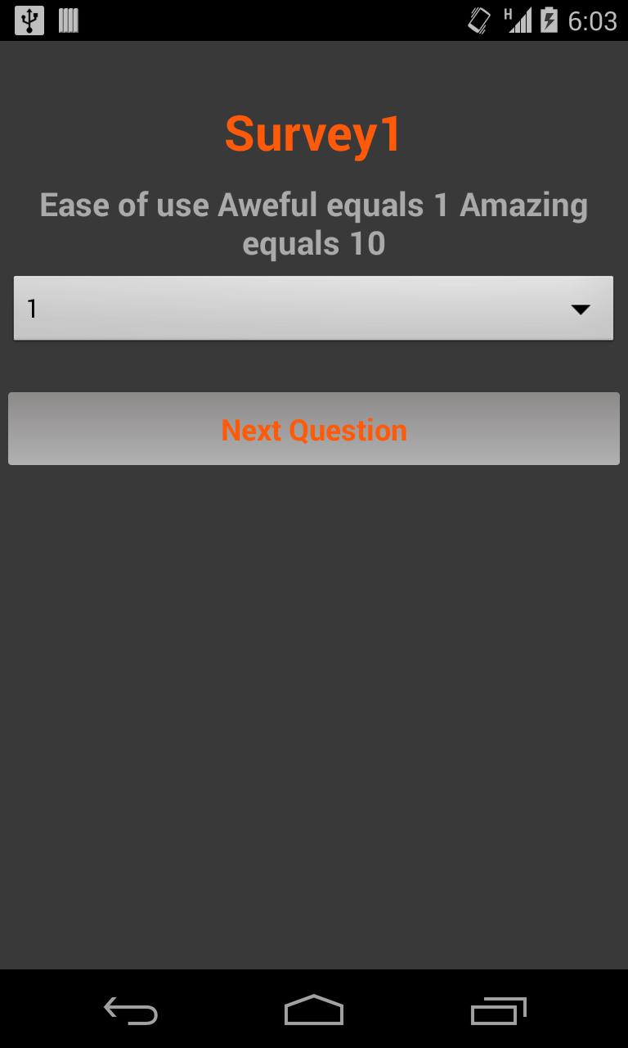
Fig. 3. Ranking question on android
- Tool chain
A number of tools have to be started in sequence to generate the code for each platform. We have created the meta-model in the Eclipse IDE, had Ecore generate the code for the model and we have defined the grammar. Xtext is the first part of the tool chain for any survey creator using Ask. With the Eclipse IDE and Xtext the user can initialize another instance of the Eclipse IDE for defining Ask surveys. After creating a concrete syntax, Xtend is used to transform the text to an instance of our meta-model, going through our previously stated M2M transformation. Before going through the code generators M2T transformation, they are passed through a constraint checker. The constraint checker is executed before the code generation and will report errors if there are any problems with the validity of the DSL instance. It is placed before the M2T transformation to increase the performance of the tool chain, so a faulty application is not generated.

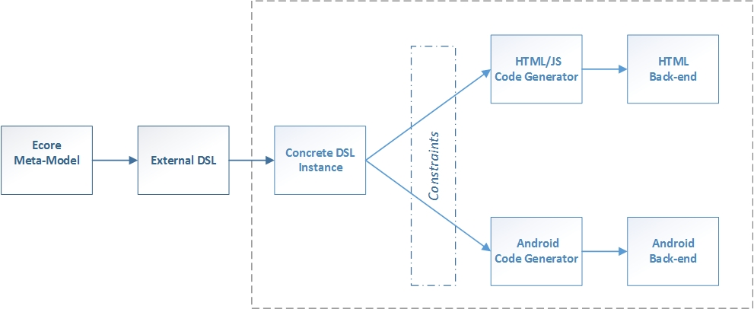
Fig. 4. Ask tool chain
The final version of our tool chain, outlining each and every component and the logical steps of implementation is illustrated in Fig 4. The back-end specific code can be generated within seconds and does not require any back-end knowledge, due to its plug-and-play nature.
- Testing
Ensuring the validity and correct behavior of a system requires the implementation of testing procedures. It is often an invaluable asset to introduce testing mechanism in the development process as early as possible [9]. We did individual component testing on each of the system parts: meta-model, external DSL and code generation.
As soon as we did the first implementation of the meta-model, we started creating dynamic instances to test its validity, see Appendix: Testing.
This helped us in finding flaws in our design. Testing of our external DSL and the code generation was done by parsing concrete syntax to an instance and ensuring verification of the constraints. The instances and the constraint verification allowed us to consider better ways to express the language. It also allowed us to introduce more constraints to prevent the incorrect use of the DSL.
Once we finished implementing each of the system components we performed system testing by running the already established testing procedures in subsequent order. Due to the limited project time frame we did not perform any unit testing via a framework, such as JUnit.
- Conclusion
The requirements of the DSL have been met through the meta-model as well as the grammar. Ask supports code generation for each type of question found during the domain analysis, mandatory and optional question and forking. We have implemented two code generators one to HTML and one to the Android Platform, that generates code based on concrete syntaxes of our DSL.
Using Ask it is possible to create surveys while maintaining the same code base. This allows swift implementation on the two supported platforms.
To further develop and make the language more usable a plug-in could be created. Due to time constraints we were unable to create an Eclipse plug-in for Ask. This plug-in would be a package of our tool chain. That would allow the user to write Ask and generate .apk files and web pages for a concrete syntax, without manually going through the tool chain.

References
- Campbell, A., Katona, G.: The Sample Survey: A Technique for Social Science Research. The Dryden Press, New York, USA (1953)
- Leeuw, E. D., Hoh, J. J., Dillman, D. A.: International Handbook of Survey Methodology. The European Association of Methodology (EAM), http://www.eam-online.org
- Fowler, M.: Domain Specific Languages, pp 33-102. Addison-Wesley Professional, Boston, USA (2010)
- Sapsford, R.: Survey Research Second Edition. Sage Publications Ltd., London, United Kingdom (2006)
- Battey K., QuestionPro, http://www.questionpro.com
- Karsai, G., Rumpe, B., Krahn, H., Schindler, M., Pinkernell, C., Völkel, S.: Design Guidelines for Domain Specific Languages, IEEE Software, 2003
- Kelly, S., Pohjonen, R.: Worst Practices for Domain-Specific Modeling, IEEE Computer Society (2009)
- Bran Selic. The pragmatics of model-driven development. IEEE Software, 20(5):19–25, 2003
- Continuous Delivery: Reliable Software Releases through Build, Test, and Deployment Automation (Addison-Wesley Signature Series (Fowler))
Appendices
Appendix: Question Types Model Implementation

Question Subclasses | Attributes
Ranking | min -The possible answers lower bound  max -The possible answers upper bound  first - A string stating what should be stated at the minimum number in the question  last - A string stating what should be stated at the maximum number in the question
Staple | first - A string stating what should be stated at the minimum number in the question  last - A string stating what should be stated at the maximum number in the question  mid - A string stating what should be stated at the middle of min and max
Open
Multiple Choice | other - Whether its possible to input another choice not stated  choices - The choices that can be chosen to answer the question.  answerCount - The amount of choices that can be chosen to answer.
Ranking | choices - The choices that can be chosen to answer the question.
Constant Sum | choices - The choices that can be chosen to answer the question.  constant - The integer that the inputted numbers has to add up to.

Appendix: Ranking Question template
Ranking Question template
var forkName = it.name.toLowerCase + "ForkId"
var forkArrName = it.name.toLowerCase + "ForkArrId"
'''
RatingQuestion «it.name» =
new RatingQuestion ("«it.name»","«it.question» ",«it.isRequired», «it.min», «it.max», "«it.first»"," «it.last»");
«FOR q : forks»
«IF (it.forks.size >0)»«toTemplate(forkName,forkArrName,q.questions, it.name, q.min, q.max)»
« ENDIF »«ENDFOR»
questions.add(«it.name»);'''
Appendix: Testing
Dynamic Instance Testing:
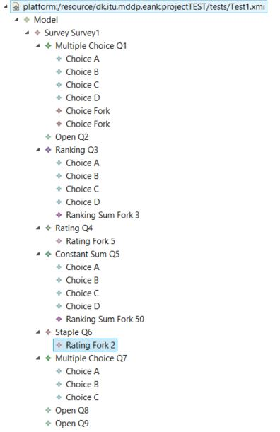
Concrete Syntax Instance
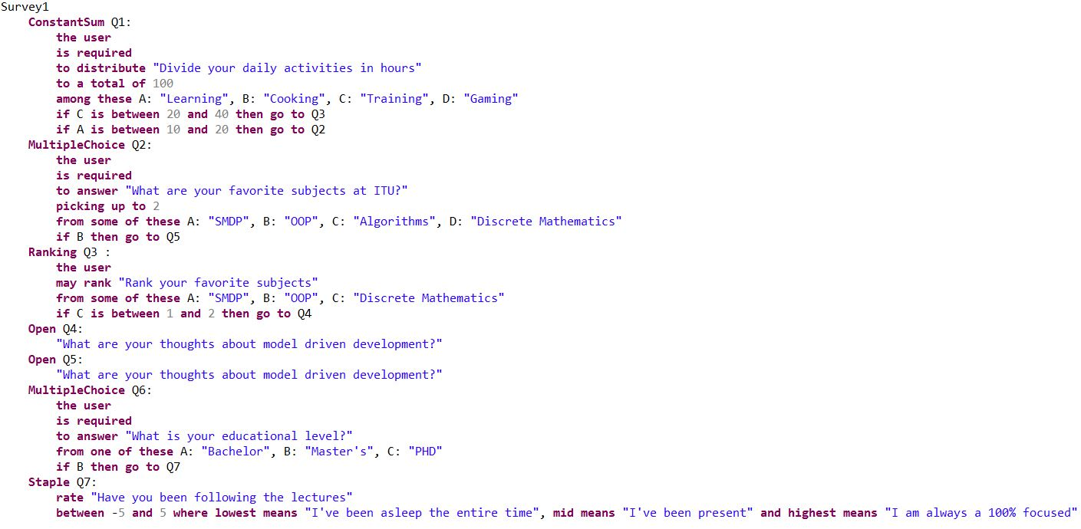
Constraints
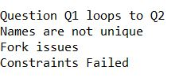
- Example of Code Gen data
package com.smdp.surveytoandroid;

import java.util.ArrayList;

import com.smdp.surveytoandroid.questionstructure.Choice;

import com.smdp.surveytoandroid.questionstructure.Fork;

import com.smdp.surveytoandroid.questionstructure.MultipleChoiceQuestion;

import com.smdp.surveytoandroid.questionstructure.OpenQuestion;

import com.smdp.surveytoandroid.questionstructure.Questionable;

import com.smdp.surveytoandroid.questionstructure.RankingQuestion;

import com.smdp.surveytoandroid.questionstructure.RatingQuestion;

import com.smdp.surveytoandroid.questionstructure.SumConstantQuestion;

import com.smdp.surveytoandroid.questionstructure.Staple;

import com.smdp.surveytoandroid.questionstructure.Survey;

public class CodeGenData {

private static ArrayList<Questionable> questions = new

ArrayList<Questionable>();

public static ArrayList<Questionable> addQuestionsToArrList() {

find the Ask language useful?",true, "", arrMultiQ1 );

10, "Aweful"," Amazing");

Features",true, arrRankQ3);

Survey ExampleSurvey = new Survey ("ExampleSurvey");

ArrayList<Choice> arrMultiQ1 = new ArrayList<Choice>();

arrMultiQ1.add(new Choice ("A","Yes"));

arrMultiQ1.add(new Choice ("B","No"));

MultipleChoiceQuestion Q1 = new MultipleChoiceQuestion ("Q1","Did you

Fork q1ForkId = new Fork();

ArrayList<Questionable> q1ForkArrId = new ArrayList<Questionable>();

q1ForkArrId.add(Q2); q1ForkArrId.add(Q3);

q1ForkId.bindingChoiceQuest.put("A",q1ForkArrId);

Q1.forks.add(q1ForkId);

questions.add(Q1);

RatingQuestion Q2 = new RatingQuestion ("Q2","Ease of use ",false, 1,

questions.add(Q2);

ArrayList<Choice> arrRankQ3 = new ArrayList<Choice>();

arrRankQ3.add(new Choice ("A","Code Generation"));

arrRankQ3.add(new Choice ("B","Editor"));

arrRankQ3.add(new Choice ("C","Forking"));

RankingQuestion Q3 = new RankingQuestion ("Q3","Favorite

questions.add(Q3);

return questions;

}

}

def dispatch toTemplate(String forkname, String forkarrayname,

EList<Question> questions, String choicename, String questionname) {

ArrayList<Questionable>();

«forkname».bindingChoiceQuest.put("«choicename»",«forkarrayname»);

'''

Fork «forkname» = new Fork();

ArrayList<Questionable> «forkarrayname» = new

«FOR q : questions»«forkarrayname».add(«q.name»); «ENDFOR»

«questionname».forks.add(«forkname»);

'''

}

//rank + sum constant forks template

def dispatch toTemplate(String forkname, String forkarrayname,

EList<Question> questions, String choicename,String questionname, int min, int max) {

ArrayList<Questionable>();

«forkname».bindingChoiceQuest.put("«choicename»",«forkarrayname»);

'''

Fork «forkname» = new Fork(«min», «max»);

ArrayList<Questionable> «forkarrayname» = new

«FOR q : questions»«forkarrayname».add(«q.name»); «ENDFOR»

«questionname».forks.add(«forkname»);

'''

}

//rate + staple forks template

def dispatch toTemplate(String forkname, String forkarrayname,

EList<Question> questions,String questionname, int min, int max) {

ArrayList<Questionable>();

'''

Fork «forkname» = new Fork («min», «max»);

ArrayList<Questionable> «forkarrayname» = new

«FOR q : questions»«forkarrayname».add(«q.name»); «ENDFOR»

«forkname».forkQues.add(«forkarrayname»);

«questionname».forks.add(«forkname»);

'''

}

def dispatch toTemplate(MultipleChoice it) {

//name for the choice array

var arrName = "arrMulti" + it.name

//name for the specific forks

var forkName = it.name.toLowerCase + "ForkId"

//name for forks array

var forkArrName = it.name.toLowerCase + "ForkArrId"

'''

ArrayList<Choice> «arrName» = new ArrayList<Choice>();

«FOR c : it.choice»«toTemplate(c,

arrName)»«ENDFOR»MultipleChoiceQuestion «it.name» = new MultipleChoiceQuestion

("«it.name»","«it.question»",«it.isRequired», "«it.other»", «arrName» );

«FOR p : choice»

«FOR q : forks»

«IF (q.on.contains(p))»

«toTemplate(forkName,forkArrName,q.questions,p.name, it.name)»

« ENDIF »«ENDFOR»

«ENDFOR»

questions.add(«it.name»);

'''

}

//choice template

def dispatch toTemplate(Choice it, String arrname) {

'''

«arrname».add(new Choice ("«it.name»","«it.description»"));

'''

}

//ranking question template

def dispatch toTemplate(Ranking it) {

("«it.name»","«it.question»",«it.isRequired», «arrName»);

forks.indexOf(q),forkArrName,q.questions,p.name, it.name, q.min, q.max)»

//name for the choice array

var arrName = "arrRank" + it.name

//name for the specific forks

var forkName = it.name.toLowerCase + "ForkId"

//name for forks array

var forkArrName = it.name.toLowerCase + "ForkArrId"

'''

ArrayList<Choice> «arrName» = new ArrayList<Choice>();

«FOR c : it.choices» «toTemplate(c, arrName)»«ENDFOR»

RankingQuestion «it.name» = new RankingQuestion

«FOR p : choices»

«FOR q : forks»

«IF (q.on.contains(p))»

«toTemplate(forkName +

« ENDIF »«ENDFOR»

«ENDFOR»

questions.add(«it.name»);

'''

}

//cosntantSum question template

def dispatch toTemplate(ConstantSum it) {

//name for the choice array

var arrName = "arrConstSum" + it.name

//name for the specific forks

var forkName = it.name.toLowerCase + "ForkId"

//name for forks array

var forkArrName = it.name.toLowerCase + "ForkArrId"

'''

ArrayList<Choice> «arrName» = new ArrayList<Choice>();

«FOR c : it.choices» «toTemplate(c,

arrName)»«ENDFOR»ConstantSumQuestion «it.name» = new ConstantSumQuestion

("«it.name»","«it.question»",«it.isRequired», «it.constant»,«arrName» );

forks.indexOf(q),forkArrName,q.questions,p.name, it.name, q.min, q.max)»

«FOR p : choices»

«FOR q : forks»

«IF (q.on.contains(p))»«toTemplate(forkName +

« ENDIF »«ENDFOR»

«ENDFOR»

questions.add(«it.name»);

'''

}

//rating question template

def dispatch toTemplate(Rating it) {

("«it.name»","«it.question» ",«it.isRequired», «it.min», «it.max», "«it.first»"," «it

.last»");

>0)»«toTemplate(forkName,forkArrName,q.questions, it.name, q.min, q.max)»

}

//staple question template

def dispatch toTemplate(Staple it) {

var forkName = it.name.toLowerCase + "ForkId"

var forkArrName = it.name.toLowerCase + "ForkArrId"

'''

RatingQuestion «it.name» =

new RatingQuestion

«FOR q : forks»

«IF (it.forks.size

« ENDIF »«ENDFOR»

questions.add(«it.name»);'''

//name for the specific forks

var forkName = it.name.toLowerCase + "ForkId"

//name for forks array

var forkArrName = it.name.toLowerCase + "ForkArrId"

("«it.name»","«it.question»",«it.isRequired»,"«it.first»", "«it.last»", "«it.mid»");

>0)»«toTemplate(forkName,forkArrName,q.questions, it.name, q.min, q.max)»

« ENDIF »«ENDFOR»

'''

Staple «it.name» = new Staple

«FOR q : forks»

«IF (it.forks.size

questions.add(«it.name»);

'''

}

Appendix: HTML Code Generation

Generated HTML code example for Survey1:

- MultipleChoice question:

<form method="POST" action="" id="Q2" class="smdp required" autocomplete="off" role="form">
<div class="question_container">
<h3 class="smdp_question">Did you find the Ask Language useful?</h3>
</div>
<div class="options_container">
<div class="radio">
<label>
<input type="radio" name="Q2" id="option_A" value="Yes" onClick="return Survey.changeSubmitButtonStatus(this);" data-next="" /> Yes
</label>
</div>
<div class="radio">
<label>
<input type="radio" name="Q2" id="option_B" value="No" onClick="return Survey.changeSubmitButtonStatus(this);" data-next="" /> No
</label>
</div>
</div>
<button type="button" class="btn btn-primary btn-sm btn-block" disabled="disabled" name="submitQuestion" onclick="return Survey.saveAnswerData('#Q2', 3);">Next Question <span class="glyphicon glyphicon-chevron-right"></span></button>
</form>

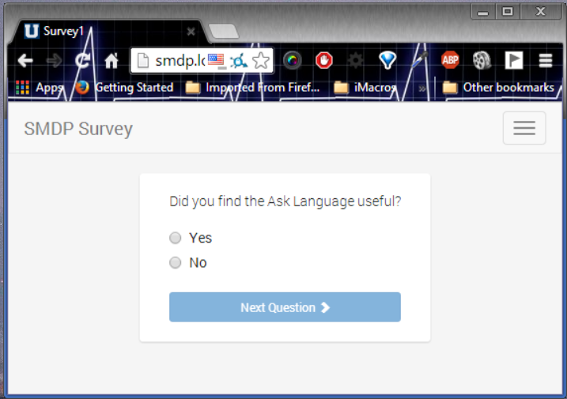

- Rating question:

<form method="POST" action="" id="Q5" class="smdp" autocomplete="off" role="form">
<div class="question_container">
<h3 class="smdp_question">Ask's ease of use:</h3>
</div>
<div class="options_container">
<table class="table table-striped table-bordered table-condensed">
<tr>
<th>(+1) Awful</th>
<th>(+2) </th>
<th>(+3) </th>
<th>(+4) </th>
<th>(+5) </th>
<th>(+6) </th>
<th>(+7) </th>
<th>(+8) </th>
<th>(+9) </th>
<th>(+10) Amazing</th>
</tr>
<tr>
<td>
<label class="radio-inline">
<input type="radio" id="option_1" name="option_Q5" value="1" onclick="return Survey.ratingUpdate(this);">
</label>
</td>
<td>
<label class="radio-inline">
<input type="radio" id="option_2" name="option_Q5" value="2" onclick="return Survey.ratingUpdate(this);">
</label>
</td>
<td>
<label class="radio-inline">
<input type="radio" id="option_3" name="option_Q5" value="3" onclick="return Survey.ratingUpdate(this);">
</label>
</td>
<td>
<label class="radio-inline">
<input type="radio" id="option_4" name="option_Q5" value="4" onclick="return Survey.ratingUpdate(this);">
</label>
</td>
<td>
<label class="radio-inline">
<input type="radio" id="option_5" name="option_Q5" value="5" onclick="return Survey.ratingUpdate(this);">
</label>
</td>
<td>
<label class="radio-inline">
<input type="radio" id="option_6" name="option_Q5" value="6" onclick="return Survey.ratingUpdate(this);">
</label>
</td>
<td>
<label class="radio-inline">
<input type="radio" id="option_7" name="option_Q5" value="7" onclick="return Survey.ratingUpdate(this);">
</label>
</td>
<td>
<label class="radio-inline">
<input type="radio" id="option_8" name="option_Q5" value="8" onclick="return Survey.ratingUpdate(this);">
</label>
</td>
<td>
<label class="radio-inline">
<input type="radio" id="option_9" name="option_Q5" value="9" onclick="return Survey.ratingUpdate(this);">
</label>
</td>
<td>
<label class="radio-inline">
<input type="radio" id="option_10" name="option_Q5" value="10" onclick="return Survey.ratingUpdate(this);">
</label>
</td>
</tr>
</table>
</div>
<button type="button" class="btn btn-primary btn-sm btn-block" name="submitQuestion" onclick="return Survey.saveAnswerData('#Q5', 6);">Next Question <span class="glyphicon glyphicon-chevron-right"></span></button>
</form>

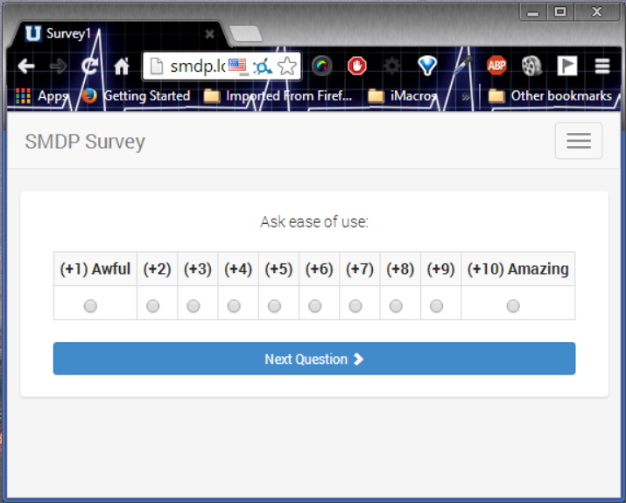

- Ranking question:

<form method="POST" action="" id="Q1" class="smdp" autocomplete="off" role="form">
<div class="question_container">
<h3 class="smdp_question">Favorite Features</h3>
</div>
<div class="options_container">
<div class="form-group">
<label for="ranking_A3" class="col-xs-9 control-label">Code Generation</label>
<div class="col-xs-3">
<input type="number" class="form-control rating" id="ranking_A3" maxlength="2" onkeyup="return Survey.rankingUpdate(this);" data-next="" />
</div>
</div>
<div class="form-group">
<label for="ranking_B3" class="col-xs-9 control-label">Editor</label>
<div class="col-xs-3">
<input type="number" class="form-control rating" id="ranking_B3" maxlength="2" onkeyup="return Survey.rankingUpdate(this);" data-next="" />
</div>
</div>
<div class="form-group">
<label for="ranking_C3" class="col-xs-9 control-label">Forking</label>
<div class="col-xs-3">
<input type="number" class="form-control rating" id="ranking_C3" maxlength="2" onkeyup="return Fork.calculate(this, 'ranking_C3');" data-next="" />
</div>
</div>
</div>
<button type="button" class="btn btn-primary btn-sm btn-block" name="submitQuestion" onclick="return Survey.saveAnswerData('#Q1', 2);">
Next Question <span class="glyphicon glyphicon-chevron-right"></span>
</button>
</form>

<script type="text/javascript">
var Fork = Fork || {};
Fork = (function(){
return {
calculate: function(input, targetid)
{
// Get the field object
var numberField = (typeof input !== 'undefined' ? jQuery(input) : false);

if(numberField !== false)
{
// Actul inout value
var value = numberField.val();
if (Survey.isBetween(value, 1, 3)) {
numberField.attr(Survey.SURVEY_FORK_SEL, 2);
}
numberField.on('keyUp', function() {
return Survey.rankingUpdate(this);
});
}
}
}
})(jQuery);
</script>

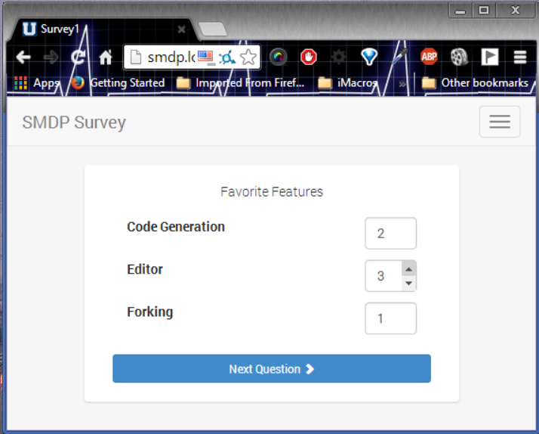

Example browser output for a Rank question:

Forking questions: Depending on the answer to the question one or another series of questions will appear to the user
http://www.berent-online.com, http://www.questionpro.com
http://www.eclipse.org/Xtext/
The template has been reduced to increase readability, the full Ranking question template is in Appendix: Ranking Question template
http://www.junit.org

