Report on Project for Advanced Web Design

As our needs increase day by day, so do the needs for new applications that will allow us to achieve these goals faster and create new ones. For this purpose, we are constantly trying to create new and modern applications that will make our lifestyle easier and simplified. The applications can help us to accomplish a wide range of goals. For example It can help us better serve the customers, improve our productivity, help us with better organization. Following this we can say that the power of the applications is strong and they can have great meaning in our everyday life. The applications can tether to the cloud, physical hardware or both. They can also can also work together. And no matter if they are working in collaboration or individually, they are designed to open the door to data that can be used and acted on in real time. When built and supported effectively, a modern application should not be confusing or frustrating for the user, but should instead make things clear for and engender further use.
The way of developing the modern applications is much easier having in mind that back in the days you had to find a server to run an application, and the app had to be not too big or not too fast. But with the development of technology itself the applications these days will scale up as you need it. You do not need hardware and you do not even need software. You can simply do this, for example with the help of the cloud. When we are building an application we should have few things in mind that might help us with the development and with the improving of the application The most important thing is always to think of the user and of his needs. The form and function of consumer apps should carry over into workforce apps. Next thing is reducing the complexity and to do that, developers must create an app that provides clear context. That comes after anticipating what the user wants to do. Most of the users want to switch devices and expect an app to behave as if it is still open on the initial device. So when we are developing an app we should have in mind that the app should respond and looks the same on any device. Also, the users should be able to interact with the app in whichever manner they prefer, and it should be able to access their data quickly.
When we are creating an app we should all bear in mind that most modern apps require a cell phone signal or Internet connection to get tasks done. By using offline mobile app development, you ensure that users can use your app without having to worry about the presence of a Wi-Fi or cell signal.
Such a difference may seem small, but it can make all the difference. In situations where people want to access information or capture information when they need to, offline apps make it possible to collect and store data on the phone if the user is not connected, get important tasks completed and stored in the field without a connection and many more things. Building this type of apps also have a great predispositions as saving the users battery. Offline apps drain batteries at a slower rate than
apps that are connected on the internet and because there is no need to continually connect to a remote server, offline apps are able to deliver greater speed and performance.
Other great thing about this types of apps is that they are cost-effective as we do not have to use the internet. Users of typical online Web applications are only able to use the applications while they have a connection to the Internet. When they go offline, they can no longer check their e-mail, browse their calendar appointments, or prepare presentations with their online tools. Meanwhile, offline applications provide those features: e-mail clients cache folders locally, calendars store their events locally, presentation packages store their data files locally. Therefore we need a way to create offline application so the client can enjoy this features. Offline-First is a software paradigm where the software must work as well offline as it does online. To implement this, data need to be stored at the client side, so that the application can still access it when the internet goes away. This can be either done with complex caching strategies, or by using an offline first database (like pouchDB) that stores the data inside of an Indexed Database and replicates it from and to the back-end in the background. This makes the local database, not the server, the gateway for all persistent changes in application state.

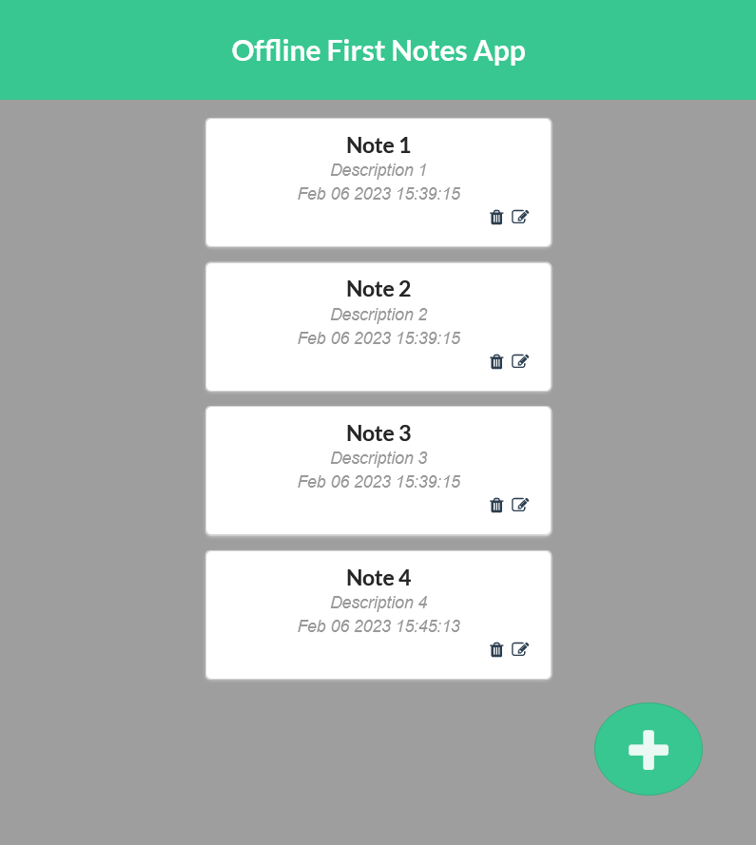
Offline First Notes App is an offline application which is intended to help the users to write notes, save them locally in the browser’s cache and then save them remotely in a database should there be an internet connection available. The app is an offline application that can save a note along with a description and the time it has been written. It utilizes a JavaScript framework Vue3 for it’s capabilities to create and reuse separate components and building web user interfaces.
The notes are JSON objects that are saved in an object known as a store created from the Vue.js library Vuex. It allows us to create, read, update and delete the notes that are currently saved from anywhere in the application.
The application consists of a couple of components. First, we have the “App” component which serves as a container for three different components. The “HeaderPrompt” component that simply displays the title. The “ListNotes” component is a component that displays the saved notes. And the “CreateNote” component is used to create new notes. There is also a button that the users click when they want to add a new note. In order to make a new note, the green button on the bottom-right of the screen is clicked, and this triggers an event that hides the list of notes and opens the “CreateNote” component which is used as an interface to aid the user in creating a new note.

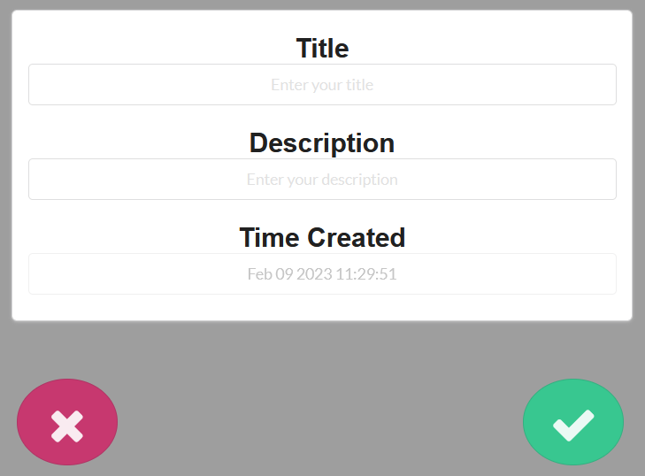
The “CreateNote” component is made from 3 input fields, each accompanied with a label and a placeholder that tell the user what to write in each field. The third field is disabled and it only shows the time the note is created.
Once the note is finished, the user can either save it by clicking the green check-mark button, or erase it by clicking the red cross button. Once a button is clicked, the “CreateNote” component is hidden and the “ListNotes” component is visible once again. If the note is saved, then an object containing the title, description and timestamp is send to the store which then saves it to an indexed database, which saves the note inside the browser’s cache memory and tries to save the note in a database that is accessed remotely. If it fails to do so, it will just try again a bit later.

The “ListNotes” component contains multiple “TextNote” components which represent each note currently saved. Every note can either be edited or deleted. Both actions can be executed by clicking the trashcan or pencil icons respectively and they can be easily noticed by the user considering that the icons are placed at the bottom-right side of each note.

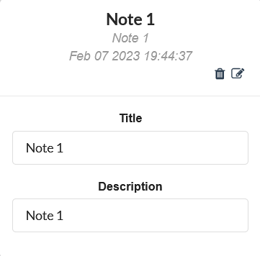
If the user decides that the note needs to be changed then an interface appears that allows the user to change the name and description of the note. Then the note can be saved by click by clicking the green check-mark button at the right bottom part of the screen to save the new values. Also it is very important to be mentioned that the input fields are filled with the original data by default in case the user changes their mind about editing the note.
If the user deletes the note, then the note will be removed from both the local and remote databases.
The local database that is used in this application is called PouchDB, which is an open-source JavaScript database that is designed to run within the browser. It enables applications to store data locally while they are offline, then synchronize it with a remote database such as CouchDB, which is developed by the same company allowing seamless synchronization with PouchDB.

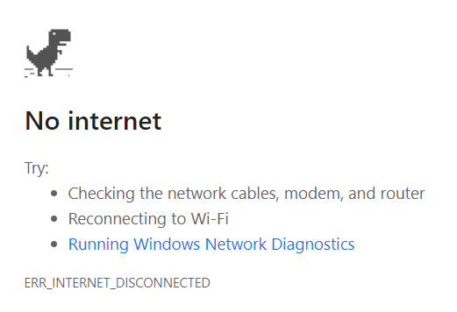
In order to save and load the web-page from cache when the internet connection is weak or almost non-existent, a service worker is used. That’s essentially a JavaScript file that runs separately from the main browser thread, intercepting network requests, caching or retrieving resources from the cache, and delivering push messages. So, instead of getting a “No Internet” error, the web application will continue to work even when there is no internet connection.

As we have already noticed the number of new applications is growing bigger day by day with the use of trending technologies. When you start building a new web application, you are going to undoubtedly notice that there are two primary kinds of web applications – the online and offline ones.
The most obvious and biggest difference between the 2 is that one is the need for consistent internet connection. While online apps can offer a great benefits such as help for saving up space on your computer or the online web app is more likely to be updated as compared to the app that is cached onto our browser, building an offline app can also have a great advantages such as the decreased time-delay when fetching new data from a remote database, as well as general accessibility when there is no internet connection present.
The application is currently hosted on Netlify, a platform used for hosting web sites. It allows the application to be currently accessible to everyone instantly. All it takes is to load it once while online and then it can work completely fine without ever needing internet access again, as long as the browser’s cache isn’t cleared. The Google Chrome application has a built-in feature that allows us to install the web app as an actual native application on our computers and phones. The application initially needs an internet connection in order to load itself, but after that it’s completely internet independent as long as the browser’s cache memory is left intact.

