03/03/2015

Design and Implementation of a Console Game

Name of Game: SNAKE

Team Name: Hell Hound

Team members:

Stefan Stefanov (username: simonspirit)

Adrian Dilov (username: adriannn1)

Mihail Seikov (username: MSeykov)

Ivan Rusev (username: IvanR90)

Vanya Karaasenova (username: VanyaD)

Petur Kokalov (username: Pehata)

Vasil Stilianov (username: shtilyanov)

# **Summary**

The purpose of this team project is to design and implement the console game “Snake” by adding to its basic features some additional elements and improvements.

As listed in the project requirements, the source code of our game contains the following components:

* 10 methods – WriteAt, SinglePlayer, Multiplayer, GenerateSnake, SnakeNewHead, NextDirection, PrintHead, PrintSnake, GoingThroughWalls, Directions()
* 1 use of external text file – to keep players score
* 1 multi-dimensional array – to hold the count of apples eaten by the snake
* 3 existing .NET classes
* 3 one-dimensional arrays
* 2 exception handlings

# **Improvements and additional features added**

* New Levels
* New obstacles
* Multiplayer mode

# **Screenshots**

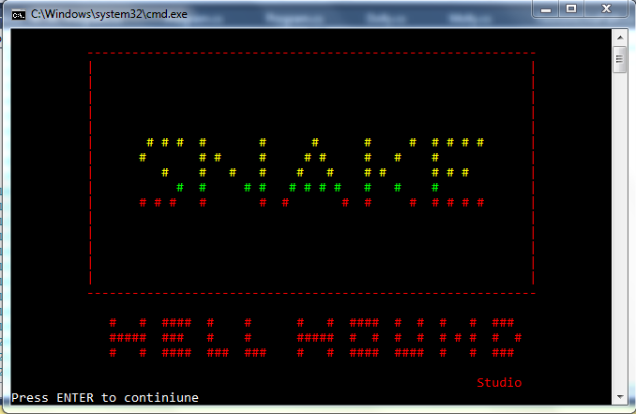

Figure 1 - Home Page

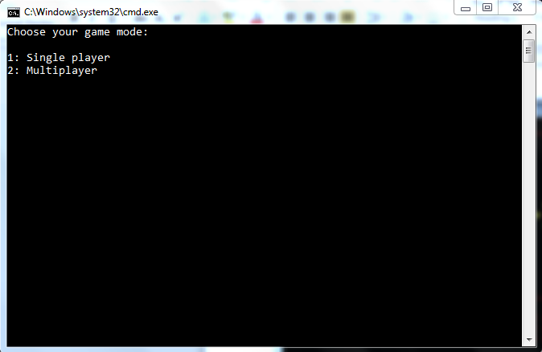

Figure 2 - Mode Menu

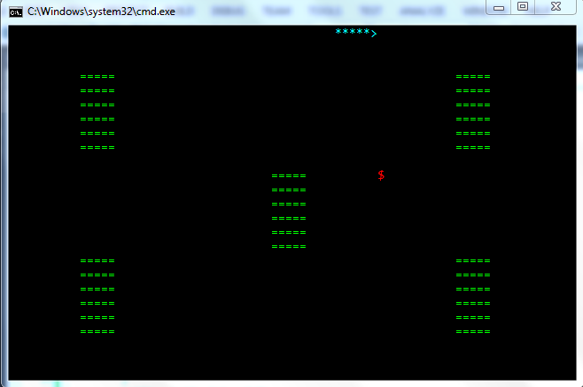

Figure 3 – Obstacles

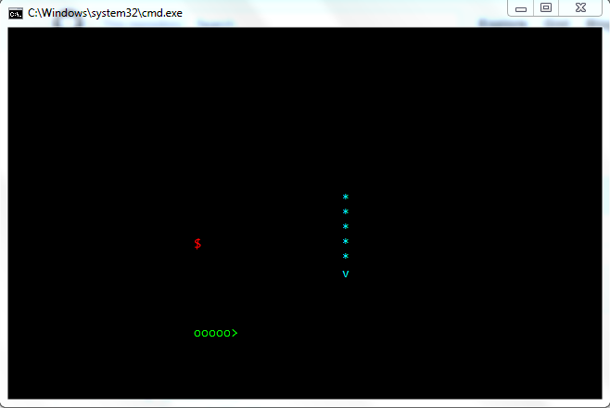

Figure 4 - Multiplayer Mode

# **Link to GitHub:**

To ease the project communication between team members, the GitHub Source Control system has been used. The shared project repository can be found on the following link:

<https://github.com/MihailSeykov/Team-Work-CSharp--2>