**Template version: 1.0**

[[doc-title]]

[[doc-subtitle]]

[[doc-type]]

**[[doc-company]]**

**[[doc-company-url]]**

**Document Number: [[doc-id]]**

**Version: [[doc-version]]**

**Release Date: [[release-date]]**

Document History

Author Name: [[doc-author]]

Author Contact: [[doc-author-email]]

Document Revision

|  |  |  |  |  |
| --- | --- | --- | --- | --- |
| Version Number | Release Date | Status | Change Description | Author |
| [[doc-version]] | [[doc-release-date]] | Draft | [[change-description]] | [[doc-author-name]] |
|  |  |  |  |  |
|  |  |  |  |  |
|  |  |  |  |  |

Intellectual Property Rights

This document is exclusive property of [[doc-company]] and all rights are reserved.

Table of Contents

Introduction 1

References 1

[puzzles-cloud
1](#_Toc16256477827688099439187799)

[mnogo je dobro
1](#_Toc16256477828277837237299038)

[UML diagrams
1](#_Toc162564778288594334292350)

[Sequence Diagram
1](#_Toc16256477829508597611088481)

[Use Case Diagram
1](#_Toc16256477830198769797337925)

[Class Diagram
1](#_Toc16256477830745974446582462)

[Activity Diagram
1](#_Toc16256477831279818135593703)

[Component Diagram
1](#_Toc16256477831829524366034312)

[State Diagram
1](#_Toc16256477832323914347048748)

[Object Diagram
1](#_Toc16256477832869255051438832)

[Deployment diagram
1](#_Toc16256477833353408775182010)

[Timing Diagram
1](#_Toc16256477833812344357825174)

Table of Tables

Table 1: Document references 1

# Introduction

## References

Referenced documents in creation of this document are listed in the Table 1.

|  |  |  |  |
| --- | --- | --- | --- |
| Document Reference | Document Title | Version | Filename |
| [1] | [[ reference-doc-title ]] |  | [[ reference-doc-filename ]] |
| [2] |  |  |  |
| [3] |  |  |  |
| [4] |  |  |  |
| [5] |  |  |  |
| [6] |  |  |  |
| [7] |  |  |  |
| [8] |  |  |  |

Table 1: Document references

# puzzles-cloud

## mnogo je dobro

# UML diagrams

## Sequence Diagram

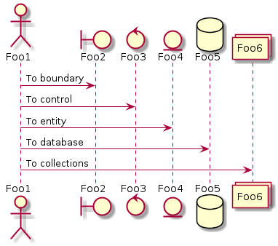

## Use Case Diagram

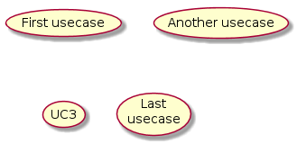

## Class Diagram

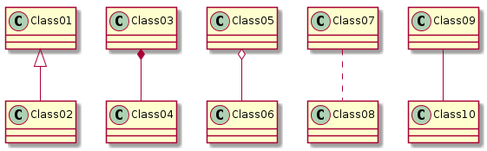

## Activity Diagram

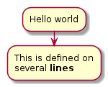

## Component Diagram

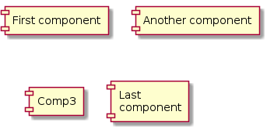

## State Diagram

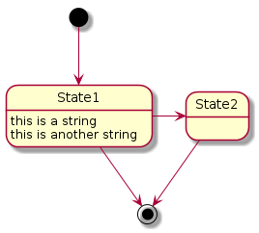

## Object Diagram



## Deployment diagram

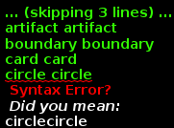

## Timing Diagram

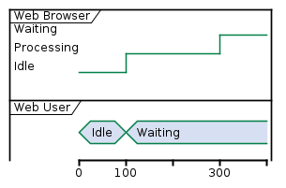



Figure 1: Last Page