**Hello World Template version: 1.0**

[[doc-title]]

[[doc-type]]

**Version: [[doc-version]]**

**Release Date: [[doc-release-date]]**

# UML diagrams

## Sequence Diagram

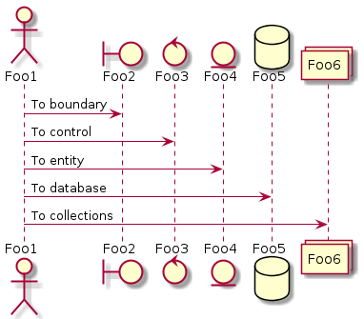

## Use Case Diagram

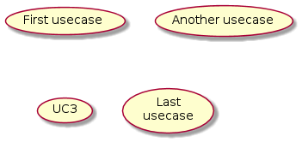

## Class Diagram

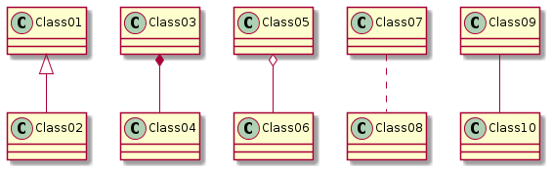

## Activity Diagram

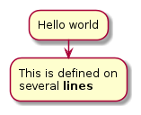

## Component Diagram

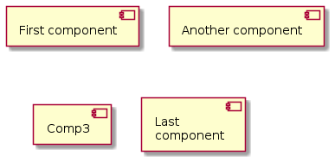

## State Diagram

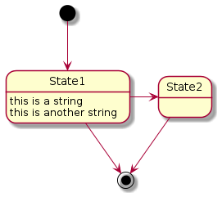

## Object Diagram



## Deployment diagram

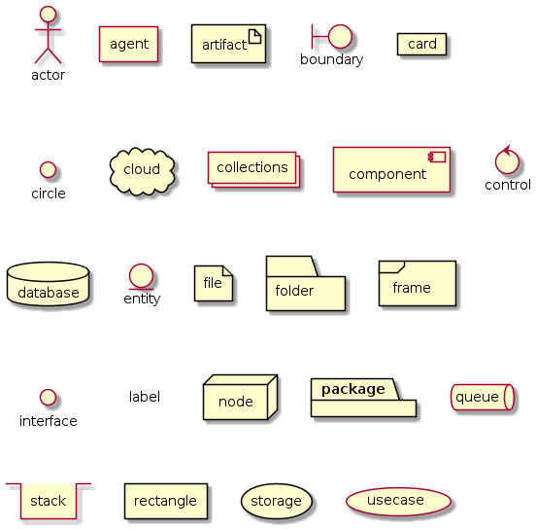

## Timing Diagram

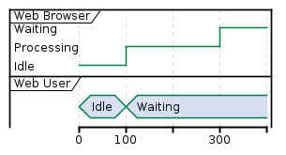

# puzzles-cloud

