XBRL UK GAAP Taxonomy Design
Public Working Draft, dated 15 May 2008
Copyright © 2008, XBRL UK Ltd, All Rights Reserved
Authors
Name | Contact | Affiliation
Peter Calvert | pscalvert@googlemail.com | Calvert Consulting Ltd

Contributors
Name | Contact | Affiliation
Neil Griffiths | neg@decisionsoft.com | DecisionSoft Ltd

Abstract
This document describes the design of the XBRL UK GAAP taxonomy, focussing on key features and the critical design choices underlying them. It will help reviewers, users and implementers to understand the taxonomy, provide informed feedback on it and use it efficiently.

Status
This is a Public Working Draft which is published on the XBRL UK Ltd website. It is open to revision in the light of comments from the public, including reviewers and prospective XBRL users and implementers. Circulation of the document is not restricted.

Comments on the document and taxonomy are welcome and should be directed to uktech@xbrl.org.

TABLE OF CONTENTS
1. Introduction 1
2. Goals and principles of taxonomy design 2
3. Method of taxonomy construction 3
4. Taxonomy components and features 3
5. Taxonomy elements and contexts 4
5.1 Definition of elements 4
5.2 Identification of elements 5
5.3 Use of contexts 5
6. Label Linkbase 6
6.1 Use of labels 6
6.2 Special labels 6
6.3 Documentation 7
6.4 Positive and negative indicators in labels 7
7. Reference Linkbase 7
8. Presentation Linkbase 8
8.1 General Presentation Linkbase features 8
8.2 Extended links 9
8.3 Presentation Linkbase examples 10
9. Calculation Linkbase 12
10. Definition Linkbase 13
11. Dimensions 13
12. Tuples 15
12.1 General use 15
12.2 Use cases 15
12.3 Tuples and dimensions 17
13. Handling of text 17
14. Data types and abstract elements 19
14.1 Use of data types 19
14.2 Use of abstract elements 20
15. Modularity 20
15.1 General structure 20
15.2 Future structure 22
15.3 Taxonomy size 22
16. Common Data Taxonomy 22
17. Taxonomy extension 23
17.1 General principles 23
17.2 Sector and industry extensions 23
17.3 Company extensions 24
18. Taxonomy implementation and use 25
18.1 Introduction 25
18.2 Availability and updating 25
18.3 Rendering 25
18.4 Requirements, feedback and quality 26
APPENDICES 27
A. Glossary 27
B. References 27
C. Document History 28
D. Intellectual Property Status 28

1. Introduction

The document explains the main features of the XBRL UK GAAP taxonomy and the design choices underlying them. It is intended to:
- Provide a formal record of those design choices, enabling discussion, comparison of alternatives and decisions on optimal design.
- Help taxonomy reviewers, prospective users and implementers to understand the taxonomy, provide informed feedback on it and use it efficiently.

The document assumes general knowledge of XBRL goals, features and technology. It is not intended as a basic primer on how XBRL works. However, it does not assume deep technical knowledge and its intended audience includes business users. Its targets include accountants who are reviewing the content of the taxonomy and accounting software vendors who are planning to implement XBRL in their products. The Glossary provides explanations of some terms and the References section points to sources of further information on XBRL.

This version of the document focusses on the taxonomy formally dated 2008-01-15, available on the XBRL UK website at http://www.xbrl.org/uk/Taxonomies/.

It is part of a suite of documents on the taxonomy and related information, which include:
- Scope. Intended accounting coverage of the taxonomy.
- Design. This document, covering basic features and design. It is the core document to understanding the design of the taxonomy.
- Dimensions. Detailed description of the use of XBRL dimensions in the UK GAAP taxonomy. This is a subsidiary document to Design, offering more detail and analysis.
- Style Guide. This defines various rules and conventions followed in the taxonomy, particularly, for example, for the construction of labels. The guide is important to the internal consistency of the taxonomy. It is relevant to reviewers and essential to anyone doing any work on the taxonomy itself.
- Common Data Taxonomy. Description of the Common Data taxonomy, which covers standard information typically used in business reporting, such as organisation name, address, activity, legal form and the like. The Common Data taxonomy will be used in conjunction with the UK GAAP and other UK taxonomies.
- Instance Samples. These files showing reports or fragments of reports in XBRL, including annotations where appropriate, illustrate the use of the taxonomy.

All these documents or files are published on the XBRL UK website, www.xbrl.org/uk/. Other documents explaining detailed features of the taxonomy may be added in due course. The UK website also includes links to useful documents published on other sites, particularly XBRL International, which explain XBRL or taxonomy design.

It will be clear from this list of documents that this Design document does not attempt to cover all features of the taxonomy and the reasons for them in exhaustive detail. That would require far too large and unwieldy a document. It does however attempt to cover all critical design choices at a reasonably high level, leaving further analysis to subsidiary documents, where necessary.

When this document refers to the UK GAAP taxonomy, it means the full set of XBRL files comprising the taxonomy, unless otherwise stated.

2. Goals and principles of taxonomy design

The chief goals of the UK GAAP taxonomy are to:
- Represent comprehensively, consistently and accurately the financial data used by UK organisations filing reports under GAAP.
- Be efficient and easy for organisations to use when filing GAAP financial reports in XBRL.
- Be efficient and easy for software vendors to implement in software designed to support GAAP reporting.

These goals introduce conflicting requirements. For example, the aim to be comprehensive and accurate may clash with targets for ease of use and ease of implementation. The design of the taxonomy thus reflects a balance of choices aimed at satisfying these goals.

The following factors, in particular, have influenced the taxonomy design:
- Technical guidelines. The taxonomy should comply with the Financial Reporting Taxonomy Architecture, FRTA, guidelines published by XBRL International. The current version does comply with these guidelines with the exception of minor issues concerned with dimensional taxonomies, which require updates to FRTA itself. Clearly, the taxonomy must also be valid according to XBRL International specifications.
- Taxonomy design practice around the world. The taxonomy is broadly consistent with approaches to design adopted for other major taxonomies. Considerable effort has been devoted to reviewing these taxonomies and contributing to international discussion on taxonomy design. However, it should be noted that views on best practice are evolving and that there is no consensus on some key questions. Certain design decisions thus represent a best judgement between differing views on taxonomy design. These are discussed in more detail in relevant sections of this document.
- Feedback. Feedback from reviewers, users and implementers has been and will be crucial to determining taxonomy content and design. The UK GAAP taxonomy has evolved through a number of versions in response to this feedback, particularly from accounting reviewers. It has been used to create a broad range of test reports in XBRL representing real company data and is also the basis for reporting by audit exempt companies to Companies House, the first major live implementation of XBRL in the UK. (This reporting uses an extension to UK GAAP which adds various presentational and calculation features designed specifically for audit exempt companies.)
Feedback from implementers adopting the full UK taxonomy on a large scale is particularly important to the content and technical design of the taxonomy. Ultimately, the taxonomy can only be as good as the input received from testing and use. Feedback must be as broad since requirements from dissimilar types of user may differ and even conflict. Design decisions will have to reflect these potentially varying requirements. Requirements or assumed requirements from differing sets of users are discussed in more detail in section 18.4.

The content of the UK GAAP taxonomy may not cover all the reporting requirements of all organisations using GAAP. Currently, the taxonomy only covers reporting by typical commercial and industrial organisations. Reporting by financial institutions, non-profit organisations and other specialised entities may require the use of taxonomy extensions. These extensions, which will be developed over time in response to requirements, will be part of the UK GAAP family and help meet the goal of comprehensive coverage. (Clearly, the UK GAAP taxonomy is not intended to cover reporting under IFRS standards by listed companies. That will be a function of a UK extension to the IFRS taxonomy.)

Even with a full family of UK GAAP taxonomies, however, it is expected that some organisations will need to create their own taxonomy extensions to cover some organisation-specific data. This is in line with the design and intentions of XBRL. It is not practical for a national GAAP taxonomy to cover every possible reporting requirement which may be defined by any organisation. The design and scope of extensions are discussed in section 17 of this document.

The separate Scope document describes the current scope of the UK GAAP taxonomy in further detail.

3. Method of taxonomy construction

The UK GAAP taxonomy’s content and design is primarily based on the following sources:
- Model financial statements from accounting firms.
- Checklists for GAAP reporting.
- Financial statements from various companies.
- Input from reviewers on desirable content.
- Checks against accounting regulations, in so far as these provide direct guidance on line items to be included in statements.

It is thus built to cover real examples of reporting, rather than being built directly from accounting regulations themselves.

Effectively, it represents a common-denominator view across the sources listed above. Its content and data structures are designed to encompass all the types and styles of reporting represented in the models, checklists and sample accounts. Its basic coverage is thus far broader than would be found in any individual company statement, even if it does not cover some company-specific line items.

4. Taxonomy components and features

The chief components and features in the UK GAAP taxonomy are standard ones found in other comparable, major taxonomies. Components are:

Schema file | Basic definition of elements in the taxonomy. Defines element names, element features, such as type and period type, and the content of tuple elements.
Label Linkbase | Defines the human readable labels used for taxonomy elements.
Presentation Linkbase | Arranges the elements in a taxonomy in a hierarchy (or sets of hierarchies) which should be recognisable to human users. Intended to help human understanding and use of the taxonomy.
Calculation Linkbase | Defines the summation relationships which may exist between elements in a taxonomy. Can only represent simple summation relationships between elements with the same context. Provides assistance in checking the validity of instance documents.
Definition Linkbase | Principally used in defining XBRL dimensions, but may also be used for defining other detailed relationships.
Reference Linkbase | Defines the accounting references which relate to individual elements. Helps to identify individual elements.

Principal features used in the taxonomy include:

Data type | Defines the nature of the element. Chief types include string, monetary, decimal, date, boolean. Distinction by type enables correct entering of data in instance documents and automated validation by software.
Period type | Defines whether an item is measured at an instant (a stock) or over a period (a flow). Required to support correct entry of data, calculations and automated validation by software.
Balance type | Defines whether an item is a credit or a debit. Used, in combination with other information, to ensure the correct positive or negative sign is entered against items in an instance document.
Extended links | Used to partition data in linkbases to avoid illegal cycles, aid creation of linkbase hierarchies and improve clarity.
Abstract element | Used, typically as headings, to aid organisation of data in linkbase hierarchies. Abstract items cannot appear in instance documents.
Tuple element | Used to group and identify elements which may be used repetitively in an instance document.

It is not the purpose of this document to describe in detail these components, features and other technical aspects of XBRL. Readers should refer to the XBRL Specification for this information. This document concentrates on UK GAAP taxonomy design decisions related to these components and features.

5. Taxonomy elements and contexts

5.1 Definition of elements

In general, a single element is required in the taxonomy to represent each accounting concept which may appear as a line item in a financial report. This principle applies whether the concept takes the form of a monetary or numerical value or a textual statement. However, there are a number of important comments and qualifications on the principle.
- A single element or concept may take multiple values in a financial report if it has a different context, such as period, in each case. The occurrence of single concept in different contexts should not be confused as a requirement for multiple elements. Contexts are discussed in more detail section 5.3.
- The use of dimensions, a special case of context, limits the required number of elements in the taxonomy. Effectively, dimensions represent the different forms in which a single element may appear. For example, values for continuing and for discontinued operations are represented by different dimensions of an element.
- Tuple elements are used to organise and identify groupings of elements which may be repeated in an instance document. For example, the concept of director salary may be repeated for each director in the company. The use of tuples, rather than a separate element for each possible repetition of a concept, significantly reduces the number of elements required in a taxonomy.

Dimensions are covered in section 11 and tuples in section 12 of this document.

5.2 Identification of elements

Each element is represented by a unique element name in the taxonomy schema file.

Individual elements are identified and distinguished for human users in a number of ways:
- Label. Each standard label in the UK taxonomy is unique and is intended to provide a clear description of the accounting concept concerned. The label alone, even if viewed in isolation, should be sufficient to identify most elements clearly to users. In some cases, a subsidiary documentation field provides additional information on an element to users.
- Presentation and Calculation Linkbases. The position of an element in the Presentation and Calculation Linkbases should indicate the meaning of an element clearly to users, even if the label content leaves some uncertainty.
- Accounting references. The accounting references, which identify the official source for the accounting concept, will also help to confirm meaning.

Later sections of this document cover the use of label, presentation and other linkbases in more detail.

5.3 Use of contexts

The UK GAAP taxonomy follows XBRL practice in expecting contexts to be used to distinguish between different “flavours” in the way an element may be used. In particular, contexts are used to distinguish the following:

Period | Context identifies the time or period to which a particular business fact applies.
Entity | Context identifies the entity to which a particular business fact applies.
Segment and Scenario | Context identifies:  - The forms of reporting which may apply to an individual fact. For example, the UK GAAP taxonomy uses context, in the form of dimensions, to distinguish between continuing and discontinued operations.  - The business segments for which a fact may be reported. For example, the UK GAAP taxonomy uses contexts, in the form of dimensions, to identify facts related to particular subsidiaries and business segments.  - The different scenarios for a business fact. Potential examples include forecast, actual, restated and the like. The UK GAAP taxonomy uses contexts to distinguish between original and restated values.

Different elements are therefore not required, for example, to distinguish between operating profit reported at the individual entity or consolidated level. Similarly, the same element is used for turnover whether it is reported by a company, subsidiary, business division or geographical segment or whether it is forecast or actual.

Dimensions provide a means of ensuring that standard, comparable contexts are used for each standard aspect of reporting, including typical entity breakdowns, segments and scenarios.

The XBRL Specification permits two forms of business context: segment and scenario. The UK GAAP taxonomy uses only segment context since there is no practical benefit in using both forms.

6. Label Linkbase

6.1 Use of labels

The Standard Label in the UK GAAP taxonomy is intended to provide a clear and unambiguous description of each element, enabling human users to identify the element accurately and distinguish it from others. Each Standard Label is unique.

In practice, given the need to limit labels to an easily usable length and the variety of terminology used in UK financial reporting, it is not possible for all labels to be immediately and unambiguously identifiable when seen in isolation. However, the combination of Standard Label and the position of the item in the Presentation Linkbase should in general be sufficient to identify any item clearly and accurately. The accounting reference will then provide confirmation to any user that the coverage of the item is as expected and required.

A key test of the usability of the taxonomy lies in the ability of different users to locate items which they require via labels and presentation views. (Inevitably, searches for obscure items which do not have a standard position in financial reports may take some effort and users may also need to accustom themselves to the presentational styles used in the taxonomy in order to search efficiently.)

XBRL offers a wide range of other label types (terse, verbose, definition guidance, disclosure guidance etc.), but these are in general NOT used in the UK taxonomy. They have been found to be unnecessary in practice and potentially clumsy to use. The taxonomy is not seen at this stage as an appropriate means of providing guidance on required disclosure. That is the role of checklists and other material.

Standard Labels may sometimes be longer than the labels which organisations typically use in published reports, where position can always be relied on to provide meaning. For example, the taxonomy label ‘Tax on profit or loss on ordinary activities’ might simply be represented by the word ‘tax’ in a real company income statement. The Standard Label may also not accord with the exact terminology preferred by a particular company. For these and other reasons, organisations may well use labelling in a human-readable rendering of an XBRL report which differs from that in the taxonomy.

The language of the UK GAAP taxonomy is English and labels are only provided in English.

The Style Guide sets outs the rules and conventions followed in the construction of labels.

6.2 Special labels

The only special label types used in the taxonomy are listed below, aside from Documentation which is described in the next sub-section.

Period End / Start | Used for elements which may represent a value at both the beginning and the end of a period. Helpful for the clarity of the Presentation Linkbase and may be used in rendering.
Verbose | Used for a very small number of elements whose meaning can be described by alternative and very distinct terminology. The Verbose Label contains both versions of the terminology, when it is impractical for reasons of length to include both in the Standard Label.

6.3 Documentation

The Documentation Label enables the provision of important supplementary information about an element. Typically, Documentation will clarify meaning and the correct use of an element.

The field is used in the UK taxonomy to provide a variety of information. It indicates which dimensions may operate on an element. It identifies elements used for heading or grouping information and also contains comments which help distinguish closely similar or related elements.

Users and implementers may thus find the Documentation Label provides importance guidance. It is desirable that XBRL software implementations should make the information in the Documentation Label easily visible or accessible to users.

6.4 Positive and negative indicators in labels

Conventions in labels are used to indicate whether a positive or negative sign should be used for element values. Correct use of positive and negative signs in instance documents is obviously essential for accurate and consistent representation of data.

The UK GAAP taxonomy provides a number of indicators to help a user decide on the correct sign for data, including debit / credit attributes, calculation weights and calculation hierarchies. These are discussed in the section on the Calculation Linkbase.

The most important indicator, however, is the Standard Label itself. This uses brackets around terms to show which data should be entered as negative in an instance document. For example:
Profit (loss) on ordinary activities before tax: Shows that a profit should be entered as positive and a loss as negative.
Exchange gain (loss) on foreign borrowings: Gain positive and loss negative.
Increase (decrease) in creditors: Increase positive and decrease negative.
Decrease (increase) in provisions: Decrease positive and increase negative.
Cash surplus (deficit) from difference between pension charge and cash contribution: Surplus is positive and deficit negative.
Cash flow (outflow) arising from restructuring: Inflow is positive and outflow is negative.
Net debt (funds): A debt figure should be entered as positive and a funds figure as negative.

The default for all entries, if no sign is indicated, is positive. Provided users follow the sign convention in Standard Labels, data entry in XBRL instances, databases and financial reports should be consistent and correct.

7. Reference Linkbase

The Reference Linkbase provides references to the sections in official accounting literature on which individual taxonomy elements are based. Reference Linkbase entries identify the publication concerned, together with schedule, section, paragraph, sub-paragraph and similar information which indicates the specific reference. Note that they do NOT contain the text of the reference itself; nor do they contain a hyperlink to any online resource.

Chief references used in the UK taxonomy are:

Companies Act | Year, schedule, part, paragraph and sub-para.
Financial Reporting Standards (FRS) | Number, para.
Statements of Standard Accounting Practice (SSAP) | Number, para, sub-para

The Style Guide document gives more information on the references used and their abbreviations in the UK taxonomy.

References are an important source of authority for the taxonomy and will sometimes help taxonomy users to confirm, if necessary, the meaning of an element. However, their practical use in distinguishing some elements may be limited. Many similar elements are derived from the same paragraph or sub-paragraph in the accounting literature, so carry identical references. Not all elements have specific accounting references; many are included on the basis that they are typically used in reporting. These are identified only by a Common Practice reference. Other items may only have high-level references available (i.e. not to the level of a specific paragraph), which limits the value of the reference in distinguishing information.

8. Presentation Linkbase

8.1 General Presentation Linkbase features

The Presentation Linkbase enables the arrangement of elements in hierarchies in order to help users understand the taxonomy and identify elements easily and efficiently.

The presentation view in the UK taxonomy shows elements arranged broadly as they would be in a model financial statement. The view shows primary statements (balance sheet etc.), notes to the primary statements and standard reports (directors’ report, auditor’s report etc.).

The view is designed for display on screen and is intended to appear similar to standard screen displays of files, such as the folder displays in ‘My Computer’ in Windows. Major accounting items or collections of items thus appear at high levels in the hierarchy, with less important or component items opening below them. Clearly, this is opposite to the typical view in printed financial statements, which may put major items, such as totals, at the bottom of statements or notes, but experience has shown that this ‘reverse ordering’ does not cause significant problems to users. It provides by far the most effective means of displaying such accounting items on screen.

The Presentation Linkbase includes all elements in the taxonomy which represent accounting concepts so it potentially may display far more elements than would appear in a typical company statement. (This emphasises the requirement for reverse ordering, so that users can focus on important items before selecting more detailed branches of the hierarchy.)

In arranging items in statements, notes and reports, the Presentation Linkbase provides a common denominator view which is not likely exactly to match any individual company statement, since these vary widely in the presentation and ordering of data. However, the view should be easily recognised and used by those familiar with the typical formatting of financial statements under UK GAAP.

The presentation view includes a limited number of alternative formats, such as the main statutory formats for the Income Statement and the Balance Sheet. A small number of elements which may frequently appear in alternative locations are shown in both locations. In general, however, the Presentation Linkbase avoids alternatives and duplications, focussing instead on providing a single coherent and consistent view of data. Experience so far has shown that this is less confusing to users than presenting multiple, slightly varying formats.

It is important to note that the Presentation Linkbase is NOT primarily intended as a basis for human readable rendering of XBRL instance documents. Its aim is to enable efficient viewing of the content of a taxonomy and easy identification of elements among a large volume of data. Rendering of instances is discussed later in this document.

The presentation hierarchy includes some items used purely as headings and for grouping purposes. These elements, required only to help create efficient displays of data, are designated as ‘Abstract’ and cannot appear in instance documents or take values.

The only elements in the taxonomy which are not included in the Presentation Linkbase are those which are used purely to define dimensions. They are shown in the Definition Linkbase, described in section 10.

The Presentation Linkbase examples in section 8.3 show a number of screen shots of sections of the linkbase.

It is theoretically possible to provide multiple Presentation Linkbases with the UK GAAP taxonomy to present alternative views of the data which might suit different types of user. Currently, however, we only plan to provide one single comprehensive Presentation Linkbase with the core taxonomy. Other Presentation Linkbases will only be provided as part of extension taxonomies dedicated to specific areas, such as non-profit organisations. This is discussed further in Modularity, section 15.

8.2 Extended links

Extended Links are used to group elements within linkbases, effectively partitioning linkbases into sections. They are used in XBRL for technical reasons. Without them, it would be difficult to avoid creating technically illegal cycles of links in large linkbases. They help to organise groups of elements into coherent sections, while avoiding technical clashes. They are used in the Presentation, Calculation and Definition Linkbases in the UK taxonomy.

In the Presentation Linkbase, a separate Extended Link is used for each main statement and report and for the whole notes section. Non-technical users of the taxonomy should simply consider Extended Links in the Presentation Linkbase as main section headings. They have no direct relevance to the creation of instances.

A problem with Extended Links is that XBRL provides no means of ordering them. Their ordering in the Presentation Linkbase is thus application dependent. This is unfortunate, since the ordering of statements, reports and notes may therefore not appear as intended to many users. The Extended Links are ordered correctly in the main taxonomy editing application used to create the UK taxonomy, as examples below will show, but there is no guarantee they will appear in this order in other applications.

8.3 Presentation Linkbase examples

Fig 1. A presentation view of the main part of the Cash Flow Statement.

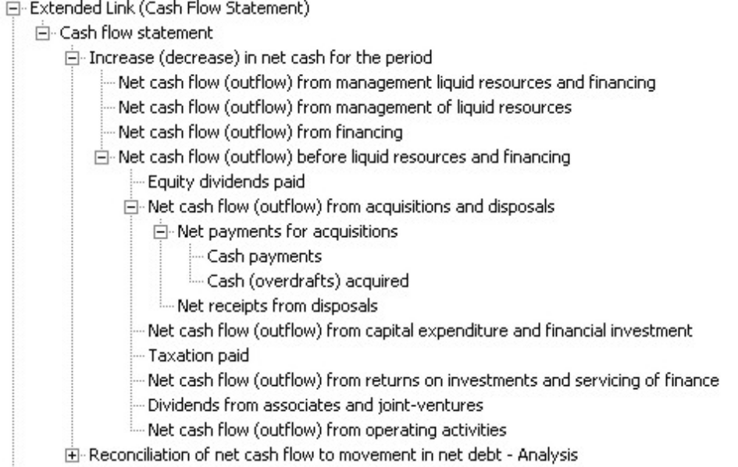

Fig 2. A view of the Balance Sheet under Format 1. The + signs in front of items show that they can be opened to show further elements which are components of the item concerned.

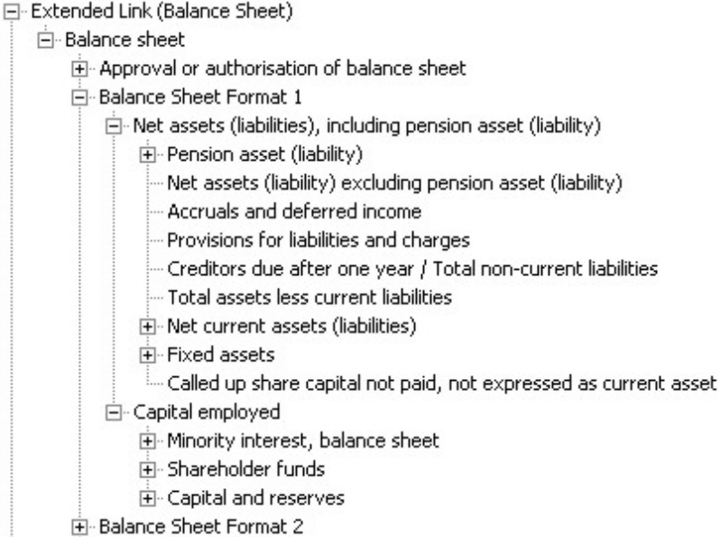

Fig 3. The top-level list of Notes provided in the UK GAAP taxonomy. Most of these Notes contain large numbers of sub-sections and a considerable number of elements.

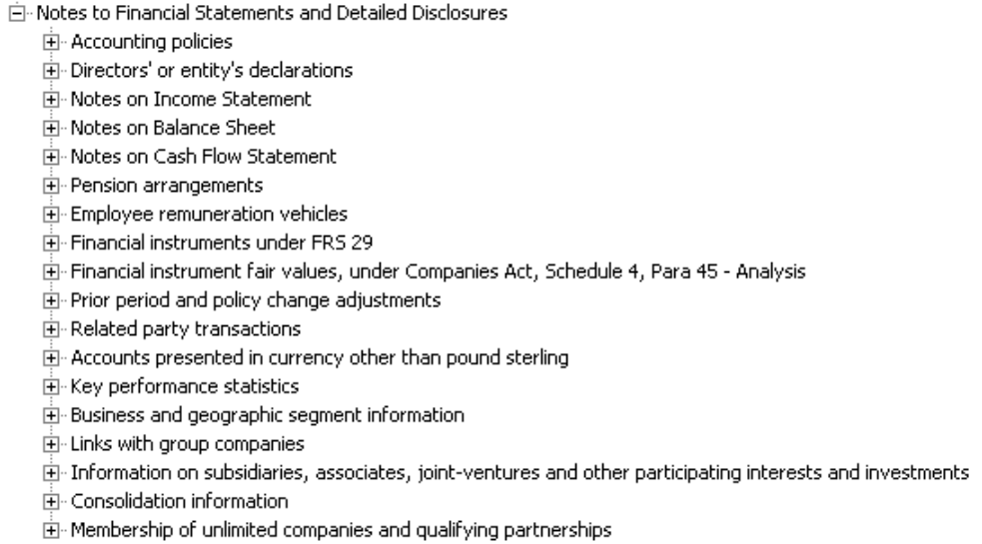

Fig 4. The second-level headings under Notes on Income:

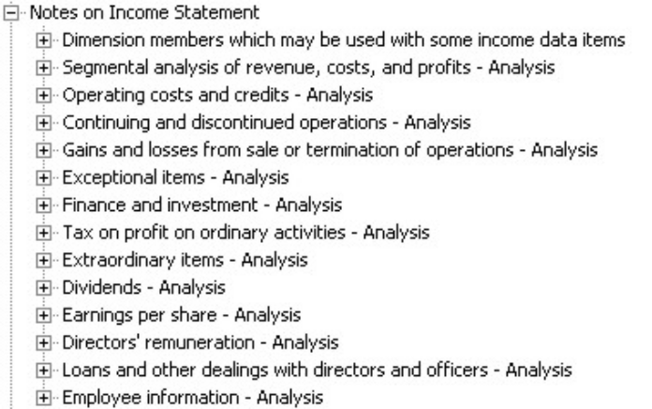

Fig 5. The full set of Extended Links or sections in the UK GAAP taxonomy presentation view: This is the top level of the presentation view.

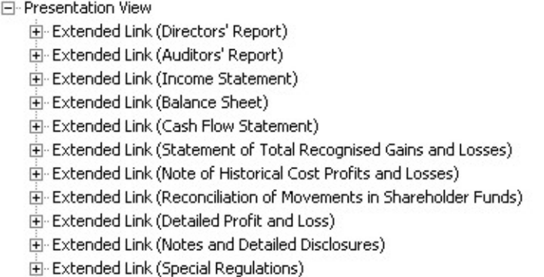

9. Calculation Linkbase

The Calculation Linkbase enables the representation of summation relations between elements. However, its capabilities are limited.
- It cannot handle calculations across contexts. For example, calculations across periods (as in movement analyses) or across entities (such as operating units) cannot be shown.
- It cannot represent calculations across dimensions or tuples. This rules out the use of calculations links between large ranges of facts in business reports.
- It is not flexible in coping with intermediate sub-totals. For example, if a taxonomy contains two calculations, A=B+C and C=D+E, but a company does not use the sub-total C in its statement and simply reports A=B+D+E, this will cause an XBRL calculation error in the instance document to be reported. A taxonomy may contain alternative calculations to deal with intermediate sub-totals, putting them in different extended links or files. However, there are a plethora of subtotals and alternative calculation pathways in UK GAAP statements, and it is not practical to cover more than a core subset in the UK taxonomy.

Despite these issues, a Calculation Linkbase is included with the UK taxonomy. This represents a range of basic summations, including standard calculations for the primary statements and a large number of calculations for common sub-totals.

Its chief purposes are to:
- Aid the correct creation of instance documents. Calculation hierarchies help to confirm the identity and use of elements. Calculation breaks or errors may help identify instance document errors.
- Provide a basis which companies can extend, if they wish, to provide a fuller representation of the calculations underlying their statement.

It is important, however, that users understand that the Calculation Linkbase is a limited representation of the possible calculations which may underlie a financial statement. It is unlikely that the calculations represented in the taxonomy will fully match the requirements of any individual company.

Users should therefore see the Calculation Linkbase as an aid but not a certain guide. When the taxonomy is modularised, as described in section 15, we will put the linkbase in a separate optional file, so that instance creators or implementers may use it as they wish, but not reference it from their final instance documents. It will not then raise any calculation errors which may confuse consumers of instances.

The use of the linkbase can help verify that values are entered in their correct positive or negative form. Credit and debit attributes on elements, combined with weight attributes set in the Calculation Linkbase, enable correct handling of positive and negative values.

Like the Presentation Linkbase, the Calculation Linkbase contains separate extended links which partition calculations, enabling the same elements to participate in different calculations without creating illegal cycles.

The following example shows a section of the calculation hierarchy for the main Income Statement. Opening the + sign against an element would show the calculations between its various component items. The (1), (-1) symbols indicate the weight – in other words, whether the link represents an addition or a subtraction.

Fig 6. Section of the Calculation Linkbase showing part of the calculations for the Income Statement.

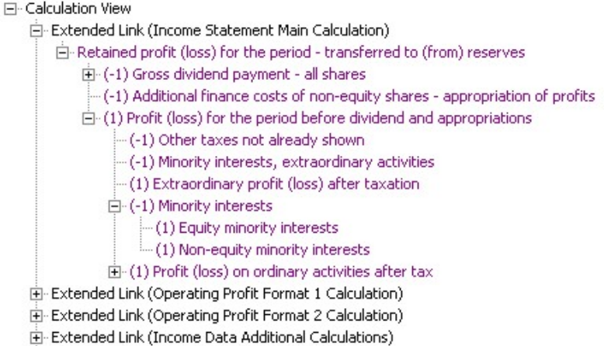

10. Definition Linkbase

The Definition Linkbase is capable of representing a range of different types of relationships between elements, although a chief use is the definition of dimensions, described in the next section.

Aside from dimensions, the linkbase is used in the UK taxonomy only to define Essence-alias links. These link elements which are identical but which for technical or accounting reasons need to be defined as separate elements. A very small number of essence-alias links occur in the taxonomy. Clearly, linked pairs of elements must take identical values in instance documents.

11. Dimensions

Dimensions are used in the UK GAAP taxonomy to represent the different forms in which an accounting concept may be reported.

For example, ‘profit (loss) on ordinary activities before tax’ may be reported for the consolidated entity, the group, subsidiaries, joint-ventures, associates and various combinations of these; for continuing, discontinued or acquired operations; for individual business or geographic segments and even for individual joint-ventures or associates in certain cases. It may be reported before or after exceptional items as well as before or after various forms of amortisation and/or impairment of goodwill and/or intangible assets (and so forth). Many other concepts may also be reported in a similar variety of forms.

Representing all of these possible forms of concepts by individual taxonomy elements is not practical. It would lead to a hopelessly large and clumsy taxonomy.

Instead, XBRL allows a ‘dimension’ to be defined for each of the typical forms in which an element may be reported. The combination of elements and dimensions then enables a wide range of data to be flexibly and efficiently represented by taxonomies of manageable size.

Technically, contexts are used to represent the various forms in which an element may be reported. Dimensions provide a means of formally defining these contexts so they are used consistently and correctly by all taxonomy users.

The following table shows some of the forms of data which are represented by dimensions in the UK taxonomy. It shows only a limited example of the members of some dimensions.

Dimension Title | Dimension members include:
Operating activities | Continuing operations; acquisitions; discontinued operations.
Consolidation | Consolidated total; group; various totals for group, joint-ventures and associates.
Tangible fixed asset classes | All; land & buildings; investment properties; plant and machinery; fixtures, fittings, tools & equipment; etc.
Provisions classes | All; pensions; taxation; restructuring; legal proceedings; bad debts; product guarantees; environmental costs; etc.
Exceptional items | Before exceptionals; related exceptionals; after exceptionals
Subsidiaries | Total; individual subsidiaries should be defined in a company-specific extension taxonomy.
Joint-ventures | Total; individual joint-ventures should be defined in a company-specific extension taxonomy.
Business segments | Various (sub-)totals; individual segments should be defined in a company-specific extension taxonomy.

A total of 19 dimensions are defined in the taxonomy. Among others are dimensions for Associates, Geographic segments, Acquisition assets and liabilities, Fixed asset investment types and Fair values.

Clearly, dimensions may be used in combination, so this set of dimensions, each with a comprehensive set of members, gives the UK GAAP taxonomy the power to represent a wide variety of data.

The UK taxonomy is intended to define the structure and available combinations of all necessary dimensions, but the specific members of some dimensions must be defined in company-level extension taxonomies. For example, the identification of individual subsidiaries, joint-ventures, associates and business and geographic divisions can clearly only be done at the company level.

All dimensions have a default member for each particular combination of dimensions which automatically represents that dimension if the instance creator makes no dimensional selection. That simplifies the use of dimensions, particularly for simple accounts which require limited or no use of dimensions. For example, the default member for the Tangible fixed asset classes dimension is always ‘All tangible fixed assets’.

Dimensions in the taxonomy have not yet been defined to cover standard business reporting scenarios, such as Budgeted, Forecast and Actual. The requirement for these scenarios is still to be evaluated.

A separate Dimensions note describes the use of dimensions in the taxonomy in more detail and gives a full breakdown of all dimensions, their definitions and members.

It should be noted that there is no absolute rule to determine what data should be represented in a taxonomy by elements and what by dimensions. In some cases, this is a matter of judgement based on the nature and details of the data typically used in reporting. It is thus important that the intended function of elements, contexts and dimensions is made clear to taxonomy users. Software which implements XBRL and the UK taxonomy must implement dimensions correctly and make the correct selection of elements and dimensions clear and easy for users.

12. Tuples

12.1 General use

Tuple elements are used in the UK GAAP taxonomy to organise and identify groups of related elements which may be used repetitively in an instance document and financial report.

A good example of the use of tuples is the directors’ remuneration report. A typical form of such a report is shown below.

Fig 7. Typical form of remuneration report.

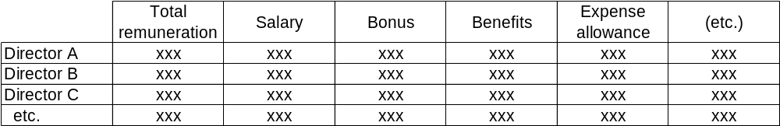

This type of repeating data may be represented by a tuple which groups an element for ‘Director name’ with elements representing each of the column headings. This group of elements can then be repeated indefinitely in the instance document, using a different ‘Director name’ in each case to achieve unique meaning and values. This type of pattern is NOT handled by the use of elements such as ‘Director Name 1’, ‘Salary Director 1’, and so forth. That approach would lead to an unmanageable explosion of taxonomy elements.

A characteristic of a tuple is that some elements within it may not be understood in isolation – they must be linked with other elements in the tuple in order to have any useful meaning. For example, ‘Director Salary’ cannot take a meaningful value unless it is linked with an element identifying the director concerned.

In some cases, tuples may contain other tuples. This enables the representation of repeating groups of data items which themselves contain further repeating sets of data. In theory, there should be no limit to the nesting of tuples, but in practice the highest level of nesting generally used in the taxonomy is two. A couple of special cases have three levels. Most tuples are not nested.

In a few cases, tuples may contain only one element. For example, the tuple ‘Accounting policy changes – Details’ contains one text string element ‘Description of change in accounting policy and its impact’. The inclusion of this element within a tuple allows it to be repeated an unlimited number of times in an instance document to describe different accounting policy changes.

All tuples are identified in the UK GAAP and Common Data taxonomies by the word Details, appended following a dash at the end of the tuple’s label.

12.2 Use cases

A wide range of data in the taxonomy is organised in tuples. There are 248 tuples in the main GAAP taxonomy and another 41 in the Common Data taxonomy described in section 16. Use cases fall into two main categories:

1. Grouping of a simple set of related information.

This is the typical form of tuple in the taxonomy. It consists of one tuple which groups a range of tightly related elements. An example is the tuple element ‘Dividends per share for each class of non-equity share – Details’ which groups items representing the type of share and the interim, final and total dividends.

Clearly, such tuples may represent many different types of data. Another example is the tuple for ‘Address – Details’, which groups elements representing address elements such as street name, town, and post code.

2. Nested tuples grouping an extensive range of information.

These tuples group a broad range of related information which falls under a specific heading. A fairly simple example is the ‘Auditor’s report – Details’ tuple which contains two further separate tuples, one grouping information on the audit firm and the other grouping information on the audit report itself.. Since each of these tuples are unbounded and can be repeated, this design enables the representation of multiple audit opinions with different scopes and dates, as well as reports from different firms. (Clearly, this is not the typical case but may occur.)

A presentation view of the Auditor’s report tuple in the taxonomy is shown below.

Fig 8. Auditor’s report tuple. The three tuples are ‘Auditor’s report – Details’, ‘Auditor information – Details’ and ‘Audit report – Details’. Other elements are ordinary monetary or string (text) type.

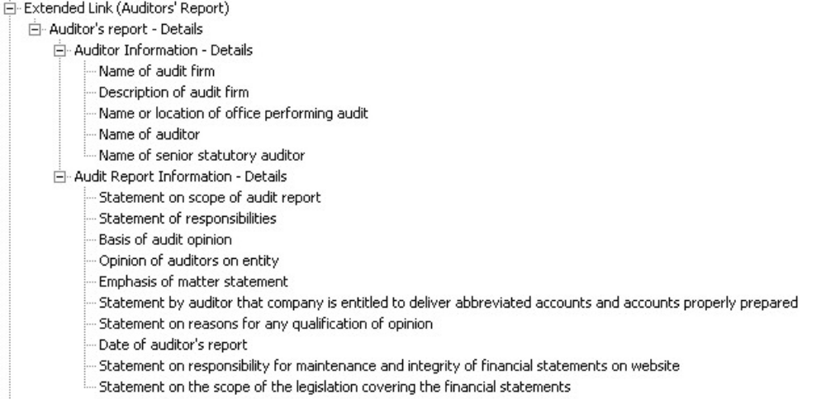

Another example is a set of tuples grouping information on directors. This consists of a top-level tuple covering basic information on the director, which contains a further tuple on the director’s interest in shares of the organisation, which in turn contains another tuple on grants of rights to subscribe to shares and debentures. Clearly, the latter may be repeated in an instance if there are multiple grants of rights, while its parent may also have to be repeated if a director has multiple interests. The top-level tuple will be repeated for each director. (Directors’ remuneration provides the only cases in the taxonomy of three levels of nesting.)

These two categories of tuple described above are NOT technically different. They are distinguished here purely to illustrate and explain the wide variety of data handled by tuples in the taxonomy.

12.3 Tuples and dimensions

Although tuples appear more appropriate to modelling some forms of data and dimensions more appropriate to other forms, there is no absolute distinction between the types of data for which each should be used. It is theoretically possible, although potentially clumsy, to use tuples to model some data for which dimensions have been chosen in the UK GAAP taxonomy and vice versa.

In most cases, the choice between the use of tuples and dimensions to represent particular types of data in the UK taxonomy is based on fairly obvious criteria. Dimensions are used when broad ranges of elements may be reported in a variety of forms (e.g. for continuing and discontinuing operations). Tuples are used when a narrowly-defined package of data is being used repetitively (e.g. dividends for non-equity shares) or when particular data must be grouped together to be correctly understood (e.g. related information within an audit report).

Tuples and dimensions also have significantly different consequences for instance construction and requirements for taxonomy extension. These consequences may also play a major role in determining whether tuples or dimensions are used to model specific data.

In some cases, however, the decision between the use of tuples or dimensions is a narrow one.

A detailed examination of the choices made between tuples and dimensions in UK taxonomies is outside the scope of this note. However, there is a growing body of XBRL documentation on the relative merits of dimensions and tuples for different types of data and circumstance. Clearly, such design choices will be kept under review as use and experience of the taxonomies increases.

13. Handling of text

Textual information occurs extensively in financial reports and takes a wide variety of forms, including sections consisting entirely of free text, textual declarations in statements or notes and footnotes related to specific line items. The UK taxonomy takes the following approaches to representing such textual data:

1. Free format textual sections of reports.

Free-format text sections of reports which provide general commentary, such as those which appear in the Directors’ Report, are NOT represented in the taxonomy. It would be possible to include a single text-string type element to represent each of these sections, but it is not clear that this is a useful way to handle such data. It is assumed that such general commentary will continue to be represented in human-readable renderings of financial reports without XBRL tagging.

Specific statutory statements, predictable statements and related numeric data which may be included within the Directors’ or similar reports ARE represented by specific elements in the taxonomy.

2. Structured text.

Structured text contains predictable sets of information typically arranged by section or paragraph. A good example is the Accounting Policies note – each of its main paragraphs will typically cover a specific accounting policy.

The taxonomy contains individual string-type elements to represent each appropriate section of structured text. The level of granularity at which structured text is represented is determined on a case-by-case basis according to the predictable detail of the text. For example, most individual accounting policies are each represented by a single element. By contrast, ‘Related party transactions’ are handled by a number of detailed elements covering the specifics of a transaction alongside a string element which could be used for a general description of a transaction.

The level of granularity required in representing structured text – and the desirability of including ‘catch-all’ elements alongside detailed elements – may be reviewed in the light of experience with XBRL reporting. (Clearly, the provision of detailed elements promotes granular analysis. However, the nature of textual statements does not necessarily allow easy and predictable subdivision. A plethora of elements for potential sub-divisions may create confusion and inaccurate use of the taxonomy.)

3. Textual declarations or descriptions of specific items.

Predictable textual items which report particular business facts are represented by individual string-type elements. Examples include ‘Name of xxxx’, ‘Description of yyyy’, ‘Statement on zzzz’.

4. Textual explanation or comments included as part of a statement or note.

The taxonomy provides a range of string-type elements to represent general explanation or comment which may be included in a primary statement or note to the accounts. One is allocated to each primary statement and main subdivision or note. Each contains the identifying phrase ‘…free-text comment’ at the end of its label.

It is expected that this approach will be sufficient for such general commentary in statements and notes since the XBRL footnote mechanism should be used to handle individual comments appended to specific line items in accounts, as described below.

5. Expected use of XBRL footnote mechanism.

It is expected that the XBRL footnote mechanism will be used to handle all individual comments related to specific line items in accounts. This is the only practical means of representing such data and was the specifically designed for the purpose. Footnote elements may be linked to items in an instance document and are created by the instance author. They may contain a simple text string or formatted content, such as XHMTL.

Software implementations intended for general reporting under UK GAAP should provide support for the XBRL footnote mechanism.

A particular issue which regulators should consider is whether they wish to introduce guidelines on what facts may be included within textual comments or footnotes in XBRL filings. If numeric or monetary values are included within footnotes or text strings rather than recorded as values against the appropriate taxonomy elements, then that data will not be available for automated analysis by software and may be overlooked by regulators or other consumers of information.

The taxonomy Style Guide gives more detail on the labelling and identification of taxonomy elements representing textual data.

14. Data types and abstract elements

14.1 Use of data types

The UK GAAP taxonomy makes use of a restricted set of XBRL data types. It does not use all available XBRL types, since some are unnecessary for UK GAAP purposes, and it does not add any types. Data types used in the taxonomy, aside from tuples, and the rules for their application are:

1. Monetary

Used for all facts which take a monetary value.

2. String

Used for all facts which have a text string value. This includes dates which do not fit the specific data format (yyyy-mm-dd) of the Date data type. Age bands and other data which contain numeric values but cannot be represented by an integer or decimal alone also take the String data type.

3. Decimal

Used for all facts which have a numeric value apart from those which may only have a whole number value and are represented by the Integer data type. Percentages take the Decimal data type. The fact that they are percentages is defined by their label.

4. Integer

Used for all facts which may only take a whole-number value.

5. Date

Used for all facts which may only take a date value which may be represented by yyyy-mm-dd. Note that this does not restrict how they may be rendered – only the value that they take in an instance document.

6. Boolean

Used for all facts which may only take a ‘true’ or ‘false’ value. For example, the item ‘Company is trading’ takes the Boolean data type and may only take a ‘true’ or ‘false’ value if it appears in an instance document.

7. Unused data types

Data types which are not used in the UK GAAP taxonomy include Shares, URI and Token.

8. Data types in the Common Data taxonomy.

The Common Data taxonomy uses the URI data type and also extends some data types. The Common Data Taxonomy document provides further information.

The addition of further data types to the UK GAAP taxonomy, for example to cover dates defined only as yyyy, is subject to review in the light of experience.

14.2 Use of abstract elements

Abstract elements cannot directly take a value in an instance document.

In the UK GAAP and CD taxonomies, all items used purely for heading and grouping purposes in the Presentation Linkbase are abstract.

All items required purely for constructing and using dimensions are also abstract. This includes the domain members of dimensions and items used to represent dimensions in the Presentation Linkbase.

All abstract items have String data type.

15. Modularity

15.1 General structure

The UK GAAP taxonomy is currently published as a single set of files for ease of review. In XBRL jargon, this is known as a monolithic taxonomy. When published in its final form, however, it will be divided into separate taxonomy modules which may be used independently. This technical division of the taxonomy is intended to enable flexible use of key parts of the taxonomy. It should also improve control and maintenance processes.

The modules of the UK GAAP taxonomy set will probably be as set out below. However, the structure, and particularly the need for a separate dimensions module, will be reviewed ahead of modularisation.

1. Primary terms (PT) taxonomy.

This contains the definitions of all elements used to represent financial data. It consists of a schema file and the Label and Reference Linkbases.

2. Dimensions (DIMS) taxonomy.

This defines the structure and content of all dimensions used in the taxonomy. It contains the definitions of a small number of technical elements used to organise dimensions. It consists of a small schema file and Label Linkbase defining these elements and a Definition Linkbase defining the structure and content of dimensions.

3. Presentation (PRES) taxonomy.

This contains a Presentation Linkbase showing a full presentation view of the contents of the taxonomy. This provides the chief entry point into the UK GAAP taxonomy set. It imports the DIMS taxonomy which in turn imports the PT taxonomy, so users of the PRES taxonomy are linked automatically to these other taxonomies.

It will also import the separate Common Data taxonomy which covers standard information used in business reporting, such as organisation name, address, activity, legal form and the like. The Common Data taxonomy, described more fully in section 16, is intended to be used in conjunction with UK GAAP, UK-IFRS and other general business reporting taxonomies in the UK.

4. Calculation (CALC) taxonomy.

This contains a Calculation Linkbase covering a range of potential summation relationships between some elements in the taxonomy. It will import the PT taxonomy. Its provision in a separate module enables its optional use by instance creators and implementers. As explained in section 9, many taxonomy users may only want to use the Calculation Linkbase for checking instances and will not want to reference the linkbase from their instance documents.

5. Reference (REF) taxonomy.

This defines the structure of accounting references used in the Reference Linkbase. It is directly related to the use of that linkbase and is required for technical reasons. It consists of a small schema file. It is imported by the PT taxonomy.

Users of the full taxonomy will typically reference the PRES taxonomy, giving them the benefit of all information in the base PT, DIMS, REF and Common Data taxonomies.

Other users and implementers, however, may not require the PRES or DIMS taxonomies. The modular structure enables them to reference only the taxonomies which they need, potentially simplifying processing. For example, users who are only mapping a limited range of data may link directly to the PT taxonomy. These issues are discussed more fully in section 17 on taxonomy extension.

The following diagram shows the relationships between the main UK GAAP taxonomy modules, excluding the calculation taxonomy.

Fig 9. Main UK GAAP taxonomy modules. The arrows indicate that a taxonomy imports another taxonomy.
PRES Taxonomy
Presentation L/B
imports
DIMS taxonomy
Definition L/B
PT Taxonomy
Label L/B
Reference L/B
General Users
REF Taxonomy
UK Common Data taxonomy
imports
imports
imports

15.2 Future structure

The modular structure of the UK GAAP taxonomy set may evolve as coverage is reviewed and expanded.

It is possible that additional presentation linkbases, and perhaps calculation linkbases, will be introduced to represent the requirements of particular market or user sectors, such as not-for-profit and finance companies. This may help users in each sector to identify more easily the data relevant to their organisation and reference calculations adjusted to suit the data concerned.

There will, however, always be a main Presentation Linkbase which shows the full accounting content of the taxonomy set.

15.3 Taxonomy size

It will be clear that the modular nature of the taxonomy means there is not a simple answer to the question “what size is the UK GAAP taxonomy?” Direct size comparisons between different taxonomies are also misleading since data structures, particularly the use of dimensions and tuples, have a major impact on the number of elements in a taxonomy. Coverage may also depend on imported taxonomies, such as the Common Data taxonomy, which may or may not be included in size measures.

For the record, the number of elements in current monolithic version of the UK taxonomy is just under 4,400. The Common Data taxonomy contains some 900 elements, but many of these are elements to represent countries, currencies and languages.

The full package of UK GAAP and Common Data taxonomies thus contains some 5,300 elements.

16. Common Data Taxonomy

As has already been mentioned, the UK GAAP taxonomy imports, and is intended to work in conjunction with, the UK Common Data taxonomy. The latter represents typical information used in business reporting including:
- Entity and entity-related information. This includes name, trading and former names, identifying codes, legal form, activities, contact information, public listing information and third party agents, such as bankers, lawyers, accountant and the like.
- Dates and periods covered by the business report being represented in XBRL.
- General contact information, including elements and structures representing addresses, phone numbers and website URLs.
- Common information, including elements representing countries, languages and exchanges.
- Information on instance documents which may be produced from the taxonomy. This includes document name, version, revision history, authors, languages and contact information.

The UK Common Data taxonomy is intended to be used with general business reporting taxonomies in the UK, including UK-IFRS, as well as UK GAAP. In its final version, it will be a modular taxonomy with various entry points to suit different requirements.

An important technical feature of the CD taxonomy is that it uses substitution groups to control the content of particular types of data, such as elements representing entity activity or entity legal form, enabling these to be expanded in a controllable and comparable way.

A separate Common Data Taxonomy document describes the taxonomy in more detail.

17. Taxonomy extension

17.1 General principles

Taxonomies may be extended in a variety of ways so that they better meet the needs of particular users or offer improved coverage of particular types of data.

The following are the main forms of extension which may be applied to the UK taxonomy. (This is not an exhaustive list of all possible technical adjustments in extensions.)
- Addition of elements to extend coverage.
- Modification of labels to suit particular purposes. Such modification should not change the fundamental meaning of the elements concerned.
- Amendment or addition of a presentation linkbase to present an alternative view of the data in a taxonomy.
- Amendment or addition of a calculation linkbase to provide alternative calculations.
- Addition of dimension members in the taxonomy to represent specific business segments and entities.
- Creation of new tuples to represent extended groupings of data.
- Addition of accounting references to clarify the meaning of elements.

A fundamental principle is that extensions must NOT change the definition of accounting concepts in the base taxonomy being extended. Labels in extensions should therefore be consistent in meaning with base taxonomy labels. Extensions cannot delete base elements. They must not remove base accounting references. It is also not possible to add or remove elements in tuples in the base taxonomy. If such a change to a tuple is required, this must be achieved through the creation of a new tuple which encompasses the changed set of elements (and which can be linked to the existing tuple through a ‘similar tuple’ link).

Extensions must not change the fundamental structure of dimensions in the base taxonomy, since this will alter the definition and use of standard contexts, undermining comparability.

17.2 Sector and industry extensions

The modular design of the UK taxonomy is intended to support the creation of extension taxonomies to suit the needs of specialised industry sectors or organisations of a particular size or type. For example, it has already been used as the base for an extension taxonomy for reporting by Audit Exempt companies.

Such extensions will import the Primary Terms taxonomy so that they provide a consistent set of UK GAAP elements, making all available to potential users.

They will typically add a presentation and perhaps a calculation linkbase tailored to the type and scope of data being reported – effectively providing a ‘window’ into the relevant parts of UK GAAP. Such extensions may be easier to use than the full taxonomy for the reporting of restricted data sets. They can also represent calculations which are appropriate for the particular data concerned.

The extensions may or may not import the Dimensions taxonomy, depending on the scope of coverage required.

They may include new elements appropriate to the area of coverage of the taxonomy. For example, these might include elements for textual declarations used only by the organisations concerned (and that are not typical elements for GAAP reporting, which should be in the Primary Terms taxonomy).

Currently, no extensions of this type are planned for the UK GAAP taxonomy other than the existing Audit Exempt taxonomy. However, they may be introduced as requirements are identified, for example for non-profit organisations.

The Primary Terms taxonomy is intended to remain as a monolithic taxonomy representing all relevant reporting concepts under UK GAAP. This ensures that all such elements are available to all users, enabling consistency and comparability across different forms of reporting. The Primary Terms taxonomy is not particularly large or cumbersome and there appears no good reason to divide it.

More information on the Audit Exempt taxonomy may be found on the Companies House website at http://ewf.companieshouse.gov.uk/xbrl.

17.3 Company extensions

Individual companies and other organisations are expected to use extension taxonomies to cover line items in their financial statements which exist purely to represent entity-specific data. They will also need extension taxonomies to define dimension members which are entity-specific, such as individual subsidiaries. It is clearly not practical for a national GAAP taxonomy to cover all unusual line items which may be created by any individual organisation.

(However, unusual entity-specific line items should NOT be confused with generic items which have simply been tailored to the needs of a particular organisation – for example, a standard line item whose label or description has been adapted to the specific requirements of a company. Such items are or should be in the UK GAAP taxonomy and simply require a presentational adjustment by the organisation concerned. This can be achieved by an extension to the Label Linkbase or appropriate rendering mechanisms.)

General implementations of XBRL, for example in accounting software, must therefore support the creation of organisation-level extension taxonomies, where necessary. Similarly, individual organisations using XBRL may have to create their own extensions.

There are several qualifications on this general point on the need for extensions:
- Implementations for reporting by smaller companies or those with simpler accounts may not need to support extensions. Currently, the filing of Audit Exempt financial statements does not require the use of company-level extension taxonomies.
- Extensions are only likely to be required in specific areas of the taxonomy.
- Use of the taxonomy will help identify the likely scope of such extensions and enable us to optimise taxonomy and software design to make extension as straightforward as possible.
- We expect, based in particular on point 3 above, to produce detailed guidelines to help implementers and users produce extension taxonomies, where required.

The taxonomy is intended to support clear and effective extension. Currently, there is no reason to believe that it will be difficult to extend or that it will require broad or frequent extension other than to cover the entity-specific data described above.

18. Taxonomy implementation and use

18.1 Introduction

This section covers a number of general issues related to the implementation, use and quality of the UK GAAP and Common Data taxonomies.

18.2 Availability and updating

The taxonomies and supporting documentation will be available on the web for downloading. Currently, the XBRL UK Ltd site is the home for the taxonomies but other official bodies may host them in due course.

The aim is to update the taxonomies regularly to reflect changes in financial reporting regulations and practice. Any updated version should be available well before it is required for implementation and use. However, the full set of processes for regular updating of “production” versions of the taxonomy is still to be put in place. The current version is intended for initial implementation and will be updated as required, testing the updating and versioning processes.

We expect to communicate changes between taxonomy versions clearly and efficiently on the basis of the XBRL Versioning Specification, which is under development.

Older versions of taxonomies will remain available on the web.

All versions will be clearly identified. Accompanying documentation will spell out their scope and the reporting periods to which they apply.

The UK GAAP and Common Data taxonomies are owned and developed by XBRL UK Limited, which also provides the accompanying documentation. The taxonomies and related documentation are made available for royalty-free use under the Copyright, Intellectual Property and Licensing policies of XBRL International Inc and XBRL UK Limited which are published at http://www.xbrl.org/legal/ and http://www.xbrl.org/uk/legal.aspx.

18.3 Rendering

‘Rendering’ in XBRL parlance means the presentation of XBRL instance documents in human readable form. Various methods for rendering are available or being specified. These include the use of stylesheets and Inline XBRL, which embeds XBRL data within XHTML versions of financial reports.

The UK GAAP and CD taxonomies are neutral as to the method of rendering used. Some stylesheet approaches require additional data in taxonomies – for example, the provision of verbose labels with particular content or the use of particular data types. Where this is necessary, it should be achieved through the provision of extension taxonomies specifically to support the stylesheet concerned.

XBRL UK expects mechanisms adopted in the UK to support to the rendering of XBRL reports in a form acceptable to both providers and users. We expect filing mechanisms to support the delivery and presentation of textual material which accompanies or is part of financial statements, but which is not covered specifically by taxonomy elements.

18.4 Requirements, feedback and quality

The current version of the UK taxonomy is intended to produce useful feedback from initial use by accounting software vendors and other users. As already stated, informed and broad feedback is crucial to the development of a high-quality taxonomy.

The conflicting demands for taxonomies to be comprehensive and accurate, while also consistent, simple to use, easily maintainable and extensible, present a number of challenges for GAAP taxonomy design. The taxonomy developers have to consider, among other issues, how future XBRL-aware software will present taxonomy information and how users are likely to interact with the taxonomy in different software environments and under different forms of implementation.

In particular, the taxonomy developers recognise that:
- Different sets of users may have conflicting design requirements. For example, users from different companies may have differing opinions on the optimal presentation and calculation hierarchies and the precise labelling of items. Accounting software vendors may be less concerned with presentation and calculation hierarchies but may have differing views on the precise range and detail of accounting concepts covered in the taxonomy.
As far as practical, the developers wish to encompass all the varying needs of different users and implementers. We expect to document important areas where we are not able to meet stated needs from particular users and to propose solutions for these cases.
- Accounting software vendors will already have design paradigms built into their software which will not necessarily match those of XBRL.
While we obviously wish to design the UK taxonomies for easy implementation, it is unlikely to be possible to adapt to the design models of all vendors; not only are these models likely to conflict with one another but they may not meet – or need to meet – the generic reporting requirements which XBRL has to accommodate. Whether or not we are able to align with all design models, however, we want to understand vendor requirements so that we can achieve an optimal compromise on taxonomy design. We expect, however, that some vendors may need to redesign aspects of their products in order to provide full support for XBRL.

As already stated, particular issues on which feedback is sought include:
- Detailed content, particular any perceived gaps in coverage.
- Clarity of labels and the need, if any, for special additional labels.
- The design and use of tuples and dimensions.
- The handling of textual data.
- The handling of taxonomy extensions.

Clearly, feedback is welcome on all aspects of the UK GAAP and CD taxonomies and should not be restricted to these subjects.

All feedback may be directed to uktech@xbrl.org.

APPENDICES

A. Glossary

The XBRL International website provides extensive explanation of XBRL, ranging from a basic to a detailed technical level. See the References section below for specific links to this explanatory material. The FRTA and Specification documents both include definitions of XBRL terms. The following terms are used extensively within this document.

Taxonomy | Taxonomies are the dictionaries used by the XBRL language. They are the categorisation schemes which define the specific tags for individual items of data (such as "net profit"). Different countries have different accounting regulations, so each may have its own taxonomy for financial reporting.
Extension taxonomy | A taxonomy which amends another taxonomy to adapt it for a particular purpose. Extensions may add data to a ‘base’ taxonomy but may also prohibit relations in the base, effectively restricting coverage. They may also adapt the presentation and calculation linkbases, providing alternative views of the data in the base. Extensions should NOT change the accounting definitions of items in the base taxonomy. See section 17.
Instance document | An XBRL version of a financial report. It contains a set of values which can be understood by reference to the taxonomies on which the instance is based. An instance is created by matching business data against a taxonomy, among other steps. Every instance must reference the taxonomies on which it is based, so that its contents can be understood. It is a technical file intended for consumption by appropriate software and is not easily human readable.
Label | The human readable title attached to an element in a taxonomy. See section 6 for a fuller discussion of labels.
Context | See section 5.3.
Linkbase | See section 4 for a definition of all linkbases.
Extended link | See section 4.
Abstract element | See section 4.
Data type, balance type and other ‘types’ | See section 4 for a description of all ‘types’.
Dimension | Dimensions represent the different forms in which an accounting item may be reported. See section 11.
Tuple | Groups and identifies related elements which may be used repetitively in an instance document. See section12.

B. References

In addition to the specific references below, readers may refer to the XBRL International website at http://www.xbrl.org/Home/ for documents explaining XBRL and its uses. Particularly useful sections include What is XBRL, Technical Support and Education and Training.

XBRL UK Taxonomies | UK GAAP and CD Taxonomies dated 2008-01-15. Available at http://www.xbrl.org/uk/Taxonomies/.
Scope | XBRL UK GAAP Taxonomy Scope, draft dated May 2008. Available at http://www.xbrl.org/uk/TechGuidance/.
Style Guide | XBRL UK GAAP Taxonomy Style Guide, draft dated May 2008. Available at http://www.xbrl.org/uk/TechGuidance/.
Dimensions | XBRL UK GAAP Taxonomy – Use of Dimensions, draft dated May 2008. Available at http://www.xbrl.org/uk/TechGuidance/.
Common Data Taxonomy | XBRL UK Common Data Taxonomy Design, draft dated May 2008. Available at http://www.xbrl.org/uk/TechGuidance/.
Instance Samples | Samples of financial reports in XBRL, dated May 2008. Available at http://www.xbrl.org/uk/XBRLSamples/.
FRTA | Financial Reporting Taxonomies Architecture, recommendation dated 2005-04-25. Available at http://www.xbrl.org/TaxonomyGuidance/.
XBRL Specification | XBRL Specification 2.1, recommendation dated 2003-12-31 with errata dated 2006-12-18. Available at http://www.xbrl.org/SpecRecommendations/.

C. Document History

Date | Author | Summary of changes
2007-09-15 | P Calvert | Public working draft covering 2007-01-15 taxonomy.
2008-05-15 | P Calvert | New public working draft covering 2008-01-15 taxonomy. Number of detailed changes reflecting amendments and additions in the new version of the taxonomy. Added section on data types and abstracts.

D. Intellectual Property Status

Copyright © 2008, XBRL UK Limited. All Rights Reserved

This document and translations of it may be copied and furnished to others, and derivative works that comment on or otherwise explain it or assist in its implementation may be prepared, copied, published and distributed, in whole or in part, without restriction of any kind, provided that the above copyright notice and this paragraph are included on all such copies and derivative works. However, this document itself may not be modified in any way, such as by removing the copyright notice or references to XBRL International or XBRL organizations, except as required to translate it into languages other than English. Members of XBRL International agree to grant certain licenses under the XBRL International Intellectual Property Policy (www.xbrl.org/legal).

This document and the information contained herein is provided on an "AS IS" basis and XBRL INTERNATIONAL AND XBRL UK LIMITED DISCLAIM ALL WARRANTIES, EXPRESS OR IMPLIED, INCLUDING BUT NOT LIMITED TO ANY WARRANTY THAT THE USE OF THE INFORMATION HEREIN WILL NOT INFRINGE ANY RIGHTS OR ANY IMPLIED WARRANTIES OF MERCHANTABILITY OR FITNESS FOR A PARTICULAR PURPOSE.

