XBRL UK GAAP Taxonomy – Use of Dimensions
Public Working Draft, dated 15 May 2008
Copyright © 2008, XBRL UK Ltd, All Rights Reserved
Authors
Name | Contact | Affiliation
Peter Calvert | pscalvert@googlemail.com | Calvert Consulting Ltd

Contributors
Name | Contact | Affiliation
Neil Griffiths | neg@decisionsoft.com | DecisionSoft Ltd

Abstract
This document describes the use of dimensions in the UK GAAP taxonomy. It extends the explanation on dimensions given in the UK GAAP taxonomy Design Guide and assumes familiarity with that document. It is aimed at users, implementers and reviewers of the UK GAAP taxonomy who require a detailed technical understanding of the implementation of dimensions in the taxonomy.

Status
This is a Public Working Draft which is published on the XBRL UK Ltd website. It is open to revision in the light of comments from the public, including reviewers and prospective XBRL users and implementers. Circulation of the document is not restricted.

Comments on the document and taxonomy are welcome and should be directed to uktech@xbrl.org.

TABLE OF CONTENTS
1. Introduction 1
2. Use of dimensions – general principles 1
3. Types of data represented by dimensions 2
4. Dimensions used in UK GAAP taxonomy 4
5. Features of dimensions 5
6. Structure of dimensions 5
6.1 Basic definition 5
6.2 Default members of dimensions 7
6.3 Structure of dimensional information 7
6.4 Use of ‘Not applicable’ element as dimension member 8
7. Extension and implementation 9
7.1 Modularity 9
7.2 Extension 9
7.3 Data modelling 10
7.4 Implementation 10
8. Dimensions and tuples 11
APPENDICES 12
A. Dimensions in UK GAAP taxonomy 12
B. Hypercubes in UK GAAP taxonomy 15
C. Example of application of dimensions in UK GAAP taxonomy 17
D. References 18
E. Document History 18
F. Intellectual Property Status 18

1. Introduction

The document describes the use of dimensions in the UK GAAP taxonomy. It extends the explanation on dimensions given in the UK GAAP taxonomy Design Guide and assumes familiarity with that document.

It is aimed at users, implementers and reviewers of the UK GAAP taxonomy who require a detailed technical understanding of the implementation of dimensions in the taxonomy.

It provides a detailed explanation of the design choices made on dimensions and the features of the Dimensions (DIMS) taxonomy in the UK GAAP taxonomy set. It will help in the evaluation and use of the taxonomy set and enable the provision of informed feedback.

Questions and comments on the design and use of dimensions and on this document are welcome. All feedback may be directed to uktech@xbrl.org.

2. Use of dimensions – general principles

As described in the Design Guide, dimensions are used in the UK GAAP taxonomy to represent the various forms in which an accounting concept may be reported.

For example, ‘profit (loss) on ordinary activities before tax’ may be reported for a range of different entities in a financial report, including the consolidated entity, the group, subsidiaries, joint-ventures, associates and various combinations of these. It may be reported for continuing, discontinued or acquired operations as well as for individual business or geographic segments It may also be reported before or after exceptional items and before or after various forms of amortisation and impairment.

Representing all the possible different forms of such concepts by individual elements would lead to impractically large and clumsy taxonomies. Instead, the UK GAAP taxonomy defines dimensions to represent the standard forms in which concepts may be reported. These dimensions may then be applied to elements to enable the representation of all the various forms of concepts.

Technically, ‘contexts’ are used to represent the various forms, or combinations of forms, in which concepts may be reported. Dimensions provide a means of formally defining these contexts so they are used consistently and correctly by all taxonomy users.

The next sections in this note provide further examples of the sort of data represented by dimensions and explain the detailed design of dimensions in the UK GAAP taxonomy.

Some of the specific choices made in the design of dimensions reflect matters of judgement. There are no absolute rules to determine which forms of data should be represented by dimensions, individual elements or by combinations of elements in tuples. This note explains the choices and judgements made.

Readers should refer to the XBRL Dimensions Specification for a detailed technical explanation of dimensions.

3. Types of data represented by dimensions

The following figures show extracts from company financial statements. These contain tables with typical breakdowns for various aspects of profit and loss data.

Fig 1. Part of an Income Statement.

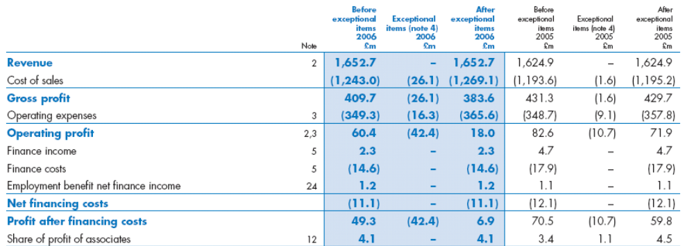

Fig 2. Part of an Income Statement.

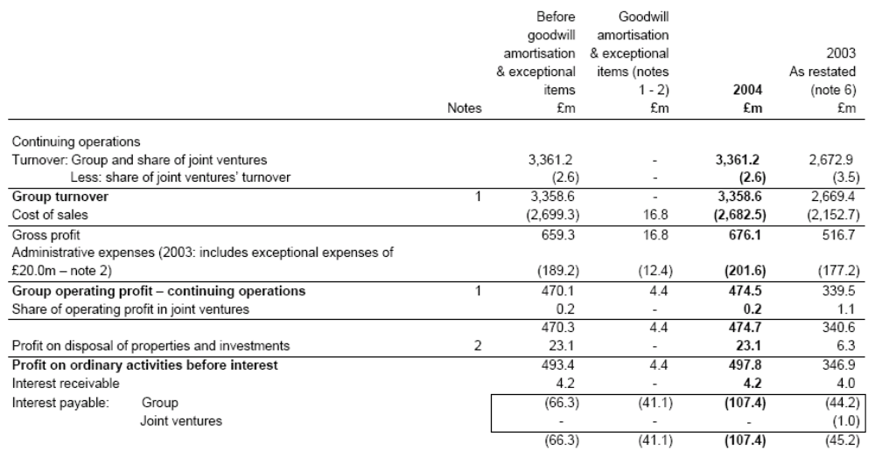

Fig 3. Breakdown of operating costs.

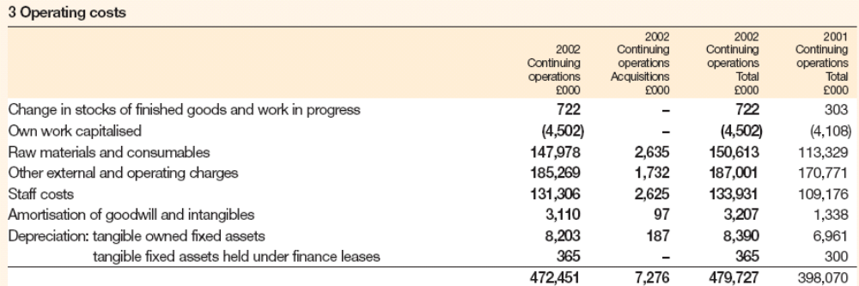

Fig 4. Income data analysed by industry sector.

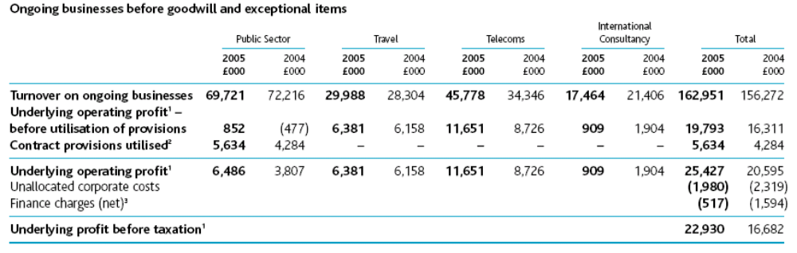

In all these examples, the rows contain accounting concepts which are represented by elements in the UK GAAP taxonomy, while the columns contain breakdowns which are represented by dimensions.

The examples provide a typical picture of the use of dimensions. Dimensions are typically used when:
- An accounting concept (such as turnover) can be reported in different forms (such as continuing operations, discontinued operations, industry sectors etc.). The different forms are represented using dimensions.
and
- Each form of reporting may apply to a number of concepts. For example, the ‘continuing operations’ distinction may apply to a wide range of data. Similar, the industry sectors shown in figure 4 apply to a range of different income data elements.

It is not the case that columns or rows in all tables which may appear in financial reports will be represented by dimensions. In some cases, individual elements may be used to represent each ‘cell’ in a table. They may be the choice when tables are very small or are not a typical presentation of the data concerned.

Alternatively, tuples may be used to group sets of tightly-related data items, which only have meaning when linked together, and which are used repetitively in an instance document. An example is the director’s remuneration report, often presented as a table in financial statements. Data for total remuneration, salary, bonus and the like is repeated for each director and only has meaning when linked together with the identity of the director – it cannot be understood in isolation. Elements for all these concepts, including director name, are thus grouped together in a tuple.

The use of tuples is explained further in the Design Guide. The factors which determine whether dimensions or tuples are used to handle particular types of data in the UK GAAP taxonomy are covered in more detail in Section 8 of this note.

4. Dimensions used in UK GAAP taxonomy

The following table lists the 19 dimensions defined in the UK GAAP taxonomy. The Dimension Title is simply a convenient label to identify the dimension. The Dimension Members are elements representing the various forms in which data may be reported. (The ordering of dimensions in the table follows the order in which dimensions are defined in the taxonomy.)

Dimension Title | Dimension members include:
Consolidation | Consolidated total; group; various totals for group, joint-ventures and associates.
Restatements | Restated amount; various adjustments; original amount
Subsidiaries | Various (sub-)totals; individual subsidiaries should be defined in a company-specific extension taxonomy.
Joint-ventures | Various (sub-)totals; individual joint-ventures should be defined in a company-specific extension taxonomy.
Associates | Various (sub-)totals; individual associates should be defined in a company-specific extension taxonomy.
Business segments | Various (sub-)totals; individual segments should be defined in a company-specific extension taxonomy.
Geographic segments | Various (sub-)totals; individual segments should be defined in a company-specific extension taxonomy.
Operating activities | Continuing operations; acquisitions; discontinued operations.
Exceptional items | Before exceptionals; related exceptionals; after exceptionals.
Exceptional items and amortisation | Before and after exceptionals, amortisation and impairment.
Acquisition assets and liabilities | Totals for subsidiaries, joint-ventures, associates; book value; fair value; fair value adjustment; other adjustments.
Provisions classes | All provisions; various types of provisions
Intangible fixed asset classes | All classes; various specific classes
Tangible fixed asset classes | All classes; various specific classes
Tangible fixed asset ownership | Total owned and leased; various forms of ownership
Fixed asset investment holdings | All; group; non-group; participating interests, joint-ventures, subsidiaries and various other subtotals.
Fixed asset investment types | All; various specific types of fixed asset investment.
Fair values | Fair value; change in fair value included in income statement; change in fair value included in fair value reserve.
Dividends | Paid and proposed; paid; proposed

A list of dimensions showing all member elements is in Appendix A.

Separate dimensions are defined for ‘Exceptional items’ and ‘Exceptional items, amortisation’ because these contain different combinations of forms of data. Each applies to a different set of accounting concepts. (Most major income items on the Profit and Loss statement use the ‘Exceptional items, amortisation’ dimension, while most operating costs use the ‘Exceptional items’ dimension.)

5. Features of dimensions

Elements may only be used with the dimensions to which they are explicitly linked in a taxonomy. They cannot take dimensions to which they are not linked. If an element is linked to a dimension in the UK GAAP taxonomy, then it may use any of the members of that dimension.

For example, a range of income data elements are linked to the ‘Operating activities’ dimension. All such income items may thus be used with any member of the ‘Operating activities’ dimension. However, income data is not linked to the ‘Fair value’ dimension – which would have no meaning or application to income data.

Creators of instance documents are thus constrained to selecting dimensions which are appropriate to each element.

A group of dimensions may be defined to act in combination. For example, the dimensions for ‘Operating activities’, ‘Consolidation’, and ‘Exceptional items, amortisation’, among others, all apply simultaneously to a range of income data. In such cases, data may be reported for each combination of dimension members. As a specific example, a single element, such as ‘Operating profit (loss)’, may be reported for any entity, including the group, joint-venture, associate or subsidiary, according to any operating activity, both before and after various combinations of exceptional items, amortisation and / or impairment. This use of combined dimensions enables a taxonomy to represent a wide range of data powerfully, flexibly and accurately.

The full set of members of some dimensions, such as those representing subsidiaries, business segments and geographic segments, can obviously only be defined at the level of individual company or organisation. The UK GAAP taxonomy only defines the structure and use of such dimensions, together with the basic members ‘All’ and ‘Other’. Instance creators who need to use these dimensions will require organisation-specific taxonomy extensions to define other dimension members. The extension of dimensions is discussed further in Section 7.2.

All dimensions defined in the UK GAAP taxonomy are explicit dimensions which contain an explicit list of members. It does not make any use of ‘typed’ dimensions, which contain too many members to enumerate individually. (An example of the latter would be dimensions for Longitude and Latitude, which would contain an infinite range of numbers from -180 to +180.)

6. Structure of dimensions

6.1 Basic definition

The structure and content of dimensions are defined in the Definition Linkbase of the UK GAAP taxonomy. This defines, among other things, the following aspects of dimensions:

1. Dimension Identity.

Each dimension has a ‘head’ element which defines it and provides its human-readable title or label. This element (which appears in the ‘dimensionItem’ substitution group) is abstract and exists purely for definition purposes – it cannot appear in instance documents. An example of a dimension is ‘Operating activities [Dimension]’. All such items include [Dimension] in their label.

2. Dimension members.

The elements in the taxonomy which are members of a dimension are defined by a link between them and the head element. For example, ‘Continuing operations’, ‘Acquisitions’ and ‘Discontinued operations’ are members of the ‘Operating activities’ dimension.

3. Dimensions which act in combination.

As explained in Section 5, a group of dimensions may act in combination.

‘Hypercubes’ are used to define a set of dimensions which act simultaneously together. A hypercube may contain a single dimension or multiple dimensions.

For example, a single hypercube which applies to a wide range of income data contains the dimensions for ‘Operating activities’, ‘Consolidation’, and ‘Exceptional items, amortisation’, among others. This is the ‘Income data all dimensions’ hypercube.

Another hypercube, the ‘Operating activities’ hypercube, contains only the ‘Operating activities’ dimension. It applies to a different range of elements from the ‘Income data all dimensions’ hypercube.

Each hypercube has a ‘head’ element which defines it and provides its human-readable title or label. This element (which appears in the ‘hypercubeItem’ substitution group) is abstract and exists purely for definition purposes – it cannot appear in instance documents. All such items include [Hypercube] in their label.

Appendix B lists the hypercubes defined in the UK GAAP taxonomy and the dimensions they contain.

4. Elements to which each dimension or set of dimensions may apply.

The ordinary elements to which a set of dimensions may apply are defined by a link between the elements and the appropriate hypercube.

Some elements may be linked to several hypercubes, some to one and some to none.

Dimensions which are grouped in different hypercubes will not act in combination. For example, the ordinary element ‘Total liabilities’ is linked to the ‘Operating activities’ hypercube and the ‘Joint-ventures’ hypercube. This enables ‘Total liabilities’ to be reported for each individual operating activity and, separately, for each individual joint-venture. However, it does not provide for a breakdown of ‘Total liabilities’ for each joint-venture by operating activity (because this is not expected to be a reporting requirement). If the latter had been a requirement, it would have required the definition of a hypercube combining the ‘Operating activities’ and ‘Joint-ventures’ dimensions.

The conceptual structure used in the definition of dimensions is shown in figure 5. The full structures used in the definition linkbase are more complex and are explained in further detail in section 6.3.

Figure 5. Conceptual structure of dimensions. Arrows represent various types of taxonomy links.

Definition of Dimension
‘Head’ element,
defines dimension
‘Aggregator’
(e.g. Total Regions)
Individual members
(e.g. Region 1, 2, 3 etc.)
Definition of Hypercube
‘Hypercube’ element,
defines hypercube
Individual dimensions contained in Hypercube
Elements using dimensions defined in hypercube

6.2 Default members of dimensions

A default member is defined in each dimension in every hypercube in which the dimension participates. This default member automatically represents that dimension if an instance creator makes no selection for that dimension in the hypercube.

Default members represent the standard form in which an element is expected to be reported. For example, the default member for the ‘Tangible fixed asset classes’ dimension is always ‘All tangible fixed assets’.

These default members greatly simplify the use of dimensions in practice. Instance creators need only make dimensional selections if the form of reporting which they require to represent departs from the standard form. This means creators of instances for simple accounts can largely ignore the dimensional structure. (There is no other technical mechanism for users validly to ignore dimensions linked to an element. Such links must be processed in line with the dimensions specification.)

6.3 Structure of dimensional information

The various groups of elements which define dimensions are organised in sets of extended links in the Definition Linkbase. This partitioning into what may be considered as separate sections of the linkbase is partly for technical reasons but is also intended to help users understand the dimensional structure and to support easier extension of dimensions when this is necessary.

An important factor which underlies the design of extended links is that a number of dimensions are used in multiple hypercubes. For example, as already mentioned, the ‘Operating activities’ dimension participates in a range of hypercubes which apply to different elements. These include the ‘Income data all dimensions’ hypercube, the ‘Operating activities’ hypercube and various hypercubes which apply specifically to the reporting of data related to joint-ventures, associates, and business and geographic segments. These many-to-many relationships require that each dimension and each hypercube be in its own, separate extended link, both for clarity and to avoid illegal cycles of links.

The basic structure of extended links for dimensions in the Definition Linkbase is as follows:
- Dimension members definition extended link. Each group of elements which defines the members of a dimension is in its own extended link. The names of such extended links follow the pattern ‘DimensionDomain-abcd’, where ‘abcd’ identifies the specific dimension.
- Hypercube extended link. Each hypercube definition is in its own extended link. The definition consists of the hypercube element linked to each participating dimension. The names of these extended links follow the pattern ‘Hypercube-efgh’ where ‘efgh’ identifies the specific hypercube.
- Primary items extended link. This extended link, which exists for each hypercube, contains a link between the hypercube and all the primary, or ordinary, taxonomy elements which use the hypercube. This effectively completes a dimensional structure which other ordinary elements can then easily use. The names of these extended links follow the pattern ‘PrimaryItems-efgh’ where ‘efgh’ identifies the hypercube concerned.

In total, 73 extended link roles are used for dimensional definitions. Appropriate ‘target roles’ are set on links between elements to ensure that different extended links function correctly together. Readers should refer to the XBRL Dimensions Specification for further explanation on this concept.

The specification permits two forms of context to be used for dimensions: segment and scenario. All dimensions in UK GAAP are defined using only the segment form of context, since there is no practical benefit in using both forms.

Clearly, the structure of dimensions explained in this and preceding sections should be hidden from non-technical creators of instance documents, who should not need more than simple instructions for entering specific data, such as names of individual subsidiaries, which may have to be added as members of entity-specific dimensions. The nature of these instructions will obviously depend on the particular software application that they may be using.

6.4 Use of ‘Not applicable’ element as dimension member

As already stated, the design of dimensions in the UK GAAP taxonomy is intended to ensure that elements may only be used with dimensions which may sensibly apply to them.

This will help achieve consistent and accurate construction of instances and avoid instance creators being presented with a range of inappropriate choices when they come to select the dimensions which they require.

It is not practical, however, to create a dimensional structure which exactly meets the needs of every user and which eliminates all redundancy.

In particular, dimension members in some hypercubes cannot in practice operate together. For example, the ‘Income data all dimensions’ hypercube contains dimensions for joint-ventures, associates, geographic segments and business segments, as well as for operating activity, consolidation and the like. Clearly, the joint-ventures dimension cannot operate in tandem with the associates dimension, while the geographic segments dimension is unlikely to be required in tandem with the business segments dimensions.

To cope with these and similar cases, many dimensions contain a ‘Not applicable’ element as a member. This effectively allows the dimension to be ignored when not required, given the other dimensional choices made.

The alternative to using a ‘Not applicable’ element would be to construct a different hypercube for each possible valid combination of dimensions. This would lead to an impractically large and clumsy dimensional structure. For example, the ‘Income data all dimensions’ hypercube would have to be split into a number of separate hypercubes for each possible valid combination of dimensions. Each of these would in turn require their own extended links for primary items.

It is not expected that users will have any difficulty in selecting the ‘Not applicable’ element when necessary from what is basically an appropriate set of dimensional choices for each element.

In a number of dimensions, the ‘Not applicable’ element is always used as the default member, effectively allowing the dimension to be ignored by default, further simplifying the construction of instances for simple accounts.

7. Extension and implementation

7.1 Modularity

The UK GAAP taxonomy is currently published as a single set of files for ease of review. When published in its final form, however, it will be divided into separate taxonomy modules which may be used independently.

At that stage, the dimensional information in the UK GAAP taxonomy set may be put in a separate DIMS taxonomy. This would enable users and implementers who do not require dimensional information to avoid it entirely. However, such users and implementers would not be able to make any use of dimensional information and would not be able to report consistently in XBRL the forms of data covered by dimensions. The requirement for a separate DIMS module will be assessed ahead of the modularisation of the taxonomy.

Such modularisation will not alter the basic content and functionality of dimensions in the UK GAAP taxonomy set.

7.2 Extension

From a technical perspective, the dimensional information in the UK GAAP taxonomy set may be extended in any of the ways permitted by the XBRL Specification.

In practice, it is not expected that the basic dimensional structure will be amended through extension – and certainly not at the individual organisation or company level. Such extensions would be likely to lead to loss of comparability and consistency. For example, if a new dimension member was introduced to represent ‘Continuing operations’, all comparability with other instances using the original dimension member would be lost.

Extension of the basic dimensional structure is also not a trivial exercise and will usually require manual effort and expertise.

However, it is expected that the members of a limited number of dimensions will routinely require extension at the organisation or company level. These dimensions are identified in the table in Section 4. They are the dimensions representing subsidiaries, joint-ventures, associates, business segments and geographic segments. Clearly, the individual members of these dimensions can only be known at organisation or company level.

Instructions or software supporting the UK GAAP taxonomy should enable the easy extension of the members of these dimensions.

In practice, this means defining new elements which are children of the ‘All subsidiaries’ element in the ‘DimensionDomain-Subsidiaries’ extended link, and/or the ‘All joint-ventures’ element in the ‘DimensionDomain-Joint-ventures’ extended link and so forth.

Some reporting entities may also need to extend other dimensions, such as ‘Tangible fixed asset classes’ or ‘Provisions classes’, if the content of these dimensions is insufficient for their needs. The aim is that such dimensions should be comprehensive enough to meet all common requirements, so extension will be an exception. Nevertheless, software, depending on its target market, may need to support this.

Dimensions have not so far been defined in the UK GAAP taxonomy to represent typical business reporting scenarios, such as Budgeted, Forecast, and Actual. The requirement for these scenarios is still to be evaluated. Feedback on the need for such additional dimensions is welcome.

7.3 Data modelling

The design of dimensions is based on data models showing what forms of reporting may apply to particular accounting concepts. The models reflect an extensive range of sample financial statements and company accounts. The models are intended to be extensive, embracing all the various forms of reporting that are seen in practice. Clearly, they have to go beyond the forms of reporting which any individual organisation may employ. As already stated, it is not desirable for organisations to have to extend the structure of dimensions, both because of the loss of comparability and consistency across financial statements and because of the technical difficulty in creating such extensions.

The data models have been developed iteratively and are not published. The best way of reviewing them in practice is to look at the content of hypercubes and the elements which are linked to them. Appendix C contains an illustrative example of a model showing the dimensions which apply to a range of income data.

An underlying principle of the design of dimensions is that instance creators should only be able to select dimensions which may legitimately apply to an element. Simpler dimensional structures might be possible if a ‘catch-all’ design was used which allowed any dimension to be applied to any element. However, this would be likely to confuse instance creators, would pose major challenges for the user interfaces of software supporting XBRL and would threaten both consistency and comparability.

7.4 Implementation

Software implementations which support the UK GAAP taxonomy set must provide full and efficient support for dimensions as used in the taxonomy. Accompanying documentation which explains the taxonomy to instance creators and other end-users must make clear the role of dimensions.

Although the structure of extended links, hypercubes and other data in the Definition Linkbase may appear complex, this should translate into a simple set of choices for end-users.

Software implementations should:
- Present end-users with a simple process of selecting the dimension members which may apply to a particular value of an ordinary element.
- Support easy extension of the data which organisations will typically need to extend, as described in Section 7.2.
- Show accurately and clearly what data is represented by ordinary elements and what by dimensions. For example, without an understanding of dimensions, it may not be intuitively obvious that specific values for exceptional items related to operating expenses or operating profit (as shown in figure 1) are handled by dimensions rather than individual elements.

Feedback from all users and implementers on the design and use of dimensions in the UK GAAP taxonomy is welcome.

8. Dimensions and tuples

As explained in the Design Guide, dimensions are appropriate to modelling some forms of data while tuples are appropriate to other forms, but there is no absolute distinction between the types of data for which each should be used.

In most cases, the choice between the use of tuples and dimensions to represent particular types of data in the UK taxonomy is based on fairly obvious criteria. Dimensions are used when broad ranges of elements may be reported in a variety of forms (e.g. for continuing and discontinuing operations). Tuples are used when a narrowly-defined package of data is being used repetitively (e.g. dividends for non-equity shares) or when particular data must be grouped together to be correctly understood (e.g. related information within an audit report).

One difference between dimension and tuples lies in the complexity of the relationships which they can conveniently model. In the directors’ remuneration report, modelled by a tuple, the concepts for salary, bonus etc. are bound to just one other concept – that of name of director. Dimensions may more easily cope with complex cases which involve many-to-many relationships. An example is the range of different forms of reporting of income data (some of which are shown in Appendix C).

Another difference between dimensions and tuples lies in their consequences for taxonomy extension.

The content of tuples cannot be extended – an instance creator who wishes to add elements to a tuple must create a new replacement tuple in an extension taxonomy (preferably linking the new tuple to the old by a ‘similar tuple’ link). On the other hand, an instance creator can represent multiple values by using multiple occurrences of a tuple in an instance, without needing any form of taxonomy extension.

The content of dimensions can be extended, but in practice this may only be desirable in narrowly defined circumstances to avoid undue complexity for users.

The likelihood that a taxonomy extension will be required, and the form of any such extension, is thus one of the considerations in a choice between the use of tuples and dimensions to represent particular types of data. As far as possible, design choices are intended to:
- Avoid the need for instance creators to extend the taxonomy.
- Discourage or prevent certain types of extension which might lead inconsistent use of the taxonomy and loss of comparability.
- Ensure that any extensions which are required should follow easily understood and repeatable patterns. They may then be more easily supported by software and understood by users.

The design and application of dimensions in the UK GAAP taxonomy thus reflects careful judgements on how data can be efficiently and accurately represented and on how the taxonomy may be easily and efficiently used in practice. A more detailed examination of these design questions is outside the scope of this note, but there is a growing body of XBRL documentation and experience on such matters. As already stated, feedback is welcome on the use of dimensions in the taxonomy.

APPENDICES

A. Dimensions in UK GAAP taxonomy

The following table shows the dimensions used in the UK GAAP taxonomy and their full set of member elements.

Dimension title | Dimension aggregator | Other dimension members
Consolidation | Consolidated total | Total of group and joint-ventures
 |  | Group
 |  | Total subsidiaries / group undertakings
 |  | Total of joint-ventures and associates
 |  | Total joint-ventures
 |  | Total associates
 |  | Not applicable
Restatements | Restated amount | Total restatement adjustment
 |  | Accounting errors adjustment
 |  | Changes in accounting estimates, adjustment
 |  | Changes in accounting policy, adjustment
 |  | Prior period adjustment
 |  | Other causes, adjustment
 |  | Original amount
Subsidiaries / group undertakings | Total subsidiaries / group undertakings | Other subsidiaries / group undertakings
 |  | Not applicable
 |  | Individual subsidiaries should be defined in a company-specific extension taxonomy.
Joint-ventures | Total joint-ventures | Other joint-ventures
 |  | Not applicable
 |  | Individual joint-ventures should be defined in a company-specific extension taxonomy.
Associates | Total associates | Other associates
 |  | Not applicable
 |  | Individual associates should be defined in a company-specific extension taxonomy.
Business segments | Total business segments | Other business segments
 |  | Not applicable
 |  | Individual segments should be defined in a company-specific extension taxonomy.
Geographic segments | Total geographic segments | Other geographic segments
 |  | Not applicable
 |  | Individual segments should be defined in a company-specific extension taxonomy.
Operating activities | Total for all operating activities | Continuing operations, including acquisitions
 |  | Acquisitions
 |  | Continuing operations, excluding acquisitions
 |  | Discontinued operations
Exceptional items | Total after any adjustments for exceptional items | Related exceptional items
 |  | Total before any adjustments for exceptional items
 |  | Not applicable

Exceptional items, amortisation | Total after any adjustments for amortisation, impairment and exceptional items | Related exceptional items, amortisation and impairment of goodwill and intangible assets
 |  | Related exceptional items and amortisation of goodwill and intangible assets
 |  | Related exceptional items
 |  | Related amortisation of goodwill and intangible assets
 |  | Related amortisation of intangible assets, excluding goodwill
 |  | Related amortisation of goodwill
 |  | Related amortisation and impairment of goodwill and intangible assets
 |  | Related amortisation and impairment of goodwill
 |  | Related impairment of intangible assets
 |  | Total before any adjustments for amortisation, impairment and exceptional items
 |  | Not applicable
Acquisition assets and liabilities | Total for all acquisitions | Total subsidiaries / group undertakings
 |  | Total joint-ventures
 |  | Total associates
 |  | Book value
 |  | Fair value adjustment
 |  | Revaluation
 |  | Accounting policy alignment adjustment
 |  | Other significant adjustments
Provisions classes | All provisions | Provisions for pensions and similar obligations
 |  | Provisions for defined benefit pension schemes
 |  | Provisions for defined contribution pension schemes
 |  | Provisions for post-retirement benefits other than pensions
 |  | Provisions for taxation, including deferred taxation
 |  | Provisions for deferred taxation
 |  | Provisions for restructuring or reorganisation
 |  | Provisions for product guarantees
 |  | Provisions for legal proceedings
 |  | Provisions for onerous contracts
 |  | Provisions for decommissioning, restoration and rehabilitation
 |  | Provisions for bad debts
 |  | Provisions for environmental costs
 |  | Provisions for deferred considerations
 |  | Provisions for vacant properties
 |  | Other provisions
Intangible fixed asset classes | All intangible fixed assets | Development costs, patents and similar
 |  | Development costs
 |  | Patents, concessions, licences, trade marks and similar
 |  | Net goodwill
 |  | Positive goodwill
 |  | Negative goodwill
 |  | Payments on account, intangible fixed assets
 |  | Other intangible fixed assets

Tangible fixed asset classes | All tangible fixed assets | Land and buildings
 |  | Investment properties
 |  | Plant and machinery
 |  | Fixtures, fittings, tools and equipment
 |  | Fixtures and fittings
 |  | Tools and equipment
 |  | Office equipment
 |  | Computer equipment
 |  | Vehicles
 |  | Aeroplanes
 |  | Boats
 |  | Motor vehicles
 |  | Commercial motor vehicles
 |  | Motor cars
 |  | Other vehicles
 |  | Payments on account and assets in the course of construction
 |  | Other tangible fixed assets
Tangible fixed asset ownership | Total owned and leased tangible fixed assets | Owned or freehold tangible fixed assets
 |  | Leased tangible fixed assets
 |  | Short leasehold properties
 |  | Long leasehold properties
Fixed asset investment holdings | All fixed asset investment holdings | Group
 |  | Non-group
 |  | Total participating interests
 |  | Total of joint-ventures and associates
 |  | Total joint-ventures
 |  | Total associates
 |  | Total other participating interests
 |  | Total subsidiaries / group undertakings
Fixed asset investment types | All types of fixed asset investment | Shares, fixed asset investments
 |  | Shares, listed, fixed asset investments
 |  | Shares, unlisted, fixed asset investments
 |  | Loans held as fixed asset investments
 |  | Fixed asset investments other than shares, including loans
 |  | Fixed asset investments other than shares, not including loans
 |  | Fixed asset investments other than loans
Fair values | Fair value | Increase (decrease) in fair value included in income statement
 |  | Increase (decrease) in fair value credited (debited) to fair value reserve
Dividends | Dividends paid and proposed | Dividends paid
 |  | Dividends proposed

B. Hypercubes in UK GAAP taxonomy

The following is a list of the hypercubes in the UK GAAP taxonomy set and the dimensions which they contain.

Hypercubes | Dimensions
Acquisition assets and liabilities | Acquisition assets and liabilities | Joint-ventures | Associates | Subsidiaries | Restatements
Associates | Associates | Operating activities | Restatements
Business segments asset data | Business segments | Consolidation | Joint-ventures | Associates | Operating activities | Restatements
Business segments basic | Business segments | Restatements
Business segments income data | Business segments | Exceptional items, amortisation | Joint-ventures | Associates | Consolidation | Restatements
Consolidation, operating activities | Consolidation | Operating activities | Restatements
Dividends | Dividends
Exceptional items, amortisation | Exceptional items, amortisation | Restatements
Fair values | Fair values | Restatements
Fixed asset investment loans | Fixed asset investment holdings | Restatements
Fixed asset investments | Fixed asset investment holdings | Fixed asset investment types | Restatements
Geographic segments asset data | Geographic segments | Consolidation | Joint-ventures | Associates | Operating activities | Restatements
Geographic segments basic | Geographic segments | Restatements
Geographic segments income data | Geographic segments | Exceptional items, amortisation | Joint-ventures | Associates | Consolidation | Restatements

Income data all dimensions | Operating activities | Exceptional items, amortisation | Consolidation | Joint-ventures | Associates | Business segments | Geographic segments | Subsidiaries | Restatements
Intangible fixed assets | Intangible fixed asset classes | Restatements
Joint-ventures | Joint-ventures | Operating activities | Restatements
JVs, associates, exceptional items, amortisation | Exceptional items, amortisation | Consolidation | Joint-ventures | Associates | Restatements
Operating activities | Operating activities | Restatements
Operating activities, exceptional Items | Operating activities | Exceptional items | Restatements
Operating activities, exceptional items, amortisation | Operating activities | Exceptional items, amortisation | Restatements
Operating activities, JVs, associates | Operating activities | Consolidation | Joint-ventures | Associates | Restatements
Operating activities, JVs, associates, geog, business | Operating activities | Consolidation | Joint-ventures | Associates | Geographic segments | Business segments | Restatements
Provisions for liabilities and charges | Provisions classes | Operating activities | Restatements
Restatements | Restatements
Subsidiaries | Subsidiaries / group undertakings | Restatements
Tangible fixed assets | Tangible fixed asset classes | Tangible fixed asset ownership | Restatements

C. Example of application of dimensions in UK GAAP taxonomy

This illustrative example shows the dimensions which apply to various income items, primarily from the P&L Statement. It shows only a limited range of the income data which uses dimensions. To save space, some dimensions which apply to the same elements are merged in the same column. 'X' indicates that a dimension applies. Note that not all combinations of allowed dimensions are meaningful. All items take the Restatements dimension which is not shown.

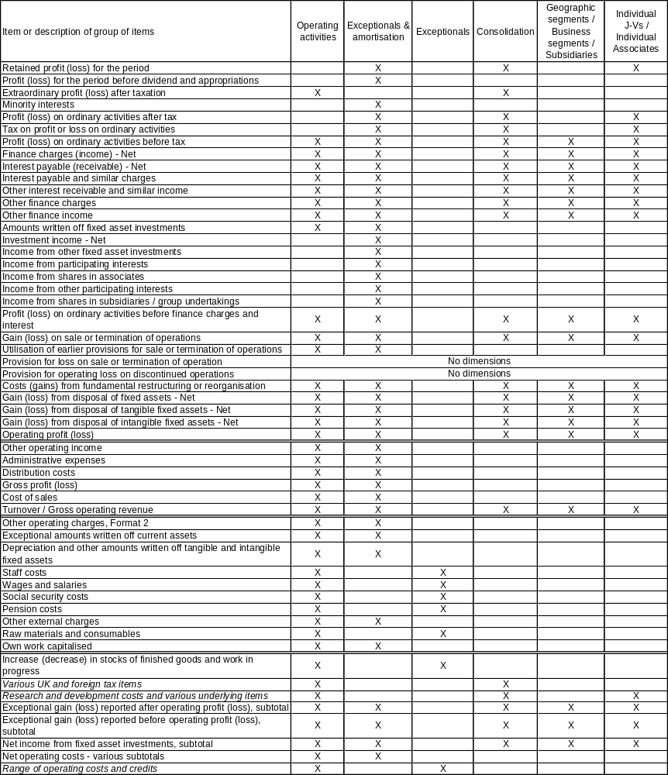

D. References

In addition to the specific references below, readers may refer to the XBRL International website at http://www.xbrl.org/Home/ for documents explaining XBRL and its uses. Particularly useful sections include What is XBRL, Technical Support and Education and Training.

XBRL UK Taxonomies | UK GAAP and CD Taxonomies dated 2008-01-15. Available at http://www.xbrl.org/uk/Taxonomies/.
Design | XBRL UK GAAP Taxonomy Design, draft dated May 2008. Available at http://www.xbrl.org/uk/TechGuidance/.
XBRL Specification | XBRL Specification 2.1, recommendation dated 2003-12-31 with errata dated 2006-12-18. Available at http://www.xbrl.org/SpecRecommendations/.
XBRL Dimensions Specification | XBRL Dimensions 1.0, recommendation dated 2006-09-18. Available at http://www.xbrl.org/SpecRecommendations/.

E. Document History

Date | Author | Summary of changes
2007-09-15 | P Calvert | Public working draft covering 2007-01-15 taxonomy.
2008-05-15 | P Calvert | New public working draft covering 2008-01-15 taxonomy. Number of detailed changes reflecting amendments and additions in the new version of the taxonomy.

F. Intellectual Property Status

Copyright © 2008, XBRL UK Limited. All Rights Reserved

This document and translations of it may be copied and furnished to others, and derivative works that comment on or otherwise explain it or assist in its implementation may be prepared, copied, published and distributed, in whole or in part, without restriction of any kind, provided that the above copyright notice and this paragraph are included on all such copies and derivative works. However, this document itself may not be modified in any way, such as by removing the copyright notice or references to XBRL International or XBRL organizations, except as required to translate it into languages other than English. Members of XBRL International agree to grant certain licenses under the XBRL International Intellectual Property Policy (www.xbrl.org/legal).

This document and the information contained herein is provided on an "AS IS" basis and XBRL INTERNATIONAL AND XBRL UK LIMITED DISCLAIM ALL WARRANTIES, EXPRESS OR IMPLIED, INCLUDING BUT NOT LIMITED TO ANY WARRANTY THAT THE USE OF THE INFORMATION HEREIN WILL NOT INFRINGE ANY RIGHTS OR ANY IMPLIED WARRANTIES OF MERCHANTABILITY OR FITNESS FOR A PARTICULAR PURPOSE.

