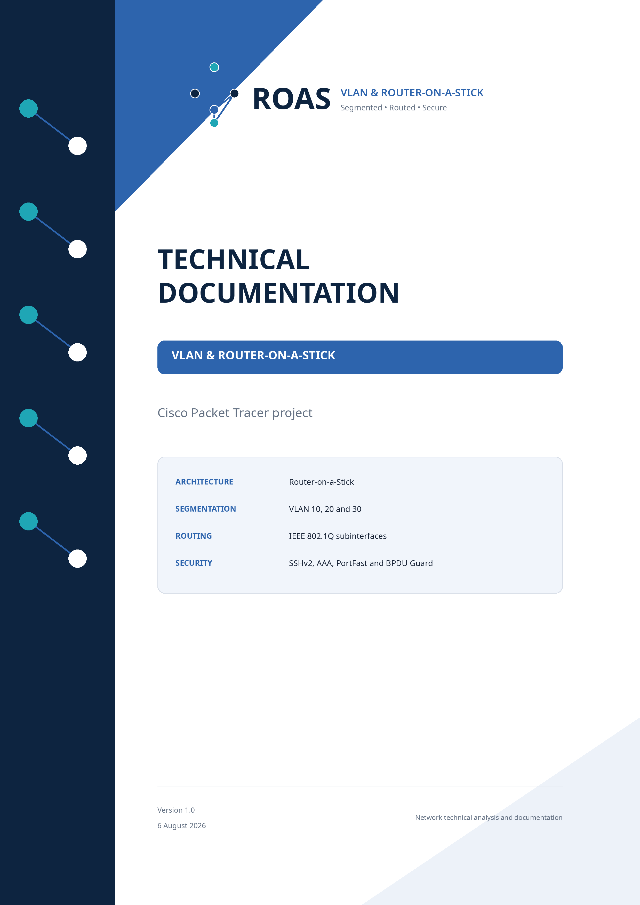

Document control
Field | Value
Document title | Technical Documentation - VLAN and Router-on-a-Stick
Version | 1.0
Date | 6 August 2026
Status | Final technical analysis of the supplied project
Platform | Cisco Packet Tracer
Covered devices | R1, SW1 and three PCs
Sources | Packet Tracer .pkt file, router and switch running-config exports, and the lab brief

Scope and reliability: VLANs, switch ports, subinterfaces, gateway addresses and security settings are taken directly from the supplied configurations. End-device IP addresses are not present in the text exports, so they are shown as unconfirmed and accompanied by recommended test values.

Contents
1. Introduction and project description
2. Project objectives and requirements
3. Network architecture and topology
4. Devices used
5. Technologies and protocols
6. Addressing table
7. VLAN plan
8. Detailed network diagram
9. Configuration analysis
10. Problem and solution
11. Testing and verification plan
12. Limitations and recommendations
13. Conclusion
Appendix A - Key configuration commands

1. Introduction and project description
Lab 01 is a small segmented LAN implemented in Cisco Packet Tracer. The network contains one Cisco 2911 router, one Cisco 2960 Layer 2 switch and three end computers. Each computer represents a separate organisational sector: Management, Sales and IT. The design uses the Router-on-a-Stick model, where one physical router interface is divided into IEEE 802.1Q subinterfaces and carries traffic for multiple VLANs over a single trunk link.
SW1 provides Layer 2 segmentation and assigns each access port to a dedicated VLAN. R1 provides the default gateway for every VLAN and performs inter-VLAN routing. The design also includes SSHv2 with local AAA authentication for remote administration, PVST on the switch, and PortFast with BPDU Guard on user-facing access ports.
Solution summary: A single 802.1Q trunk connects R1 and SW1. VLAN 10 uses 192.168.1.0/24, VLAN 20 uses 192.168.2.0/24, and VLAN 30 uses 192.168.3.0/24. The router subinterface ending in .1 is the gateway for each segment.

2. Project objectives and requirements
- Create three logically separated broadcast domains for Management, Sales and IT.
- Allow devices in the same VLAN to communicate at Layer 2.
- Enable communication between different VLANs through R1.
- Carry VLAN 10, 20 and 30 over a single 802.1Q trunk.
- Use SSH, not Telnet, for remote administration.
- Protect user-facing switch ports with PortFast and BPDU Guard.
3. Network architecture and topology
The design is a compact two-device topology. SW1 is responsible for access-layer switching and VLAN membership. Its Gi0/1 interface is configured as a static trunk that permits VLANs 10, 20 and 30. R1 uses physical interface G0/0 without an IP address and three tagged subinterfaces, one per VLAN. Frames arriving over the trunk are classified by their 802.1Q tag, routed between IP subnets, and returned over the same physical link.

3.1. Topology image
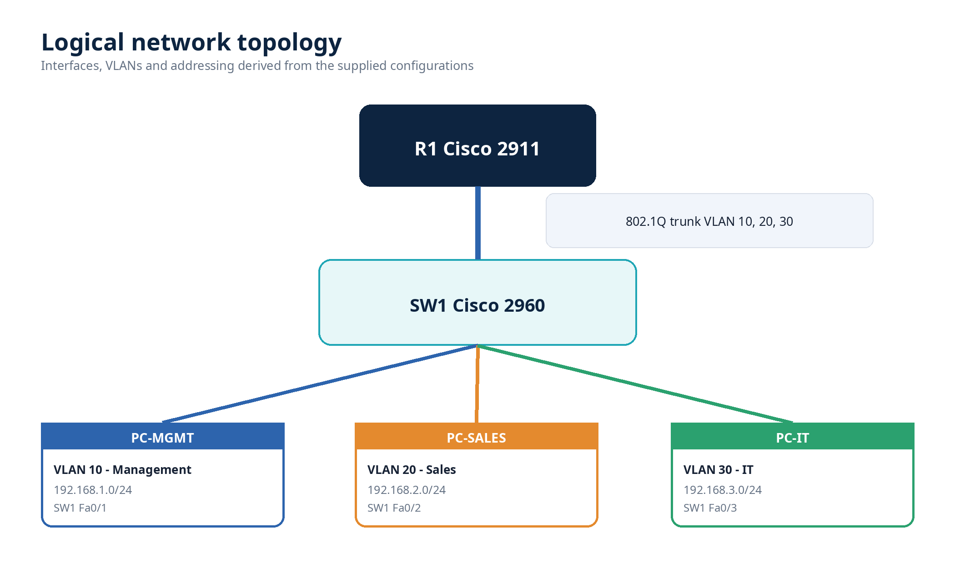
Figure 1 - Reconstructed logical topology of the network
4. Devices used
Label | Type/model | Role | IOS | Interfaces | Main functions
R1 | Cisco 2911/K9 | Inter-VLAN router | IOS 15.1 | 3× GigabitEthernet | 802.1Q subinterfaces, routing, SSH, AAA
SW1 | Cisco 2960 | Layer 2 access switch | IOS 15.0 | 24× FastEthernet + 2× GigabitEthernet | VLAN access ports, trunk, PVST, PortFast, BPDU Guard, SSH
PC-MGMT | Packet Tracer PC | Management endpoint | - | FastEthernet | VLAN 10 client
PC-SALES | Packet Tracer PC | Sales endpoint | - | FastEthernet | VLAN 20 client
PC-IT | Packet Tracer PC | IT endpoint | - | FastEthernet | VLAN 30 client

5. Technologies and protocols
Technology / protocol | Role in the project
VLAN (IEEE 802.1Q) | Separates Management, Sales and IT into independent Layer 2 broadcast domains.
Static 802.1Q trunk | Carries VLAN 10, 20 and 30 between SW1 Gi0/1 and R1 G0/0.
Router-on-a-Stick | Uses one router interface and multiple tagged subinterfaces for inter-VLAN routing.
IPv4 /24 addressing | Each VLAN is assigned a separate 255.255.255.0 subnet.
PVST | Maintains a separate spanning-tree instance per VLAN.
PortFast + BPDU Guard | Accelerates access-port activation and disables a port if unexpected BPDUs are received.
SSHv2 + local AAA | Restricts remote CLI administration to encrypted SSH sessions using a local user database.
Cisco CEF | Enabled on R1 for IPv4 packet forwarding.

6. Addressing table
Device / interface | VLAN | IP address / prefix | Default gateway | Status / note
R1 G0/0 | Trunk | No IP address | - | Parent physical interface
R1 G0/0.10 | 10 | 192.168.1.1/24 | - | Default gateway for Management
R1 G0/0.20 | 20 | 192.168.2.1/24 | - | Default gateway for Sales
R1 G0/0.30 | 30 | 192.168.3.1/24 | - | Default gateway for IT
SW1 management SVI | 10 | Not configured | 192.168.1.1 | Recommended: 192.168.1.2/24
PC-MGMT | 10 | Not confirmed | 192.168.1.1 | Suggested test: 192.168.1.10/24
PC-SALES | 20 | Not confirmed | 192.168.2.1 | Suggested test: 192.168.2.10/24
PC-IT | 30 | Not confirmed | 192.168.3.1 | Suggested test: 192.168.3.10/24

7. VLAN plan
VLAN | Name | Subnet | Gateway | Port / link | Purpose
10 | Management | 192.168.1.0/24 | 192.168.1.1 | SW1 Fa0/1 | Network administration and management endpoint
20 | Sales | 192.168.2.0/24 | 192.168.2.1 | SW1 Fa0/2 | Sales endpoint
30 | IT | 192.168.3.0/24 | 192.168.3.1 | SW1 Fa0/3 | IT endpoint
Trunk | 802.1Q | - | - | SW1 Gi0/1 ↔ R1 G0/0 | Allowed VLANs: 10, 20, 30

The configured VLAN identifiers do not numerically match the third octet of their IP subnets (for example, VLAN 10 uses 192.168.1.0/24). This is technically valid because VLAN IDs and IP network numbers are independent. A production naming convention could align them for easier operations, but no functional change is required.
8. Detailed network diagram
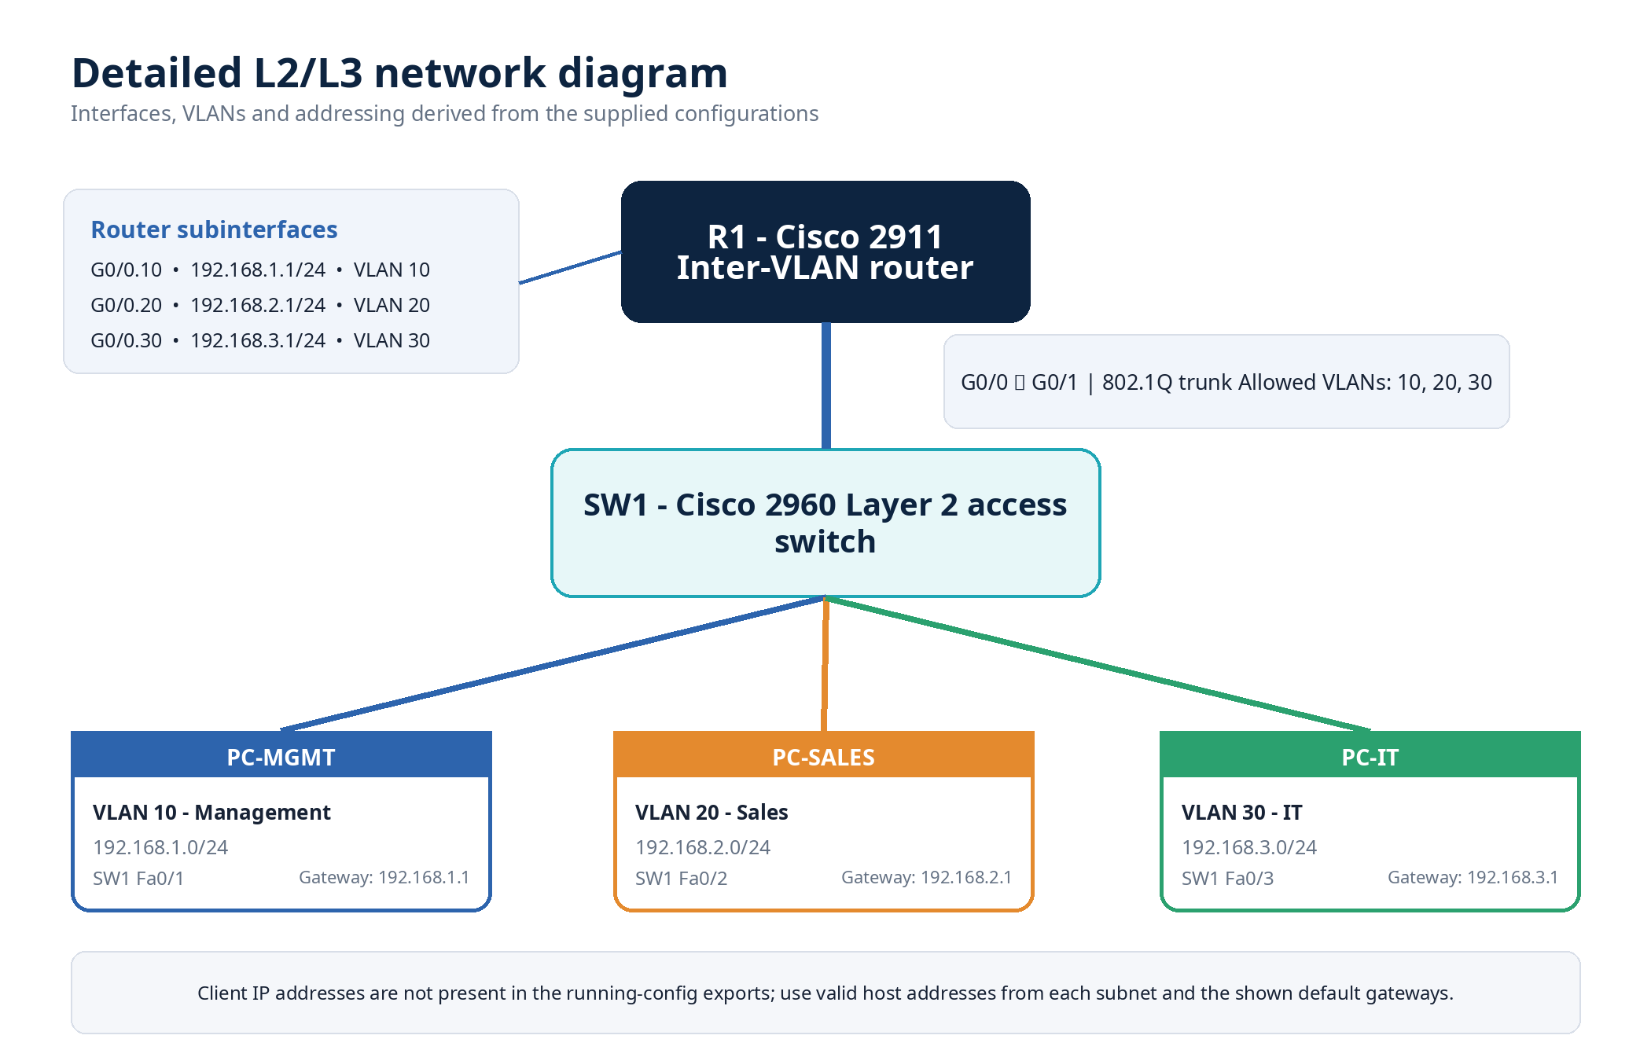
Figure 2 - Detailed L2/L3 diagram with interfaces, VLANs and gateway addresses

9. Configuration analysis
9.1. R1 - Router-on-a-Stick router
R1 is a Cisco 2911/K9 running IOS 15.1. Physical interface G0/0 has no IP address and acts only as the parent interface for three logical subinterfaces. Each subinterface uses an encapsulation dot1Q command with the matching VLAN ID and owns the .1 gateway address of its subnet. G0/1 and G0/2 are administratively shut down. IPv4 CEF is enabled and IPv6 CEF is disabled.
interface GigabitEthernet0/0.10
encapsulation dot1Q 10
ip address 192.168.1.1 255.255.255.0
interface GigabitEthernet0/0.20
encapsulation dot1Q 20
ip address 192.168.2.1 255.255.255.0
interface GigabitEthernet0/0.30
encapsulation dot1Q 30
ip address 192.168.3.1 255.255.255.0

9.2. SW1 - Layer 2 access switch
SW1 is a Cisco 2960 running IOS 15.0. Fa0/1, Fa0/2 and Fa0/3 are static access ports assigned to VLANs 10, 20 and 30. PortFast and BPDU Guard are enabled on all three user-facing ports. Gi0/1 is a manually configured trunk and restricts the allowed VLAN list to 10, 20 and 30. PVST is active.
interface FastEthernet0/1
switchport access vlan 10
switchport mode access
spanning-tree portfast
spanning-tree bpduguard enable
interface GigabitEthernet0/1
switchport trunk allowed vlan 10,20,30
switchport mode trunk

9.3. Management and security configuration
Both devices enable AAA new-model, define a local user account, set the domain name lab.local and force SSH version 2. R1 applies local AAA authentication to all configured VTY lines. SW1 applies it to VTY 0-4, while VTY 5-15 remain without the same explicit hardening. The supplied configuration contains hashed enable and user secrets, but service password-encryption is disabled; this does not expose the existing secret values as plaintext, although modern production IOS should prefer stronger type 8 or type 9 secrets where supported.

10. Problem and solution
10.1. Identified problem - SW1 cannot be managed remotely by IP
The project requirement states that router and switch administration must use SSH. SSH-related global and VTY settings exist on SW1, but the switch has no active Layer 3 management interface. Interface Vlan1 is shut down and has no IP address, while no SVI for VLAN 10 is configured. As a result, SW1 has no reachable management IP address and remote SSH access to the switch cannot operate, even though the SSH service settings are present.
10.2. Root cause
- No management SVI IP address is configured on SW1.
- No default gateway is configured for management traffic leaving the local subnet.
- VTY lines 5-15 do not explicitly enforce the same AAA and SSH-only policy as VTY 0-4.
10.3. Recommended correction
Use VLAN 10 as the switch management VLAN, assign an unused address from 192.168.1.0/24, configure R1 as the default gateway, and secure all VTY lines. The example below uses 192.168.1.2/24.
interface Vlan10
description Management-SVI
ip address 192.168.1.2 255.255.255.0
no shutdown
ip default-gateway 192.168.1.1
line vty 0 15
logging synchronous
login authentication default
transport input ssh

Expected result: SW1 becomes reachable at 192.168.1.2. Administrators can connect with SSH from any routed VLAN that is not blocked by an ACL, and Telnet is rejected on every VTY line.

10.4. Additional hardening
- Administratively shut down unused switch ports Fa0/4-24 and Gi0/2.
- Place unused ports in a dedicated unused VLAN and force access mode.
- Consider a non-default native VLAN on the trunk and disable DTP negotiation where supported.
- Verify that RSA keys exist and regenerate stronger keys if necessary.

11. Testing and verification plan
Step | Check | Command / action | Expected result
1 | Verify VLANs | show vlan brief | VLAN 10, 20 and 30 exist and Fa0/1-3 are assigned correctly.
2 | Verify trunk | show interfaces trunk | Gi0/1 is trunking and permits 10,20,30.
3 | Verify subinterfaces | show ip interface brief | G0/0.10, .20 and .30 are up/up with correct gateway addresses.
4 | Test local gateway | ping 192.168.X.1 | Each PC reaches its own gateway.
5 | Test inter-VLAN routing | ping between PCs | All three VLANs communicate through R1.
6 | Verify SSH to R1 | ssh -l mihajlok 192.168.X.1 | Encrypted login succeeds; Telnet is not accepted.
7 | Verify SSH to SW1 | ssh -l mihajlok 192.168.1.2 | Works after the management SVI correction.
8 | Verify BPDU Guard | Connect a switch to an access port | Port enters err-disabled after receiving a BPDU.

12. Limitations and recommendations
- Only one PC is provided per VLAN, so the requirement “hosts in the same VLAN can communicate” cannot be directly demonstrated. Add a second test host to each VLAN for a complete intra-VLAN test.
- The end-device addresses are not visible in the supplied text configurations. The recommended .10 addresses in this document are test values, not confirmed project data.
- The router is a single point of failure. A production design could use a multilayer switch pair or redundant routers with a first-hop redundancy protocol.
- All inter-VLAN traffic shares one physical link. Capacity and availability are therefore limited by that link.
- Interface descriptions should be standardised and typographical errors corrected for easier operations.
13. Conclusion
The project correctly demonstrates the core Router-on-a-Stick concept: VLAN segmentation on a Layer 2 switch, 802.1Q trunking, per-VLAN router subinterfaces and inter-VLAN communication through a common physical interface. PortFast, BPDU Guard, SSHv2 and local AAA add useful operational and security elements. The main functional gap is the absence of a management IP address on SW1, which prevents the stated SSH-only switch administration requirement from being fully met. After adding a VLAN 10 management SVI, a default gateway and consistent VTY hardening, the lab becomes a complete and technically coherent introductory VLAN routing solution.
Final assessment: The topology is appropriate for learning VLANs and inter-VLAN routing. With the documented management correction and hardening steps, it is also suitable as a clean reference lab.

Appendix A - Key configuration commands
A.1. Operational verification
show ip interface brief
show vlan brief
show interfaces trunk
show interfaces switchport
show spanning-tree vlan 10,20,30
show running-config
show users
show ssh
show crypto key mypubkey rsa
ping <destination-ip>
traceroute <destination-ip>

A.2. Confirmed port mapping
Interface | Mode | VLAN | Purpose / address | Key setting
SW1 Fa0/1 | Access | 10 | Management / PC-MGMT | PortFast, BPDU Guard
SW1 Fa0/2 | Access | 20 | Sales / PC-SALES | PortFast, BPDU Guard
SW1 Fa0/3 | Access | 30 | IT / PC-IT | PortFast, BPDU Guard
SW1 Gi0/1 | Trunk | 10,20,30 | Link to R1 G0/0 | Static trunk
R1 G0/0.10 | L3 subinterface | 10 | 192.168.1.1/24 | dot1Q 10
R1 G0/0.20 | L3 subinterface | 20 | 192.168.2.1/24 | dot1Q 20
R1 G0/0.30 | L3 subinterface | 30 | 192.168.3.1/24 | dot1Q 30

A.3. Source files
- Lab01_VLAN_Router_on_a_Stick.pkt - original Cisco Packet Tracer project.
- Lab 01 Router.txt - R1 running-config export.
- Lab 01 Switch cfg.txt - SW1 running-config export.
- Lab01 VLAN_Router-on_a_stick.docx - laboratory brief and requirements.

