**Task_1 Website**

This is a website for Audit Course of Web Development provided by Vidyalankar Institute of Technology and Kids Galaxy

This Project is helpful to understand Basic HTML and CSS Contains Three Web pages with Navigation bar and Footer

Start the Website from Home.html About Me - About.html Contact Us Page - Contact.html

Some Common tags and properties used in this website are:

**HTML Tags:**

**li** - tag defines a list item.

**ul** - The li tag used under this tag which mentions Unordered Lists

**p** - tag defines a paragraph

**h1 and h2** - tag defines headings

**div** - tag defines division and section in a document that is styled with CSS

**CSS Properties:**

**background-color** -property sets the background colour of an element

**padding**-Padding is used to create space around an element's content, inside of any defined borders.

**Position** -property specifies the type of positioning method used for an element

**text align** -property specifies the horizontal alignment of text in an element

**decoration** -property specifies the decoration added to text, and is a shorthand property

**overflow** -property specifies what should happen if content overflows an element's box.

**list-style-type**- specifies the type of list-item marker in a list**.**

**Output:-**

Home Page:-  
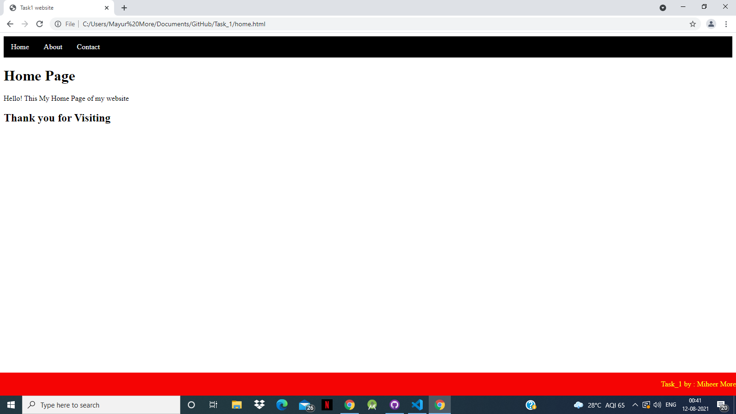

About Me:- 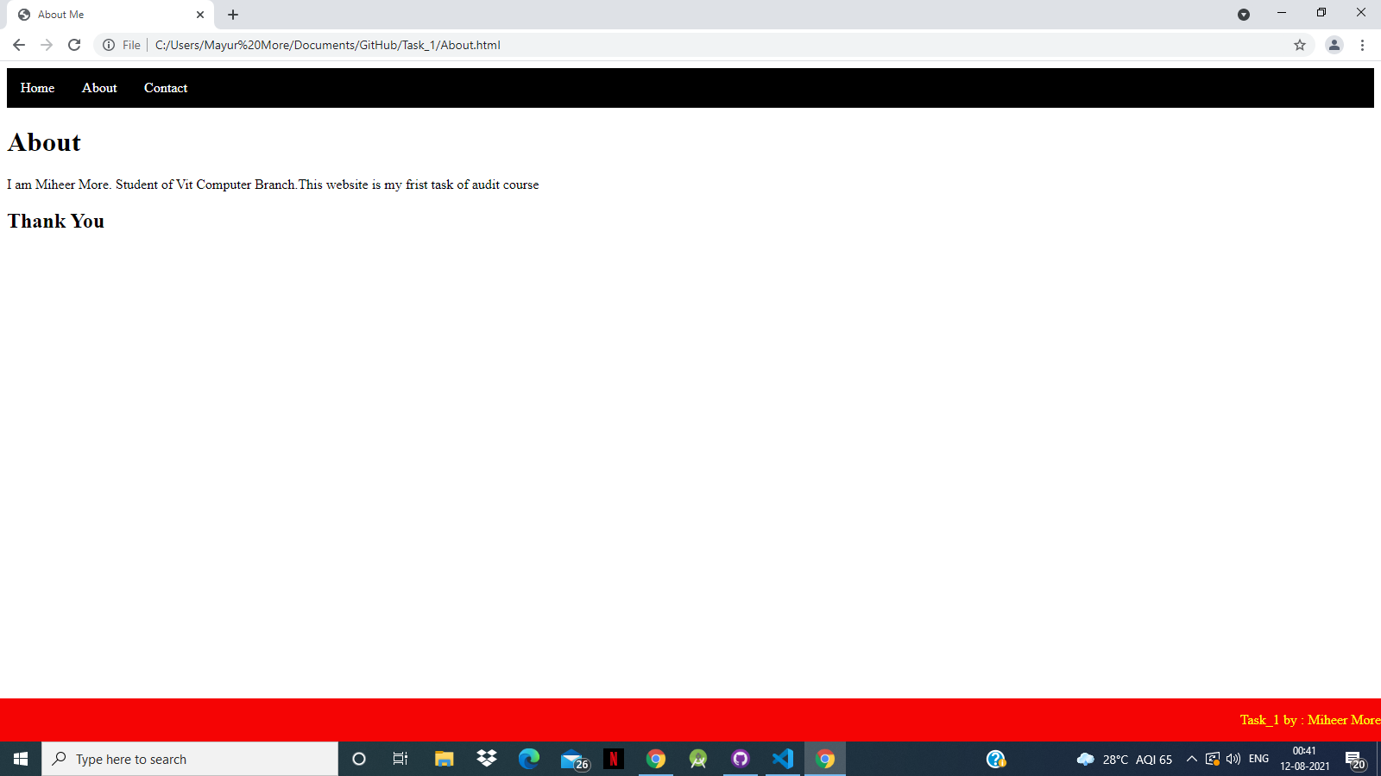

Contact :-

