Name: Miheer Abhyankar

Code Challenge

SQL

Q1 - Update the daily rate for a Mercedes car to 68.

Query –

UPDATE Vehicle

SET dailyRate = 68

WHERE make = 'Mercedes'

Output:

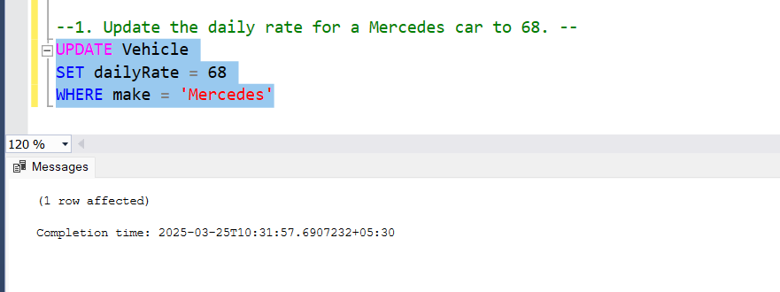

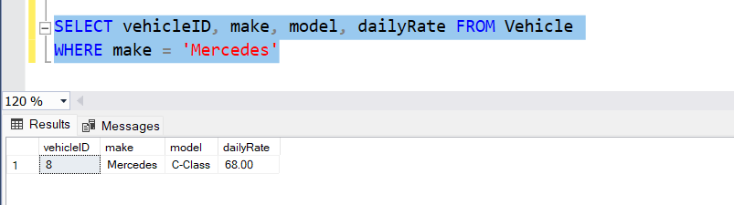

Q2 - Delete a specific customer and all associated leases and payments.

Query –

DELETE FROM Payment

WHERE leaseID IN (SELECT leaseID FROM Lease WHERE customerID = 2)

DELETE FROM Lease

WHERE customerID = 2

DELETE FROM Customer

WHERE customerID = 2

Output:

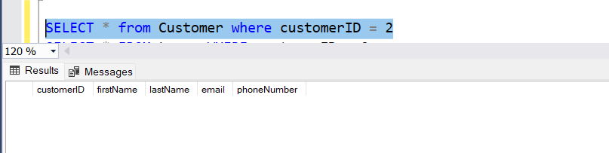

No record for customerID = 2

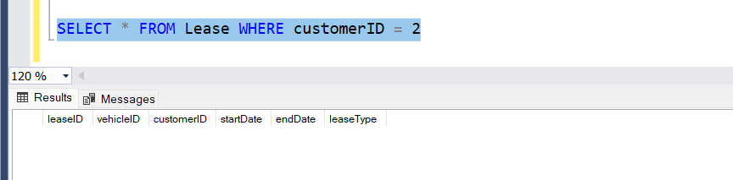

Q3 - Rename the "paymentDate" column in the Payment table to "transactionDate".

Query –

EXEC sp_rename 'Payment.paymentDate', 'transactionDate', 'COLUMN'

Output:

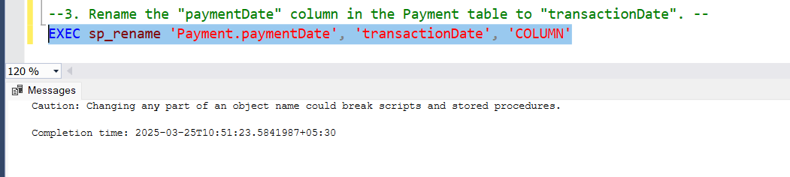

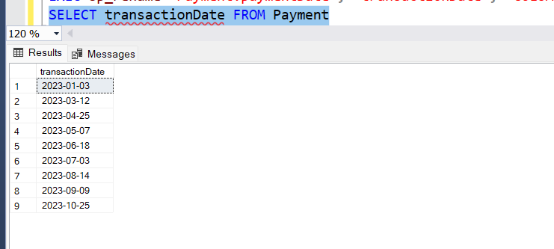

Q4 - Find a specific customer by email.

Query –

SELECT * FROM Customer

WHERE email = 'sarah@example.com'

Output:

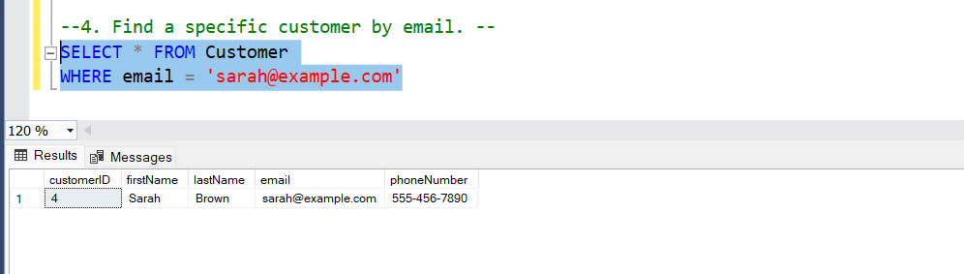

Q5 - Get active leases for a specific customer.

Query –

SELECT * FROM Lease

WHERE customerID = 3 AND endDate >= GETDATE()

Output:

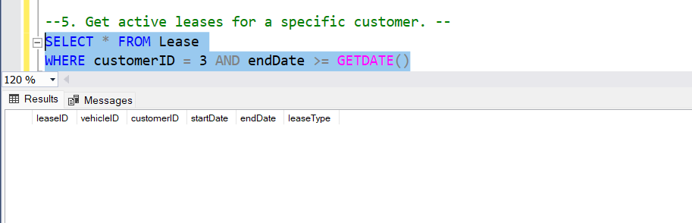

Returns nothing because the latest record lies in 2023.

Q6 - Find all payments made by a customer with a specific phone number.

Query –

SELECT Payment.* FROM Payment

JOIN Lease ON Payment.leaseID = Lease.leaseID

JOIN Customer ON Lease.customerID = Customer.customerID

WHERE Customer.phoneNumber = '555-555-5555'

Output:

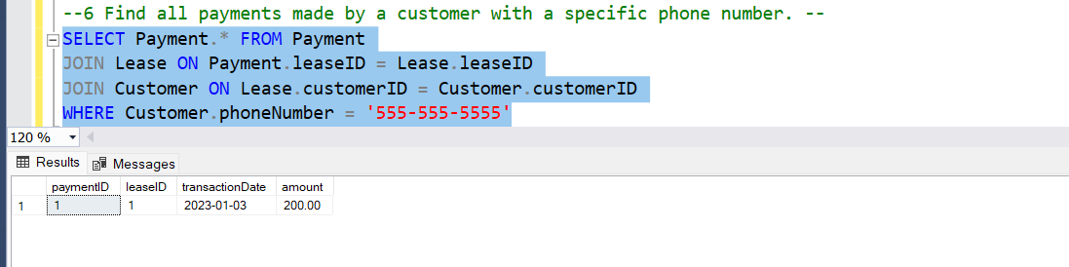

Q7 - Calculate the average daily rate of all available cars.

Query –

SELECT AVG(dailyRate) as Avg_Daily_Rate

FROM Vehicle

WHERE status = 'available'

Output:

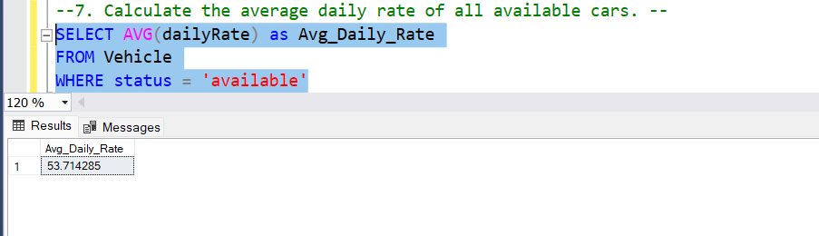

Q8 – Find the car with the highest daily rate.

Query –

SELECT TOP 1 * FROM Vehicle

ORDER BY dailyRate DESC

Output:

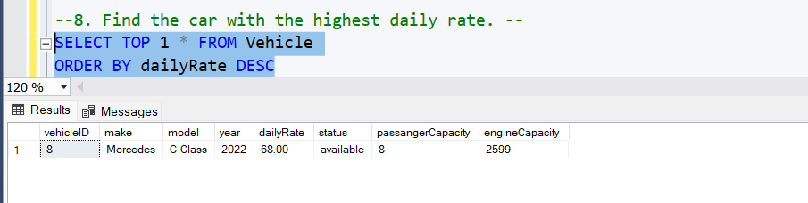

Q9 - Retrieve all cars leased by a specific customer.

Query –

SELECT Vehicle.* FROM Vehicle

JOIN Lease ON Lease.vehicleID = Vehicle.vehicleID

WHERE customerID = 7

Output:

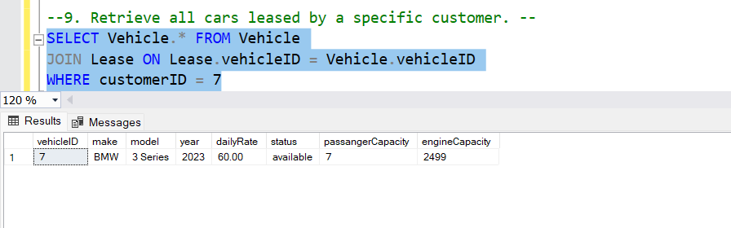

Q10 - Find the details of the most recent lease.

Query –

SELECT TOP 1 * FROM Lease

ORDER BY startDate DESC

Output:

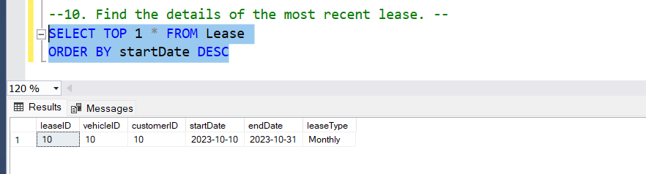

Q11 - List all payments made in the year 2023.

Query –

SELECT * FROM Payment

WHERE YEAR(transactionDate) = '2023'

Output:

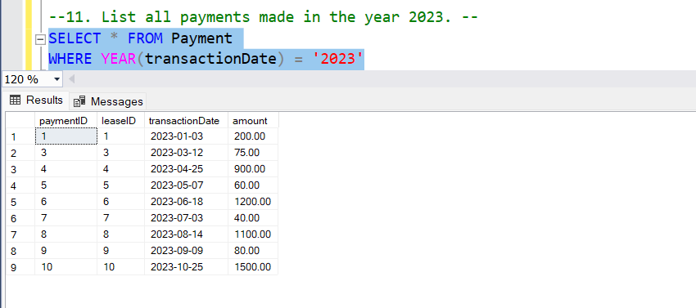

Q12 - Retrieve customers who have not made any payments.

Query –

SELECT * FROM Customer

WHERE NOT EXISTS (

SELECT 1 FROM Lease

JOIN Payment ON Lease.leaseID = Payment.leaseID

WHERE Customer.customerID = Lease.customerID

)

Output:

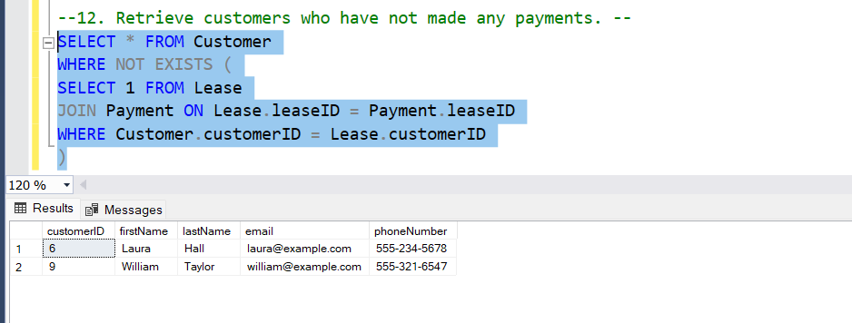

Q13 - Retrieve Car Details and Their Total Payments.

Query –

SELECT Vehicle.vehicleID, make, model, SUM(Payment.amount) as total_payment FROM Vehicle

JOIN Lease ON Vehicle.vehicleID = Lease.vehicleID

JOIN Payment ON Lease.leaseID = Payment.leaseID

GROUP BY Vehicle.vehicleID, Vehicle.make, Vehicle.model

Output:

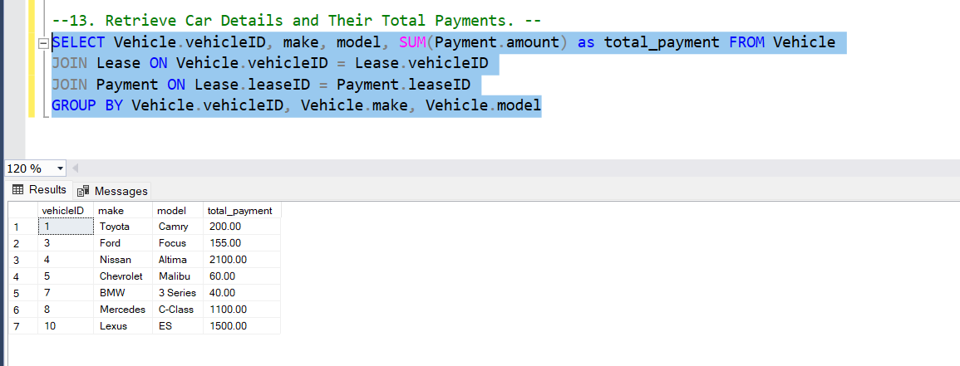

Q14 - Calculate Total Payments for Each Customer.

Query –

SELECT C.customerID, c.firstName, c.lastName, SUM(Payment.amount) as Total_Spend FROM Customer c

JOIN Lease ON Lease.customerID = c.customerID

JOIN Payment ON Payment.leaseID = Lease.leaseID

GROUP BY c.customerID, c.firstName, c.lastName

Output:

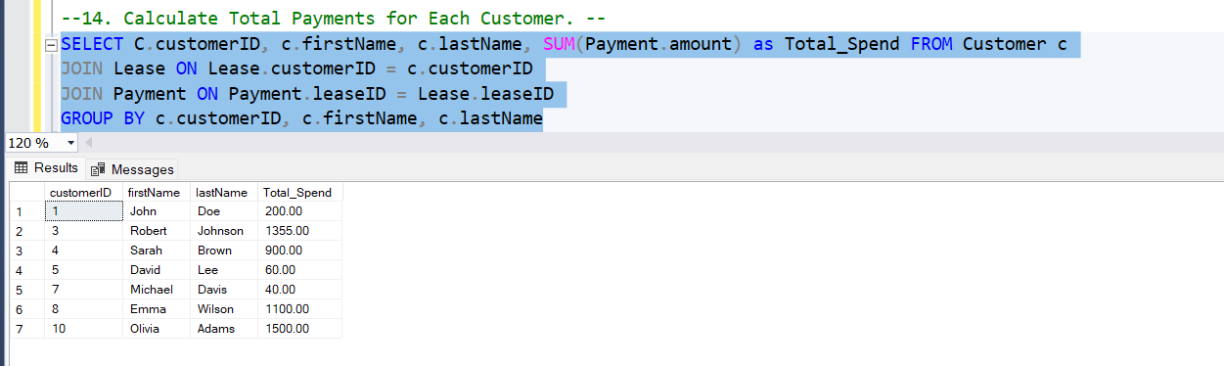

Q15 - List Car Details for Each Lease.

Query –

SELECT L.leaseID, v.vehicleID, make, model, c.firstName, c.lastName, L.startDate, L.endDate, L.leaseType

FROM Lease L

JOIN Vehicle v ON L.vehicleID = v.vehicleID

JOIN Customer c ON L.customerID = c.customerID

Output:

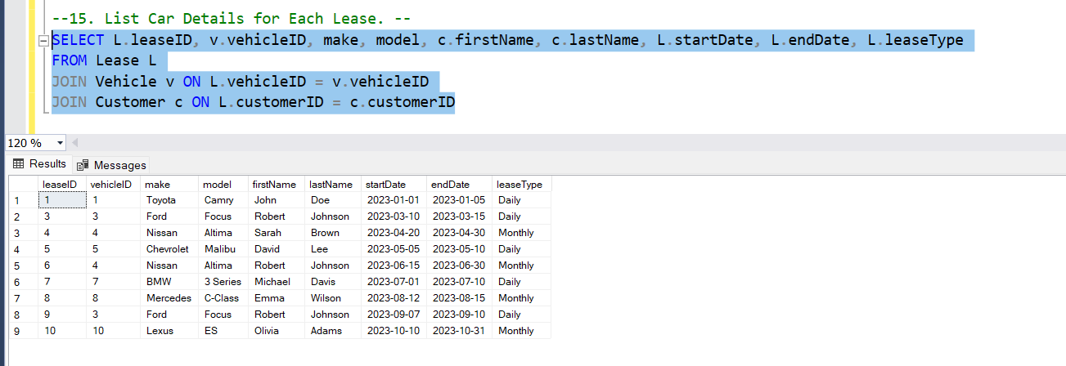

Q16 - Retrieve Details of Active Leases with Customer and Car Information.

Query –

SELECT L.leaseID, C.firstName, C.lastName, V.make, V.model, L.startDate, L.endDate, L.leasetype

FROM Lease L

JOIN Customer C ON L.customerID = C.customerID

JOIN Vehicle V ON L.vehicleID = V.vehicleID

WHERE L.endDate >= GETDATE()

Output:

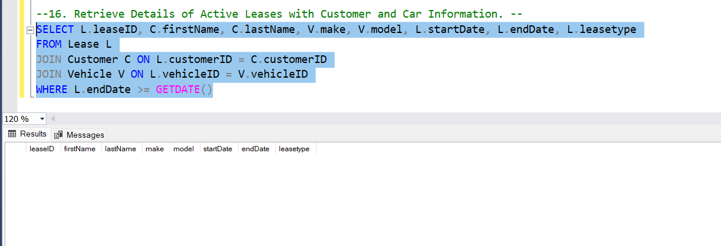

Empty because latest lease lies in 2023.

Q17 - Find the Customer Who Has Spent the Most on Leases.

Query –

SELECT TOP 1 C.customerID, C.firstName, C.lastName, SUM(P.amount) as Total_Spent

FROM Customer C

JOIN Lease L ON C.customerID = L.customerID

JOIN Payment P ON L.leaseID = P.leaseID

GROUP BY C.customerID, C.firstName, C.lastName

ORDER BY Total_Spent DESC

Output:

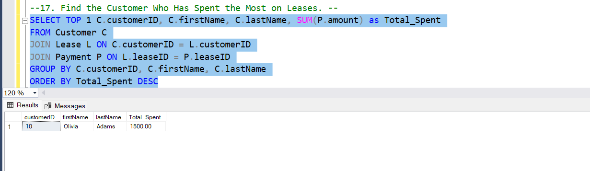

Q18 - List All Cars with Their Current Lease Information.

Query –

SELECT V.vehicleID, V.make, V.model, L.leaseID, L.leasetype, C.firstName, C.lastName, L.startDate, L.endDate

FROM Vehicle V

JOIN Lease L ON V.vehicleID = L.vehicleID

JOIN Customer C ON C.customerID = L.customerID

Output:

