4.3.1 Overview of the Proposed System
The proposed Datacenter Resource Management and Predictive Analytics System is a centralized web-based application developed to improve the monitoring, management, and prediction of datacenter resources. The system integrates resource monitoring, equipment inventory management, predictive analytics, reporting, and user management into a single platform. It collects operational data from various datacenter components, processes the data using machine learning algorithms, and presents the results through interactive dashboards that support timely and informed decision-making.
Unlike the existing environment, where administrators relied on multiple vendor-specific monitoring tools, the proposed system provides a unified interface that consolidates resource information across the entire datacenter. The system continuously monitors CPU utilization, memory usage, storage capacity, network performance, and equipment status while applying machine learning models to predict future resource utilization, identify abnormal behaviour, and generate early warning alerts. This enables administrators to perform proactive maintenance, optimize resource allocation, improve system availability, and enhance the overall efficiency and reliability of the datacenter infrastructure.

4.3.2 Functional Requirements
The functional requirements define the core services and operations that the proposed Datacenter Resource Management and Predictive Analytics System must perform to support efficient monitoring, management, and predictive analysis of datacenter resources.
Table 2: Functional Requirements of the Proposed System
No. | Functional Requirement | Description
1 | User Authentication | The system shall allow users to securely log in and access the system according to their roles.
2 | Dashboard Management | The system shall display real-time summaries of datacenter resource utilization and equipment status.
3 | Server Monitoring | The system shall monitor CPU usage, memory utilization, storage, and server health.
4 | Storage Monitoring | The system shall monitor storage capacity, utilization, and available disk space.
5 | Network Monitoring | The system shall monitor network traffic, bandwidth utilization, latency, and connectivity status.
6 | Equipment Inventory Management | The system shall maintain records of servers, switches, routers, storage devices, and other datacenter equipment.
7 | Resource Utilization Monitoring | The system shall continuously collect and display resource utilization metrics from datacenter devices.
8 | Predictive Analytics | The system shall use machine learning algorithms to predict resource utilization trends and potential equipment failures.
9 | Alert Management | The system shall generate alerts when abnormal resource utilization or potential failures are detected.
10 | Report Generation | The system shall generate monitoring reports, performance reports, and prediction reports.
11 | User Management | The system shall allow administrators to create, update, delete, and manage user accounts and permissions.
Source: Researcher (2026)

4.3.3 Non-Functional Requirements
The non-functional requirements describe the quality attributes that the proposed Datacenter Resource Management and Predictive Analytics System should satisfy to ensure reliable, secure, and efficient operation.
Table 3: Non-Functional Requirements of the Proposed System
No. | Non-Functional Requirement | Description
1 | Performance | The system shall provide real-time monitoring and respond to user requests with minimal delay.
2 | Reliability | The system shall operate continuously with high availability and accurately monitor datacenter resources.
3 | Security | The system shall protect user accounts and system data through secure authentication and role-based access control.
4 | Scalability | The system shall support the addition of new servers, storage devices, network equipment, and users without affecting performance.
5 | Usability | The system shall provide a simple, user-friendly interface that enables administrators to perform monitoring and management tasks efficiently.
6 | Maintainability | The system shall be easy to update, troubleshoot, and maintain to accommodate future improvements.
7 | Availability | The system shall remain accessible to authorized users whenever monitoring and management services are required.
8 | Compatibility | The system shall integrate with different datacenter devices and support multiple hardware vendors.
9 | Data Integrity | The system shall ensure that monitoring data and prediction results remain accurate and consistent during storage and processing.
10 | Backup and Recovery | The system shall support data backup and recovery mechanisms to minimize data loss in case of system failure.
Source: Researcher (2026)

4.3.4 Proposed System Workflow
The proposed Datacenter Resource Management and Predictive Analytics System follows an automated workflow that integrates real-time resource monitoring with machine learning-based predictive analytics. The process begins when an authenticated user logs into the system and accesses the monitoring dashboard. The system continuously collects resource utilization data from servers, storage devices, network equipment, and other datacenter infrastructure components.
The collected data are stored in a centralized database and processed by the machine learning module, which analyses historical and real-time resource information to identify usage patterns, predict future resource utilization, and detect abnormal system behaviour. Based on the prediction results, the system generates alerts and recommendations whenever potential equipment failures or resource bottlenecks are detected. Finally, the processed information is displayed through interactive dashboards and reports to support timely decision-making, proactive maintenance, and efficient resource management.
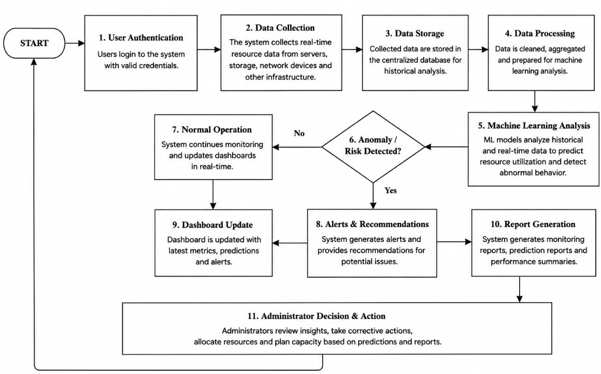
Figure 3: Proposed Datacenter Resource Management System Workflow
Figure 4.2 illustrates the workflow of the proposed system. The process starts with user authentication, followed by automatic data collection from datacenter devices. The collected data are stored and analysed by the machine learning engine to generate predictions and detect anomalies. The system then produces alerts, updates the monitoring dashboard, and generates reports to assist administrators in managing datacenter resources proactively.

4.3.5 Advantages of the Proposed System
The proposed Datacenter Resource Management and Predictive Analytics System provides several improvements over the existing system used at the Rwanda Revenue Authority Main Datacenter. It centralizes resource monitoring, reduces dependence on multiple vendor-specific platforms, and provides a unified view of servers, storage devices, network equipment, and other infrastructure components.
The system also applies machine learning to analyze historical and real-time data, predict resource utilization, detect abnormal behaviour, and provide early warning alerts. This supports proactive maintenance, improves resource allocation, reduces downtime, and enhances decision-making. In addition, automated dashboards and reports reduce manual work and improve the accuracy, availability, and accessibility of datacenter information.
Table 4: Comparison of the Existing and Proposed Systems
Area | Existing System | Proposed System
Monitoring | Uses separate vendor-specific tools | Provides centralized monitoring
Data management | Data is fragmented across platforms | Data is stored in a centralized database
Fault detection | Mainly manual and reactive | Automated and predictive
Resource analysis | Limited historical analysis | Machine learning-based trend analysis
Alerts | Depends on basic thresholds | Provides intelligent alerts and recommendations
Reporting | Reports are prepared manually | Reports are generated automatically
Decision-making | Based mainly on current observations | Supported by real-time and predictive insights
Maintenance | Problems are addressed after occurrence | Supports proactive maintenance
Resource planning | Limited capacity forecasting | Predicts future resource requirements
Operational efficiency | Time-consuming and complex | Faster, integrated, and efficient
Source: Researcher (2026)
The proposed system therefore offers a more intelligent, proactive, and integrated approach to datacenter resource management. It improves operational visibility, strengthens system reliability, and supports better planning and utilization of RRA datacenter resources.

4.4 System Design
The system design presents the structural and behavioural representation of the proposed Datacenter Resource Management and Predictive Analytics System. It shows how the different system components, users, database, monitoring devices, and machine learning modules interact to support centralized datacenter monitoring and predictive decision-making. The design was developed based on the functional and non-functional requirements identified during the analysis of the existing system.

4.4.1 Overall System Architecture
The overall system architecture was designed using a layered structure composed of the presentation layer, application layer, data layer, monitoring layer, and machine learning layer. The presentation layer provides web-based interfaces through which authorized users access dashboards, equipment information, alerts, predictive results, and reports. The application layer processes user requests and coordinates communication between the interfaces, database, monitoring services, and machine learning module.
The monitoring layer collects operational data from servers, storage devices, network equipment, and virtualization platforms. The collected data include CPU utilization, memory usage, storage capacity, network traffic, equipment status, and other performance indicators. These data are stored in the centralized database and transferred to the machine learning layer for preprocessing, pattern identification, resource forecasting, and anomaly detection.
The machine learning layer analyses historical and real-time resource data and generates predictions, alerts, and recommendations. The results are returned to the application layer and displayed to system administrators through the monitoring dashboard. This architecture enables centralized monitoring, automated analysis, secure data management, predictive maintenance, and timely decision-making within the Rwanda Revenue Authority Main Datacenter.
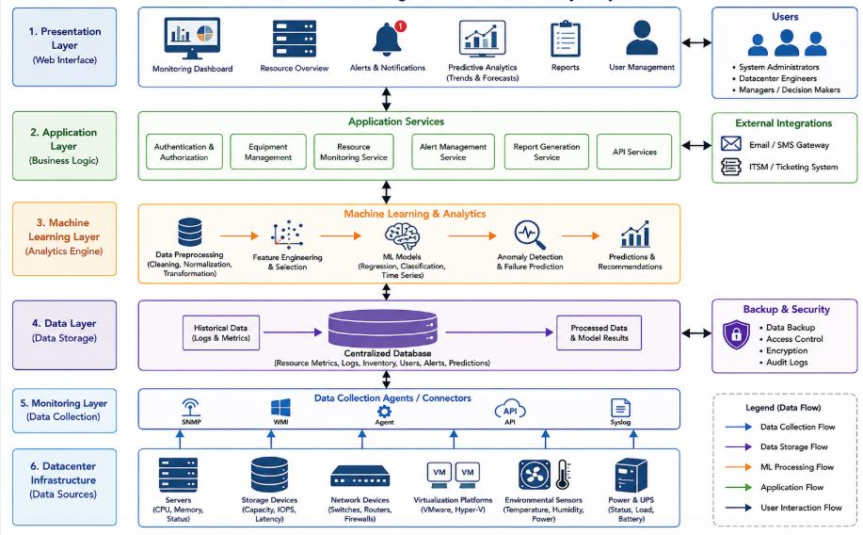
Figure 4: Overall System Architecture

4.4.2 Machine Learning Architecture
The machine learning architecture explains how datacenter resource data are collected, processed, analysed, and converted into predictions and recommendations. The process begins with the collection of historical and real-time data from servers, storage devices, network equipment, virtualization platforms, power systems, and environmental sensors. The collected data include CPU utilization, memory usage, storage capacity, network traffic, equipment status, temperature, power consumption, and system logs.
The data are then cleaned, normalized, and transformed before relevant features are selected for model development. The processed dataset is divided into training and testing sets. Machine learning algorithms are trained to identify resource utilization patterns, detect abnormal behaviour, and predict possible equipment failures or future resource demand. The trained model is then evaluated using suitable performance measures such as accuracy, precision, recall, F1-score, Mean Absolute Error, Root Mean Squared Error, and R-squared, depending on the prediction task.
After evaluation, the best-performing model is integrated into the system. It continuously receives new datacenter data, generates predictions, identifies risks, and provides recommendations. The results are stored in the centralized database and displayed through dashboards, alerts, and reports to support proactive maintenance and resource planning.
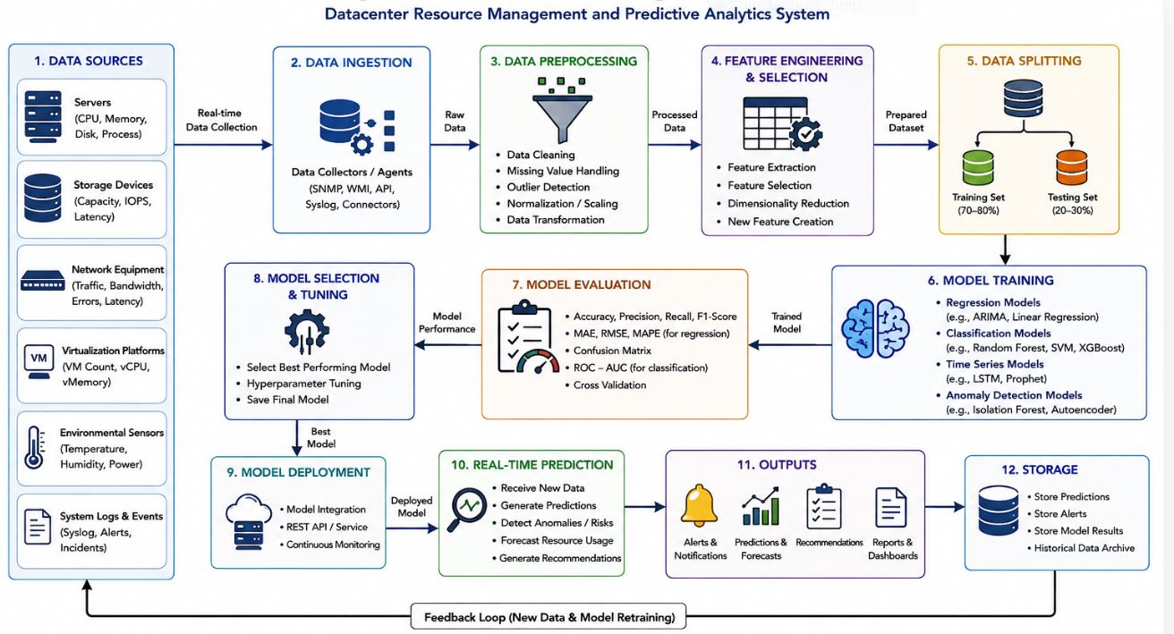
Figure 5: Machine Learning Architecture

4.4.3 Use Case Diagram
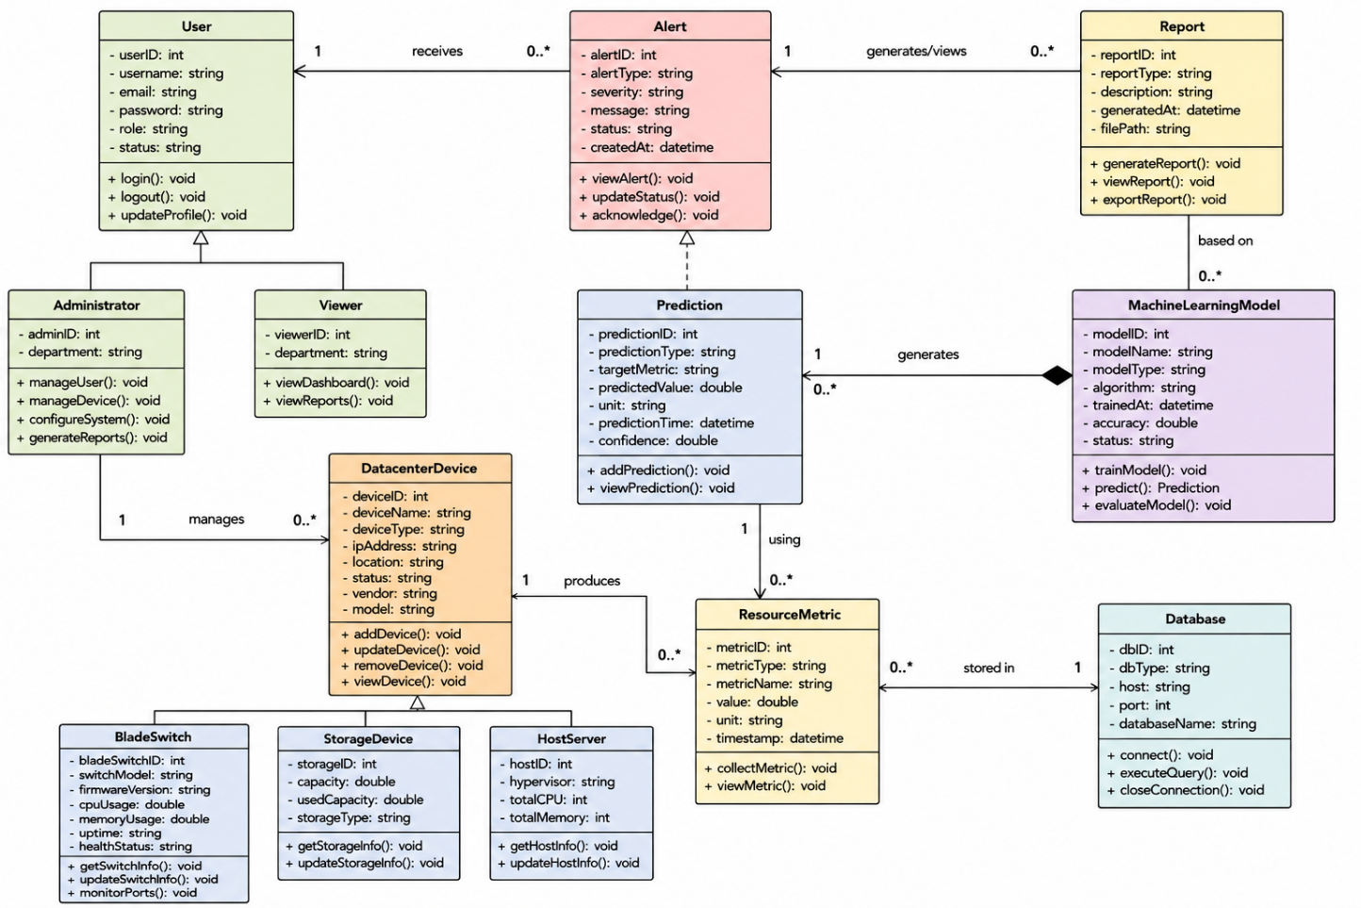
Figure 6:class diagram
Figure 6 presents the class diagram of the proposed Datacenter Resource Management and Predictive Analytics System. The diagram illustrates the static structure of the system by showing the main classes, their attributes, methods, and relationships. The User class is specialized into Administrator and Viewer, representing different user roles and access privileges within the system. The Datacenter Device class represents the monitored infrastructure and is specialized into Blade Switch, Storage Device, and Host Server, each containing attributes and operations specific to the corresponding device type. Resource utilization data collected from these devices are represented by the Resource Metric class and stored in the Database. The Machine Learning Model uses the collected metrics to train prediction models and generate resource utilization forecasts through the Prediction class. Based on these predictions, the system generates Alerts to notify administrators of potential issues and produces Reports to support monitoring, predictive maintenance, capacity planning, and informed decision-making. Overall, the class diagram demonstrates how the system components interact to provide centralized datacenter monitoring and machine learning-based predictive analytics.

4.4.4 Database Design (Entity Relationship Diagram)
The Entity Relationship Diagram (ERD) illustrates the logical structure of the database developed for the proposed Datacenter Resource Management and Predictive Analytics System. It identifies the major entities, their attributes, and the relationships established to support resource monitoring, equipment management, machine learning predictions, alert generation, report management, and user administration.
The database was designed to ensure data integrity, minimize redundancy, and facilitate efficient storage and retrieval of datacenter information. The primary entities include User, Datacenter Device, Resource Metric, Machine Learning Model, Prediction, Alert, Report, and Database. These entities are interconnected through defined relationships that enable the system to collect resource metrics, generate predictions, issue alerts, produce reports, and maintain user information in a centralized repository.
The ERD provides a structured representation of how monitoring data flow through the system and supports the implementation of predictive analytics by linking resource metrics with machine learning models and prediction results.
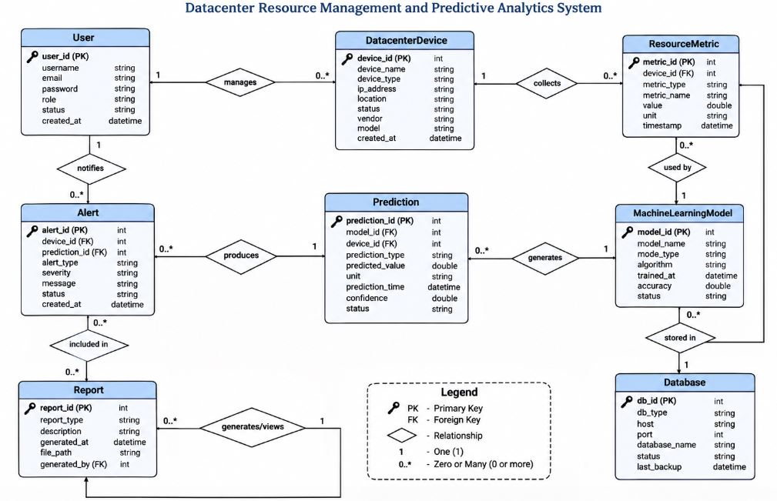

Figure 7: Entity Relationship Diagram (ERD) of the Proposed System
Figure 4.9 presents the Entity Relationship Diagram of the proposed Datacenter Resource Management and Predictive Analytics System. It illustrates the major database entities and their relationships, showing how users, datacenter devices, resource metrics, predictions, alerts, reports, and machine learning models are connected to support centralized monitoring, predictive analytics, and efficient datacenter management.

4.5 Machine Learning Model Development
This section presents the development of the machine learning component used in the proposed Datacenter Resource Management and Predictive Analytics System. The model was developed to analyse historical and real-time datacenter data, identify resource utilization patterns, detect abnormal behaviour, and predict future resource requirements or possible equipment failures. The development process involved dataset preparation, data collection, preprocessing, feature selection, algorithm selection, model training, evaluation, and integration of the prediction workflow into the system.

4.5.1 Dataset Description
The dataset used for machine learning model development consisted of historical and real-time performance data collected from datacenter infrastructure. The main data sources included servers, storage devices, network equipment, virtualization platforms, system logs, and environmental monitoring devices.
The dataset contained variables such as CPU utilization, memory usage, disk capacity, storage consumption, network traffic, latency, equipment status, temperature, power consumption, error logs, and timestamps. These variables were used to analyse resource utilization trends, identify abnormal operating conditions, and support prediction of future resource demand and potential equipment failures.
The dataset was organized in a structured format, where each record represented the performance of a specific datacenter device at a particular time. Historical data from the period 2020 to 2025, as indicated in the proposal, were considered for model development and trend analysis. The data were divided into training and testing sets to support model development and evaluation.

4.5.2 Data Collection
The data used to develop the machine learning model were collected from multiple datacenter infrastructure components, including servers, storage devices, network equipment, virtualization platforms, and system monitoring logs. Both historical and real-time operational data were gathered to provide a comprehensive representation of datacenter resource utilization and system performance.
The collected data included CPU utilization, memory usage, disk utilization, storage capacity, network bandwidth, latency, equipment status, power consumption, environmental conditions, system events, and error logs. These data were automatically captured through monitoring agents and stored in a centralized database for further analysis.
To ensure data quality, the collected records were reviewed for completeness, consistency, and relevance before being used for machine learning model development. The resulting dataset provided sufficient information for identifying resource utilization patterns, detecting anomalies, and predicting future resource requirements and potential equipment failures.

4.5.3 Data Preprocessing
Data preprocessing was performed to improve the quality and consistency of the collected datacenter data before training the machine learning model. During this stage, incomplete records, duplicate entries, and inconsistent values were identified and removed to ensure data accuracy. Missing values were handled using appropriate imputation techniques, while noisy and irrelevant data were filtered out to improve the reliability of the dataset.
The numerical features, including CPU utilization, memory usage, storage capacity, network bandwidth, power consumption, and temperature, were normalized to a common scale to prevent differences in measurement units from affecting model performance. Categorical variables, such as device type and equipment status, were encoded into numerical values suitable for machine learning algorithms. Finally, the cleaned dataset was transformed into a structured format ready for feature selection and model training.

4.5.4 Feature Selection
Feature selection was performed to identify the most relevant variables that contribute to accurate prediction of datacenter resource utilization and equipment performance. Selecting the appropriate features helped improve model accuracy, reduce computational complexity, and eliminate redundant or irrelevant information from the dataset.
The selected features included CPU utilization, memory usage, storage utilization, disk input/output operations, network bandwidth, latency, power consumption, temperature, device status, and system event logs. These variables were chosen because they directly influence datacenter performance and provide valuable information for detecting abnormal behaviour and forecasting future resource demands. The selected features were then used as inputs for training and evaluating the machine learning models.

4.5.5 Machine Learning Algorithms
The proposed system employed several machine learning algorithms to analyse datacenter resource utilization and generate predictive insights. The algorithms considered included Random Forest, Support Vector Machine (SVM), Extreme Gradient Boosting (XGBoost), Artificial Neural Network (ANN), and Long Short-Term Memory (LSTM), owing to their ability to identify complex patterns, classify abnormal system behaviour, and forecast future resource utilization. Random Forest and XGBoost were selected for their high prediction accuracy and robustness with structured data, SVM for effective anomaly classification, ANN for modelling nonlinear relationships among resource utilization variables, and LSTM for analysing time-series data and predicting future trends. The algorithms were evaluated using performance metrics such as accuracy, precision, recall, F1-score, Mean Absolute Error (MAE), Root Mean Squared Error (RMSE), and the coefficient of determination (R²), after which the best-performing model was integrated into the proposed system to support predictive analytics, anomaly detection, and proactive datacenter resource management.

4.5.6 Model Training
The selected machine learning algorithms were trained using the preprocessed dataset to learn the relationships between datacenter resource utilization variables and system performance. The dataset was divided into training and testing sets, where the training data were used to build the prediction models and the testing data were used to validate their performance. During training, the models learned patterns related to CPU utilization, memory usage, storage consumption, network traffic, equipment status, and other operational metrics. Model parameters were optimized to improve prediction accuracy and minimize errors, ensuring that the trained model could effectively forecast resource utilization trends, detect anomalies, and support proactive datacenter resource management.

4.5.7 Model Evaluation
The performance of the trained machine learning models was evaluated using both classification and regression evaluation metrics to determine their accuracy and reliability. Classification models were assessed using accuracy, precision, recall, and F1-score, while regression models were evaluated using Mean Absolute Error (MAE), Root Mean Squared Error (RMSE), and the coefficient of determination (R²). The evaluation results were compared to identify the best-performing model based on its prediction accuracy, error rate, and ability to generalize to unseen data. The selected model demonstrated satisfactory performance and was integrated into the proposed system to support predictive analytics, anomaly detection, and intelligent decision-making for datacenter resource management.

4.5.8 Prediction Workflow
The prediction workflow begins with the continuous collection of real-time resource utilization data from servers, storage devices, network equipment, and other datacenter infrastructure components. The collected data are transmitted to the centralized database, where they undergo preprocessing and feature extraction before being submitted to the trained machine learning model. The model analyses the incoming data to identify utilization patterns, forecast future resource demands, and detect abnormal system behaviour. Based on the prediction results, the system automatically generates alerts and recommendations whenever potential equipment failures or resource bottlenecks are identified. The prediction results are then displayed through the monitoring dashboard and reports, enabling system administrators to make timely decisions, perform proactive maintenance, and optimize datacenter resource utilization.
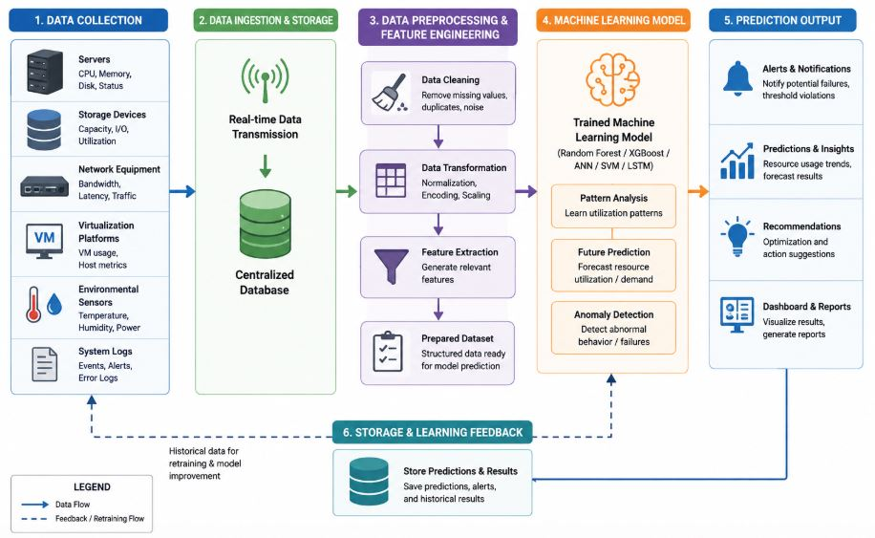
Figure 8: Machine Learning Prediction Workflow
Figure 4.10 illustrates the prediction workflow of the proposed system. The process starts with real-time data collection from datacenter devices, followed by data preprocessing and feature extraction. The processed data are analysed by the trained machine learning model to generate predictions and detect anomalies. Finally, the prediction results are stored in the database and presented through dashboards, alerts, and reports to support proactive resource management and decision-making.

4.6 System Implementation
This section presents the practical implementation of the proposed Datacenter Resource Management and Predictive Analytics System. It describes the development environment, hardware and software requirements, programming languages, frameworks, database technologies, and user interfaces used to transform the system design into a functional application. The implementation integrated resource monitoring, equipment management, predictive analytics, alert generation, reporting, and user administration into one centralized platform.

4.6.1 Development Environment
The system was developed and tested in a local development environment before deployment in the on-premises datacenter environment. The development setup included a computer with sufficient processing power, memory, and storage to support application development, database operations, machine learning model training, and system testing. A code editor and integrated development environment were used to write, debug, and maintain the source code.
The development environment also included a local application server, database management system, web browser, machine learning libraries, and version-control tools. These technologies supported frontend and backend development, database implementation, model training, API integration, interface testing, and system debugging. The environment provided the necessary resources for implementing and evaluating the proposed system before deployment.

4.6.2 Software and Hardware Requirements
The implementation of the proposed system required both hardware and software resources to support application development, machine learning, database management, and system testing. The hardware requirements included a computer with an Intel Core i5 processor or equivalent, 8 GB RAM, 256 GB storage, and a stable internet connection. The software requirements included Windows or Ubuntu, Visual Studio Code, Python, Django, React.js, MySQL, Git, and a web browser. Machine learning libraries such as Scikit-learn, Pandas, NumPy, TensorFlow, and Matplotlib were used for data preprocessing, model development, and evaluation. Together, these resources provided a suitable environment for developing and testing the proposed system.

4.6.3 Programming Languages and Frameworks
The proposed Datacenter Resource Management and Predictive Analytics System was developed using modern programming languages and frameworks to ensure efficiency, scalability, and maintainability. The frontend was developed using React.js to provide a responsive and interactive user interface, while the backend was implemented using Django and Python to handle business logic, API services, and machine learning integration. MySQL was used as the database management system to store users, datacenter devices, resource metrics, predictions, alerts, and reports. Machine learning functionalities were implemented using libraries such as Scikit-learn, TensorFlow, Pandas, and NumPy, while Git was used for version control throughout the development process.

4.6.4 User Interfaces
This section presents the graphical user interfaces of the proposed Datacenter Resource Management and Predictive Analytics System. The interfaces were designed to provide an intuitive and user-friendly environment for monitoring datacenter resources, managing equipment, viewing predictive analytics, generating reports, and administering system users. The following screenshots illustrate the major system modules and their functionalities.

4.6.4.1 Home Page
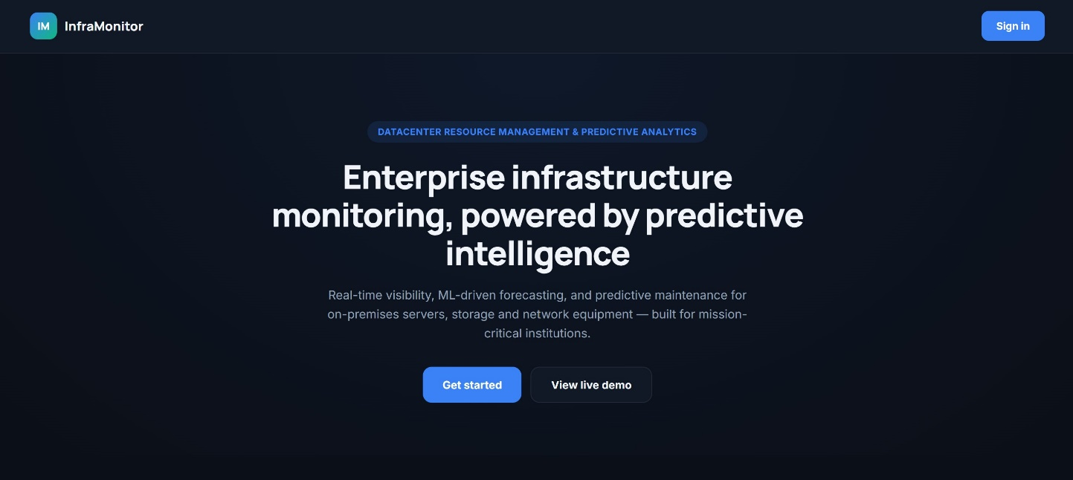
Figure 9: Home Page of the Proposed Datacenter Resource Management System
The Home Page serves as the entry point to the proposed Datacenter Resource Management and Predictive Analytics System. It provides users with an overview of the system and offers access to the main features, including user authentication, resource monitoring, predictive analytics, reporting, and equipment management. The interface was designed to be simple, responsive, and easy to navigate, enabling users to quickly access the required system functions.

4.6.4.2 Login Page

Figure 10: Login Page of the Proposed Datacenter Resource Management System
The Login Page provides secure access to the Datacenter Resource Management and Predictive Analytics System. It requires users to enter their registered username and password before accessing the system. The authentication mechanism verifies user credentials and grants access based on assigned roles and permissions, ensuring that only authorized personnel can manage datacenter resources and view sensitive system information.

4.6.4.3 Dashboard
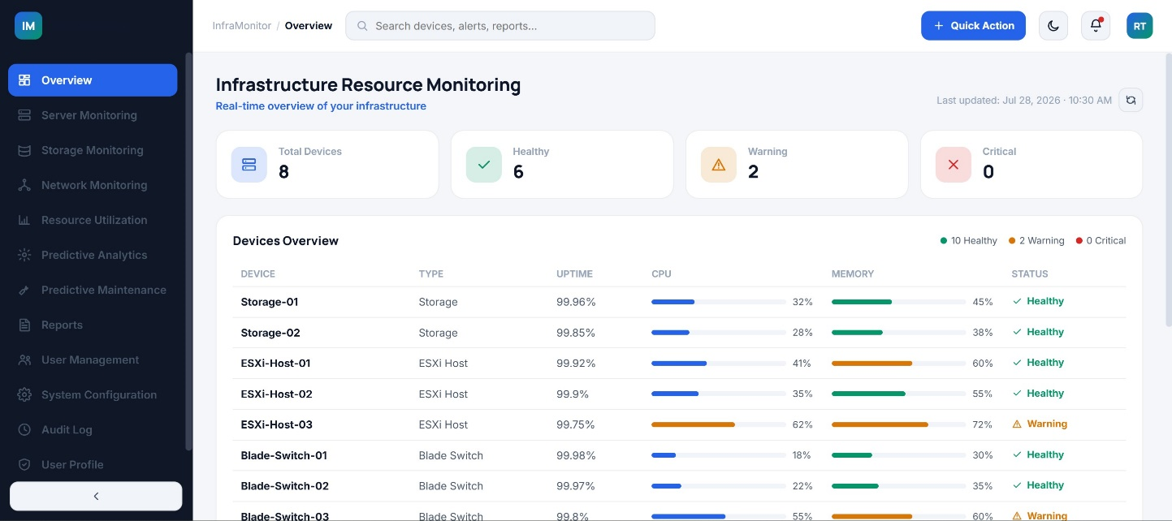
Figure 11: Dashboard of the Proposed Datacenter Resource Management System
The Dashboard serves as the main interface of the proposed Datacenter Resource Management and Predictive Analytics System. It provides a centralized overview of the datacenter environment by displaying key performance indicators, including server status, CPU utilization, memory usage, storage capacity, network performance, active alerts, and predictive analytics results. The dashboard enables administrators to monitor the overall health of the datacenter in real time and quickly identify abnormal conditions that require immediate attention. It also provides shortcuts to major system modules, allowing users to efficiently manage resources and access detailed monitoring information.

4.6.4.4 Server Monitoring
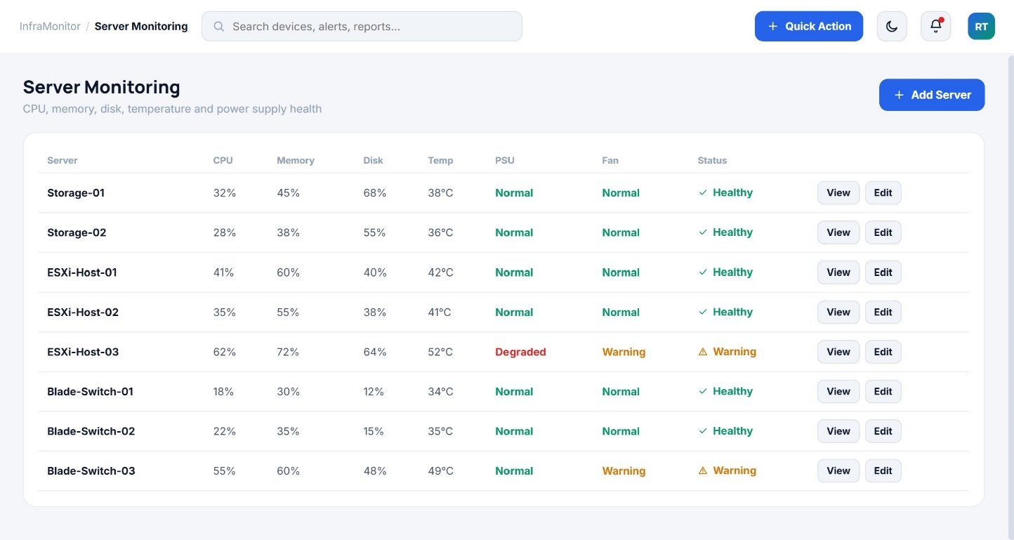
Figure 12: Server Monitoring Interface of the Proposed Datacenter Resource Management System
The Server Monitoring interface enables administrators to monitor the operational status and performance of servers within the datacenter. It displays real-time information such as CPU utilization, memory usage, disk utilization, server availability, and system health. The interface allows administrators to identify overloaded or underutilized servers, monitor resource consumption, and respond promptly to abnormal conditions. This functionality supports proactive resource management and improves the reliability and availability of datacenter services.

4.6.4.5 Storage Monitoring
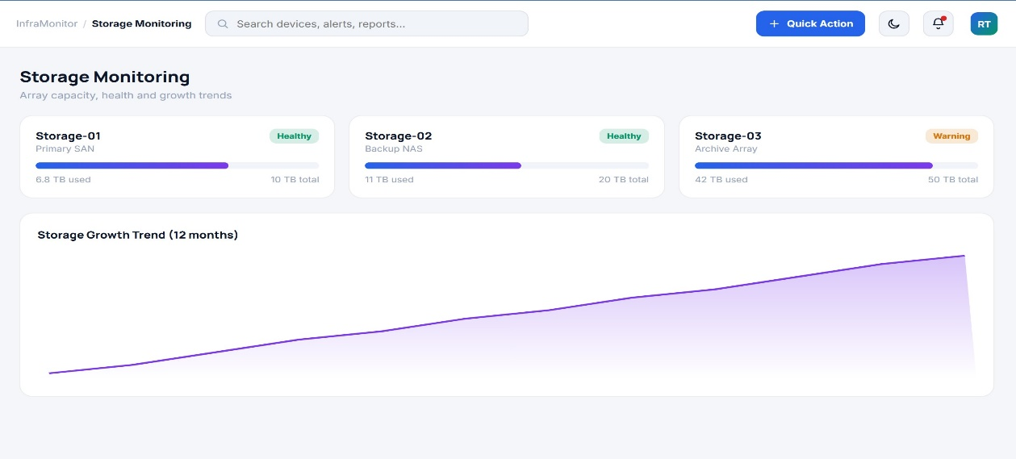
Figure 13: Storage Monitoring Interface of the Proposed Datacenter Resource Management System
The Storage Monitoring interface provides real-time information on storage devices within the datacenter. It displays storage capacity, available space, disk utilization, input/output performance, and storage health status. The interface assists administrators in tracking storage usage trends, identifying capacity shortages, and planning future storage expansion. Continuous monitoring of storage resources helps maintain system performance and prevents service interruptions caused by insufficient storage capacity.

4.6.4.6 Network Monitoring
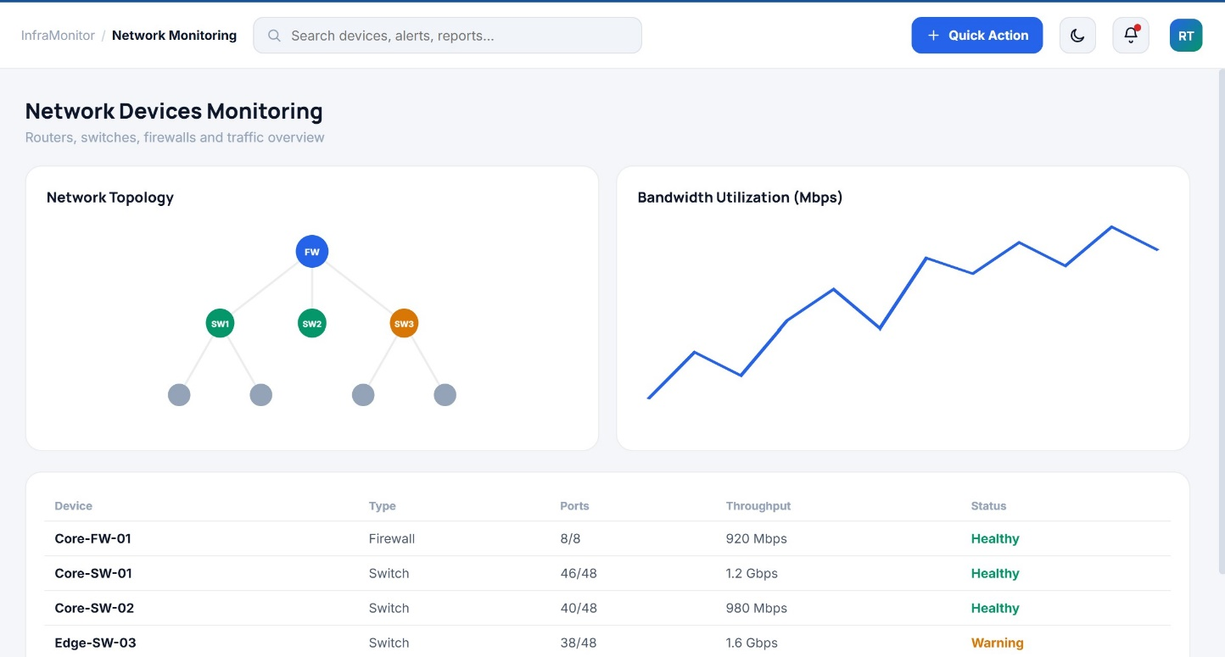
Figure 14: Network Monitoring Interface of the Proposed Datacenter Resource Management System
The Network Monitoring interface provides real-time monitoring of the datacenter network infrastructure. It displays key network performance indicators, including bandwidth utilization, network traffic, latency, packet transmission, and device connectivity status. The interface enables administrators to identify network congestion, communication failures, and abnormal traffic patterns, thereby supporting timely troubleshooting and ensuring stable network performance across the datacenter.

4.6.4.7 Resource Utilization
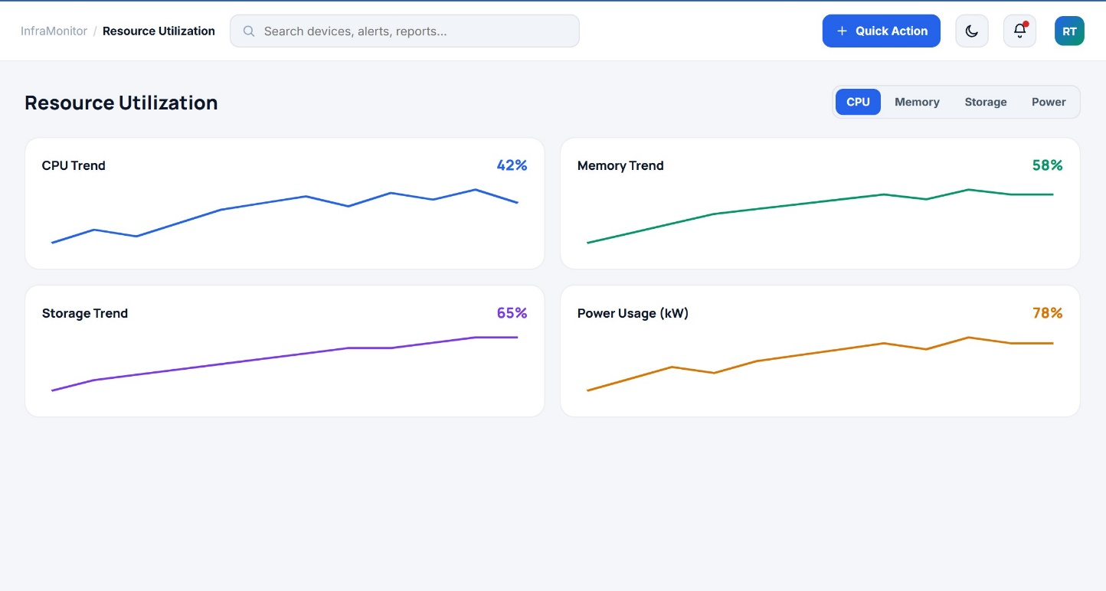

Figure 15: Resource Utilization Interface of the Proposed Datacenter Resource Management System
Description
The Resource Utilization interface provides real-time visualization of datacenter resource consumption. It displays the utilization trends of CPU, memory, storage, and power through graphical charts, enabling administrators to monitor infrastructure performance and identify changes in resource usage. The interface supports proactive resource management by helping users detect utilization trends, optimize resource allocation, and prevent performance bottlenecks.

4.6.4.8 Predictive Analytics
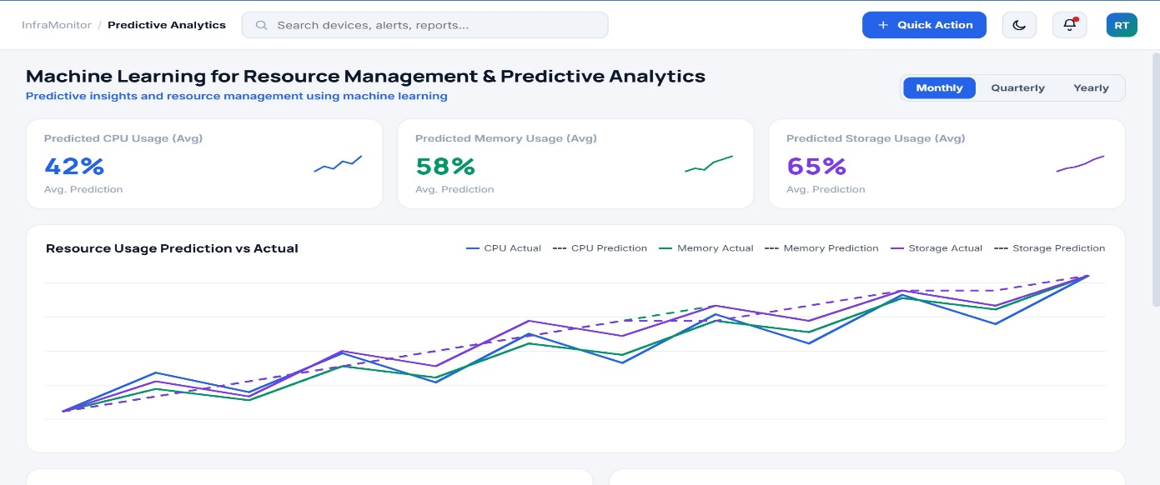
Figure 16: Predictive Analytics Interface of the Proposed Datacenter Resource Management System
The Predictive Analytics interface presents the machine learning predictions generated from historical and real-time datacenter resource data. It provides visualizations and analytical results that help administrators forecast resource utilization trends, identify potential performance bottlenecks, and support proactive decision-making. By analysing CPU, memory, storage, network, and power utilization patterns, the interface enables administrators to optimize resource allocation, improve operational efficiency, and reduce the risk of unexpected system failures.

4.6.4.9 Predictive Maintenance
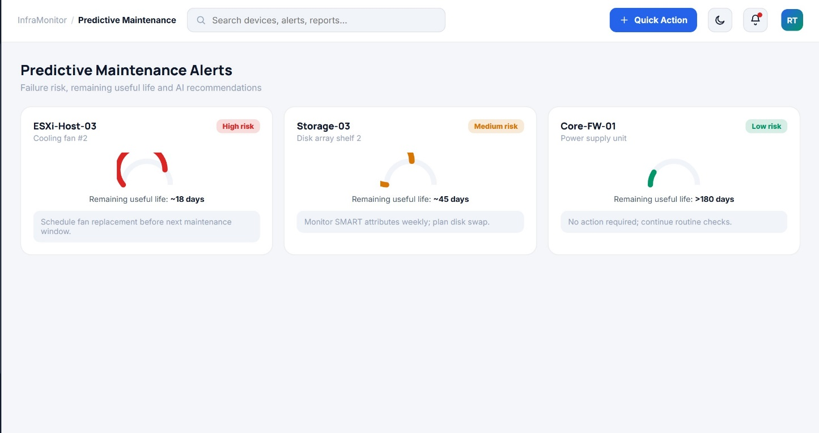
Figure 17: Predictive Maintenance Interface of the Proposed Datacenter Resource Management System
The Predictive Maintenance interface enables administrators to identify potential equipment failures before they occur by analysing historical and real-time resource utilization data using machine learning techniques. The interface presents maintenance predictions, equipment health status, and recommended maintenance actions, allowing administrators to schedule timely interventions and minimize unexpected downtime. This functionality enhances the reliability, availability, and operational efficiency of the datacenter by supporting proactive maintenance planning.

4.6.4.10 Report Generation Interface
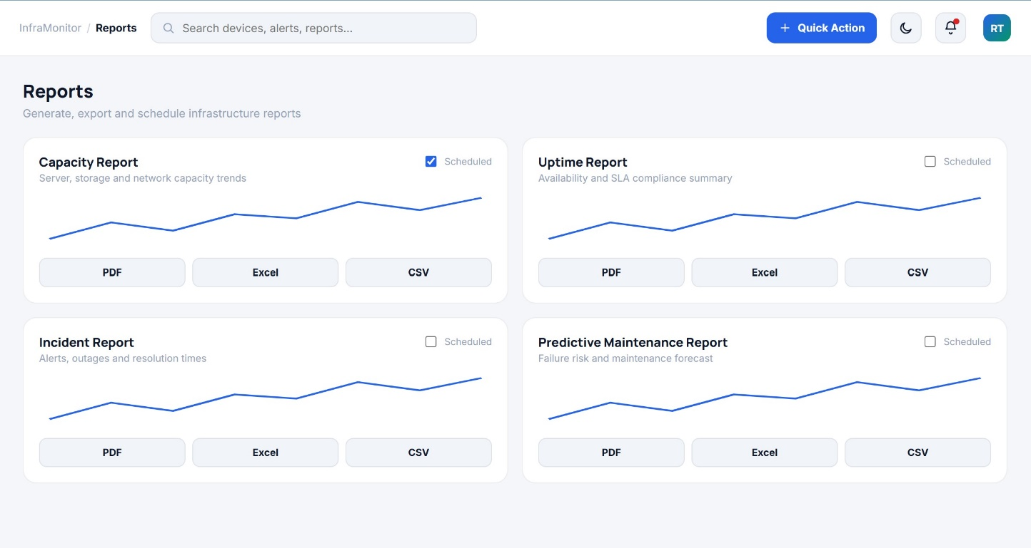
Figure 18: Report Generation Interface of the Proposed Datacenter Resource Management System
The Report Generation interface enables users to generate and export reports related to datacenter resource utilization, system performance, predictive analytics, and maintenance activities. The interface allows administrators to select report categories, specify time periods, and produce comprehensive reports for monitoring, auditing, and decision-making. This functionality improves documentation, simplifies performance analysis, and supports informed management of datacenter resources.

4.6.4.11 Audit Log Interface
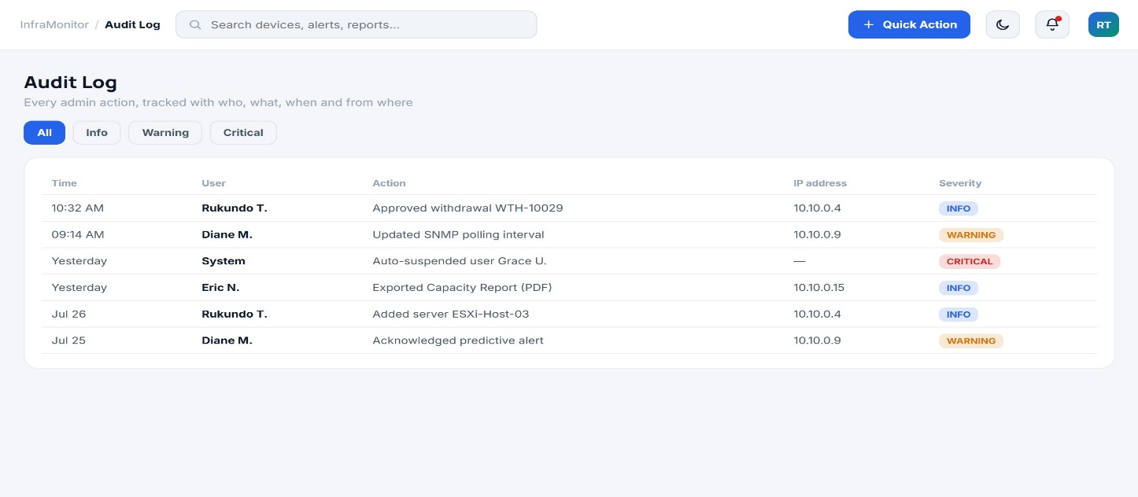
Figure 19: Audit Log Interface of the Proposed Datacenter Resource Management System
The Audit Log interface records all significant activities performed within the system to enhance accountability, security, and traceability. It maintains detailed logs of user authentication, resource management operations, system updates, configuration changes, and other administrative activities. Each log entry includes information such as the user, activity performed, date and time, and status of the operation. This enables administrators to monitor system usage, investigate security incidents, and maintain an accurate history of system events.

4.6.4.12 System Configuration Interface
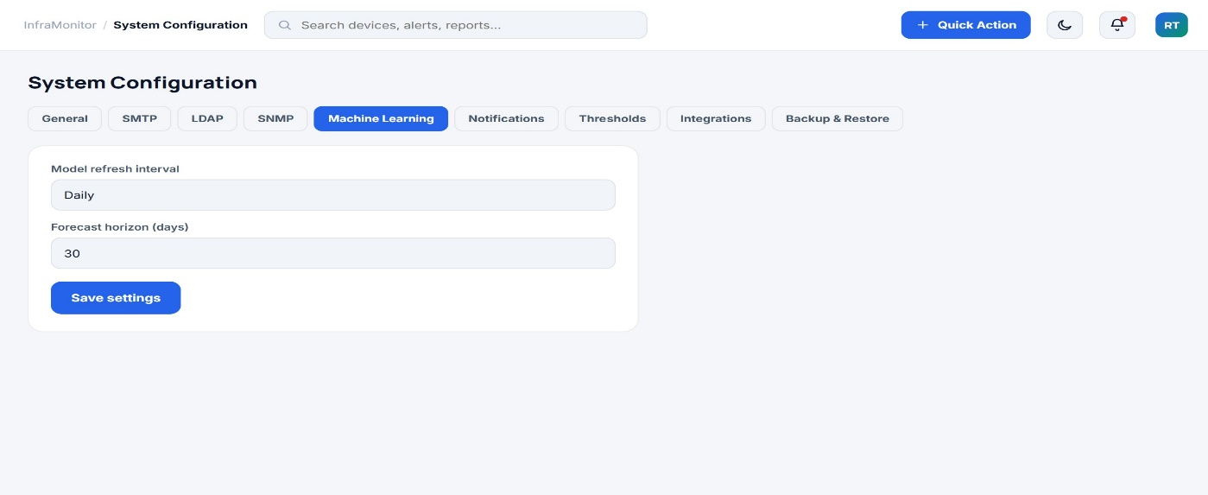
Figure 20: System Configuration Interface of the Proposed Datacenter Resource Management System
The System Configuration interface enables administrators to configure and manage the operational settings of the proposed system. It allows users to define monitoring parameters, configure prediction settings, manage system preferences, and customize application behaviour according to organizational requirements. The interface provides flexibility in controlling system operations while ensuring consistent and reliable performance.

4.6.4.13 User Profile
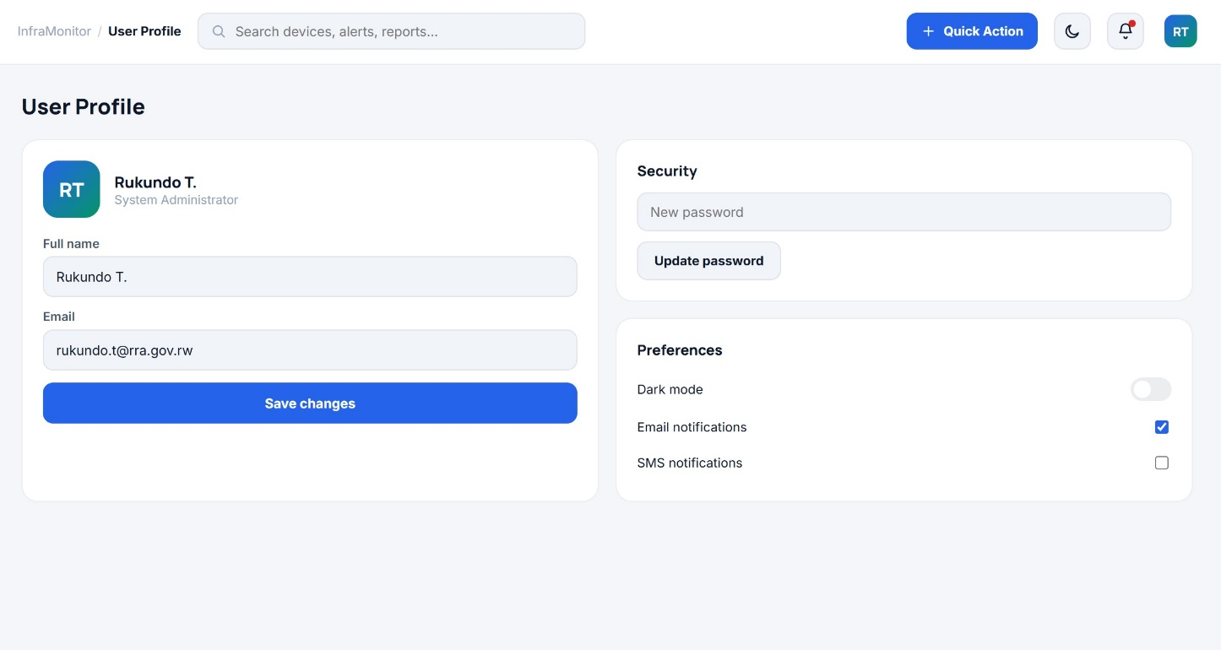
Figure 21: User Profile Interface of the Proposed Datacenter Resource Management System
The User Profile interface allows users to view and manage their personal account information within the system. It provides functionality for updating profile details, changing passwords, and managing account preferences while maintaining secure access to the application. The interface ensures that users can keep their account information current and supports the overall security of the system through proper user account management.

