NEWS AGGERGATOR

Group Members :

202001002 - Suyash Vyas

202001005 - Mann Joshi

202001015 - Om Vaghani

202001017 - Mihir Patel

202001019 - Ruchi Detroja

202001022 - Meet Shrimali

202001025 - Nilav Shah

202001030 - Ritik Mahyavanshi

202001048 - Dakshveer Singh Chauhan

Github : <https://github.com/Mihir-18/IT314_project_4>

**General description :**

1. The project would enable people to share ideas and opinions on world events and allow them to see different viewpoints.

2. Users can follow and form communities with like minded individuals or individuals whose viewpoints are different.

3. It would also allow users to post news and share other news which might otherwise have gone unnoticed or suppressed.

4. The users can see the general consensus towards a world event or towards different views of the people.

5. This can be a one stop destination to get to know about different world events be it sports, technology, entertainment, politics.

**Functional Requirements :**

1. By adding their email/username, and password, users may log in and new users can register also.

2. Users can Post or Delete any news.

3. Users can also add any image or add the video link related to their posted news.

4. To maintain the privacy of the user , he/she can also share it anonymously.

5. While sharing any news , the user can add the related tag for that news so that other users can filter the news as per his/her interests.

6. Age of the user will be taken while registering and on uploading the post the user can restrict the content on the basis of age.

7. People can search for any user profile and can also follow that user.

8. Any registered user can comment on any of the news posts to share their views.

9. The starting feed can be based on the news Popularity and time elapsed since it was posted.

10.Can separate unverified news on the basis of whether the reference to the news is provided or not.

11.Users can upvote and downvote on both the posts and comments.

12.Report as Inappropriate option can be used to deal with fake news.

**Non-Functional Requirements :**

Performance: The system should be able to handle a high volume of users and content without slowing down or crashing.

Availability: The system should be available 24/7 with minimal downtime for maintenance and updates.

Security: The system should be secure against attacks, including data breaches and unauthorized access.

Scalability: The system should be able to handle an increasing number of users and content without affecting its performance.

Usability: The system should be easy to use and navigate for all types of users, including those with disabilities.

Reliability: The system should be reliable, with minimal errors or bugs that could cause user frustration or data loss.

Compatibility: The system should be compatible with different web browsers, operating systems, and devices.

Maintainability: The system should be easy to maintain and update, with clear documentation and a modular design that allows for easy changes and upgrades.

Compliance: The system should comply with relevant laws and regulations, such as data protection laws and accessibility standards.

Supportability: The system should have adequate support options, including user support and technical support, to help users troubleshoot issues and get the most out of the system.

**Interface Requirements :** Interface requirements are the requirements that define how the system should look and behave from the user's perspective. Here are some interface requirements that might be important for a Reddit clone:

Navigation: The system should have clear and intuitive navigation that allows users to easily browse different topics.

Search: The system should have a search function that allows users to quickly find specific content, users.

User profiles: The system should allow users to create and customize their profiles, including their profile picture, bio, and interests.

Content creation: The system should allow users to easily create and submit content, including text, links, images, and videos.

Voting: The system should allow users to upvote or downvote content to indicate their preferences and help surface popular content.

Commenting: The system should allow users to comment on content, including threaded discussions and the ability to reply to specific comments.

Use Cases

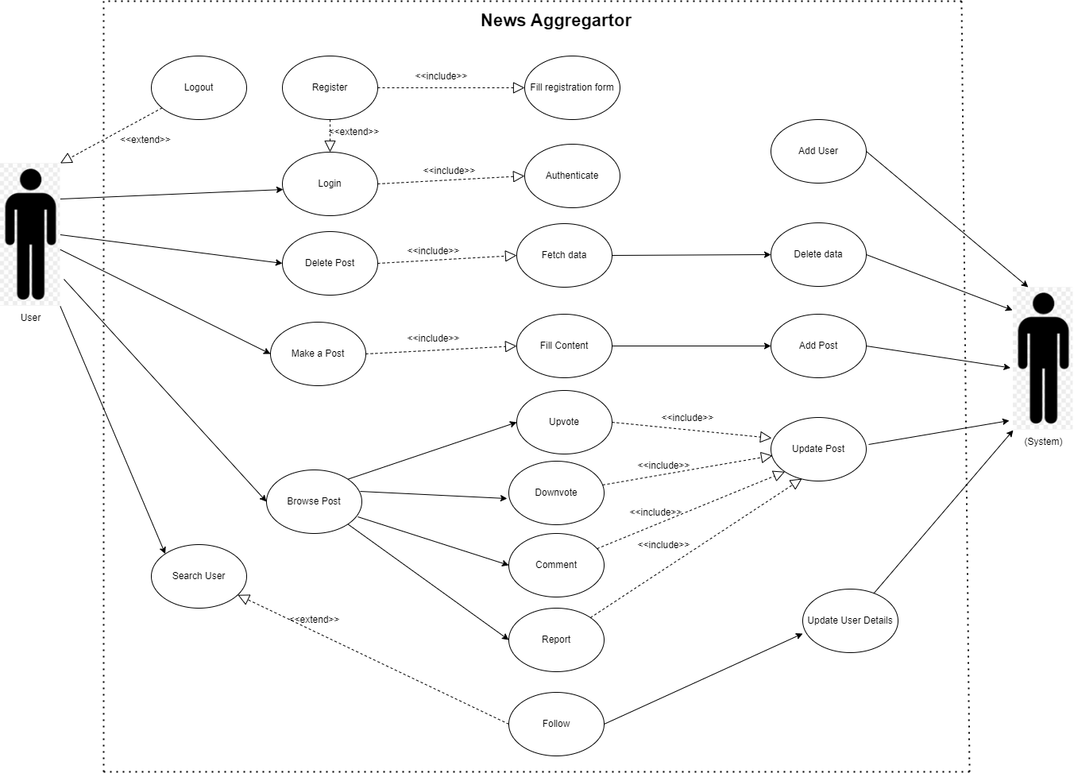

Use case description

**Identifier: UC1**

Name: Login/Register new user

Primary Actor: User

Secondary Actor: System

Goal: To login into a news aggregator website with an existing account or register as a new user. Precondition:

● User has access to a device with a proper internet connection.

● The News Aggregator website is up and running and is accessible by the user.

Post Condition:

● The User is either logged or registered in the website and now can access the features of News Aggregator.

Main Flow:

1. The user opens the News Aggregator Website and lands on the login page.

2. If the user has an existing account, the user enters its username and password and clicks on the “login” button.

3. The system verifies the user’s credentials.

Alternative flow:

2a.1: If the user does not have an existing account, the user can click on “Create New Account” button.

2a.2: User fills up the registration forms.

2a.3: Systems add the data of the user in the database and create a new profile from him.

3a: The user will be informed that no such account with such a username exists if the system cannot find the username in its database.

3b: If the user enters an incorrect password then the system displays an error message and prompts the user to re-enter their credentials.

**Identifier: UC2**

Name: Create/Make a new Post

Primary Actors: User

Secondary actor:

System Goal: To create or make a new post.

Pre condition:

● The user must be registered on the website.

● The user must be logged in on the website. Post condition: The user will be able to post the news and it would be made visible to other users who can upvote, downvote or comment on it.

Main flow:

1. User selects the option to create a new post.

2. User is presented with a form where it will typically add any links , images and content about the post

3. User fills the form successfully.

Alternate Flow:

2a. If the user leaves required fields blank , the system presents an error message indicating that required fields must be filled out.

**Identifier: UC3**

Name: Upvote

Actors: User

Secondary actor:

System Goal: To upvote on a post or comment.

Pre conditions:

● The user must be registered on the website   
● The user must be logged in to the website.

● The post or comment that the user wants to upvote should exist on the system Post condition: The user has upvoted the post/comment according to the system. If the user had previously downvoted the post/comment then that downvote is removed. The upvote button for the post or comment becomes highlighted and the downvote button if it was previously highlighted now becomes unhighlighted.

Main flow

1. The user moves the mouse to the upvote button near the post or comment that he wants to upvote.

2. User clicks the upvote option once.

3. An update query is sent to the database with the new upvotes and downvotes value for the post /comment.

Alternative flow

3a. The upvote button does not become highlighted. Refresh the page and try again.

**Identifier: UC4**

Name: Downvote

Actors: User

Secondary user:

System Goal: To downvote on a post or comment.

Pre conditions:

● The user must be registered on the website.

● The user must be logged in to the website.

● The post or comment that the user wants to downvote should exist on the system. Post condition: The user has downvoted the post/comment according to the system. If the user had previously upvoted the post/comment then that upvote is removed. The downvote button for the post or comment becomes highlighted and the upvote button if it was previously highlighted now becomes unhighlighted.

Main flow:

1. The user moves the mouse to the downvote button near the post or comment that he wants to downvote.

2. User clicks the downvote option once.

3. An update query is sent to the database with the new downvotes and upvotes value for the post comment.

Alternative flow:

3a. The downvote button does not become highlighted. Refresh the page and click try again.

**Identifier: UC5**

Name: Comment

Actors: User

Secondary actor:

System Goal: To comment under a post or comment.

Pre condition:

● The user must be registered on the website.

● The user must be logged in on the website.

● There should be a post or comment in the system under which the user wants to add his/her comment.

Post condition: That comment will be visible to all the users under that particular post or comment. Main flow: User clicks on the comment button under a particular post or comment. When a user clicks on a comment button, the comment box will appear. Inside that white space users can write something. That written data will be sent to the database when the user hits the send button. Alternate Flow:

1a. Comment button is not active. Refresh the page and click the comment button again.

2a. Comment box won’t appear. Refresh the page and do the 1st step again.

4a. Send button is not active then refreshes the page and does all the steps from starting.

4b. The comment doesn’t appear under the post or comment. Refresh the page if it still won’t appear then repeat the steps.

**Identifier: UC6**

Name: Report any Post

Actors: User

Goal: Report a post to the system.

Pre condition:

● The user must be registered on the website.

● The user must be logged in on the website.

● There should be a post in the database which the user wants to report to the system.

Post condition:

● Post will be reported as inappropriate to the system.

Main flow:

1. The user takes his/her cursor near the report as an inappropriate button.

2. User clicks on the report as an inappropriate button.

3. A query will be sent to the system which will show that particular post has been reported as inappropriate.

Alternate Flow:

3a. Report button is not active then refresh the page then try to click the report button again.

**Identifier: UC7**

Name: Search User

Actor: User

Secondary actor:

System Goal: To find specific user and its information

Preconditions:

● The user must be registered on the website.

● The user must be logged in on the website.

Post-conditions:

● If the user is already registered then the system will give access to perform necessary actions, such as upvoting, downvoting, commenting and sharing that post.

● The user can initiate another search if needed.

Main flow:

1. The user accesses the search user feature in the system.

2. The system represents a search bar to the user.

3. The user enters the required search criteria, such as name, username, email, ID, etc.

4. The system searches the database for the specified search criteria.

5. The system presents the search result in a list format.

6. The user selects the desired user from the search results list.

7. The system displays the selected user’s profile which contains the activities like posts created by the user, upvotes, downvotes and comments on posts made by the user and posts shared by the user.

Alternative flow:

3a. If the search criteria do not match any registered user in the system, the system displays a message indicating that no results were found.

3b. If the search criteria entered by the user are invalid, the system displays an error message and prompts the user to enter valid search criteria.

**Identifier: UC8**

Name: Delete a Post

Actors: User

Goal: Delete the particular post from the system.

Pre condition:

● The user must be registered on the website.

● The user must be logged in on the website.

● There should be a post in the database which the user wants to delete from the system.

Post condition:

● Post will be deleted from the system and will not be visible to any users.

Main flow:

1. User clicks on the My Profile button.

2. Profile will be visible to the user with his/her posts.

3. User can click on the delete button under any of these posts.

4. That post will be deleted from the system and will not be visible to any user.

Alternate Flow:

2a. The My Profile button is inactive. Refresh the page and try again.

4a. Delete button is inactive, then refresh the page and try to click on the delete button again.

4b. Post is still visible to the users, then do all the steps again.

**Identifier: UC9**

Name: Logout

Actors: User

Goal: Logout from the system.

Pre condition:

● The user must be logged in on the website.

Post condition:

● User will be logged out from the system.

Main flow:

1. User Click on the “Logout” button.

**Non Functional requirements**

1. Consistency The system should be consistent with posts, upvotes, downvotes, comments. It should not be that some comments are visible to some users and not visible to others. It should also not be that the website shows some upvote-downvote value to one user and other values to another user. It is important that a system should be consistent with the data it provides to its users as a post not being visible to some users blocks access of those users to free information. Inconsistent upvote-downvote values can lead to a false impression about a post or comment.

2. Privacy The system should not give the identity of users who report a post as inappropriate to the post or comment owner or to the general public as this can lead to harassment of that user.

3. Speed The system should add comments, upvote-downvotes, and posts as quickly as possible. The user should not have to wait long for their upvote-downvote to get reflected, their comment or post to get added or their authentication or registration to complete as this leads to a bad impression of the website and the user might just stop using the website altogether if he/she has is made to wait a long time for back-end operations to complete.

4. Good UI The UI of the website should be simple and easily understandable; most used options on the website should not be buried under other options. The should be able to deduce just by seeing what each element on the web page does. It the website does not have a good UI then the user might get frustrated finding it hard to do anything on the website.