**PRACTICAL-1**

**Aim: Prepare report on various security trends and security services.**

**Theory:**

**Security Trends:**

In 1994, the Internet Architecture Board (IAB) issued a report entitled "Security in the Internet Architecture" (RFC 1636). The report stated the general consensus that the Internet needs more and better security, and it identified key areas for security mechanisms. Among these were the need to secure the network infrastructure from unauthorized monitoring and control of network traffic and the need to secure end-user-to-end-user traffic using authentication and encryption mechanisms.

These concerns are fully justified. As confirmation, consider the trends reported by the Computer Emergency Response Team (CERT) Coordination Center (CERT/CC).



**Fig.1.1 Vulnerabilities Report**

Figure 1.1 shows the trend in Internet-related vulnerabilities reported to CERT over a 10-year period. These include security weaknesses in the operating systems of attached computers (e.g., Windows, Linux) as well as vulnerabilities in Internet routers and other network devices.

Figure 1.**2** shows the number of securityrelated incidents reported to CERT. These include denial of service attacks; IP spoofing, in which intruders create packets with false IP addresses and exploit applications that use authentication based on IP; and various forms of eavesdropping and packet sniffing, in which attackers read transmitted information, including logon information and database contents.

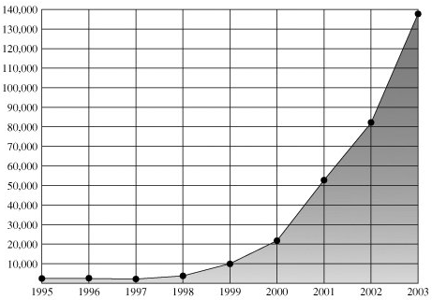

**Fig.1.2 Incidents Report**

Figure 1.**2** shows the number of securityrelated incidents reported to CERT. These include denial of service attacks; IP spoofing, in which intruders create packets with false IP addresses and exploit applications that use authentication based on IP; and various forms of eavesdropping and packet sniffing, in which attackers read transmitted information, including logon information and database contents.

Over time, the attacks on the Internet and Internet-attached systems have grown more sophisticated while the amount of skill and knowledge required to mount an attack has declined Figure 1.3. Attacks have become more automated and can cause greater amounts of damage.

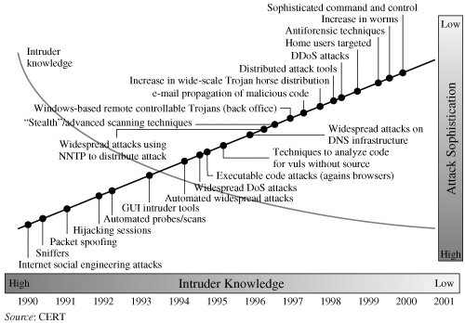

**Fig.1.3 Trends in Attack Sophistication and Intruder Knowledge**

This increase in attacks coincides with an increased use of the Internet and with increases in the complexity of protocols, applications, and the Internet itself. Critical infrastructures increasingly rely on the Internet for operations. Individual users rely on the security of the Internet, email, the Web, and Web-based applications to a greater extent than ever. Thus, a wide range of technologies and tools are needed to counter the growing threat. At a basic level, cryptographic algorithms for confidentiality and authentication assume greater importance. As well, designers need to focus on Internet-based protocols and the vulnerabilities of attached operating systems and applications. This book surveys all of these technical areas.

**Security Services:**

X.800 defines a security service as a service provided by a protocol layer of communicating open systems, which ensures adequate security of the systems or of data transfers. Perhaps a clearer definition is found in RFC 2828, which provides the following definition: a processing or communication service that is provided by a system to give a specific kind of protection to system resources; security services implement security policies and are implemented by security mechanisms.

**Authentication:**

The authentication service is concerned with assuring that a communication is authentic. In the case of a single message, such as a warning or alarm signal, the function of the authentication service is to assure the recipient that the message is from the source that it claims to be from. In the case of an ongoing interaction, such as the connection of a terminal to a host, two aspects are involved. First, at the time of connection initiation, the service assures that the two entities are authentic, that is, that each is the entity that it claims to be. Second, the service must assure that the connection is not interfered with in such a way that a third party can masquerade as one of the two legitimate parties for the purposes of unauthorized transmission or reception. Two specific authentication services are defined in X.800:

1. **Peer entity authentication:** Provides for the corroboration of the identity of a peer entity in an association. Two entities are considered peers if they implement to same protocol in different systems; for example two TCP modules in two communicating systems. Peer entity authentication is provided for use at the establishment of, or at times during the data transfer phase of, a connection. It attempts to provide confidence that an entity is not performing either a masquerade or an unauthorized replay of a previous connection.
2. **Data origin authentication**: Provides for the corroboration of the source of a data unit. It does not provide protection against the duplication or modification of data units. This type of service supports applications like electronic mail, where there are no prior interactions between the communicating entities.

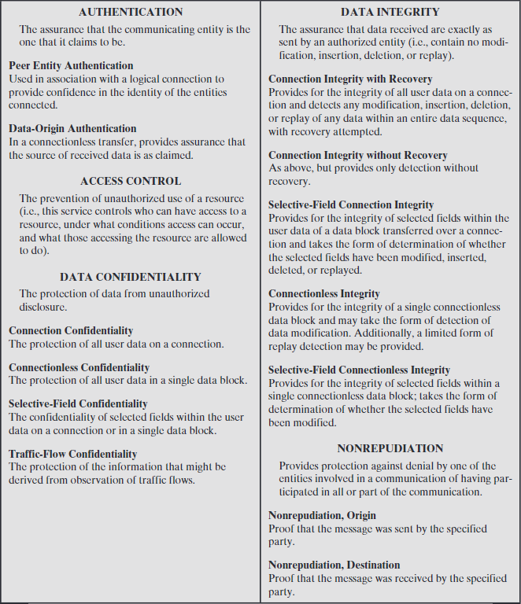

**Table 1.1 Security Services**

**Access control:**

In the context of network security, access control is the ability to limit and control the access to host systems and applications via communications links. To achieve this, each entity trying to gain access must first be identified, or authenticated, so that access rights can be tailored to the individual.

**Data Confidentiality:**

Confidentiality is the protection of transmitted data from passive attacks. With respect to the content of a data transmission, several levels of protection can be identified. The broadest service protects all user data transmitted between two users over a period of time. For example, when a TCP connection is set up between two systems, this broad protection prevents the release of any user data transmitted over the TCP connection. Narrower forms of this service can also be defined, including the protection of a single message or even specific fields within a message. These refinements are less useful than the broad approach and may even be more complex and expensive to implement.

The other aspect of confidentiality is the protection of traffic flow from analysis. This requires that an attacker not be able to observe the source and destination, frequency, length, or other characteristics of the traffic on a communications facility.

**Data Integrity:**

As with confidentiality, integrity can apply to a stream of messages, a single message, or selected fields within a message. Again, the most useful and straightforward approach is total stream protection.

A connection-oriented integrity service, one that deals with a stream of messages, assures that messages are received as sent with no duplication, insertion, modification, reordering, or replays. The destruction of data is also covered under this service. Thus, the connection-oriented integrity service addresses both message stream modification and denial of service. On the other hand, a connectionless integrity service, one that deals with individual messages without regard to any larger context, generally provides protection against message modification only.

We can make a distinction between service with and without recovery. Because the integrity service relates to active attacks, we are concerned with detection rather than prevention. If a violation of integrity is detected, then the service may simply report this violation, and some other portion of software or human intervention is required to recover from the violation. Alternatively, there are mechanisms available to recover from the loss of integrity of data, as we will review subsequently. The incorporation of automated recovery mechanisms is, in general, the more attractive alternative.

**Non repudiation:**

Non repudiation prevents either sender or receiver from denying a transmitted message. Thus, when a message is sent, the receiver can prove that the alleged sender in fact sent the message. Similarly, when a message is received, the sender can prove that the alleged receiver in fact received the message.

**Available services:**

Both X.800 and RFC 4949 define availability to be the property of a system or a system resource being accessible and usable upon demand by an authorized system entity, according to performance specifications for the system (i.e., a system is available if it provides services according to the system design whenever users request them). A variety of attacks can result in the loss of or reduction in availability. Some of these attacks are amenable to automated countermeasures, such as authentication and encryption, whereas others require some sort of physical action to prevent or recover from loss of availability of elements of a distributed system.

X.800 treats availability as a property to be associated with various security services. However, it makes sense to call out specifically an availability service. An availability service is one that protects a system to ensure its availability. This service addresses the security concerns raised by denial-of-service attacks. It depends on proper management and control of system resources and thus depends on access control service and other security services.