**PRACTICAL-6**

**Aim:**

**Theory:**

**Monoalphabetic Substitution Cipher:**

A better solution is to create a mapping between each plaintext character and the corresponding ciphertext character. Alice and Bob can agree on a table showing the mapping for each character. Figure 6.1 shows an example of such a mapping.

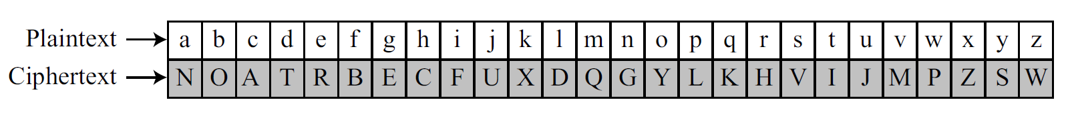

**Figure 6.1 an example key for monoalphabetic substitution cipher**

**Example of :**

We can use the key in to encrypt the message

my name is parth kannsara

The ciphertext is:

QSGNQRFVLNHICXNGGVNHN

**Conclusion:**

_______________________________________________________________________________________________________________________________________________________________________________________________________________________________________________________________________________________________________________________________________________________________________________________