Exploratory Data Analysis (EDA) Report
Symptom-to-Disease Prediction System

1. Introduction
Exploratory Data Analysis (EDA) was performed to understand the structure, quality, and characteristics of the symptom–disease dataset used for disease prediction. The analysis aimed to identify important patterns, evaluate data quality, understand disease and symptom distributions, and generate insights for machine learning model development.

2. Dataset Overview
Total Records: 246,512
Total Features: 331
Symptom Features: 328
Disease Classes: 677
Target Variable: diseases
The dataset represents a large-scale healthcare multi-class classification problem.

3. Data Quality Assessment
Missing Value Analysis:
No missing values were detected across the dataset.
Duplicate Analysis:
57,093 duplicate records were identified (23.16% of the dataset). These were retained because repeated symptom-disease combinations may represent multiple valid patient observations rather than data-entry errors.

4. Disease Distribution Analysis
Disease frequencies were examined to evaluate class balance. The top diseases included Cystitis, Vulvodynia, Nose Disorder, Complex Regional Pain Syndrome, and Spondylosis. Most disease classes contain approximately 1,200 observations, indicating a highly balanced dataset.
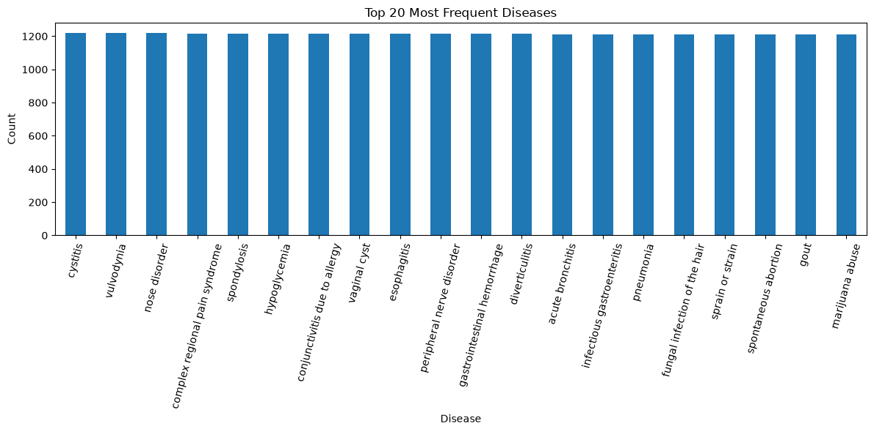

5. Symptom Frequency Analysis
The most frequently occurring symptoms include sharp abdominal pain, vomiting, headache, cough, sharp chest pain, nausea, back pain, shortness of breath, fever, and dizziness. These symptoms occur across multiple disease categories and therefore require contextual symptom combinations for accurate diagnosis.
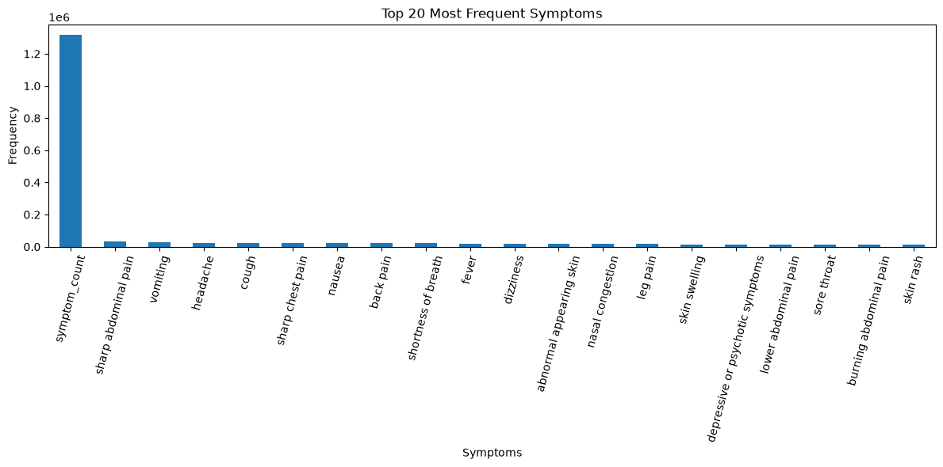
6. Symptom Count Distribution
A symptom_count feature was engineered to represent the number of active symptoms per patient. Most patients reported between 8 and 13 symptoms, with a peak around 10 symptoms. This suggests that disease prediction depends on combinations of symptoms rather than isolated indicators.
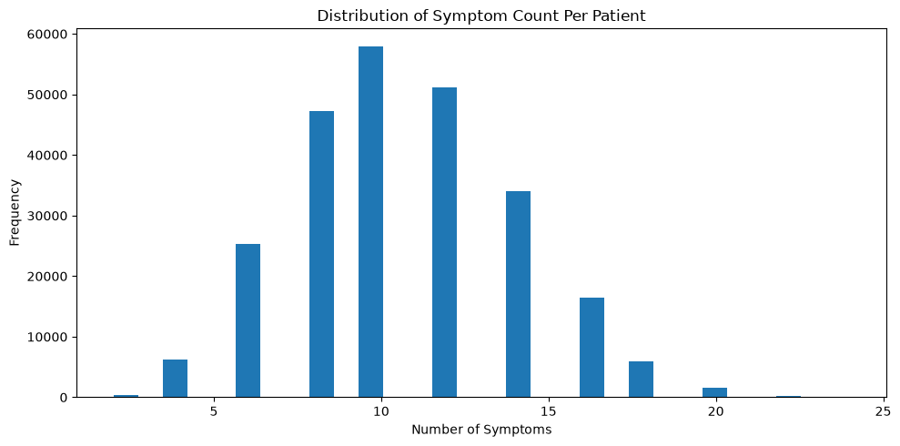

7. Feature Engineering Analysis
Feature engineering included creation of the symptom_count feature and label encoding of disease classes. These transformations improved model readiness and supported downstream machine learning workflows.

8. Data Preparation for Modeling
The dataset underwent inspection, validation, duplicate analysis, feature standardization, label encoding, feature engineering, and train-test preparation before model development.

9. Key Insights
• The dataset is large and suitable for machine learning.
• Disease classes are highly balanced.
• No missing values were present.
• Patients generally exhibit multiple symptoms simultaneously.
• Common symptoms alone are insufficient for accurate diagnosis.
• Symptom combinations provide stronger predictive signals.

10. Conclusion
The EDA confirmed that the dataset is complete, balanced, and suitable for multi-class disease prediction. The findings supported the development of machine learning models and contributed to the successful implementation of the Symptom-to-Disease Prediction System.

