**DH parameter assignment guidelines**

1. Label all joints from {1, 2, … , *n*}.
2. Label all links from {0, 1, …, n} starting with the fixed base link as 0.
3. Draw lines through all joints, defining the joint axes.
4. Identify the common normal between each frame ​*Z*​^​​​*i*−1​​ and frame ​*Z*​^​​​*i*​​ .
5. Assign the Z-axis of each frame to point along its joint axis.
6. The endpoints of "intermediate links" (i.e., not the base link or the end effector) are associated with two joint axes, {i} and {i+1}. For *i* from 1 to *n*, assign the ​*X*​^​​​*i*​​ to be …
   * For skew axes, along the normal between ​*Z*​^​​​*i*​​ and ​*Z*​^​​​*i*+1​​ and pointing from {*i*} to {*i+1*}.
   * For intersecting axes, normal to the plane containing ​*Z*​^​​​*i*​​ and ​*Z*​^​​​*i*+1​​.
   * For parallel or coincident axes, the assignment is arbitrary; look for ways to make other DH parameters equal to zero.
7. For the base link, always choose frame {0} to be coincident with frame {1} when the first joint variable (*θ*​1​​ or *d*​1​​) is equal to zero. This will guarantee that *α*​0​​ = *a*​0​​ = 0, and, if joint 1 is a revolute, *d*​1​​ = 0. If joint 1 is prismatic, then *θ*​1​​= 0.
8. For the end effector frame, if joint *n* is revolute, choose *X*​*n*​​ to be in the direction of *X*​*n*−1​​ when *θ*​*n*​​ = 0 and the origin of frame {*n*} such that *d*​*n*​​ = 0.

Once the frame assignments are made, the DH parameters are typically presented in tabular form (below). Each row in the table corresponds to the transform from frame {i} to frame {i+1}.

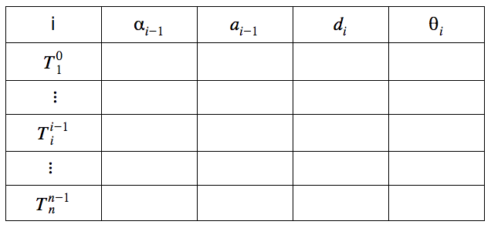

Special cases involving the ​*Z*​^​​​*i*−1​​ to ​*Z*​^​​​*i*​​ axes:

* collinear lines: alpha = 0 and a = 0
* parallel lines: alpha = 0 and a ≠ 0
* intersecting lines: alpha ≠ 0 and a = 0
* If the common normal intersects ​*Z*​^​​​*i*​​ at the origin of frame **i**, then *d*​*i*​​ is zero

**Steps for IK problem**

**Step 1:** is to complete the DH parameter table for the manipulator. Hint: place the origin of frames 4, 5, and 6 coincident with the WC.

**Step 2:** is to find the location of the WC relative to the base frame. Recall that the overall homogeneous transform between the base and end effector has the form,

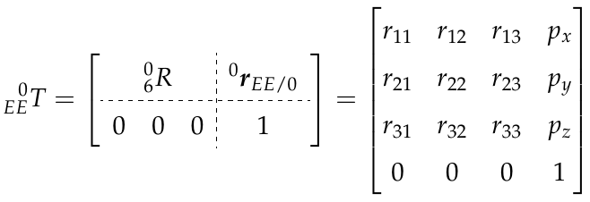

If, for example, you choose z4 parallel to z6 and pointing from the WC to the EE, then this displacement is a simple translation along z6. The magnitude of this displacement, let’s call it d, would depend on the dimensions of the manipulator and are defined in the URDF file. Further, since r13, r23, and r33 define the Z-axis of the EE relative to the base frame, the Cartesian coordinates of the WC is,

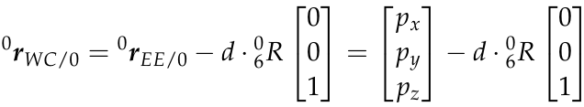

**Step 3:** find joint variables, q1, q2 and q3, such that the WC has coordinates equal to equation (3). This is the hard step. One way to attack the problem is by repeatedly projecting links onto planes and using trigonometry to solve for joint angles. Unfortunately, there is no generic recipe that works for all manipulators so you will have to experiment. The example in the next section will give you some useful guidance.

**Step 4:** once the first three joint variables are known, calculate ​0​3​​*R* via application of homogeneous transforms up to the WC.

**Step 5:** find a set of Euler angles corresponding to the rotation matrix,

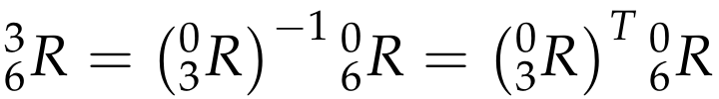

**Step 6:**choose the correct solution among the set of possible solutions