**SQL**

Day 2 Assessment

Submitted By Mihir Kumar

SQL DDL AND DML COMMANDS QUERIES

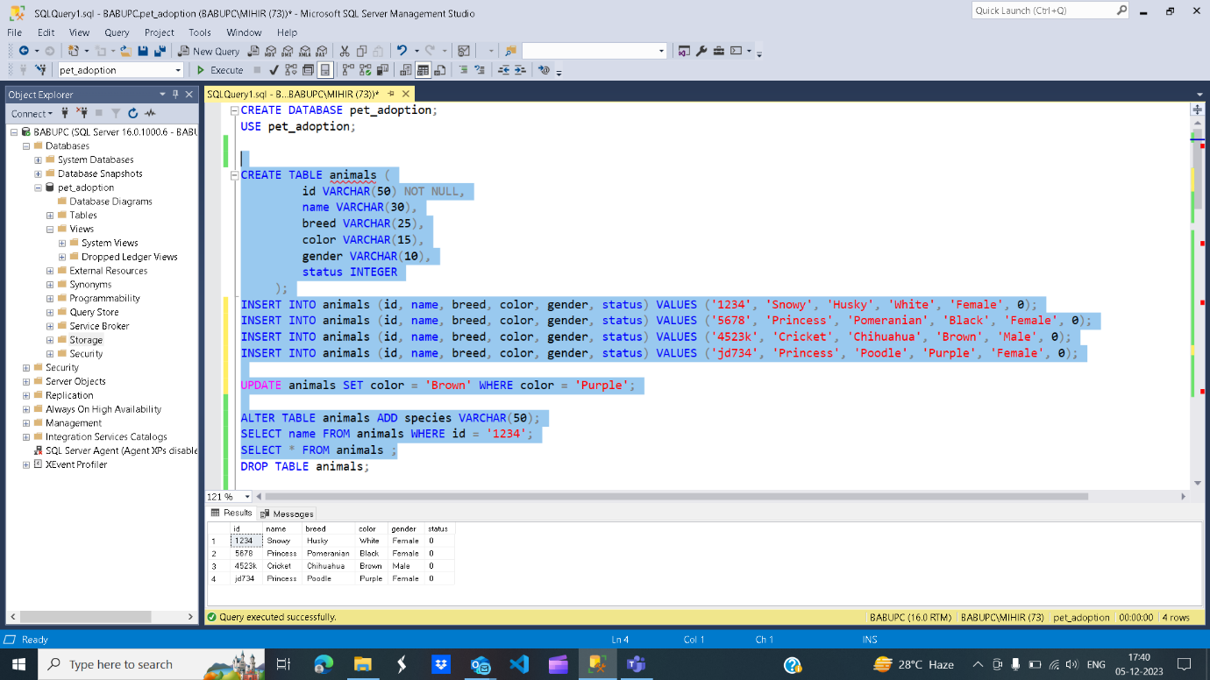

In the above screenshot , we have created pet_adoption Database and inside the database i have created animals table . I have inserted some columns as shown in the screenshot. After that I have updated color to Brown where color is purple. At last I’m retriving the data from the animal table

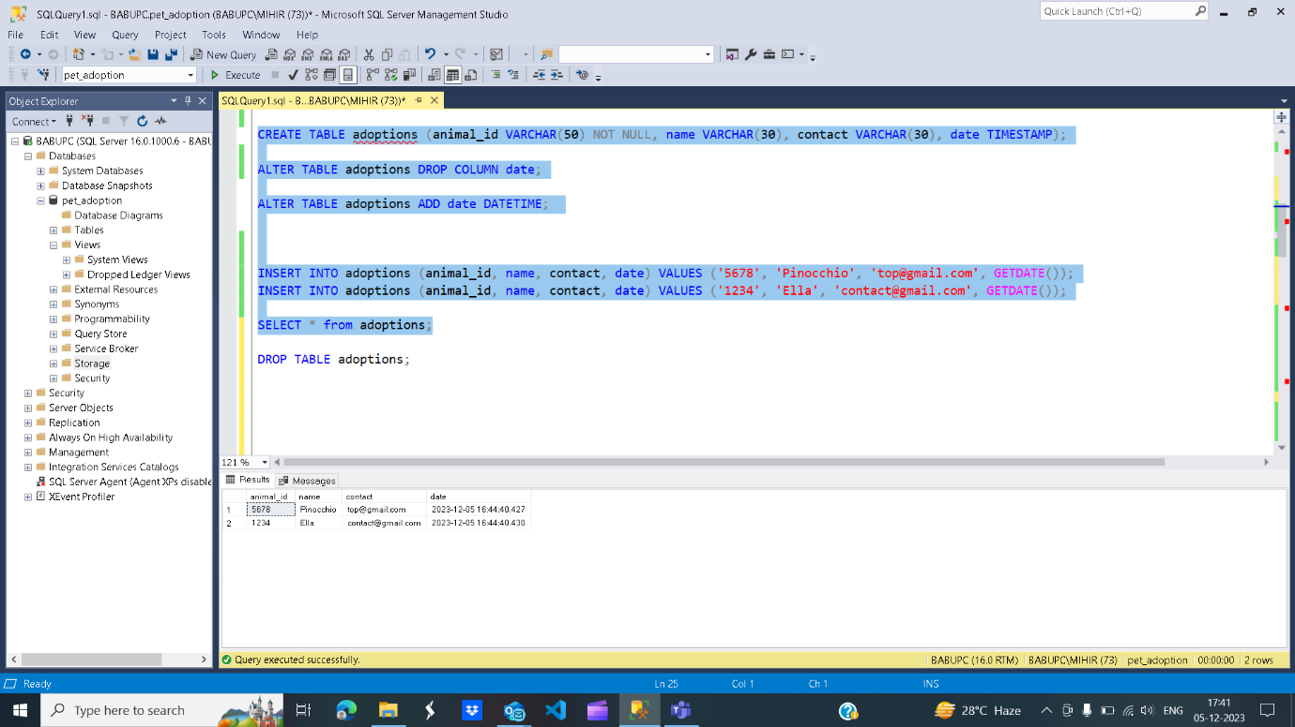

We can seen from the above fig. I have created a table named adoptions and added some columns then I have removed date column having TIMESTAMP as datatype. In the next line I have added new date column with new datatype. After that I have inserted some values in the table and show the table using SELECT command.

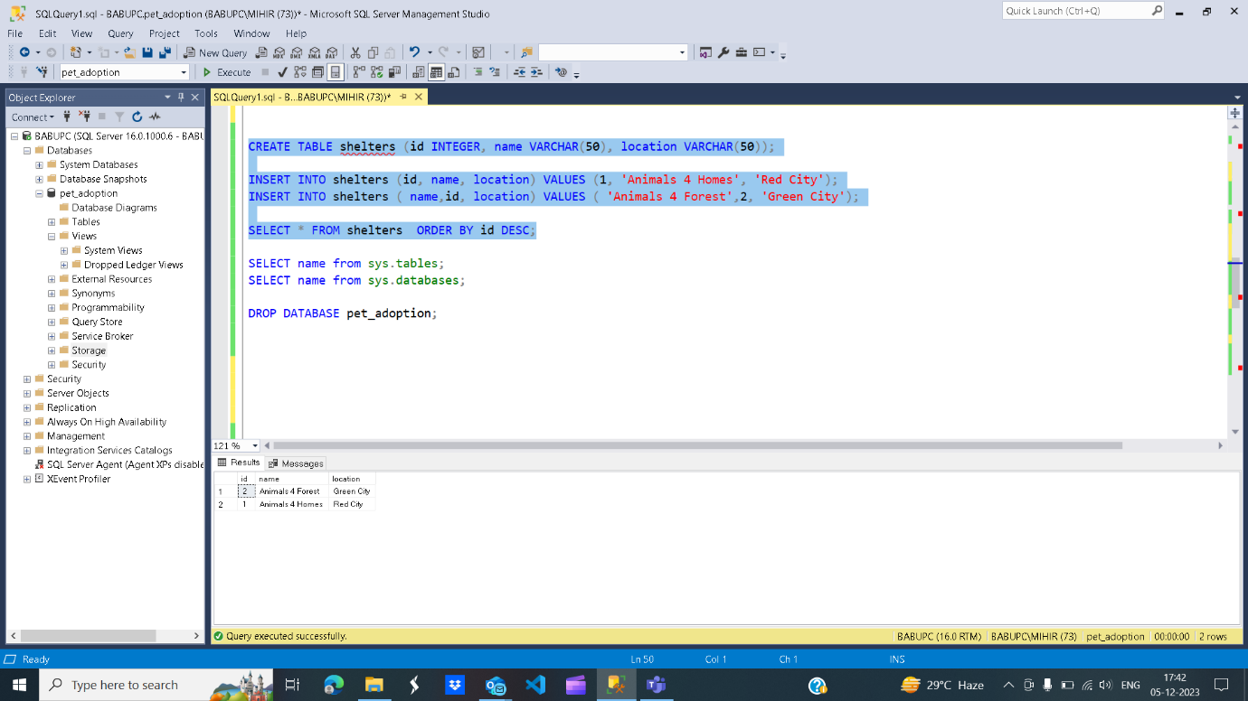

I have created another table inside the pet_adoption database i.e. shelters having some columns . Then I have inserted some values to the table . Talking about fourth command I have used ORDER BY clause to order the result in desending order. The I have knowing the name of tables inside the database and in next command I have knowing the databases present in the system. Atlast droping the pet_adoption database.

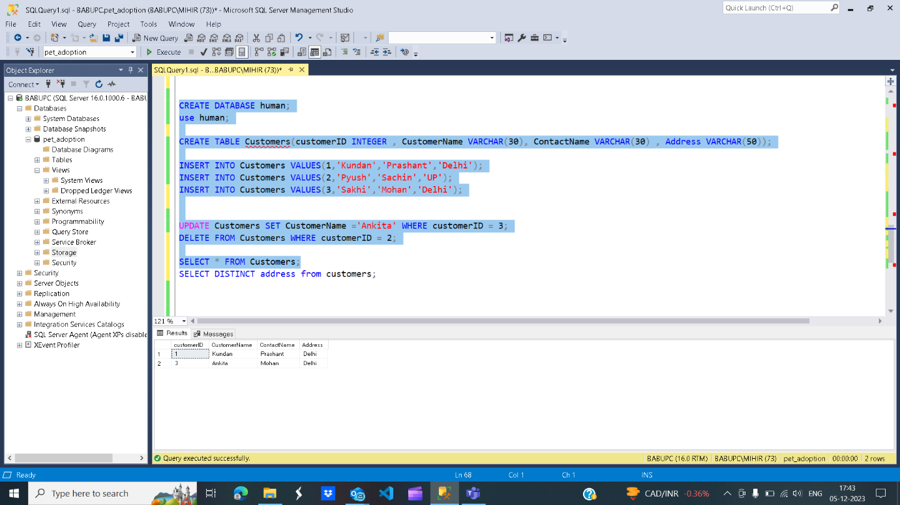

From above fig. I have created an another database human. After that I have created a table Customers inside it. Then inserted some values according to the column. In the seventh query I have update customerName according to condition. In the next line I have deleted a record based on some condition. And in last query I have getting only unique address from customers table.