Aim: To design and implement digital code conversion system for efficient data format transformation using FPGA.
Software required:
Quartus sp13.0.1

Hardware required:
FPGA, USB-BLASTER

Theory:
A code converter is a combinational digital circuit that converts data from one binary code format to another without changing the actual information represented. Code converters are widely used in digital electronics, communication systems, microprocessors, and embedded systems where different devices use different coding standards. The aim of a code converter is to ensure compatibility and efficient data exchange between digital systems. The experiment is based on designing and implementing such a digital code conversion system on an FPGA using Verilog HDL.

FPGA (Field Programmable Gate Array) is an integrated circuit that can be programmed to perform various digital logic functions. By implementing code converters on an FPGA, the design becomes fast, flexible, reliable, and easy to modify without changing the hardware. The design is written in Verilog HDL, synthesized using Quartus II 13.0.1, simulated for functional verification, and finally programmed onto the FPGA board.
Some commonly used code converters are:
- Binary to Gray Code Converter
- Gray to Binary Code Converter
- BCD to Excess-3 Converter
- Excess-3 to BCD Converter
- BCD to Seven-Segment Display Decoder
Among these, the Binary-to-Gray and Gray-to-Binary converters are widely used because Gray code changes only one bit between consecutive numbers, reducing switching errors in applications such as rotary encoders, position sensors, and digital communication.
Binary to Gray Code Conversion For an n-bit binary number:
- G(n−1) = B(n−1) (Most Significant Bit remains the same)
- Gi = Bi+1 ⊕ Bi (XOR operation) Example:-
Binary | Gray
0000 | 0000
0001 | 0001
0010 | 0011
0011 | 0010
0100 | 0110

Gray to Binary Code Conversion
To convert Gray code back to Binary:
- B(n−1) = G(n−1)
- Bi = Bi+1 ⊕ Gi
This method reconstructs the original binary number by performing cumulative XOR operations. Advantages of FPGA-Based Code Converter
- High-speed data conversion
- Low hardware complexity
- Easy to modify and upgrade
- Reliable operation
- Suitable for real-time digital systems
- Efficient utilization of FPGA resources Applications
- Digital communication systems
- Data transmission
- Error reduction in rotary encoders
- Microprocessor and microcontroller interfacing
- Digital signal processing (DSP)
- Embedded and automation systems

Block Diagram:-
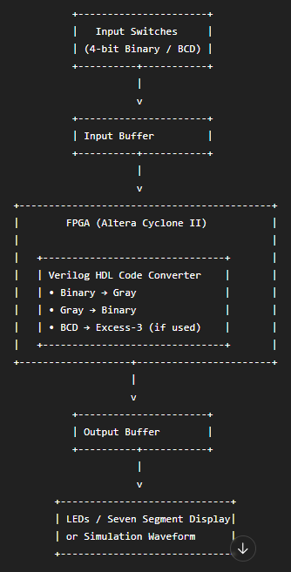

Truth Table:-
Binary Input (B3 B2 B1 B0) | Gray Output (G3 G2 G1 G0)
0000 | 0000
0001 | 0001
0010 | 0011
0011 | 0010
0100 | 0110
0101 | 0111
0110 | 0101
0111 | 0100
1000 | 1100
1001 | 1101
1010 | 1111
1011 | 1110
1100 | 1010
1101 | 1011
1110 | 1001
1111 | 1000

Boolean Expression:-
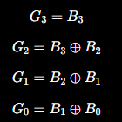

Circuit Diagram:-
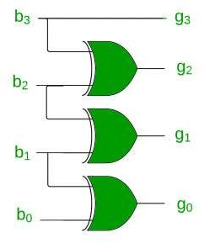

Verilog Code:-
module Exp_6 (
input [3:0] binary_in,
output [3:0] gray_out
);
assign gray_out[3] = binary_in[3];
assign gray_out[2] = binary_in[3] ^ binary_in[2]; assign gray_out[1] = binary_in[2] ^ binary_in[1]; assign gray_out[0] = binary_in[1] ^ binary_in[0];
endmodule

Simulation Results:
(Simulation Waveform and RTL Schematic View)
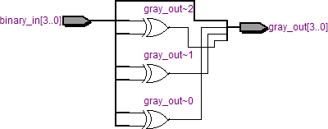

(FPGA Implementation with Pin Planning Details)

Conclusion:-
The Binary-to-Gray Code Converter was successfully designed and implemented on an FPGA using Verilog HDL. The simulation and hardware implementation verified correct code conversion for all inputs, demonstrating the FPGA's high speed, reliability, and suitability for real-time digital applications.

Post Lab Exercise:
- Why are FPGA-based code converters preferred over discrete logic implementations in modern digital systems?
FPGA-based code converters are preferred because they provide high-speed operation, low hardware complexity, flexibility for modification, reliable performance, and efficient utilization of FPGA resources.

- Why should invalid input combinations be explicitly handled in code converter designs?

Invalid input combinations should be handled to ensure reliable and error-free operation, preventing incorrect outputs and improving the stability of digital systems. (This point is not explicitly discussed in the document; this answer is based on standard digital design practice.)

- Why are code converters used in digital systems?

Code converters are used to convert data from one binary code format to another without changing the actual information, ensuring compatibility and efficient data exchange between digital systems.

- What is the advantage of gray code over binary code?
Gray code changes only one bit between consecutive numbers, reducing switching errors in applications such as rotary encoders, position sensors, and digital communication systems.

- What is the purpose of assigning FPGA pins in Quartus?

FPGA pin assignment connects the Verilog input and output signals to the physical pins of the FPGA board, allowing the design to communicate with switches, LEDs, and other hardware components. The document also includes FPGA implementation with pin planning.

- How can the output of a code converter be verified on the FPGA board?

The output can be verified by applying binary inputs using the FPGA board switches and observing the Gray code outputs on LEDs or a seven-segment display. The design can also be verified through simulation waveforms in Quartus.

