Aim: To design and verify sequential storage elements and register-based data storage systems using programmable logic devices.
Software required: Vivado Simulator

Theory:
Sequential circuits are digital circuits whose output depends not only on the present input but also on the previous state of the circuit. They are therefore capable of storing information.
A flip-flop is a basic sequential storage element capable of storing one bit of binary information. The state of a flip-flop is generally controlled by a clock signal. The output changes according to the input at a specified clock edge.
A register is a group of flip-flops used to store multiple bits of binary data. For example, an 8-bit register consists of eight flip-flops and can store an 8-bit binary value.
The important signals associated with sequential storage circuits include:
- Clock: Determines when the stored data can change.
- Data/Input: The information that is stored in the flip-flop or register.
- Reset: Initializes the storage element to a known state.
- Output: Represents the currently stored value.
In Verilog HDL, sequential circuits are generally described using an always block triggered by a clock edge. Non-blocking assignments (<=) are commonly used for sequential logic because they model the simultaneous updating of storage elements at a clock edge.
The simulation verifies whether the storage element or register responds correctly to the applied input, clock, and reset signals.

Block diagram:
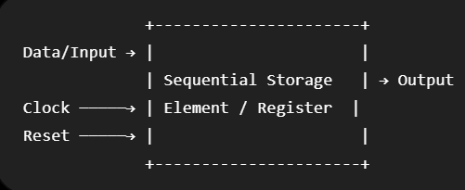
The input data is supplied to the sequential storage circuit. The clock controls when the input is stored, while the reset initializes the circuit to a known state. The stored value appears at the output.

Truth Table:
Reset | Clock | D Q(next)
1 | ↑ | X 0
0 | ↑ | 0 0
0 | ↑ | 1 1
0 | No edge | X Previous Q

Where ↑ represents the active rising edge of the clock.
If your actual circuit is different, such as a JK flip-flop, T flip-flop, register, shift register, etc., this table must be changed accordingly.

Boolean Expression:
For a D flip-flop:
𝑄𝑛𝑒𝑥𝑡 = 𝐷
when the reset is inactive and the active clock edge occurs. With an active-high synchronous reset:

𝑄𝑛𝑒𝑥𝑡
= {0, 𝑅𝑒𝑠𝑒𝑡 = 1
𝐷, 𝑅𝑒𝑠𝑒𝑡 = 0

Therefore, the next-state equation can be expressed as:
𝑄_{𝑛𝑒𝑥𝑡} = 𝑅𝑒‾𝑠𝑒𝑡 ⋅ 𝐷

Note: This Boolean expression is appropriate only if the simulated circuit is the corresponding D flip-flop with synchronous reset.

Circuit Diagram:
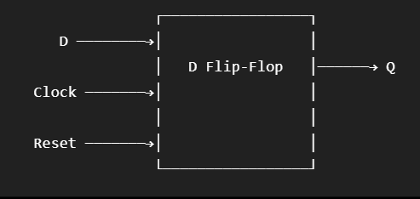

Verilog Code:

Design Module :
module d_flip_flop ( input wire clk, input wire reset, input wire d, output reg q
);

always @(posedge clk) begin if (reset)
q <= 1'b0;

else
q <= d;
end endmodule Testbench :
module d_flip_flop_tb;

reg clk; reg reset; reg d; wire q;
d_flip_flop uut (
.clk(clk),
.reset(reset),
.d(d),
.q(q)
);

initial begin clk = 0;
reset = 1;
d = 0;

#10;
reset = 0;

#10;
d = 1;

#10;
d = 0;

#10;
d = 1;

#10;
reset = 1;

#10;
reset = 0;

#10;
$finish; end

always #5 clk = ~clk; endmodule

Simulation Results:
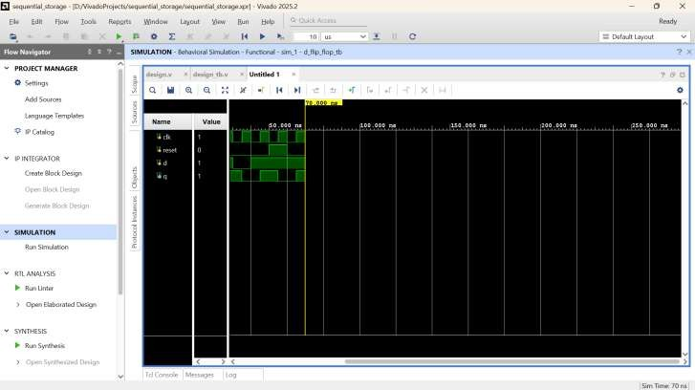

The simulation waveform verifies the operation of the sequential storage element. The output changes according to the input data at the active edge of the clock. When reset is activated, the output is initialized to the specified reset value. The waveform confirms that the designed sequential circuit operates as expected.

Conclusion:

The sequential storage element was successfully designed and verified using Verilog HDL. The design was simulated using Vivado Simulator, and its functionality was verified through the RTL schematic and simulation waveform. The output responded correctly to the applied input, clock, and reset signals. Thus, the required sequential storage operation was successfully verified through simulation.

Post Lab Exercise:
- Which signal controls the operation of a flip-flop?
The clock signal controls when a flip-flop can change its stored state. The output generally changes at a specified edge of the clock.
- Why are registers used in digital systems?
Registers are used to store and temporarily hold binary data. They are commonly used for data storage, data transfer, buffering, and intermediate processing.
- What is the purpose of the reset input in a flip-flop?
The reset input initializes the flip-flop to a known state, usually logic 0. This helps bring the sequential circuit into a predictable initial condition.
- Why is a clock edge important in sequential circuits?
A clock edge defines the specific instant at which a sequential circuit samples its input and updates its state. This provides synchronized operation of digital circuits.
- What How does setup and hold time affect the reliability of flip-flop operation?
Setup time is the minimum time the input must remain stable before the active clock edge, while hold time is the minimum time the input must remain stable after the clock edge. Violating these requirements can cause incorrect or unpredictable operation.
- Why is synchronous reset generally preferred over asynchronous reset in FPGA designs?
Synchronous reset is applied in coordination with the clock, making the circuit behavior easier to control and synchronize. It can also simplify timing analysis in many FPGA designs.
- What is the effect of using non-blocking assignments in Verilog sequential logic?

Non-blocking assignments (<=) update sequential elements without immediately affecting other statements in the same procedural block. They model the simultaneous state updates of flip-flops at a clock edge and are therefore preferred for sequential logic.

