Aim: To design and implement timing and event-generation systems using counters and frequency division techniques.

Software required:
Vivado Simulator Theory:
A counter is a sequential digital circuit that counts the number of clock pulses applied to its input. Counters
are widely used for timing, event generation, frequency measurement, and control applications.
A counter consists of flip-flops connected together so that its output changes according to the applied clock signal. In a binary up-counter, the count increases by one for every active clock edge.
For an N-bit binary counter, the counter can represent:
2𝑁

different states.
For example, a 4-bit counter has 16 possible states:
0000 → 0001 → 0010 → ⋯ → 1111
After reaching 1111, the counter returns to 0000.
A frequency divider is a circuit that generates a lower-frequency signal from a higher-frequency clock. Counters can be used to perform frequency division by using one of their output bits or by generating a toggle signal after a specific number of clock cycles.
If the input clock frequency is 𝑓_{𝑖𝑛}, the frequency of a counter output bit can be lower than the input frequency. For a binary counter, the 𝑛^{𝑡ℎ}bit divides the input frequency approximately by:
𝑓𝑖𝑛
𝑓𝑜𝑢𝑡 = 2𝑛+1
Frequency division is useful in timing and event-generation circuits because it allows a fast clock to produce slower timing signals.
The operation of the counter and frequency divider can be verified using a simulation waveform, where the clock, counter output, and divided-frequency signal are observed.

Block diagram:
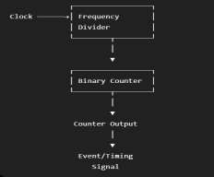

The input clock is first processed by the frequency-divider section to obtain a slower clock/timing signal. This signal is then used by the counter to generate the required count sequence and timing/event outputs.

Truth Table:
Clock Pulse | Q3 | Q2 | Q1 | Q0 | Decimal Count
0 | 0 | 0 | 0 | 0 | 0
1 | 0 | 0 | 0 | 1 | 1
2 | 0 | 0 | 1 | 0 | 2
3 | 0 | 0 | 1 | 1 | 3
4 | 0 | 1 | 0 | 0 | 4
5 | 0 | 1 | 0 | 1 | 5
6 | 0 | 1 | 1 | 0 | 6
7 | 0 | 1 | 1 | 1 | 7
8 | 1 | 0 | 0 | 0 | 8
9 | 1 | 0 | 0 | 1 | 9
10 | 1 | 0 | 1 | 0 | 10
11 | 1 | 0 | 1 | 1 | 11
12 | 1 | 1 | 0 | 0 | 12
13 | 1 | 1 | 0 | 1 | 13
14 | 1 | 1 | 1 | 0 | 14
15 | 1 | 1 | 1 | 1 | 15
16 | 0 | 0 | 0 | 0 | 0

The counter repeats after reaching its maximum value.

Boolean Expression:

For a binary counter, the next state can be represented as:
𝑄_{𝑛𝑒𝑥𝑡} = 𝑄 + 1
where Q represents the current counter value. For a 4-bit counter:
𝑄_{𝑛𝑒𝑥𝑡}[3: 0] = 𝑄[3: 0] + 1
For the frequency-divider output, the frequency relationship can be represented as:
𝑓𝑖𝑛
𝑓𝑜𝑢𝑡 = 2𝑛
where 𝑛represents the number of division stages.

Circuit Diagram:
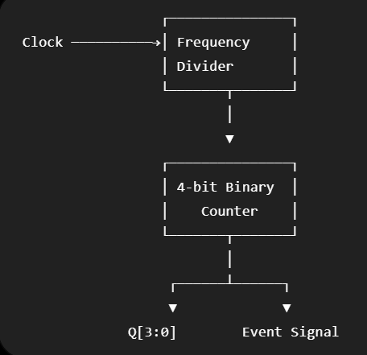

Verilog Code:

Design Module :

module counter_frequency_divider ( input wire clk,
input wire reset, output reg [3:0] count, output reg clk_div
);

always @(posedge clk) begin if (reset) begin
count <= 4'b0000; clk_div <= 1'b0;
end
else begin
count <= count + 1'b1;

if (count == 4'b1111) clk_div <= ~clk_div;
end end

endmodule

Testbench:
module counter_frequency_divider_tb;

reg clk; reg reset;

wire [3:0] count; wire clk_div;

counter_frequency_divider uut (
.clk(clk),
.reset(reset),
.count(count),
.clk_div(clk_div)
);
initial begin clk = 1'b0; reset = 1'b1;
#10;
reset = 1'b0; #200;
$finish; end

always #5 clk = ~clk; endmodule

Simulation Results:
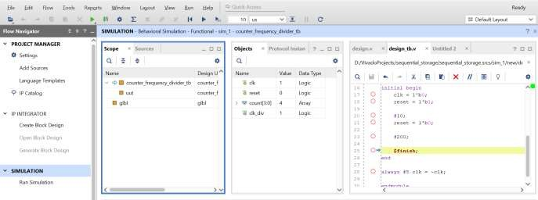

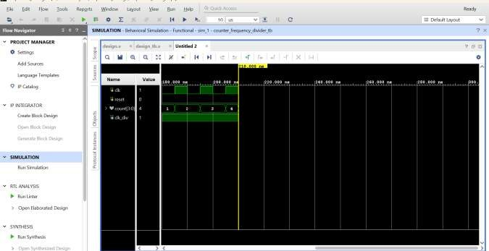

The simulation waveform shows that the counter increments by one at every active edge of the clock after reset is deactivated. The counter progresses through the binary counting sequence from 0000 to 1111 and then returns to 0000. The frequency-divider output changes state at the specified counter condition, producing a lower-frequency timing signal. Hence, the counter and frequency-divider operations are successfully verified through simulation.

Conclusion:

The counter and frequency-divider circuit was successfully designed and verified using Verilog HDL. The design was simulated using Vivado Simulator, and the counter output was observed to follow the expected binary counting sequence. The frequency-divider circuit successfully generated a lower-frequency timing signal from the input clock. The RTL schematic and simulation waveform confirmed the correct operation of the designed circuit.

Post Lab Exercise:
- Why is a frequency divider required before driving a counter on an FPGA?
A frequency divider reduces a high-frequency clock to a lower frequency suitable for timing and event-generation applications. This makes the counter operate at a manageable rate.
- How can power consumption be reduced in FPGA-based counter circuits?
Power consumption can be reduced by minimizing unnecessary switching activity, using appropriate clock frequencies, reducing the counter size when possible, and using efficient clocking techniques.
- What is the advantage of using dedicated clock resources for frequency divider circuits?
Dedicated clock resources provide controlled and reliable clock distribution with lower skew and better timing performance compared with using ordinary routing resources.
- What is the impact of propagation delay on high-speed counter operation?
Propagation delay limits the maximum operating frequency of the counter. At high speeds, excessive delay can cause incorrect timing and unreliable counter operation.
- How does the division factor of a frequency divider affect the counter output?
Increasing the division factor decreases the frequency of the output signal. For example, dividing the input frequency by 2 produces an output at half the input frequency, while dividing by 4 produces one-fourth of the input frequency.

