Marwadi University
Faculty of Engineering and Technology
FPGA Based System Design (01CT0718)
Assignment Solutions
Q1. Timing and power dissipation in FPGA-based sequential circuits
Timing: interconnect delay, not logic delay, dominates the critical path since a signal crosses several switch-matrix stages before reaching its destination. This causes clock skew across the clock tree, setup/hold violations on congested routes, and glitches on combinational inputs that can be mis-captured near a clock edge.
Power: dynamic power comes mainly from switching the programmable interconnect and the clock network (the clock toggles every register every cycle, used or not). Static power comes from leakage in the many idle configuration transistors, worsening at smaller nodes.
Optimization techniques
- Pipelining/retiming to shorten combinational paths
- Clock gating for idle registers
- Dedicated global/regional clock buffers to cut skew
- Reducing fanout, adding buffering on heavily loaded nets
- Mapping regular operations onto DSP/BRAM hard blocks instead of LUTs
- Placement/floorplanning to keep related logic physically close
Q2. SoC, SoPC, or conventional processor system for a wearable health monitor
A conventional processor-based system (discrete processor, memory, sensors) is simplest but every off-chip link costs power, and continuous signal processing competes with the processor's other tasks. An SoC integrates everything on one chip but is fixed at fabrication, so a custom accelerator can't be added or revised later.
SoPC is the better fit: it combines a processor with reconfigurable FPGA fabric, so the custom hardware acceleration the device needs (e.g. filtering ECG/PPG signals) can run continuously at low power alongside the processor, and can be updated post-fabrication as algorithms are refined.

Q3. Hardware-software co-design for a real-time image-processing system
Pixel-level, regular, highly parallel operations belong in hardware: convolution/filtering, edge detection, color-space conversion, thresholding, histograms, FFT/DCT. A pipelined hardware block can sustain one pixel per cycle, which software cannot match.
Irregular, decision-based, or infrequent tasks belong in software: capture sequencing, parameter adaptation, communication, UI, and higher-level classification. These need flexibility more than raw speed.
Co-design lets the hardware pipeline handle the throughput-critical pixel work while the processor supervises and handles exceptions, cutting latency versus a software-only design. Co-simulating both together verifies the partition before implementation.
Q4. Digital stopwatch as a top-down system design
Top-down design starts from overall behavior (start/stop/reset/display) and decomposes it into three parts.
- Datapath: counters for hundredths/seconds/minutes, a clock divider, digit-select multiplexers, and BCD/seven-segment encoding
- Control path: an FSM (Idle, Running, Paused) that reads debounced button inputs and drives count-enable/hold/clear signals into the datapath
- User interface: buttons with debounce circuits and the display driver, the boundary between user and internal logic
Separating these lets each be verified independently, and keeps new features (like lap timing) confined to the control FSM.
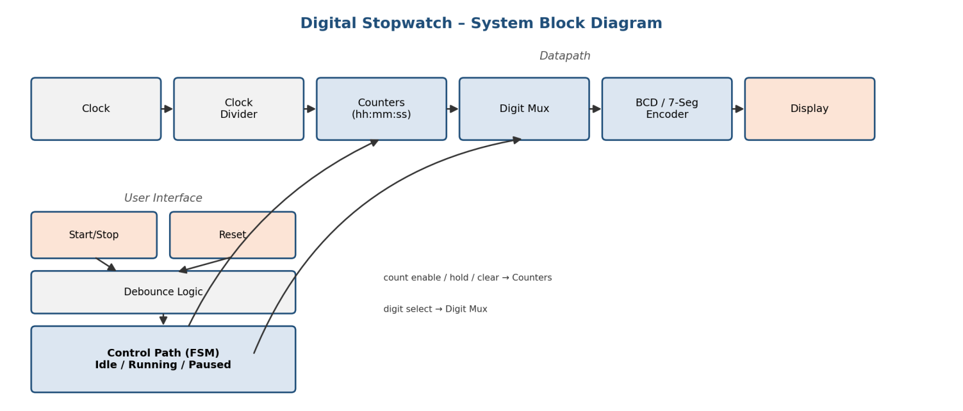

Q5. PROM, PLA, PAL, and CPLD architectures: scalability and speed
All four implement sum-of-products logic via an AND array and an OR array; they differ in which array is fixed.
- PROM: fixed AND (full decode), programmable OR. Array size grows as 2^inputs, so it scales poorly and is relatively slow
- PLA: both arrays programmable, efficient use of product terms, but two programmable stages make it slower than a PAL
- PAL: programmable AND, fixed OR. Faster than PLA, but each output has a fixed maximum number of product terms
- CPLD: multiple PAL-like macrocells linked by a programmable interconnect matrix. Best capacity and most predictable speed of the four, though still below FPGA scale
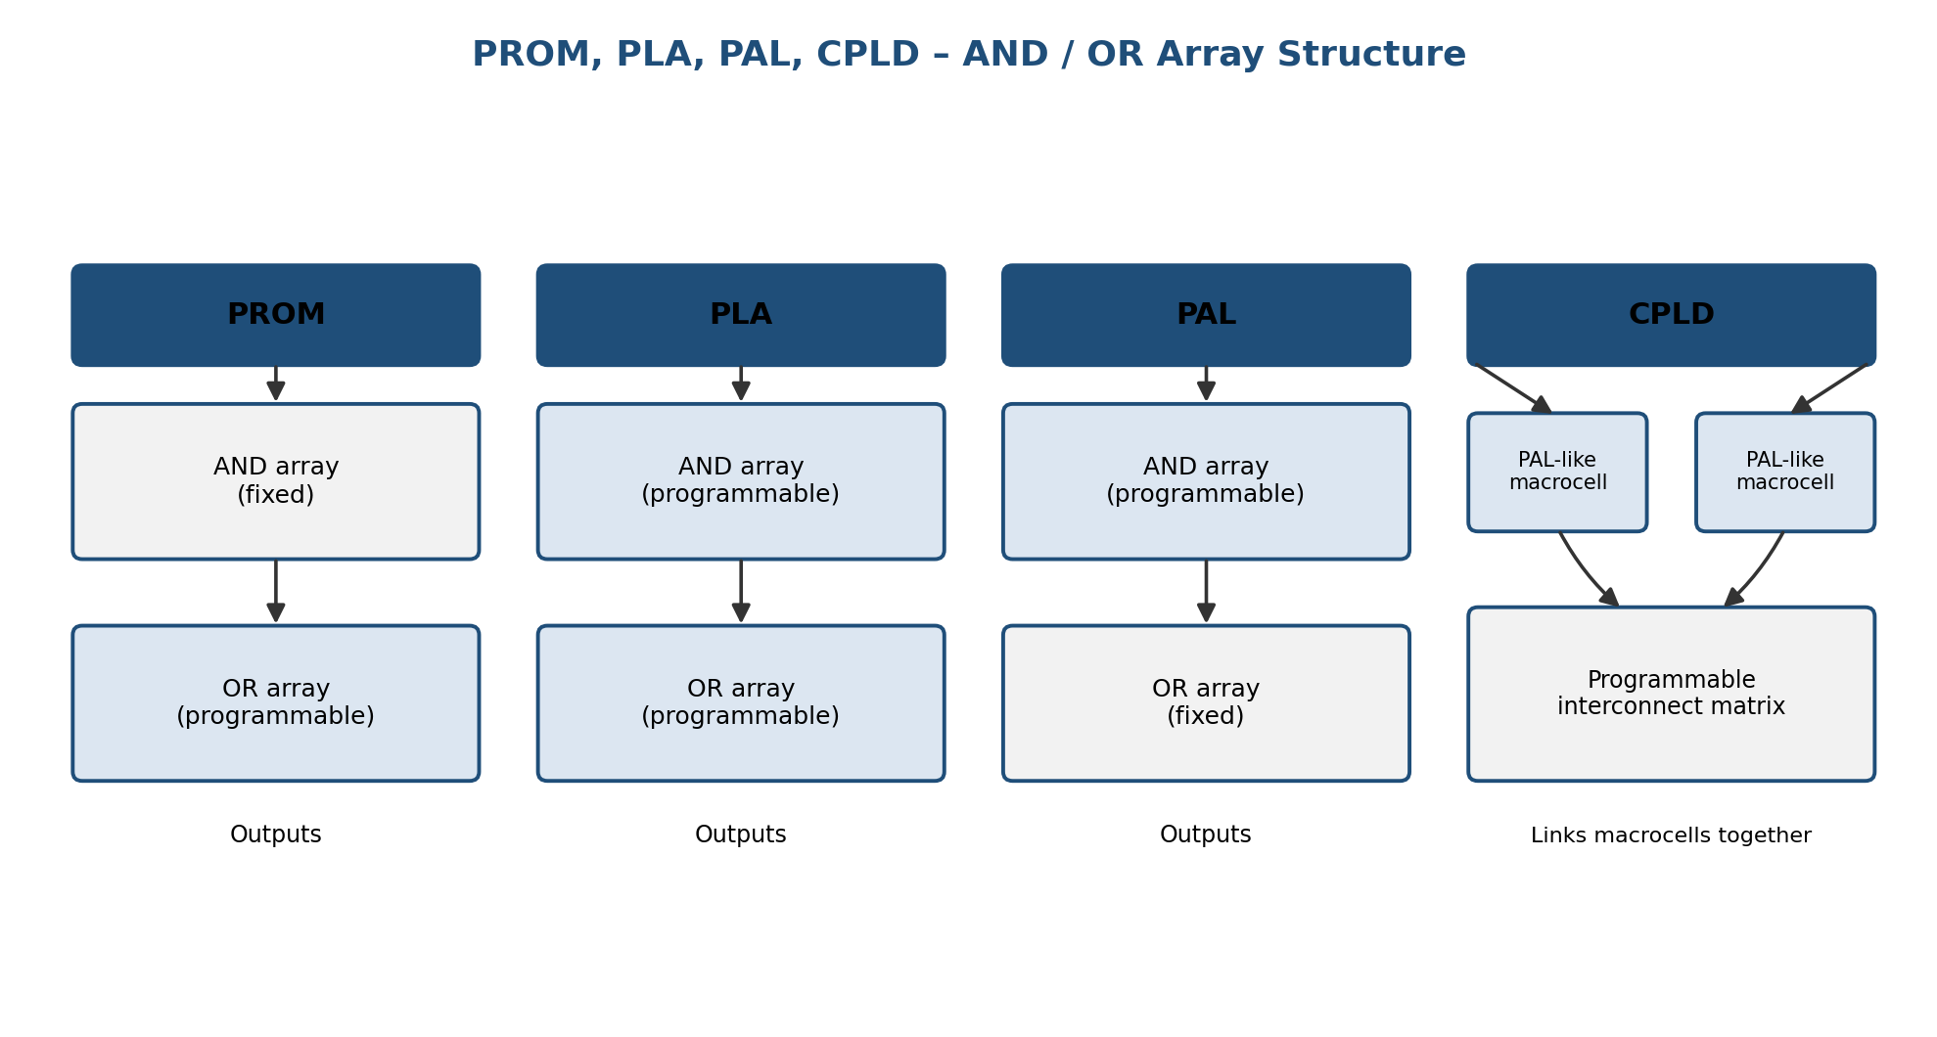
Q6. Programmable routing and interconnections: flexibility, area, power, and delay
- Flexibility: more switches/wire segments ease place-and-route and raise utilization; too little routing makes designs unroutable
- Area: interconnect typically takes up the majority of FPGA die area, so more flexibility costs significant area
- Power: each switch point adds capacitance a driver must charge/discharge, so longer, multi-hop routes draw more dynamic power, and idle switches leak
- Delay: routing delay usually exceeds logic delay, since a signal crosses several switch stages; congestion forcing longer routes directly lowers maximum clock frequency

Q7. Altera Stratix vs. Xilinx Virtex-II routing for low power
Both use segmented interconnect (multiple wire lengths plus a switch fabric) rather than one uniform resource, which helps limit power.
Stratix's MultiTrack interconnect adds direct-link paths between adjacent logic array blocks, letting local connections skip the full switch matrix and use less capacitance. Virtex-II routes through a per-CLB switch matrix with direct, hex, and long lines, giving strong global flexibility but at higher average power per connection when a local link could have been used instead.
For designs with high locality, Stratix's direct links tend to give lower routing power; Virtex-II favors large, less regular designs needing flexible global routing. Either way, the power benefit depends heavily on placement quality.
Q8. SoPC advantages and hardware-software co-simulation for an embedded system
SoPC advantages
- Single-chip integration cuts board area, power, and cost
- On-chip bus gives lower latency between processor and accelerator than an off-chip link
- Accelerator logic is reconfigurable, so updates don't need a new chip
- Work splits naturally: processor for control, accelerator for the heavy compute kernel
- New peripherals/accelerators can be added later in the same fabric
Co-simulation
Running the software (on an ISS or soft core) together with a simulated model of the hardware accelerator, over a modeled bus, verifies data transfer, interrupts, and timing before synthesis. This catches interface bugs early and gives a performance estimate before committing to hardware.
Q9. Programmable interconnection schemes and power dissipation
- Crossbar/fully connected: maximum flexibility, but switch count (and power) grows roughly with the square of connections
- Multiplexer-based: power rises with mux-tree depth and fan-in
- Switch-matrix with pass transistors (typical FPGA approach): power scales with the number of switch points a route passes through
- Segmented/hierarchical: matches wire length to connection distance, cutting average power since most connections are local
- Dedicated hard-wired links (e.g. carry chains): lowest power, but no flexibility
In general, power rises with the number of programmable switch points a route uses and with how far it travels beyond what's needed, which is why segment lengths are sized to typical connection-length statistics.

Q10. Hardware-software co-design strategy for an FPGA-based vending machine controller
Hardware
- Coin/card sensor interface and debouncing
- Keypad scanning and debouncing
- Dispense-sequence controller driving motor/solenoid actuators with precise timing
- Display driver refresh
Software
- Price lookup and transaction logic (credit check, change calculation)
- Inventory tracking and restocking alerts
- Display messages/prompts
- Transaction logging and remote communication
- Exception handling (out-of-stock, failed dispense)
Time-critical, repetitive operations go in hardware; logic that changes often (pricing, promotions) stays in software for easy updates. The two communicate over an on-chip bus, and the partition should be verified with hardware-software co-simulation before finalizing the FPGA bitstream.
