Experiment 2
Interfacing Input/Output Devices with FPGA

Objective
The goal of this experiment is to explore the various input and output (I/O) interfacing capabilities of the ALTERA Cyclone II EP2C5T144C8 FPGA. Students will learn to design and implement circuits that interact with external devices through GPIOs, such as switches, LEDs, and seven-segment displays. The experiment will cover the configuration of I/O pins, handling of digital signals, and integration of I/O devices with FPGA logic.

Introduction to FPGA I/O Interfacing

I/O Standards and Configuration
FPGAs support a variety of I/O standards to interface with external components. The Cyclone II EP2C5T144C8 supports standards such as LVTTL, LVCMOS, SSTL, and HSTL, which define the voltage levels and electrical characteristics of the I/O pins.
    - LVTTL (Low Voltage TTL): A standard for interfacing with TTL logic levels, typically 3.3V.
    - LVCMOS (Low Voltage CMOS): Supports various voltage levels, such as 1.8V, 2.5V, and 3.3V, and is widely used in modern digital systems.
    - SSTL (Stub Series Terminated Logic) and HSTL (High-Speed Transceiver Logic): Standards used for high-speed memory interfaces and other high-performance applications.

Configuring I/O Pins
Each I/O pin on the Cyclone II FPGA can be configured for different modes, such as input, output, or bidirectional. Configuration is achieved through the Quartus II software, where you specify pin assignments and I/O standards in the constraints file.
    - Input Mode: The pin receives signals from external sources.
    - Output Mode: The pin drives signals to external devices.
    - Bidirectional Mode: The pin can function as either an input or output, depending on the design's requirements.

Interfacing with LEDs
  - Overview
LEDs are used to provide visual feedback or status indicators. They are connected to GPIO pins configured as outputs. This section describes how to interface LEDs with the Cyclone II EP2C5T144C8 FPGA.
Push buttons are used to provide binary input signals. They are connected to GPIO pins configured as inputs. This section covers interfacing push buttons with the FPGA.
  - Pin Planning
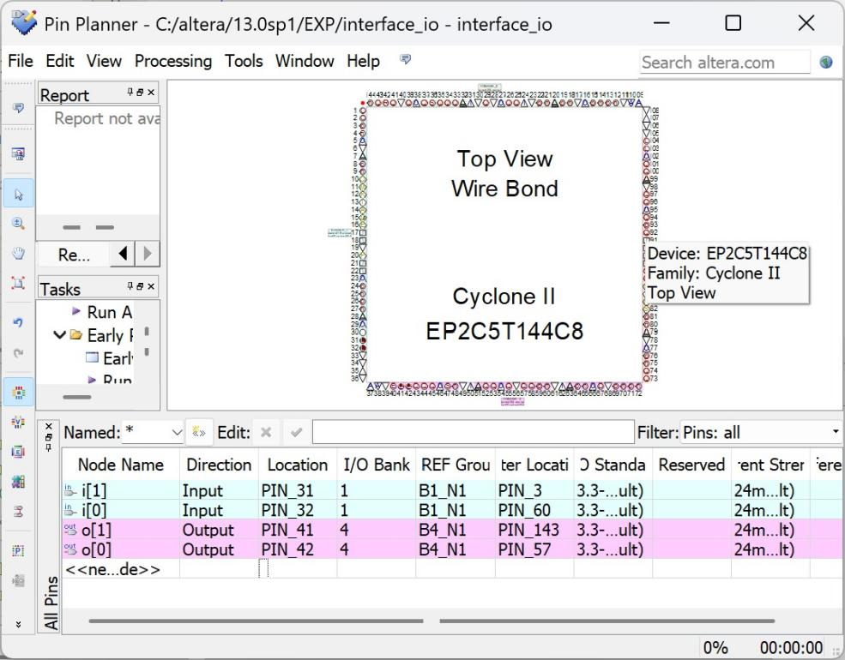

  - Technical Details
    - Connection: Connect each push button to the FPGA’s GPIO pin with a pull-down resistor to ensure a stable low state when the button is not pressed.
    - Debouncing: Implement debouncing in the design to filter out the noise caused by mechanical bounce.

  - Example Design
Push Button to LED Control
Pin Assignments in Quartus II

Implementation and Testing
    - Synthesis and Implementation: Compile the design in Quartus II, ensuring correct pin assignments.
    - Programming: Program the FPGA with the compiled design.
    - Testing: Press each button and verify that the corresponding LEDs turn on or off as expected.

3.6 RTL schematic:
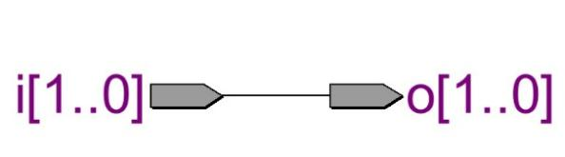

3.7 Output
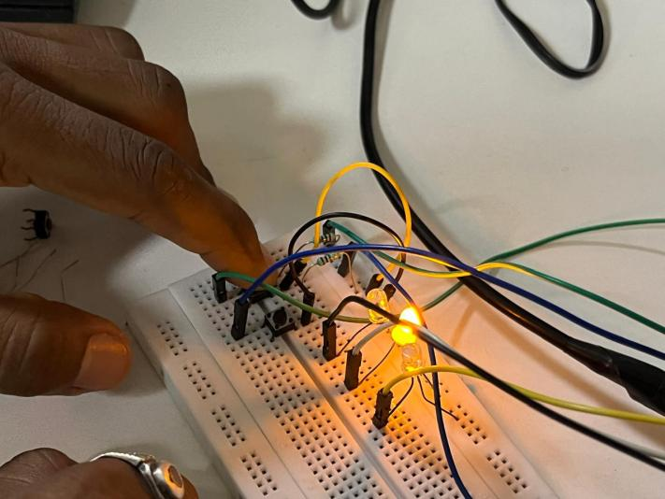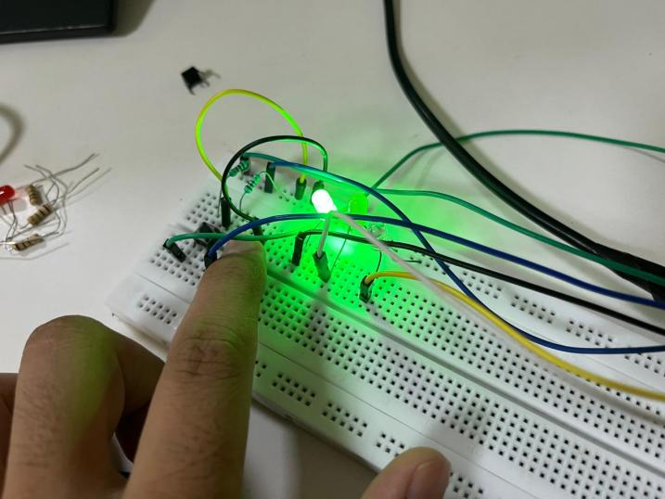

Conclusion
In this experiment, we learned to interface input and output devices with the Altera Cyclone II FPGA using Quartus II. We configured GPIO pins, assigned the correct FPGA pins, synthesized the design, and programmed the board. Push buttons served as inputs and LEDs as outputs, and pressing a button correctly controlled its corresponding LED. The experiment covered FPGA I/O interfacing, pin assignment, and hardware implementation — fundamental concepts for digital system design.

Post Lab Exercise
- What is the primary function of GPIO pins in an FPGA?
GPIO (General Purpose Input/Output) pins are used to connect the FPGA with external devices. They can be configured as input, output, or bidirectional pins to receive or send digital signals.

- What is the purpose of input switches on an FPGA development board?
Input switches provide manual digital input signals to the FPGA. They allow users to test and verify FPGA logic by changing the input values during hardware execution.

- Name one practical application of FPGA I/O interfacing.
One practical application is industrial automation, where an FPGA interfaces with sensors and actuators to monitor and control machines in real time.
Other examples:
- Traffic light control systems
- Robotics
- Home automation
- Medical devices

- What is the purpose of the Programmer tool in Quartus II?
The Programmer tool in Quartus II is used to download the compiled configuration file (.sof) into the FPGA device. It programs the FPGA so that the implemented digital circuit can operate on the hardware.

- Why is pin assignment necessary before programming an FPGA?
Pin assignment ensures that the logical input and output signals in the design are mapped to the correct physical FPGA pins. Without proper pin assignments, the FPGA cannot communicate correctly with external devices such as switches, LEDs, and displays.

