Aim: implement multiplexers and demultiplexers on the FPGA development board

Software required:

Hardware required:

Theory:

Multiplexer

A Multiplexer (MUX) is a combinational circuit that selects one input from multiple inputs and sends it to a single output. The selection is controlled by select lines. In FPGA, multiplexers are used for data selection and routing.

Demultiplexer

A Demultiplexer (DEMUX) is a combinational circuit that transfers one input to one of many outputs. The output is selected using select lines. It is commonly used for data distribution in digital systems.

Block diagram:

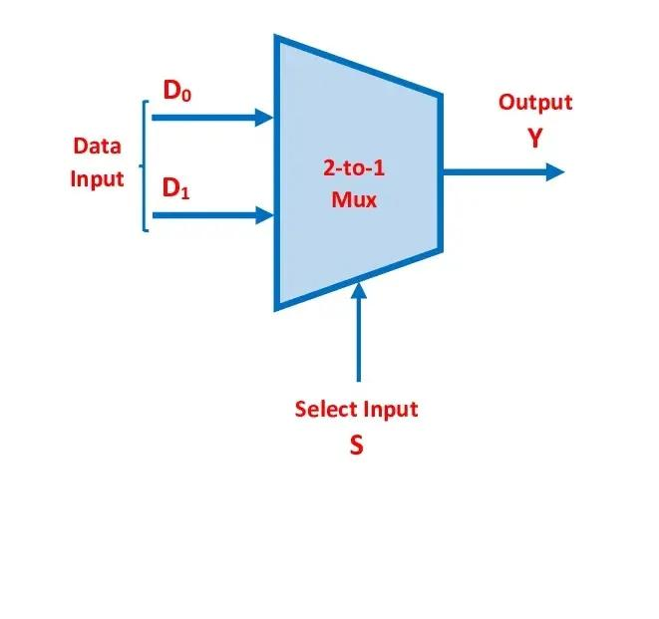
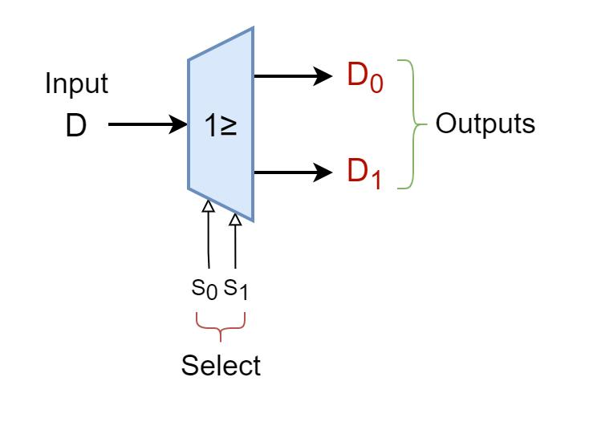

Truth Table:

MUX:
S | Output (Y)
0 | I0
1 | I1

DEMUX:

S | D | Y0 | Y1
0 | 0 | 0 | 0
0 | 1 | 1 | 0
1 | 0 | 0 | 0
1 | 1 | 0 | 1

Boolean Expression:

Boolean Expression (2:1 MUX)
$$Y=\overset{‾}{S}I_{0}+SI_{1}$$
Boolean Expression (1:2 DEMUX)
$$Y_{0}=\overset{‾}{S}⋅D$$$$Y_{1}=S⋅D$$

Circuit Diagram:
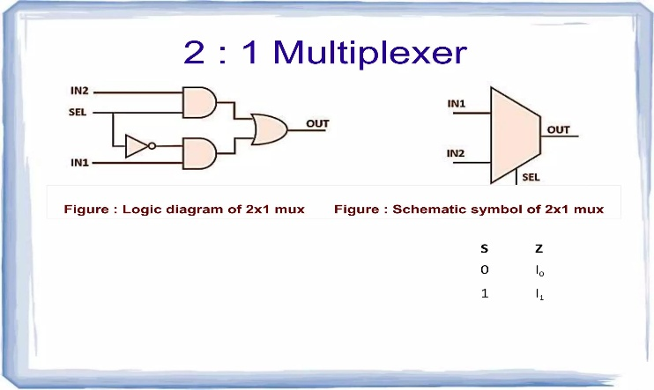
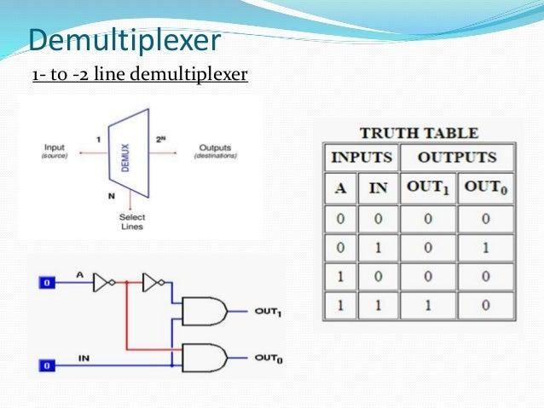

Verilog Code:

Simulation Results:

MUX DEMUX

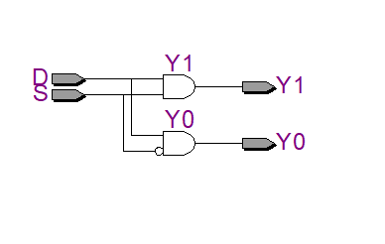
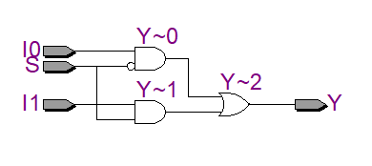

(FPGA Implementation)

Conclusion:

Post Lab Exercise:

