Aim: To design and implement digital coding and decoding systems for data representation and communication applications using FPGA.
Software required:
Quartus sp13.0.1

Hardware required:
FPGA, USB-BLASTER

Theory:

An encoder and a decoder are combinational digital circuits widely used for data representation and communication.
Encoder
An encoder converts one active input from multiple input lines into a smaller number of binary output bits.
A 4-to-2 encoder consists of:
- 4 input lines: D0, D1, D2, D3
- 2 output lines: A1, A0
Only one input is assumed to be HIGH at a time.
For example:
D0 = 1 → Output = 00
D1 = 1 → Output = 01
D2 = 1 → Output = 10
D3 = 1 → Output = 11
Thus, the encoder converts a one-hot input into its corresponding binary code.
Decoder
A decoder performs the reverse operation.
A 2-to-4 decoder consists of:
- 2 input lines: A1, A0
- 4 output lines: Y0, Y1, Y2, Y3
For each binary input combination, exactly one output becomes HIGH.
For example:
00 → Y0 = 1
01 → Y1 = 1
10 → Y2 = 1
11 → Y3 = 1
Therefore, an encoder performs coding, while a decoder performs decoding.

Block diagram:
Encoder:
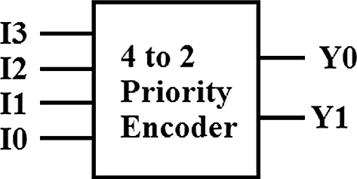

Decoder:
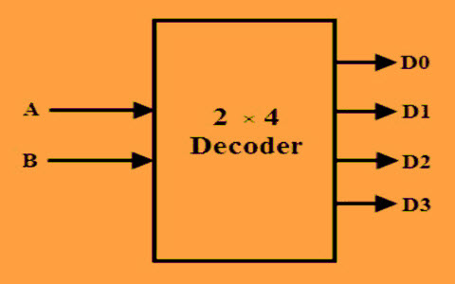

Encoder:
Truth Table:
D3 | D2 | D1 | D0 | A1 | A0
0 | 0 | 0 | 1 | 0 | 0
0 | 0 | 1 | 0 | 0 | 1
0 | 1 | 0 | 0 | 1 | 0
1 | 0 | 0 | 0 | 1 | 1

Decoder:
Truth Table:
A1 | A0 | D3 | D2 | D1 | D0
0 | 0 | 0 | 0 | 0 | 1
0 | 1 | 0 | 0 | 1 | 0
1 | 0 | 0 | 1 | 0 | 0
1 | 1 | 1 | 0 | 0 | 0

Boolean Expression:
Encoder:
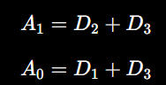
Decode:
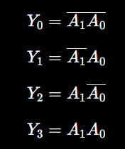

Circuit Diagram:
Encoder:
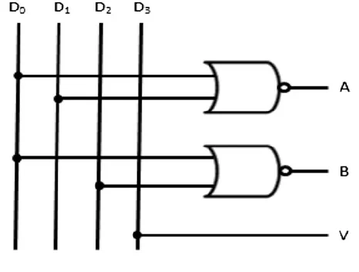
Decode:
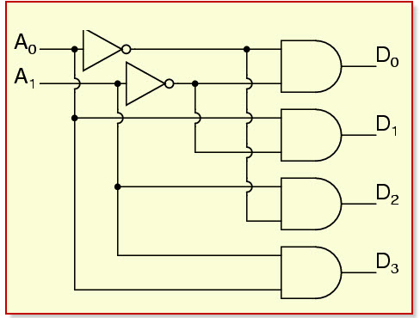

Verilog Code:

Encoder:
module en_de_coder(
input [3:0] a,
output reg [1:0] b
);
always @(*) begin
case(a)
4'b0010: b = 2'b01;
4'b0100: b = 2'b10;
4'b1000: b = 2'b11;
default: b = 2'b00;

endcase
end
endmodule

Decoder:
module en_de_coder(
input [1:0] a,
output reg [3:0] b
);
always @(*) begin
case(a)
2'b01: b = 4'b0010;
2'b10: b = 4'b0100;
2'b11: b = 4'b1000;
default: b = 4'b0001;
endcase
end
endmodule

Simulation Results:

(Simulation Waveform and RTL Schematic View)
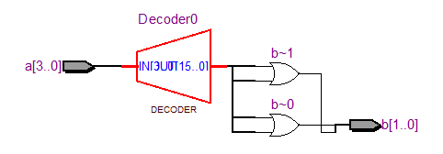
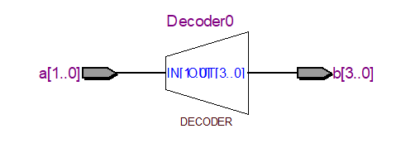
(FPGA Implementation with Pin Planning Details)
Encoder:
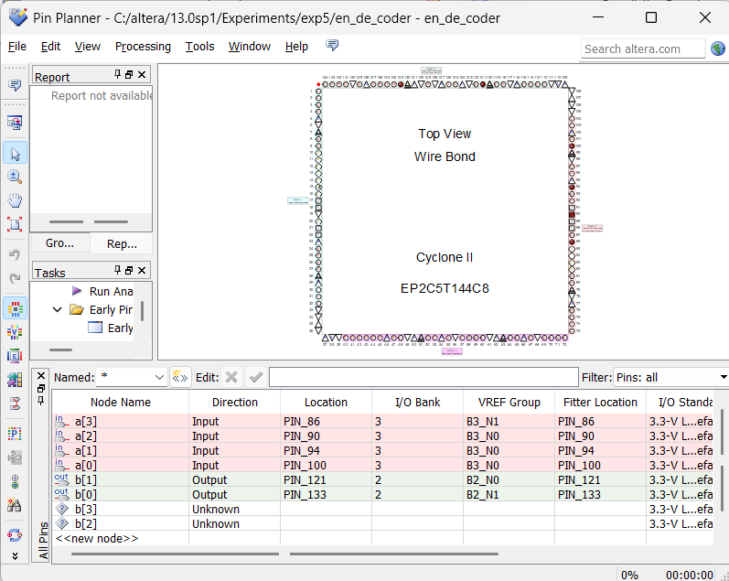
Decoder:
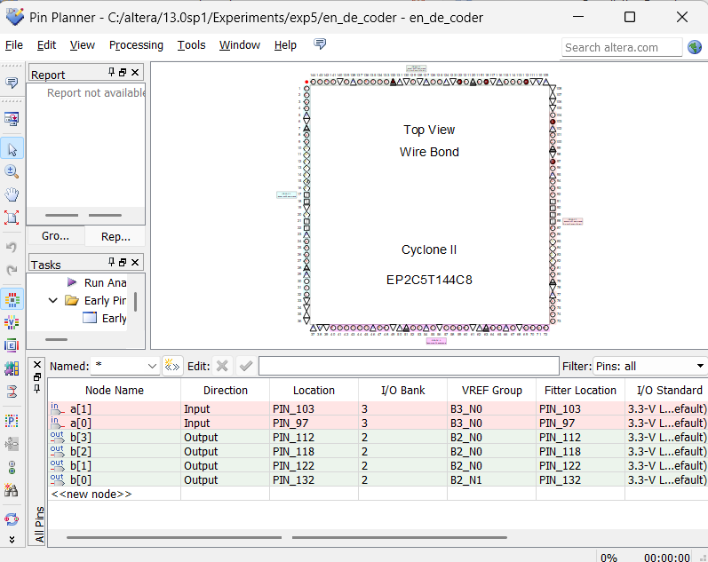
Output:
Encoder (4:2)
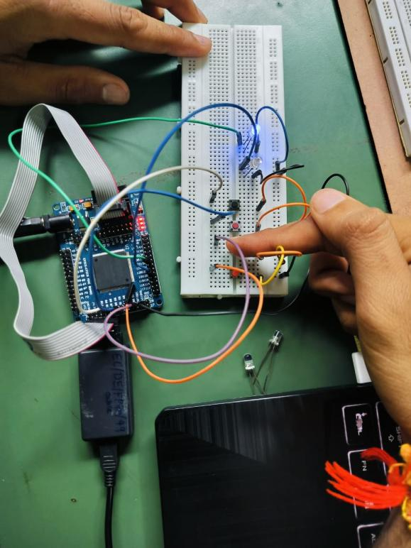
Decoder (2:4)
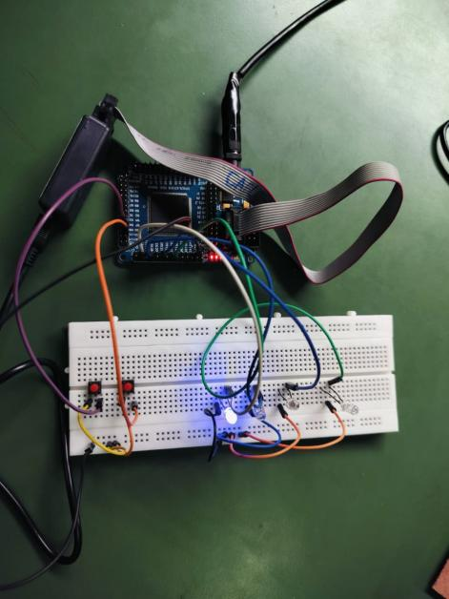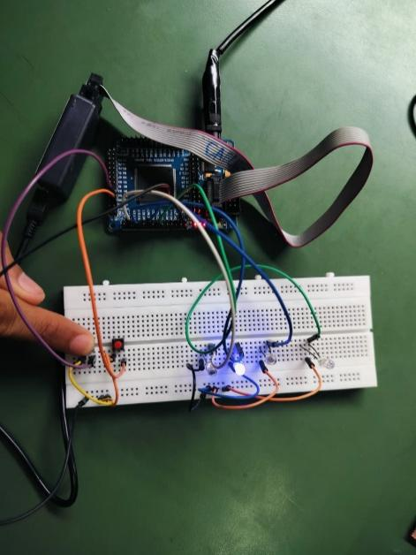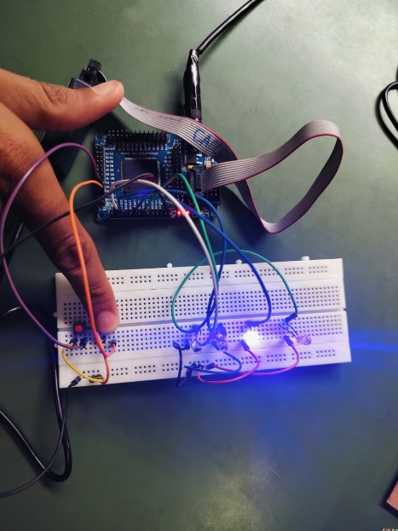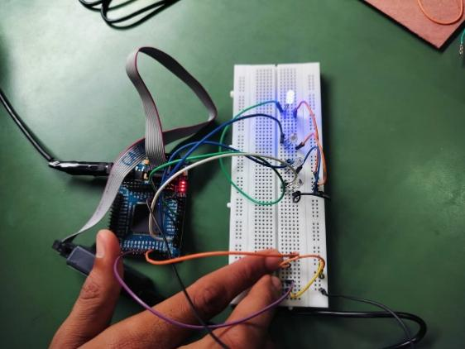

Conclusion:

The 4-to-2 encoder and 2-to-4 decoder were designed in Verilog HDL and tested against their truth tables and simulation waveforms, and both worked as expected. The encoder takes a single active input and converts it to its binary code; the decoder takes a binary input and drives the matching one-hot output. This confirms that both encoding and decoding can be implemented correctly on an FPGA.

Post Lab Exercise:
- What is a common application of decoders?
A common application of a decoder is memory address decoding, where a binary address is decoded to select a particular memory location or device. Decoders are also used in display systems, instruction decoding, and data routing.
- What is a priority encoder?
A priority encoder is an encoder that assigns priority to its input lines. If multiple inputs are HIGH simultaneously, it produces the binary code corresponding to the highest-priority active input.
For example, in a 4-to-2 priority encoder, if D3 and D1 are both HIGH and D3 has higher priority, the output represents D3.
- What is the purpose of an enable input in a decoder?
The enable input controls whether the decoder operates or not. When the decoder is enabled, it decodes the binary inputs normally. When disabled, its outputs remain in their inactive state.
- What verification technique ensures functional correctness beyond simulation?
Hardware verification on the FPGA board can be used to verify the functional correctness of the design beyond software simulation. Inputs can be applied through switches/buttons and the actual outputs can be observed using LEDs or other hardware.
- Why are behavioral HDL descriptions often preferred over structural descriptions for FPGA implementation?
Behavioral HDL descriptions are generally preferred because they are simpler, easier to write, easier to understand, and easier to modify. FPGA synthesis tools can automatically convert behavioral HDL into optimized hardware resources, reducing design complexity compared with manually connecting individual gates or modules.

