Aim: To design and implement FSM-based controllers for sequential digital systems.

Software required:

Vivado Simulator Theory:
A Finite State Machine (FSM) is a sequential digital system that operates through a finite number of predefined states. The state of the system changes according to the current state and the applied input. FSMs are commonly used to design digital controllers such as sequence detectors, traffic-light controllers, communication controllers, and control units.
An FSM mainly consists of:
- Present State: The current state of the system.
- Input: Determines the transition from one state to another.
- Next State Logic: Determines the next state based on the present state and input.
- State Register: Stores the current state.
- Output Logic: Generates the required output. There are two commonly used types of FSMs:
Mealy FSM
In a Mealy machine, the output depends on both the present state and the current input.
𝑂𝑢𝑡𝑝𝑢𝑡 = 𝑓(𝑃, 𝑟𝑒𝑠𝑒𝑛𝑡 𝑆𝑡𝑎𝑡𝑒𝐼𝑛𝑝𝑢𝑡)
Therefore, the output can change immediately when the input changes. Moore FSM
In a Moore machine, the output depends only on the present state.
𝑂𝑢𝑡𝑝𝑢𝑡 = 𝑓(𝑃𝑟𝑒𝑠𝑒𝑛𝑡 𝑆𝑡𝑎𝑡𝑒)
The output generally changes when the state changes.
For Verilog implementation, FSMs are commonly described using:
- State declaration
- State register
- Next-state logic
- Output logic
A reset state is used to initialize the FSM to a known state. This ensures predictable operation when simulation begins.
The FSM can be verified using a simulation waveform by applying different input sequences and observing the corresponding state transitions and outputs.

Block diagram:

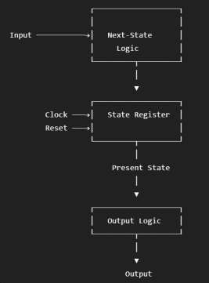
The FSM receives an input and determines the next state using the next-state logic. The state register stores the current state according to the clock. The output logic generates the required output based on the FSM state and, depending on the FSM type, the input.

Truth Table:
Present State | Input = 0 | Input = 1
S0 | S0 | S1
S1 | S2 | S1
S2 | S0 | S1
Where:
  - S0: No matching sequence
  - S1: 1 detected
  - S2: 10 detected
  - When 1 is received in S2, the sequence 101 is detected. For a Mealy sequence detector, the output is:

Present State | Input | Next State | Output
S0 | 0 | S0 | 0
S0 | 1 | S1 | 0
S1 | 0 | S2 | 0
S1 | 1 | S1 | 0
S2 | 0 | S0 | 0
S2 | 1 | S1 | 1

The output becomes 1 when the sequence 101 is detected.

Boolean Expression:
For the selected FSM, the output is asserted when:
𝑃𝑟𝑒𝑠𝑒𝑛𝑡 𝑆𝑡𝑎𝑡𝑒 = 𝑆2
and
𝐼𝑛𝑝𝑢𝑡 = 1
The output becomes HIGH when the FSM is in state S2 and the current input is 1, indicating detection of the sequence 101.

Circuit Diagram:
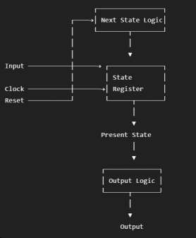

Verilog Code:

Design Module :
module sequence_detector_101 ( input wire clk,
input wire reset, input wire in, output reg detected
);
reg [1:0] state, next_state; parameter S0 = 2'b00,

S1 = 2'b01, S2 = 2'b10;
// State register
always @(posedge clk) begin if (reset)
state <= S0; else
state <= next_state;
end

// Next-state and output logic always @(*) begin
next_state = S0; detected = 1'b0;

case (state)

S0: begin if (in)
next_state = S1; else
next_state = S0;
end

S1: begin if (in)
next_state = S1; else
next_state = S2;
end

S2: begin
if (in) begin next_state = S1; detected = 1'b1;
end else
next_state = S0;
end

default: begin next_state = S0; detected = 1'b0;
end

endcase end

endmodule

TESTBENCH :
module sequence_detector_101_tb; reg clk;
reg reset; reg in;
wire detected; sequence_detector_101 uut (
.clk(clk),
.reset(reset),
.in(in),
.detected(detected)
);

// Clock generation always #5 clk = ~clk;
initial begin clk = 0;
reset = 1;
in = 0;

#10;
reset = 0;

// Input sequence: 1 0 1
#10 in = 1;
#10 in = 0;
#10 in = 1;

// Additional inputs #10 in = 1;
#10 in = 0;
#10 in = 1;

#20;

$finish; end endmodule

Simulation Results:
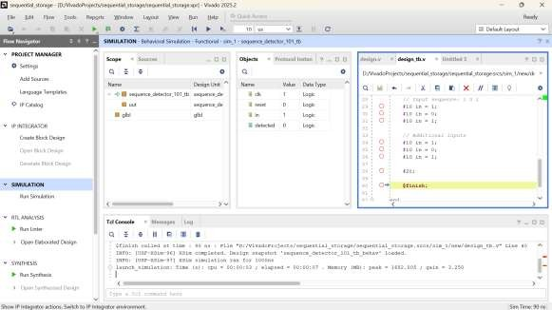
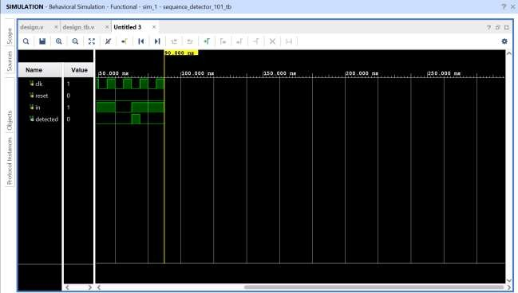

The simulation waveform verifies the state transitions of the FSM. When the input sequence 101 is applied, the FSM transitions through the required states and the output detected becomes HIGH when the complete sequence is recognized. The reset signal initializes the FSM to the initial state. Thus, the expected FSM behavior is verified through simulation.

Conclusion:

The FSM-based controller was successfully designed and implemented using Verilog HDL. The FSM was simulated using Vivado Simulator, and the state transitions and output behavior were verified for the applied input sequence. The RTL schematic and simulation waveform confirmed the correct operation of the FSM-based sequence detector.

Post Lab Exercise:
- Why is a Mealy FSM generally faster than a Moore FSM?
A Mealy FSM produces output based on both the present state and input. Therefore, the output can respond to an input change without waiting for an additional state transition.
- How does allowing overlapping sequences affect the number of FSM states?
Allowing overlapping sequences can reduce the number of states because a portion of a detected sequence can also serve as the beginning of the next sequence.
- Why is state minimization important in FSM design?
State minimization reduces the number of states and therefore reduces the required hardware resources and complexity of the FSM.
- What is the impact of an incorrect state transition in an FSM?
An incorrect state transition can cause the FSM to enter an unintended state, resulting in incorrect outputs and improper controller operation.
- Why is state encoding important in digital system implementation?
State encoding determines how FSM states are represented using binary values. A suitable encoding can improve area, speed, and implementation efficiency.
- How does one-hot encoding improve FPGA-based FSM performance?
In one-hot encoding, each state is represented by one dedicated flip-flop. This can simplify the combinational logic required for state transitions and may improve FSM speed on FPGAs.
- How does an FSM improve the reliability of a digital controller?
An FSM provides clearly defined states and transitions, making the controller behavior predictable, structured, and easier to verify.
- Why are reset states essential in FSM design?
A reset state initializes the FSM to a known starting condition. This prevents the FSM from starting in an undefined state and ensures predictable operation.

