Aim: To design and implement an intelligent traffic control system using finite state machine methodology.

Software required:

Vivado Simulator Theory:
A traffic control system manages the movement of vehicles at an intersection by controlling traffic signals such as Red, Yellow, and Green.
A Finite State Machine (FSM) is suitable for implementing a traffic controller because the traffic signal operates through a fixed sequence of states. Each state represents a particular traffic-light condition, and transitions between states occur according to the clock and control conditions.
For a two-road intersection, the controller can be designed using four basic states:
- S0 – Road A Green: Road A receives a green signal while Road B remains red.
- S1 – Road A Yellow: Road A changes to yellow before stopping.
- S2 – Road B Green: Road B receives a green signal while Road A remains red.
- S3 – Road B Yellow: Road B changes to yellow before stopping.
The FSM changes from one state to another according to the clock. A reset signal initializes the controller to a known state.
The traffic controller can be made intelligent by incorporating sensor inputs. These inputs can indicate whether vehicles are waiting on a particular road. Based on the sensor information, the controller can determine which direction should receive the green signal.
The important requirements of a traffic FSM are:
- Conflicting directions should never receive green simultaneously.
- Yellow states should be used during transitions.
- Reset should bring the controller to a safe initial state.
- Signal changes should be synchronized with the clock.
- Sensor inputs can be used to improve traffic-flow efficiency.
The behavior of the traffic controller can be verified through Vivado simulation by observing the FSM states and traffic-light outputs in the simulation waveform.

Block diagram:

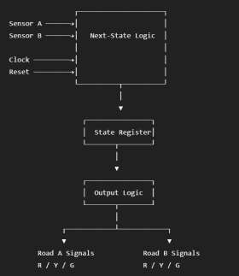
The controller receives sensor inputs from the two roads along with the clock and reset signals. The FSM determines the next traffic-light state and generates appropriate red, yellow, and green signals for both roads.

Truth Table:

For our simulation, we'll use a two-road intelligent traffic controller. Let:
- SA = 1 → Vehicles detected on Road A
- SB = 1 → Vehicles detected on Road B

State Transition Table :

Present State | SA | SB | Next State
S0 – A Green | X | X | S1
S1 – A Yellow | X | X | S2
S2 – B Green | X | X | S3
S3 – B Yellow | X | X | S0

The traffic signals are determined by the current state.

State Road A Road B

S0 | Green | Red
S1 | Yellow | Red
S2 | Red | Green
S3 | Red | Yellow

Boolean Expression:

Let the FSM states be:

𝑆0 = 00
𝑆1 = 01
𝑆2 = 10
𝑆3 = 11

The traffic-light outputs can be represented using the state bits 𝑄₁, 𝑄₀. Road A
Green:

Yellow:

Red:

Road B Green:

Yellow:

Red:
𝐴_{𝐺} = 𝑄‾1 ⋅ 𝑄‾0

𝐴_{𝑌} = 𝑄‾1 ⋅ 𝑄₀

𝐴_{𝑅} = 𝑄₁

𝐵_{𝐺} = 𝑄₁ ⋅ 𝑄‾0

𝐵_{𝑌} = 𝑄₁ ⋅ 𝑄₀

𝐵_{𝑅} = 𝑄‾1

These equations ensure that Road A and Road B cannot have green signals simultaneously.

Circuit Diagram:
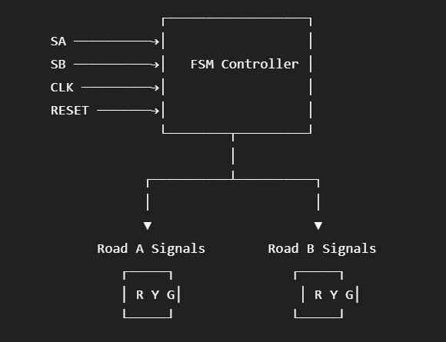

Verilog Code:

Design Module:

module traffic_controller ( input wire clk,
input wire reset, input wire sensor_a, input wire sensor_b,

output reg red_a, output reg yellow_a, output reg green_a,

output reg red_b, output reg yellow_b, output reg green_b
);

reg [1:0] state;
reg [1:0] next_state;

parameter S0 = 2'b00, S1 = 2'b01,
S2 = 2'b10, S3 = 2'b11;

// State register
always @(posedge clk) begin if (reset)
state <= S0; else
state <= next_state;
end

// Next-state logic always @(*) begin

case (state)

S0: begin next_state = S1;
end

S1: begin
// Select next green direction using sensors if (sensor_b && !sensor_a)
next_state = S2;

else
next_state = S2;
end

S2: begin next_state = S3;
end

S3: begin
if (sensor_a && !sensor_b) next_state = S0;
else
next_state = S0;
end
default: begin next_state = S0;
end

endcase end

// Output logic always @(*) begin

// Default outputs red_a = 1'b0; yellow_a = 1'b0; green_a = 1'b0;

red_b = 1'b0; yellow_b = 1'b0; green_b = 1'b0;

case (state)

// Road A Green S0: begin
green_a = 1'b1; red_b = 1'b1;
end

// Road A Yellow S1: begin
yellow_a = 1'b1; red_b = 1'b1;
end

// Road B Green

S2: begin
red_a = 1'b1; green_b = 1'b1;
end

// Road B Yellow S3: begin
red_a = 1'b1; yellow_b = 1'b1;
end
default: begin red_a = 1'b1; red_b = 1'b1;
end

endcase end

endmodule

TESTBENCH :
module traffic_controller_tb;

reg clk; reg reset;
reg sensor_a; reg sensor_b;

wire red_a; wire yellow_a; wire green_a;

wire red_b; wire yellow_b; wire green_b;

traffic_controller uut (
.clk(clk),
.reset(reset),
.sensor_a(sensor_a),
.sensor_b(sensor_b),

.red_a(red_a),
.yellow_a(yellow_a),
.green_a(green_a),

.red_b(red_b),
.yellow_b(yellow_b),

.green_b(green_b)
);

// Clock generation always #5 clk = ~clk;
initial begin clk = 0;
reset = 1;

sensor_a = 0;
sensor_b = 0;

#10;
reset = 0;
// Vehicles on Road A sensor_a = 1;
sensor_b = 0;

#40;
// Vehicles on Road B sensor_a = 0;
sensor_b = 1;
#40;
// Vehicles on both roads sensor_a = 1;
sensor_b = 1;

#40;

// No vehicles sensor_a = 0;
sensor_b = 0;

#40;

$finish; end endmodule

Simulation Results:
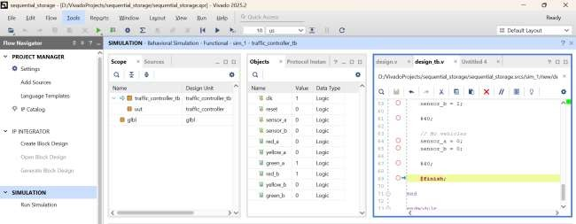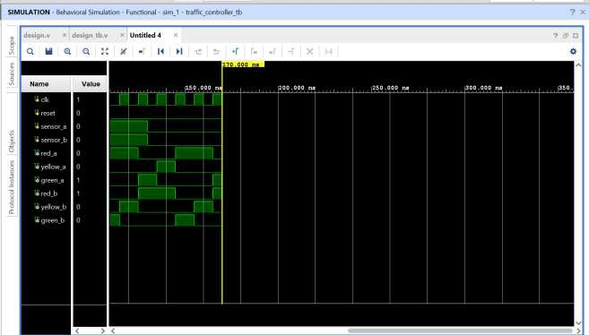

The simulation waveform verifies the operation of the FSM-based traffic controller. The traffic signals change according to the defined sequence of states. Road A receives the green signal while Road B remains red, followed by the yellow transition state. The controller then changes Road B to green while Road A becomes red, followed by the yellow transition state. The reset signal initializes the controller to the initial state. The simulation confirms that conflicting directions are not given green signals simultaneously.

Conclusion:

The intelligent traffic control system was successfully designed using finite state machine methodology and implemented using Verilog HDL. The design was simulated using Vivado Simulator, and the traffic-light signals were verified for the different FSM states. The simulation confirmed proper state transitions and ensured that conflicting traffic directions did not receive green signals simultaneously. The RTL schematic and simulation waveform verified the correct operation of the proposed traffic control system.

Post Lab Exercise:
- Why is an FSM suitable for designing an intelligent traffic control system?
An FSM is suitable because a traffic controller operates through a fixed set of states and transitions. Each state can represent a particular traffic-light condition.
- How does sensor-based traffic detection improve traffic signal efficiency?
Sensors detect the presence of vehicles and provide information about traffic density. The controller can use this information to adjust signal operation and reduce unnecessary waiting.
- Why should conflicting traffic directions never receive a green signal simultaneously?
Because simultaneous green signals for conflicting directions can allow vehicles to enter the intersection from both directions, creating a high risk of collision.
- How can adding emergency vehicle detection improve the traffic controller?
Emergency vehicle detection can allow the controller to provide priority to the emergency vehicle's direction, helping it pass through the intersection more quickly.
- Why is a reset state necessary in a traffic light FSM?
The reset state initializes the traffic controller to a known and safe condition, ensuring predictable signal behavior when the system starts.
- How does state minimization benefit a traffic control FSM?
State minimization reduces the number of states and simplifies the control logic, which can reduce hardware resources and make the FSM easier to design and verify.
- Why should pedestrian crossing requests be included in the FSM design?
Pedestrian requests allow the controller to safely provide crossing time while coordinating vehicle traffic signals.
- How does increasing the number of traffic lanes affect FSM complexity?
More traffic lanes and directions require more control states, inputs, and transitions, increasing the overall complexity of the FSM.
- Why is timing synchronization important in traffic signal control?
Timing synchronization ensures that signal transitions occur at controlled and predictable times, preventing unsafe or conflicting signal conditions.
- How can adaptive green signal timing reduce traffic congestion?
Adaptive timing can increase the green duration for roads with heavier traffic and reduce unnecessary green time for roads with fewer vehicles, improving traffic flow.

