Aim: To design and implement a real-time digital alarm clock system using programmable logic devices.

Software required: Vivado Simulator

Theory:

A digital alarm clock is a sequential digital system that keeps track of time and generates an alarm when the current time matches a predefined alarm time.
A digital clock generally represents time in the form of:
𝐻𝐻: 𝑀𝑀: 𝑆𝑆
where:
- HH represents hours.
- MM represents minutes.
- SS represents seconds.
The basic operation of a digital alarm clock consists of a clock divider, time counters, alarm registers, comparison logic, and alarm output.
A clock divider is used to convert a high-frequency input clock into a slower timing signal. For example, a suitable divider can generate a 1 Hz clock, where one clock pulse represents one second.
The seconds counter increments every second. When the seconds reach 59, they return to 00 and the minutes counter increments. Similarly, when the minutes reach 59, they return to 00 and the hours counter increments. The alarm time is stored separately. The current time is continuously compared with the stored alarm time.
When both values match, the alarm output is activated.
A reset circuit initializes the clock to a known starting time. Push-button inputs may be used for setting the current time and alarm time. In practical systems, these inputs require debouncing to prevent multiple unintended changes caused by mechanical switch bouncing.
BCD (Binary-Coded Decimal) representation is commonly used for digital clocks because each decimal digit of the time can be directly represented using four binary bits, making it convenient for display systems.
An FSM can also be used to control different operating modes such as:
- Normal clock mode
- Time-setting mode
- Alarm-setting mode
- Alarm-active mode
The complete system can be verified through simulation by observing the clock counters, alarm settings, comparison result, and alarm output.

Block diagram:

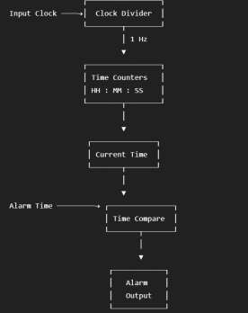

The input clock is divided to generate a suitable timing signal. The time counters maintain the current hours, minutes, and seconds. The current time is compared with the preset alarm time. When the two times match, the alarm output becomes active.

Truth Table:
For the alarm comparison:

Current Time = Alarm Time Alarm Output
0 0
1 1

For individual time components:

Hour Match | Minute Match | Second Match | Alarm
0 | X | X | 0
1 | 0 | X | 0
1 | 1 | 0 | 0
1 | 1 | 1 | 1

Therefore, the alarm activates only when the required time values match.

Boolean Expression:
Let:
- 𝐻_{𝑐}= current hour
- 𝐻_{𝑎}= alarm hour
- 𝑀_{𝑐}= current minute
- 𝑀_{𝑎}= alarm minute
- 𝑆_{𝑐}= current second
- 𝑆_{𝑎}= alarm second The alarm condition is:

Therefore:

𝐴𝑙𝑎𝑟𝑚 = (𝐻_{𝑐} = 𝐻_{𝑎}) ⋅ (𝑀_{𝑐} = 𝑀_{𝑎}) ⋅ (𝑆_{𝑐} = 𝑆_{𝑎})

𝐴𝑙𝑎𝑟𝑚 = 𝐻𝑜𝑢𝑟𝑀𝑎𝑡𝑐ℎ ⋅ 𝑀𝑖𝑛𝑢𝑡𝑒𝑀𝑎𝑡𝑐ℎ ⋅ 𝑆𝑒𝑐𝑜𝑛𝑑𝑀𝑎𝑡𝑐ℎ

where:

Circuit Diagram:

𝐻𝑜𝑢𝑟𝑀𝑎𝑡𝑐ℎ = (𝐻_{𝑐} = 𝐻_{𝑎})
𝑀𝑖𝑛𝑢𝑡𝑒𝑀𝑎𝑡𝑐ℎ = (𝑀_{𝑐} = 𝑀_{𝑎})

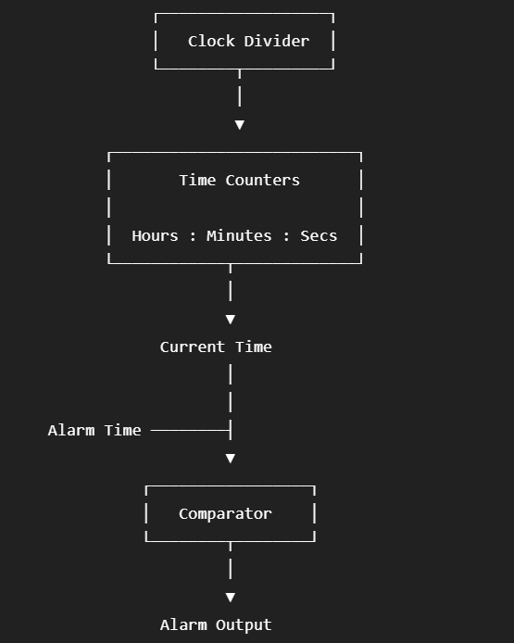

Verilog Code:

Design Module:
module digital_alarm_clock ( input wire clk,
input wire reset,

input wire [4:0] alarm_hour, input wire [5:0] alarm_minute, input wire [5:0] alarm_second,

output reg [4:0] hour, output reg [5:0] minute, output reg [5:0] second,
output reg alarm
);
always @(posedge clk) begin if (reset) begin
hour <= 5'd0;
minute <= 6'd0; second <= 6'd0;
end

else begin

// Seconds
if (second == 6'd59) begin second <= 6'd0;

// Minutes
if (minute == 6'd59) begin minute <= 6'd0;
// Hours
if (hour == 5'd23) hour <= 5'd0;
else
hour <= hour + 1'b1;

end
else begin
minute <= minute + 1'b1; end

end
else begin

second <= second + 1'b1; end
end end
// Alarm comparison always @(*) begin

if ((hour == alarm_hour) && (minute == alarm_minute) && (second == alarm_second))
alarm = 1'b1; else
alarm = 1'b0;
end endmodule

TESTBENCH :
module digital_alarm_clock_tb;
reg clk; reg reset;
reg [4:0] alarm_hour;
reg [5:0] alarm_minute;
reg [5:0] alarm_second;

wire [4:0] hour;
wire [5:0] minute;
wire [5:0] second; wire alarm;

digital_alarm_clock uut (
.clk(clk),
.reset(reset),

.alarm_hour(alarm_hour),
.alarm_minute(alarm_minute),
.alarm_second(alarm_second),

.hour(hour),
.minute(minute),
.second(second),

.alarm(alarm)
);

// Clock generation always #5 clk = ~clk;

initial begin

clk = 1'b0; reset = 1'b1;

// Set alarm time alarm_hour = 5'd0; alarm_minute = 6'd0; alarm_second = 6'd5;
#10;

reset = 1'b0;

// Run clock #100;

$finish; end endmodule

Simulation Results:
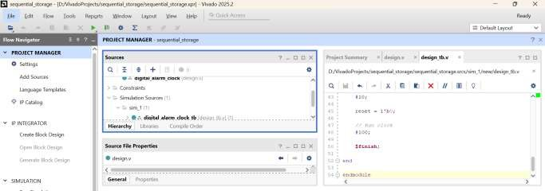

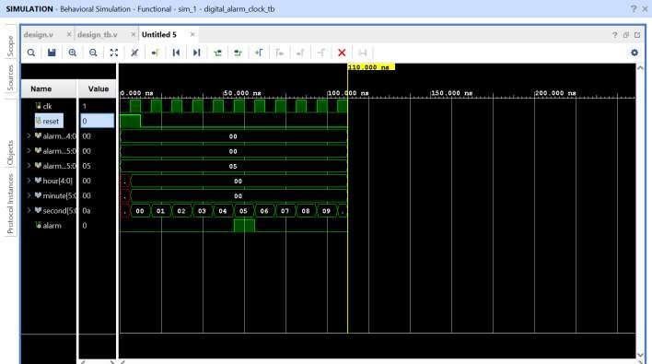

The simulation waveform verifies the operation of the digital alarm clock. The seconds counter increments with every clock pulse and rolls over from 59 to 00, causing the minute counter to increment. Similarly, the hour counter increments after the minute counter reaches 59 and rolls over after 23 hours. When the current time matches the preset alarm time, the alarm output becomes HIGH. Thus, the basic timekeeping and alarm-generation functions are successfully verified through simulation.

Conclusion:

The real-time digital alarm clock system was successfully designed and implemented using Verilog HDL. The design was simulated using Vivado Simulator, and the operation of the hour, minute, and second counters was verified. The alarm comparison logic successfully activated the alarm output when the current time matched the preset alarm time. The RTL schematic and simulation waveform confirmed the correct operation of the digital alarm clock system.

Post Lab Exercise:
- Why is a programmable logic device suitable for implementing a digital alarm clock?
A programmable logic device can implement counters, clock dividers, comparison logic, and control logic in a single programmable system. It can also be easily modified or reconfigured.
- How does a clock divider enable real-time clock operation?
A clock divider reduces a high-frequency input clock to a lower-frequency signal such as 1 Hz, where one pulse represents one second. This allows the digital clock to maintain real-time timing.

- Why is synchronous design preferred for a digital alarm clock?
Synchronous design ensures that state and counter changes occur in coordination with a common clock signal, making the system predictable and easier to verify.
- How does a finite state machine improve alarm clock functionality?
An FSM can control different operating modes such as normal clock operation, time setting, alarm setting, and alarm activation. This provides organized and predictable control of the system.
- Why is debouncing required for push-button inputs?
Mechanical push-buttons can produce multiple rapid transitions when pressed. Debouncing removes these unwanted transitions so that one button press is interpreted as a single input event.
- How does a reset circuit improve system reliability?
Reset initializes the clock and control logic to known values. This ensures predictable operation when the system starts or needs to be restarted.
- Why should the alarm operate independently of time-setting mode?
The alarm should continue to monitor the current time even when the user is setting or adjusting the clock. This ensures that the alarm function is not accidentally disabled during time-setting operations.
- Why is BCD representation commonly used in digital clocks?
BCD represents each decimal digit using four binary bits. This makes it convenient for driving decimal displays and performing digit-based time representation.

