Aim: To designandimplement FIR/IIRfiltersusing Verilog HDL on the Xilinx Artix-7 FPGA Board.

Software required:

- Xilinx Vivado Design Suite
- Verilog HDL
- Vivado Simulator

Hardware required:

- Digilent Nexys 4 DDR Development Board
- Xilinx Artix-7 FPGA (XC7A100T-1CSG324C)
- USB programming cable
- Computer/Laptop

Theory:

Digital filters are used to process digital signals by removing unwanted frequency components or modifying the characteristics of the input signal.
The two main types of digital filters are:

FIR Filter
FIR (Finite Impulse Response) filters use only present and previous input samples. The general FIR equation is:

For a 4-tap FIR filter:
𝑁−1
𝑦[𝑛] = ∑ ℎ [𝑘]𝑥[𝑛 − 𝑘]
𝑘=0

𝑦[𝑛] = ℎ₀𝑥[𝑛] + ℎ₁𝑥[𝑛 − 1] + ℎ₂𝑥[𝑛 − 2] + ℎ₃𝑥[𝑛 − 3]

FIR filters do not use feedback and are inherently stable.

IIR Filter
IIR (Infinite Impulse Response) filters use both previous input samples and previous output samples. A general IIR equation is:
𝑦[𝑛] = 𝑏₀𝑥[𝑛] + 𝑏₁𝑥[𝑛 − 1] − 𝑎₁𝑦[𝑛 − 1]
IIR filters use feedback, allowing similar filtering characteristics with fewer coefficients than FIR filters.

Comparison Between FIR and IIR

Parameter | FIR Filter | IIR Filter
Feedback | No | Yes
Stability | Always stable | Depends on coefficients
Phase Response | Can provide linear phase | Generally non-linear
Hardware | More multipliers for higher order | Fewer resources
Memory | Input samples | Input and output samples

Block diagram:

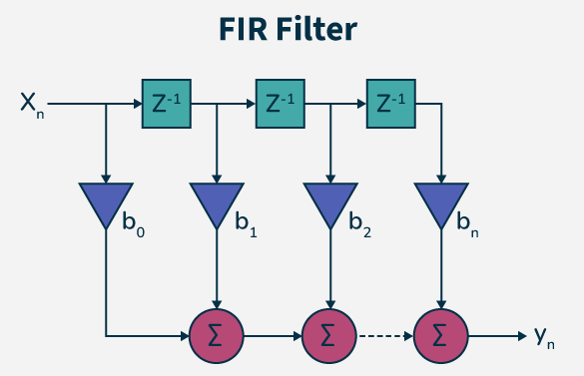

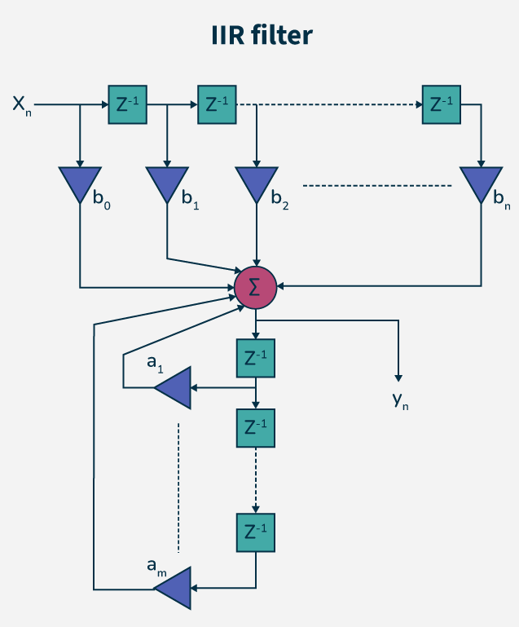

Truth Table:

Current Input | Previous Input 1 | Previous Input 2 | Previous Input 3 | Output
x[n] | x[n-1] | x[n-2] | x[n-3] | 𝑦[𝑛]
1 | 0 | 0 | 0 | 1
1 | 1 | 0 | 0 | 2
1 | 1 | 1 | 0 | 3
1 | 1 | 1 | 1 | 4

Boolean Expression:

FIR Filter
𝒚[𝒏] = 𝒉_{𝟎}𝒙[𝒏] + 𝒉_{𝟏}𝒙[𝒏 − 𝟏] + 𝒉_{𝟐}𝒙[𝒏 − 𝟐] + 𝒉_{𝟑}𝒙[𝒏 − 𝟑]

For the selected coefficients:

y[n] = x[n] + x[n - 1] + x[n - 2] + x[n - 3]

Selected IIR Filter Design

A simple first-order IIR filter can be represented as:
𝑦[𝑛] = 𝑏0𝑥[𝑛] + 𝑏1𝑥[𝑛 − 1] + 𝑎1𝑦[𝑛 − 1]

The IIR filter contains a feedback path.

Circuit Diagram:

FIR-Filter Circuit Diagram
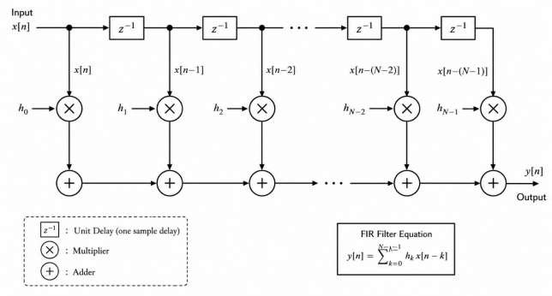

IIR-Filter Circuit Diagram
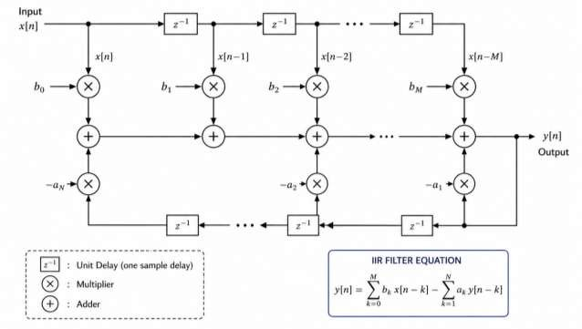

Verilog Code:

Verilog Code – 4-Tap FIR Filter

module fir_filter ( input wire clk, input wire reset,
input wire signed [7:0] x, output reg signed [9:0] y
);

reg signed [7:0] x1; reg signed [7:0] x2; reg signed [7:0] x3;

always @(posedge clk) begin if (reset) begin
x1 <= 8'd0; x2 <= 8'd0; x3 <= 8'd0; y <= 10'd0;
end
else begin

// FIR Filter:
// y[n] = x[n] + x[n-1]
// + x[n-2] + x[n-3] y <= x + x1 + x2 + x3;
// Delay line x3 <= x2; x2 <= x1;
x1 <= x;
end end

endmodule

Verilog Code – Simple IIR Filter

module iir_filter ( input wire clk, input wire reset,
input wire signed [7:0] x, output reg signed [9:0] y
);

reg signed [7:0] x1; reg signed [9:0] y1;
always @(posedge clk) begin if (reset) begin
x1 <= 8'd0; y1 <= 10'd0; y <= 10'd0;
end
else begin

// Example simplified IIR filter y <= x + x1 + (y1 >>> 1);

x1 <= x;
y1 <= x + x1 + (y1 >>> 1);

end end
endmodule

Simulation Results:

Simulation Waveform and RTL Schematic View

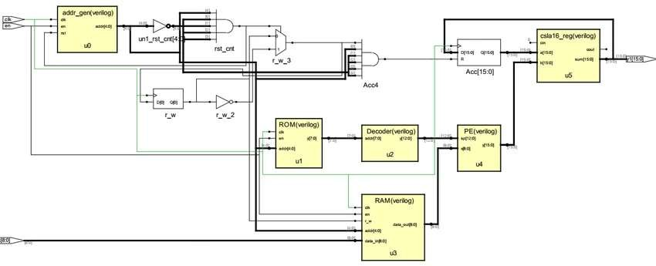

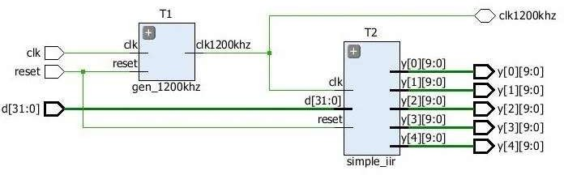

Conclusion:

In this experiment, I studied the design and implementation of FIR and IIR digital filters using Verilog HDL. I understood the difference between FIR filters, which use only feedforward paths, and IIR filters, which use feedback paths. The filter architectures were designed using delay elements, multipliers, and adders. The designs were verified through simulation before hardware implementation. Finally, the filters can be implemented on the Xilinx Artix-7 FPGA (XC7A100T-1CSG324C) hosted on the Digilent Nexys 4 DDR Development Board.

Post Lab Exercise:
- Why are FIR filters inherently more stable than IIR filters?
FIR filters do not use feedback, so their output does not accumulate indefinitely. Therefore, FIR filters are inherently stable.
- How does feedback improve the efficiency of an IIR filter?
Feedback allows IIR filters to achieve a desired response using fewer coefficients. This reduces the required hardware resources.
- Why are FIR filters preferred for applications requiring linear phase response?
FIR filters can easily provide a linear phase response. This prevents phase distortion in the filtered signal.
- How does increasing the filter order affect frequency selectivity?
Increasing the filter order generally improves frequency selectivity. It provides a sharper transition between passband and stopband.
- Why is coefficient precision important in digital filter implementation?
Coefficient precision affects the accuracy of the filter response. Low precision can introduce quantization errors.
- How does FPGA implementation improve digital filter performance?
FPGAs provide parallel processing and high-speed hardware implementation. This improves the throughput of digital filters.
- Why are multiply-accumulate (MAC) units critical in FIR filter design?
FIR filters require multiplication of samples and coefficients followed by addition. MAC units efficiently perform these operations.
- How does pipelining enhance filter throughput in programmable hardware?
Pipelining allows multiple filter operations to execute simultaneously in different stages. This increases the processing throughput.

- Why is resource sharing used in FPGA-based filter implementation?
Resource sharing reduces the number of multipliers and other hardware components required. This helps save FPGA resources.
- How does finite word length affect digital filter performance?
Finite word length introduces quantization and rounding errors. This can reduce the accuracy of the filter output.

