Aim: To design and implement sensor interfacing systems for embedded monitoring and control applications using the Xilinx Artix-7 FPGA Board

Software required:

- Xilinx Vivado Design Suite
- Verilog HDL
- Vivado Simulator

Hardware required:

- Digilent Nexys 4 DDR Development Board
- Xilinx Artix-7 FPGA (XC7A100T-1CSG324C)
- Sensor module / analog sensor
- ADC or FPGA XADC interface
- USB programming cable
- Computer/Laptop

Theory:

Sensor interfacing is the process of connecting a sensor to a digital system for monitoring physical parameters such as temperature, light, pressure, or voltage. An FPGA is suitable for sensor interfacing because it provides high-speed processing, parallel operation, and flexible hardware design.
For an analog sensor, the sensor output cannot be directly processed as normal digital logic. Therefore, the analog signal must be converted into digital data using an Analog-to-Digital Converter (ADC). The Nexys 4 DDR platform can also support analog input through the FPGA's XADC interface.
In this experiment, the sensor data is monitored by the FPGA. The digital sensor value is compared with a predefined threshold value. If the sensor value exceeds the threshold, the FPGA generates an alert signal, which can be displayed using an LED.

Block diagram:
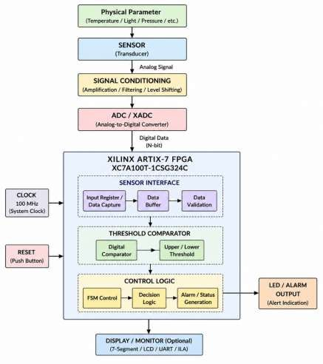

Truth Table:

Sensor Data Condition | Alert
Sensor Data < Threshold | 0
Sensor Data = Threshold | 0
Sensor Data > Threshold | 1

Example
For: Threshold = 100

Sensor Value | Alert
50 | 0
90 | 0
100 | 0
110 | 1
150 | 1

Boolean Expression:
The alert condition is:
𝐴𝑙𝑒𝑟𝑡 = 1, 𝑆𝑒𝑛𝑠𝑜𝑟_𝐷𝑎𝑡𝑎 > 𝑇ℎ𝑟𝑒𝑠ℎ𝑜𝑙𝑑

Otherwise:
𝐴𝑙𝑒𝑟𝑡 = 0

In Verilog:
alert = (sensor_data > THRESHOLD);

Circuit Diagram:

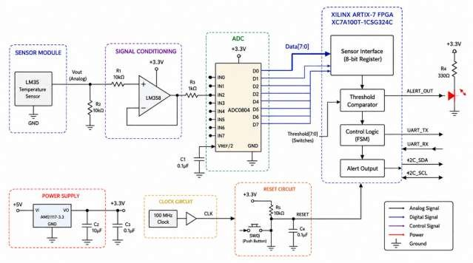

Verilog Code:

Sensor Monitoring and Alert System
module sensor_interface ( input wire clk,
input wire reset,

input wire [7:0] sensor_data,

output reg alert
);

parameter THRESHOLD = 8'd100; always @(posedge clk) begin
if (reset) begin

alert <= 1'b0; end
else begin

if (sensor_data > THRESHOLD) alert <= 1'b1;
else

alert <= 1'b0;

end end
endmodule

Testbench
module sensor_interface_tb; reg clk;
reg reset;

reg [7:0] sensor_data; wire alert; sensor_interface uut (
.clk(clk),
.reset(reset),
.sensor_data(sensor_data),
.alert(alert)

);

always #5 clk = ~clk; initial begin

clk = 0;
reset = 1; sensor_data = 8'd0;

#10;
reset = 0;

// Normal sensor value sensor_data = 8'd50;

#10;

// Normal sensor value sensor_data = 8'd90;
#10;

// Threshold value sensor_data = 8'd100;

#10;

// Alert condition sensor_data = 8'd120;

#10;

// Alert condition sensor_data = 8'd150;

#20;

$finish; end
endmodule

Conclusion:

In this experiment, I studied the interfacing of sensors with an FPGA for embedded monitoring applications. I understood how sensor signals can be converted into digital data using an ADC or XADC and processed by FPGA logic. A threshold-based monitoring system was designed using Verilog HDL to generate an alert signal. The design was simulated and can be implemented on the Xilinx Artix-7 FPGA (XC7A100T-1CSG324C) hosted on the Digilent Nexys 4 DDR Development Board.

Post Lab Exercise:
- Why is FPGA preferred for sensor interfacing in embedded systems?
FPGA provides high-speed processing and flexible hardware implementation. It can interface with different sensors according to application requirements.
- How does parallel processing improve multi-sensor interfacing on an FPGA?
An FPGA can process multiple sensor signals simultaneously. This improves speed and reduces processing delay.
- Why is signal conditioning required before interfacing sensors with an FPGA?
Signal conditioning adjusts and filters the sensor signal to a suitable voltage range. It ensures reliable and accurate sensor data processing.
- How does an Analog-to-Digital Converter (ADC) support FPGA-based sensor interfacing?
An ADC converts analog sensor signals into digital values. The FPGA can then process the digital sensor data.
- Why is clock synchronization important in sensor interfacing systems?
Clock synchronization ensures that sensor data is sampled and processed at the correct time. It prevents timing errors and incorrect data.
- How does interrupt-based sensor monitoring improve system performance?
Interrupt-based monitoring allows the system to respond only when an important sensor event occurs. This reduces unnecessary processing.
- Why is finite state machine (FSM) control commonly used in sensor interfacing?
An FSM controls different sensor operations in a proper sequence. It is useful for communication, data acquisition, and processing.
- How does FPGA implementation improve the response time of monitoring systems?
FPGAs perform hardware operations at high speed and in parallel. Therefore, sensor events can be detected with low latency.

- Why is data buffering important in embedded sensor systems?
Data buffering temporarily stores sensor data during processing. It prevents data loss when sensor data arrives continuously.
- How does hardware parallelism improve embedded monitoring applications?

ardware parallelism allows multiple operations and sensor channels to work simultaneously. This improves overall system performance and response time.

