Assignment 2 — Wireless Networks
Q1. Define Medium Access Control (MAC) in wireless networks and explain its importance. [CO3]
Medium Access Control (MAC) is the sub-layer of the data link layer that decides which device gets to use the wireless channel at a given moment, and how. Because radio is a shared, broadcast medium, any node within range can potentially transmit at the same time as another, so the MAC layer sets the rules: when a node is allowed to send, how it senses whether the channel is busy, and what happens if two transmissions collide.
Its importance comes directly from the nature of wireless links. Unlike a wired LAN where each cable segment is dedicated to one connection, a wireless channel is open to every device within radio range. Without a MAC protocol, several nodes would transmit simultaneously and destroy each other's frames at the receiver. A good MAC design (CSMA/CA in Wi-Fi, for example) keeps collisions rare, gives nodes a fair share of airtime, handles the hidden- and exposed-terminal problems specific to radio propagation, and — in battery-powered devices — reduces the time radios spend listening or colliding, which saves energy.
Q2. What is Link Adaptation in Wi-Fi, and why is it needed in wireless communication? [CO3]
Link adaptation is the practice of continuously changing transmission parameters — mainly the modulation scheme, the coding rate, and sometimes transmit power — to match the current condition of the radio channel. A Wi-Fi transmitter picks a Modulation and Coding Scheme (MCS) based on recent feedback about signal quality (SNR, packet loss, retransmissions), then switches to a different MCS as conditions change.
It is needed because the wireless channel is not static. Distance from the access point, multipath fading, movement of the device or nearby objects, and interference from other transmitters all change the signal-to-noise ratio from one moment to the next. A fixed data rate would either be too aggressive for poor conditions, causing constant packet loss and retransmissions, or too conservative for good conditions, wasting available capacity. Link adaptation lets the network use a high-order, high-throughput scheme when the channel is clean and fall back to a more robust, lower-rate scheme when it is not, keeping the connection both fast and reliable.

Q3. List the major differences between proactive and reactive routing protocols in ad hoc networks. [CO3]
Proactive protocols keep routes to every possible destination ready at all times, refreshed by periodic exchanges. Reactive protocols only look for a route once data actually needs to go to a destination. The table below lines up the main points of contrast.
Aspect | Proactive (table-driven) | Reactive (on-demand)
Route availability | Maintained continuously for all destinations | Discovered only when needed
Control overhead | Higher — periodic updates regardless of traffic | Lower when idle, spikes during discovery
Latency for first packet | Low — route is already known | Higher — must wait for route discovery
Behaviour under mobility | Struggles to keep tables current; more updates needed | Naturally re-discovers routes as needed
Memory / storage | Larger — full topology or routing table per node | Smaller — only active routes are kept
Examples | DSDV, OLSR | AODV, DSR
Q4. What is the LEACH protocol, and what type of network does it typically apply to? [CO3, CO4]
LEACH (Low-Energy Adaptive Clustering Hierarchy) is a hierarchical routing protocol built for wireless sensor networks (WSNs). Rather than every sensor sending its readings straight to a distant base station, LEACH organizes nodes into clusters. In each round, one node per cluster becomes the cluster head: it collects data from the other members, compresses or aggregates it, and forwards the summary to the base station. The cluster head role is rotated round by round so that no single node bears the transmission cost every time.
It applies to WSNs deployed for tasks such as environmental or structural monitoring, where hundreds of battery-powered, resource-limited sensor nodes must report to one or a few sinks, and where extending overall network lifetime matters more than delivering every packet on the shortest possible path.
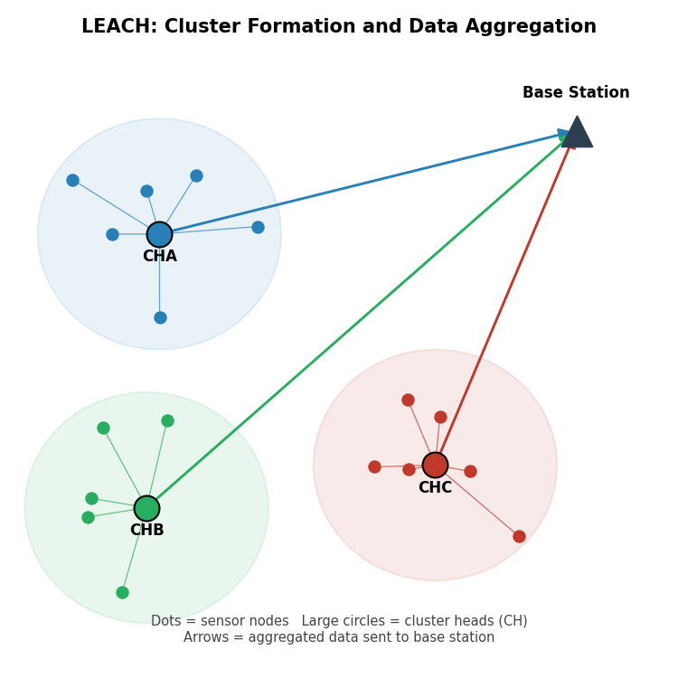
Figure 1. Sensor nodes organized into clusters; each cluster head (CH) aggregates its members' data and relays it to the base station.
Q5. Explain the role of clustering in the LEACH protocol for wireless sensor networks. [CO4]
Clustering is the mechanism that gives LEACH its energy savings. Ordinary member nodes only need to reach their own cluster head, which is usually a short hop away, instead of transmitting all the way to the base station. Long-range transmission is the most energy-expensive operation a sensor performs, so pushing it onto just one node per cluster — the cluster head — cuts the average energy spent per node substantially.
The cluster head also aggregates the raw data it receives before forwarding it, removing redundancy between readings from nearby sensors and reducing the number of bytes that actually need a long-range radio hop. Because the cluster head role rotates between rounds, the extra burden of aggregation and long-range transmission is shared across the whole network rather than draining the same few nodes, which is what keeps the network alive for longer overall.

Q6. What are the primary characteristics of Ad hoc On-Demand Distance Vector (AODV) routing protocol? [CO3]
- On-demand (reactive): a route is built only when a node has data to send and no valid route already exists.
- Destination sequence numbers: every route entry carries a sequence number from the destination, which lets nodes tell a fresh route from a stale one and keeps the protocol loop-free.
- Route discovery via RREQ/RREP: the source broadcasts a Route Request; the destination, or an intermediate node with a fresh enough route, replies with a Route Reply.
- Hop-by-hop routing: nodes store only the next hop toward a destination, not the entire path, which keeps routing tables small.
- Route maintenance with RERR: broken links are reported upstream with a Route Error so affected nodes can invalidate the route or trigger a new discovery.
- Soft state with timers: unused routing entries expire automatically, so the protocol does not need explicit route teardown signaling in most cases.
Q7. Describe the main goal of medium access control in ad hoc wireless networks. [CO3]
In an ad hoc network there is no access point or base station to coordinate transmissions, so the main goal of MAC here is to let nodes share the channel fairly and efficiently purely through distributed coordination. This means avoiding collisions between nodes that cannot always hear each other (the hidden-terminal problem), avoiding unnecessary silence between nodes that could actually transmit at the same time without interfering (the exposed-terminal problem), adapting to a topology that changes as nodes move, and doing all of this with as little energy and control overhead as possible, since ad hoc nodes are usually battery-powered and have no fixed infrastructure to lean on.
Q8. Compare and contrast LEACH protocol with other clustering protocols used in wireless sensor networks. [CO3, CO4]
LEACH is the baseline clustering protocol for WSNs, but several later protocols address its weak points — mainly that LEACH picks cluster heads by a random probability without checking whether a node actually has enough energy left.
Protocol | Cluster head selection | Key difference from LEACH
LEACH | Random probability threshold, rotated each round | Simple, but ignores each node's actual remaining energy
HEED | Residual energy combined with node degree / proximity to neighbours | More energy-aware CH choice, better load distribution across the network
PEGASIS | No clusters — nodes form a chain and pass data along it | Avoids cluster overhead entirely; one node per round sends to the base station
TEEN | Similar clustering to LEACH, but reactive: sensors report only when a value crosses a threshold | Sends far fewer packets, suited to time-critical / event-driven sensing

Q9. Explain how link adaptation dynamically adjusts the transmission parameters in Wi-Fi networks. [CO3]
Link adaptation works as a feedback loop. The receiver, or the transmitter itself by observing acknowledgements, estimates how good the channel currently is — through the signal-to-noise ratio, the bit or packet error rate, and how many retransmissions recent frames have needed. That estimate is fed into a rate-selection algorithm (examples include ARF and Minstrel) running at the transmitter.
Based on the estimate, the transmitter adjusts several parameters together: the modulation order (BPSK, QPSK, 16-QAM, 64-QAM, and higher in newer standards), the forward error correction coding rate (1/2, 2/3, 3/4, 5/6), and sometimes the number of spatial streams or the frame aggregation size. When conditions improve, it steps up to a denser modulation and higher coding rate for more throughput; when conditions worsen, or retransmissions start climbing, it steps back down to a more robust combination. This adjustment typically happens on a per-frame or per-burst basis, so the link keeps tracking the channel almost in real time.
Q10. Discuss the limitations of the traditional MAC layer in supporting high-mobility ad hoc networks. [CO3]
Traditional wireless MAC designs, largely built around CSMA/CA with a fixed contention window and static carrier-sensing assumptions, run into several problems once node mobility is high.
- Carrier-sensing information goes stale quickly: by the time a node has sensed the channel and decided to transmit, a neighbor that just moved into or out of range can make that decision wrong.
- Hidden- and exposed-terminal effects get worse, since the set of nodes within range of each other keeps changing and RTS/CTS reservations can no longer be trusted for as long.
- A fixed contention window is a poor fit for a network whose density and load fluctuate constantly as nodes come and go.
- Frequent link breaks caused by mobility interact badly with MAC-layer retransmission limits — links can be declared failed prematurely, or retransmissions waste airtime on a link that is truly gone.
- There is no central coordinator to resynchronize nodes or reallocate the channel, so any coordination overhead (beacons, synchronization) has to be repeated more often, consuming energy and bandwidth.

Q11. How does the Dynamic Source Routing (DSR) protocol differ from the AODV protocol in ad hoc networks? [CO3]
Both DSR and AODV are reactive protocols that only discover a route when one is needed, but they differ in how that route is used and stored once found.
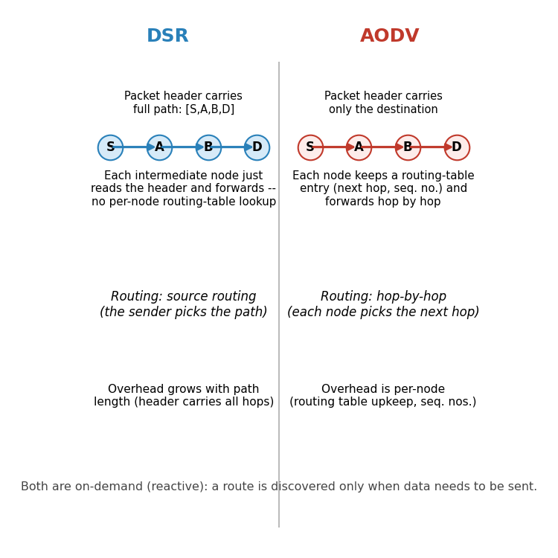
Figure 2. DSR embeds the full path in every packet header; AODV keeps a next-hop entry at each node and routes hop by hop.
DSR uses source routing: the complete sequence of nodes from source to destination is carried inside the packet header, so intermediate nodes simply read the header and forward — they do not need their own routing table entry for that destination. This also lets DSR cache several alternative routes it overhears, which can speed up recovery from a broken link. The trade-off is that the header grows with the length of the path, which becomes noticeable in larger or denser networks, and cached routes can go stale if the topology changes.
AODV instead uses hop-by-hop routing: each node keeps only a next-hop entry per destination, tagged with a destination sequence number to keep the routing loop-free and to judge freshness. Packets carry no path information, keeping headers small regardless of path length, but every node along the route must maintain and periodically refresh its own table entry. In short, DSR trades per-packet overhead for simpler node state and cached alternates, while AODV trades a small amount of per-node table maintenance for compact packets and (generally) better scaling to larger networks.
Q12. Explain the cluster head selection process in the LEACH protocol and how it contributes to network energy efficiency. [CO4]
LEACH operates in rounds. At the start of each round, every node that has not been a cluster head recently picks a random number between 0 and 1 and compares it against a threshold T(n). The threshold is set from the desired percentage of cluster heads for the network (P) and the number of rounds since that particular node last served as cluster head — nodes that were cluster heads recently get a threshold of zero and cannot be chosen again until a full cycle of rounds has passed. If a node's random number falls below T(n), it declares itself a cluster head for that round and broadcasts an advertisement; nearby nodes then join whichever cluster head they hear most strongly, and a simple TDMA schedule is set up inside the cluster.
This rotation is what makes LEACH energy-efficient at the network level rather than just within a single round. Because every eligible node gets a fair, probabilistic chance to serve as cluster head over time, the extra energy cost of aggregation and long-range transmission is spread across the whole population instead of draining the same nodes round after round. That prevents a small subset of nodes from dying early and keeps the network functioning as a whole for a longer overall lifetime, even though any single round still looks similar to non-rotating clustering schemes.
Q13. What are the main challenges in designing MAC protocols for ad hoc networks? [CO3]
- No central coordinator: every access decision has to be made in a fully distributed way, with nodes agreeing implicitly rather than through a scheduler.
- Hidden- and exposed-terminal problems: nodes cannot always sense each other directly, which complicates collision avoidance.
- Mobility and a constantly changing topology: neighbour sets and link quality shift, so any state the MAC layer keeps can go stale quickly.
- Energy constraints: most ad hoc nodes run on batteries, so idle listening, overhearing, and collisions all carry a real cost that the protocol should minimize.
- Scalability: the same protocol has to behave reasonably whether the network has a handful of nodes or several hundred, under widely varying traffic loads.
- Quality-of-service support: providing any kind of delay or throughput guarantee is difficult without central scheduling.
- Security: with no fixed infrastructure, authenticating neighbours and defending against MAC-layer attacks (for example jamming or selfish backoff manipulation) is harder than in an infrastructure-based network.
Q14. Describe the routing mechanism of the Destination-Sequenced Distance-Vector (DSDV) protocol in ad hoc networks. [CO3]
DSDV is a proactive, table-driven protocol built on the classic distance-vector (Bellman-Ford) idea, adapted to avoid the routing loops that plain distance-vector routing is prone to. Every node keeps a routing table with one entry per known destination: the next hop, the distance in hops (the metric), and a sequence number that the destination itself originates and increases each time it sends out a fresh update.
Nodes exchange table updates in two ways: full dumps, sent occasionally to carry the complete table, and smaller incremental updates, sent more frequently to carry only the entries that changed since the last dump. When a node receives an update, it prefers the entry with the higher (more recent) sequence number for a given destination regardless of the hop count advertised, and only falls back on hop count to choose between two entries that share the same sequence number. This sequence-number rule is what keeps DSDV loop-free even though it is still, at its core, a distance-vector protocol. To avoid advertising routes that are still fluctuating right after a topology change, a node also applies a settling time — a short delay before forwarding a new route onward — so that only reasonably stable routes get propagated.
Destination | Next hop | Metric (hops) | Sequence number
N1 | N2 | 2 | S1(N1) = 44
N4 | N4 | 1 | S2(N4) = 12
N7 | N3 | 3 | S3(N7) = 6
Table 1. Example of a simplified DSDV routing table entry format, one row per known destination.
Q15. Explain in detail how link adaptation works in Wi-Fi networks using techniques such as Adaptive Modulation and Coding (AMC). Include examples of how these techniques affect network performance. [CO3]
Adaptive Modulation and Coding is the core mechanism behind link adaptation in Wi-Fi. Every Modulation and Coding Scheme (MCS) index defined in the 802.11 standards pairs a modulation order with a forward error correction coding rate; higher-numbered MCS indices pack more bits per symbol but need a cleaner channel to be decoded correctly. The transmitter (or a rate-control algorithm such as ARF or Minstrel working on its behalf) tracks recent channel quality — SNR estimates, ACK success rate, and retransmission counts — and picks the highest MCS index that the current channel can support reliably.
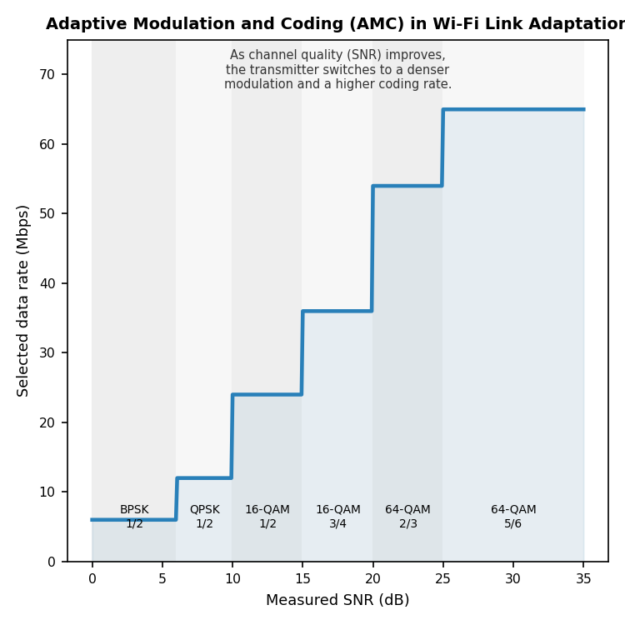
Figure 3. As SNR rises, the AMC scheme steps up through denser modulation and higher coding rates, raising the achievable data rate.
As an example, a station standing right next to the access point with a clean, strong signal (SNR above roughly 25 dB) can typically sustain 64-QAM with a 5/6 coding rate, giving it the highest available PHY rate. As that same station walks farther away, or a wall or interfering device degrades the SNR into the 10–15 dB range, the algorithm drops to a more robust scheme such as 16-QAM at a 1/2 coding rate; the raw bit rate falls, but far fewer frames need retransmission. If SNR falls further still, near the edge of coverage, the link may fall all the way back to BPSK or QPSK — slow, but usable — rather than continuing to send frames at a rate the channel cannot support and losing almost all of them.
The performance effect is a smoother trade-off curve between throughput and reliability than a single fixed rate could ever offer: peak throughput near the access point, and a connection that degrades gracefully rather than dropping out completely as distance or interference increases. The cost is some overhead in channel estimation and occasional wrong guesses by the rate-control algorithm, which is why the specific algorithm used (not just the existence of AMC itself) has a real effect on how well a Wi-Fi network performs in practice.
Q16. Describe the impact of link adaptation on Quality of Service (QoS) in Wi-Fi networks. What are the key factors influencing link adaptation performance? [CO3]
Link adaptation is generally good for QoS: by matching the transmission rate to the actual channel, it keeps throughput as high as the link can sustain and avoids the packet loss and repeated retransmissions that a badly-matched fixed rate would cause, which in turn keeps delay and jitter more predictable for applications such as video calls or streaming. But adaptation is not instantaneous. There is always a lag between a real change in the channel and the algorithm's decision to change rate, and during that lag, frames may be sent at a rate that no longer fits the channel, producing a short-lived dip in QoS — a burst of retransmissions or a brief rate drop — exactly when conditions are shifting quickly.
Several factors decide how well this trade-off plays out in a given deployment:
- Accuracy of channel estimation — noisy or infrequent SNR/error-rate measurements lead to a rate choice that does not match reality.
- Feedback delay — how quickly ACKs, or explicit channel state feedback, reach the rate-control algorithm.
- The rate-control algorithm itself — simpler schemes like ARF react more slowly and coarsely than statistics-driven schemes like Minstrel.
- Mobility speed — a fast-moving station experiences channel changes faster than the adaptation loop can track.
- Interference and multipath fading — sudden, short-lived channel degradation is harder to adapt to than a slow, steady change.
- Traffic pattern and frame aggregation settings — how much data is available to probe rates against, and how aggregation interacts with rate selection.
Q17. Describe the process of route discovery and route maintenance in the AODV routing protocol. How does this protocol handle link failures? [CO3]
Route discovery in AODV begins when a source node needs to send data to a destination it has no current route to. The source broadcasts a Route Request (RREQ), tagged with a unique request ID and the destination's last known sequence number, to its neighbours. Each neighbour that receives the RREQ for the first time records a reverse route back to the source, then either replies (if it is the destination, or has a route to the destination that is at least as fresh as the one requested) or re-broadcasts the RREQ onward, flooding it further into the network.
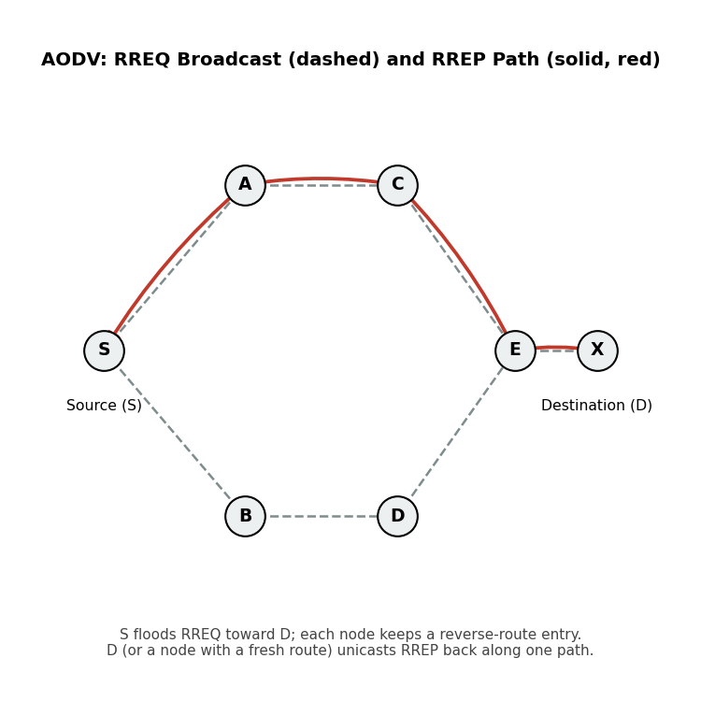
Figure 4. RREQ floods outward from the source (dashed); the destination — or a node with a fresh route — sends a Route Reply back along one path (solid).
Once the RREQ reaches the destination, or a node that qualifies to answer on its behalf, that node sends a Route Reply (RREP) as a unicast, traveling back along the reverse route that was just built. As the RREP travels, each intermediate node along that path installs a forward route entry pointing toward the destination, so that by the time the RREP reaches the source, a complete bidirectional route exists. The source then starts sending data along this route.
Route maintenance relies on nodes noticing when a link on an active route breaks — through a missing link-layer acknowledgement, a failed periodic HELLO message, or a similar signal. The node that detects the break invalidates the affected routing entries and sends a Route Error (RERR) upstream toward every source that was using that route, listing the now-unreachable destinations. When a source receives an RERR for a route it still needs, it simply repeats route discovery from scratch, issuing a new RREQ. In some implementations, a node close to the point of failure can instead attempt a local repair — a smaller-scale rediscovery limited to the broken segment — before falling back to notifying the source, which reduces disruption for routes that break only briefly or only in one small section.

