Assignment 1
Mobile Computing / Wireless Networks

Q1. Bluetooth Protocol Architecture
CO1, CO3
The Bluetooth stack is organised in layers, from the radio hardware at the bottom to applications at the top. Each layer hands off a specific job to the one above it.
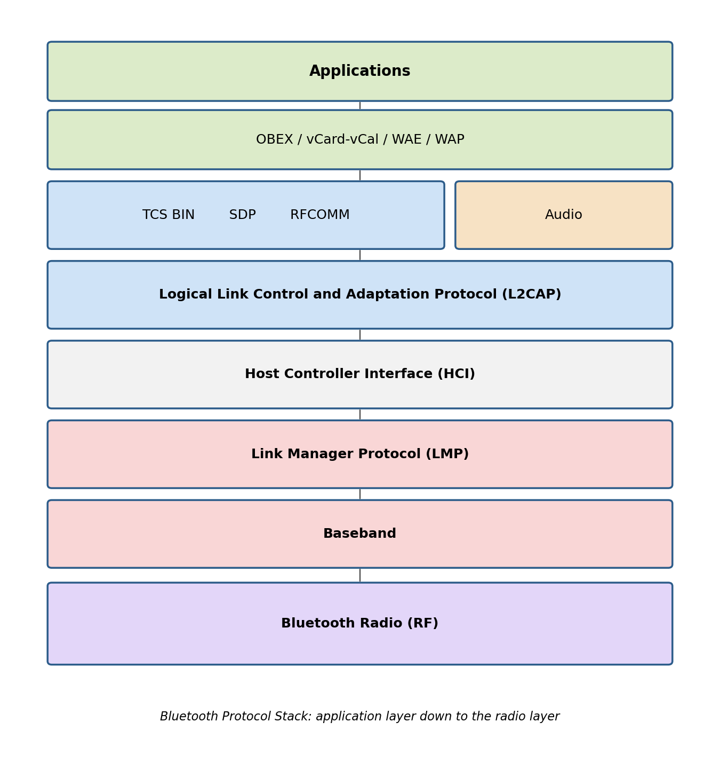
Figure 1: Bluetooth protocol stack
- Bluetooth Radio: the physical RF layer. It operates in the 2.4 GHz ISM band and uses frequency-hopping spread spectrum (1600 hops/second across 79 channels) to resist interference from other devices sharing the band.
- Baseband: manages the physical channel — timing, framing, device addressing (BD_ADDR), and packet formats. It is also where a piconet is formed, with devices taking on master or slave roles.
- Link Manager Protocol (LMP): sets up, configures, and tears down links between two Bluetooth devices. It handles authentication, encryption keys, and switches a device between the power-saving modes (sniff, hold, park).
- Host Controller Interface (HCI): a standard command interface between the Bluetooth host (the software stack on a phone or laptop) and the controller (the radio, baseband, and LMP hardware). It lets the same host software work across different Bluetooth chipsets.
- L2CAP (Logical Link Control and Adaptation Protocol): sits above the baseband and provides segmentation and reassembly of large packets, multiplexes several higher-layer protocols over one baseband connection, and negotiates quality of service.
- RFCOMM: emulates an RS-232 serial port over L2CAP, so applications originally written for wired serial communication can run over a Bluetooth link without modification.
- SDP (Service Discovery Protocol): lets a device ask another Bluetooth device what services it offers (printing, file transfer, audio, and so on) before a connection for that service is opened.
- TCS BIN (Telephony Control Specification – Binary): defines call-control signalling — call setup, alerting, release — used by Bluetooth's cordless telephony profile.
- Adopted protocols: Bluetooth reuses existing protocols rather than reinventing them — OBEX for object/file exchange (borrowed from IrDA), WAP/WAE for lightweight web content, vCard/vCal for contact and calendar exchange, and PPP/TCP/IP/UDP so ordinary networking applications can run over a Bluetooth PAN connection.

Q2. IEEE 802.11 Architecture
CO1, CO3
IEEE 802.11 defines the architecture of a wireless LAN in terms of a few building blocks that can be combined into larger networks.
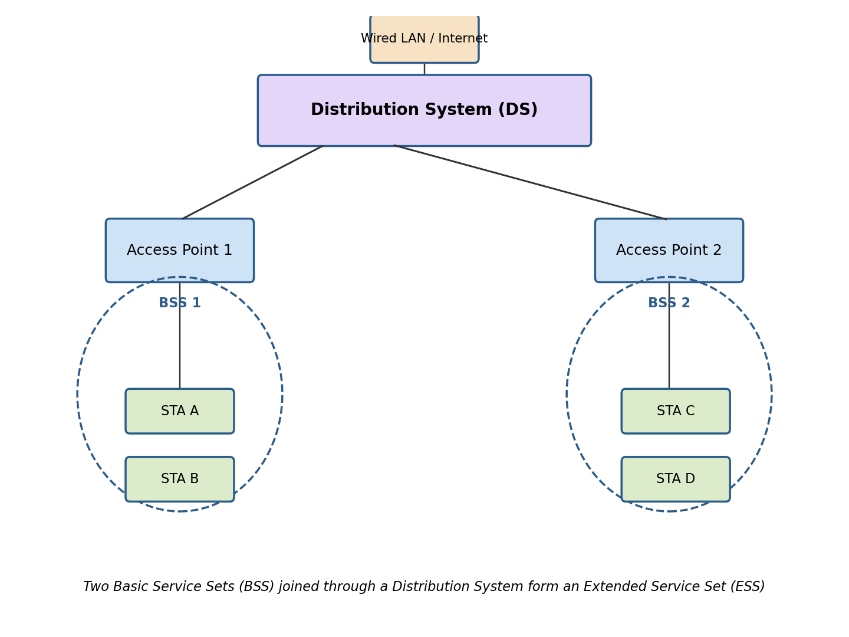
Figure 2: IEEE 802.11 architecture — two BSSs joined into an ESS
- Station (STA): any device with an 802.11 radio and MAC — a laptop, phone, or access point.
- Basic Service Set (BSS): the fundamental building block, a group of stations that communicate with each other under a common MAC coordination. An Infrastructure BSS routes all traffic through an Access Point (AP); an Independent BSS (IBSS) has stations talk directly to each other with no AP, which is the ad-hoc mode.
- Access Point (AP): a station that also bridges wireless stations to the wired backbone, forwarding frames between them.
- Distribution System (DS): the backbone — usually a wired Ethernet segment, though it can itself be wireless — that connects multiple APs together.
- Extended Service Set (ESS): two or more BSSs connected through a DS. To the layers above the MAC, an ESS looks like one single LAN, which is what lets a station roam from one AP's coverage area to another's without the connection breaking.
- Portal: a logical point where the 802.11 LAN is bridged into a different type of LAN, such as a conventional 802.3 Ethernet network.

Q3. GSM Architecture
CO2
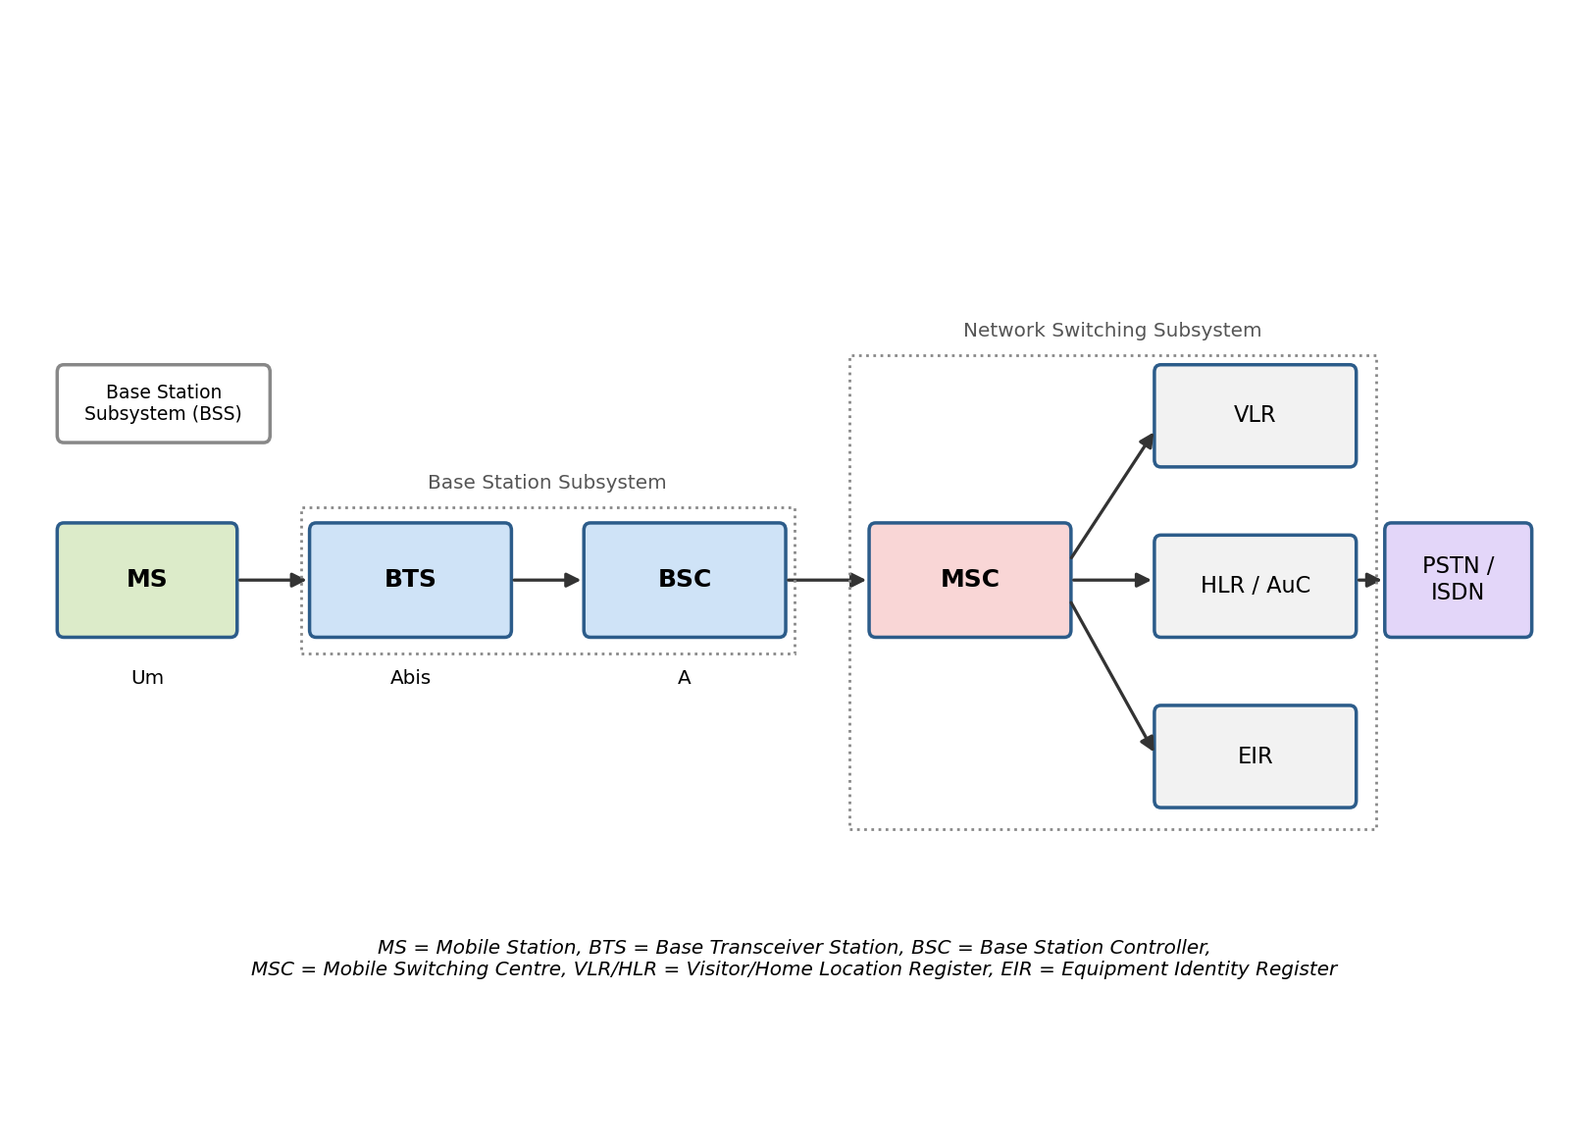
Figure 3: GSM network architecture
A GSM network is organised into three subsystems:
- Mobile Station (MS): the handset together with the SIM card, which holds the subscriber's identity and authentication keys.
- Base Station Subsystem (BSS): consists of the BTS (Base Transceiver Station), which handles radio transmission and reception to and from the MS over the Um air interface, and the BSC (Base Station Controller), which manages radio resources, power control, and handovers for a group of BTSs over the Abis interface.
- Network Switching Subsystem (NSS): the MSC (Mobile Switching Centre) switches calls and connects the mobile network to the PSTN/ISDN over the A interface. The HLR (Home Location Register) is a permanent database of subscriber details; the VLR (Visitor Location Register) temporarily stores details of subscribers currently located in an MSC's area; the AuC (Authentication Centre) stores the keys used to authenticate subscribers and encrypt calls; and the EIR (Equipment Identity Register) keeps track of handset IMEIs, including blacklisted stolen devices.
- Operation and Support Subsystem (OSS): monitors and manages the network — fault reporting, performance statistics, and subscriber provisioning.

Q4. Wi-Fi vs Wi-Max
CO3
Parameter | Wi-Fi | Wi-Max
Standard | IEEE 802.11 | IEEE 802.16
Full form | Wireless Fidelity | Worldwide Interoperability for Microwave Access
Typical range | 30–100 m indoors, up to a few hundred metres outdoors | Several kilometres, up to ~50 km line-of-sight
Data rate | Up to several hundred Mbps (802.11ac/ax) | Tens of Mbps shared across subscribers
Frequency band | Unlicensed 2.4 GHz and 5 GHz | Licensed and unlicensed bands, 2–11 GHz (NLOS) and 10–66 GHz (LOS)
Network scope | Wireless LAN — a building or campus | Wireless MAN — a city or region
Mobility | Nomadic; roaming is limited to one ESS | Designed to support mobility (802.16e)
Typical deployment | Home and office routers, public hotspots | Base-station towers providing last-mile broadband
QoS support | Best-effort, with limited QoS extensions (802.11e) | Strong, built-in QoS classes for voice/video/data

Q5. Piconet and Scatternet
CO1, CO3
A piconet is the smallest Bluetooth network: one master device and up to seven active slave devices, all synchronised to the master's clock and following its frequency-hopping sequence. The master controls when each slave may transmit, since Bluetooth uses a polling-based time-division duplex scheme, and it assigns each active slave a 3-bit active member address. A piconet can also hold parked slaves — devices that stay synchronised but are not actively addressed, which lets more than seven devices belong to the same piconet even though only seven can be active at once.
A scatternet is formed when one device takes part in more than one piconet at the same time — as a slave in one and master or slave in another. That shared device links the piconets together, relaying data between them. Because each piconet hops through frequencies on its own independent sequence, the bridging device cannot transmit in both piconets simultaneously; it has to time-share its attention between them. Scatternets let Bluetooth networks scale beyond the eight-device limit of a single piconet and connect otherwise separate clusters of devices.

Q6. LAN vs WAN
CO1
Parameter | LAN | WAN
Full form | Loc  al Area Network | Wide Area Network
Coverage | A building or campus | A country, continent, or the whole globe
Ownership | Usually owned by a single organisation | Usually built on infrastructure leased from telecom carriers
Speed | High — typically 100 Mbps to several Gbps | Lower than LAN, though fibre backbones narrow this gap
Setup cost | Relatively low | High, due to leased lines, satellite links, or long-haul fibre
Underlying technology | Ethernet, Wi-Fi | MPLS, leased lines, satellite links, fibre backbones
Error rate | Low, since distances are short | Higher, since signals travel farther and pass through more hops
Administration | Managed by one entity | Spans multiple administrative domains
Example | An office or home network | The Internet; a bank's inter-branch network

Q7. 1G vs 2G vs 3G vs 4G
CO2
Parameter | 1G | 2G | 3G | 4G
Era | 1980s | 1990s | Early-mid 2000s | 2010s onward
Signal type | Analog | Digital | Digital | Digital, all-IP
Switching | Circuit switching | Circuit switching, with limited packet data | Mostly packet switching | Pure packet switching (IP)
Multiplexing | FDMA | TDMA / CDMA | CDMA (WCDMA) | OFDMA / SC-FDMA
Data rate | ~2.4 kbps, voice only | 9.6–64 kbps, plus SMS | 384 kbps – 2 Mbps | 100 Mbps – 1 Gbps
Services | Voice calls only | Voice, SMS, basic data (GPRS/EDGE) | Voice, video calling, mobile internet | HD video, VoLTE, streaming, low-latency data
Example standards | AMPS, NMT | GSM, IS-95 | UMTS, CDMA2000 | LTE, LTE-Advanced

Q8. Infrastructure vs Ad-hoc Network
CO3
Parameter | Infrastructure Network | Ad-hoc Network
Central control | Fixed Access Point or base station coordinates the network | No fixed infrastructure — nodes organise themselves
Topology | Star, with all stations linked to the AP | Dynamic mesh / peer-to-peer
Deployment | Needs the AP to be installed and configured beforehand | Can be set up instantly, wherever the nodes happen to be
Routing | The AP forwards traffic between stations | Nodes route traffic for each other, often over multiple hops
Mobility handling | Handover between APs is managed by the infrastructure | Topology reshapes itself continuously as nodes move
Scalability | Easier, since management is centralised | Harder — coordination overhead grows with node count
Typical example | A Wi-Fi hotspot, a cellular network | A MANET, a Bluetooth piconet, a disaster-response network

Q9. Applications of Bluetooth; Piconet vs Scatternet
CO1, CO4
Common applications of Bluetooth:
- Wireless audio — headsets, earbuds, and speakers
- File and data transfer between phones, laptops, and tablets
- Wireless peripherals — keyboards, mice, game controllers
- Hands-free calling and audio streaming in vehicles
- Wireless printing
- Fitness and health wearables using Bluetooth Low Energy
- Pairing and control of IoT and smart-home devices
- Tethering a laptop to a phone's internet connection through a Personal Area Network (PAN) profile
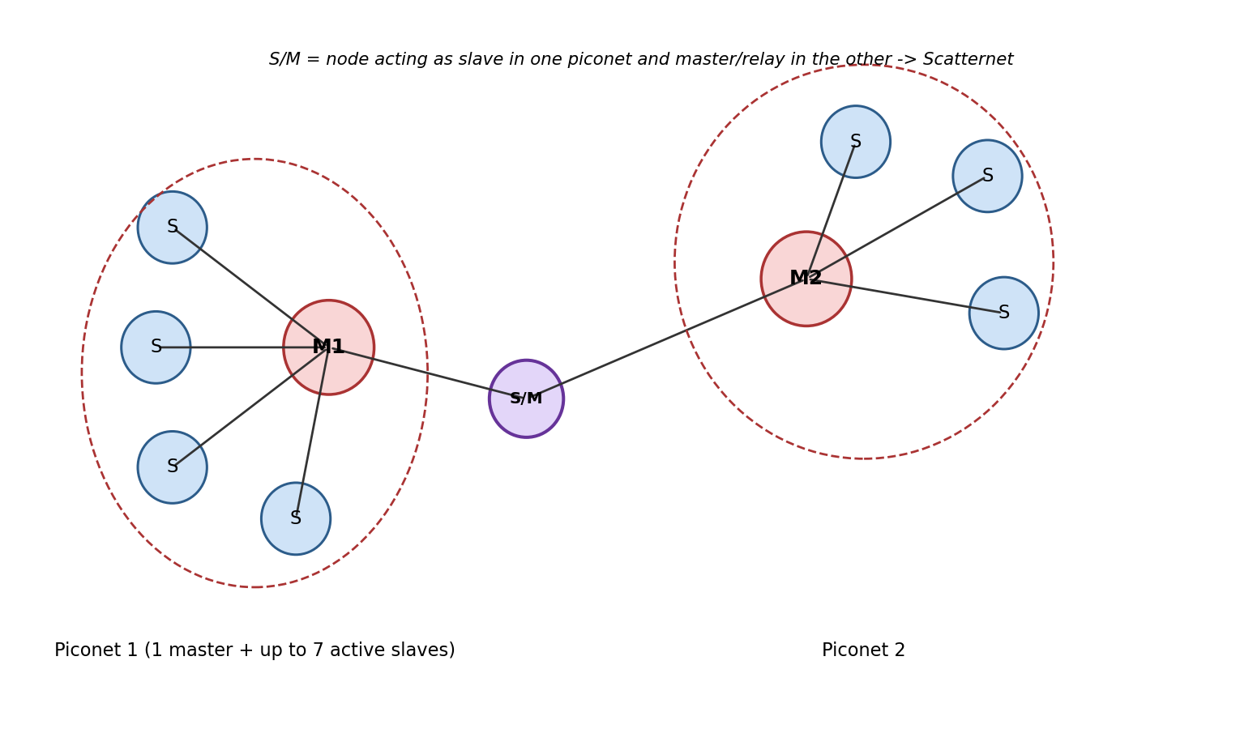
Figure 4: A scatternet formed from two piconets sharing a bridge device
Parameter | Piconet | Scatternet
Definition | One master with up to 7 active slaves | Two or more piconets interconnected
Number of masters | Exactly one | One per piconet, several overall
Bridging node | Not applicable | A device acts as slave/master (or slave in both) to relay between piconets
Synchronisation | All devices share one hopping sequence and clock | Each piconet keeps its own hopping sequence; the bridge node switches between them
Scale | Limited to 8 active devices | Extends coverage and device count beyond a single piconet

Q10. Power-Saving States of a Bluetooth Device
CO1
Beyond fully Active mode, Bluetooth defines three low-power connection modes that trade off responsiveness against battery life:
- Active mode: the device takes part in the piconet normally, transmitting and receiving in every slot it is scheduled for. This uses the most power.
- Sniff mode: the lightest power-saving mode. The device only listens at agreed, periodic intervals instead of every slot, cutting its duty cycle while still being able to respond fairly quickly.
- Hold mode: the device temporarily suspends ACL (data) traffic for an agreed period. It stays connected to the master but is free to do something else in the meantime — for instance scan for other devices — since no data needs to flow.
- Park mode: the deepest power-saving state. The device gives up its active member address but keeps its clock synchronised with the master, so it can still listen for broadcast messages and rejoin the active piconet quickly when needed. Parking also lets more devices be logically associated with a piconet than the seven-active-slave limit allows.

Q11. Bluetooth vs Wi-Fi vs Zigbee
CO1, CO3
Parameter | Bluetooth | Wi-Fi | Zigbee
Standard | IEEE 802.15.1 | IEEE 802.11 | IEEE 802.15.4
a) Range | ~10 m typically, up to ~100 m for Class 1 devices | ~50–100 m | ~10–100 m per hop; a mesh extends this further
b) Data rate | 1–3 Mbps (BLE is lower) | Up to several hundred Mbps | 20–250 kbps
c) Power consumption | Moderate; Bluetooth Low Energy is very low | High relative to the other two | Very low — devices can run for years on a coin cell
d) Network topology | Piconet / scatternet | Infrastructure (star, via AP) or ad-hoc | Star, tree, or mesh
Similarities: all three operate mainly in the license-free 2.4 GHz ISM band, all are short-to-medium range wireless technologies, and all support device-to-device communication without cellular infrastructure. Differences follow mainly from what each was designed for — Wi-Fi trades power for throughput and is built for LAN-grade data, Bluetooth balances the two for personal-area peripherals and audio, and Zigbee sacrifices data rate entirely to get years of battery life for sensor and automation networks.

Q12. Role of Wi-Max in Bridging the Rural-Urban Digital Divide
CO3, CO4
Wi-Max was designed to deliver broadband over long distances without laying cable, which is exactly the constraint that keeps rural areas underserved — running fibre or DSL to a scattered, low-density population is rarely economical for an operator. A single Wi-Max base station, mounted on a tower, can cover tens of kilometres in a point-to-multipoint layout and connect an entire village, school, or health centre back to the internet, at a much lower cost per subscriber than a wired rollout.
Later revisions of the standard (802.16e) added non-line-of-sight support, which matters in areas without a clear path to the tower, and Wi-Max also builds in proper QoS classes, so a single base station can carry voice, video, and data with different priority levels. That combination made it a reasonable fit for services rural regions particularly benefit from — telemedicine, e-governance kiosks, and distance education — where consistent, prioritised connectivity matters more than raw peak speed.
In practice, Wi-Max's rural role turned out to be transitional rather than permanent. Licensed spectrum costs, the capital expense of tower and backhaul infrastructure, and reliable power in remote sites all limited how far operators pushed it. By the mid-2010s, LTE and now fixed-wireless access over newer standards had largely absorbed the same point-to-multipoint idea, backed by a much larger device and vendor ecosystem. Wi-Max's contribution was less about the technology surviving long-term and more about proving that a licensed, wide-area wireless last mile could work — a template rural broadband policy still leans on today.

Q13. Zigbee-Based Smart Agriculture Sensor Network — Design
CO4
The design uses Zigbee's three device roles — coordinator, router, and end device — laid out to match a farm's physical zones.
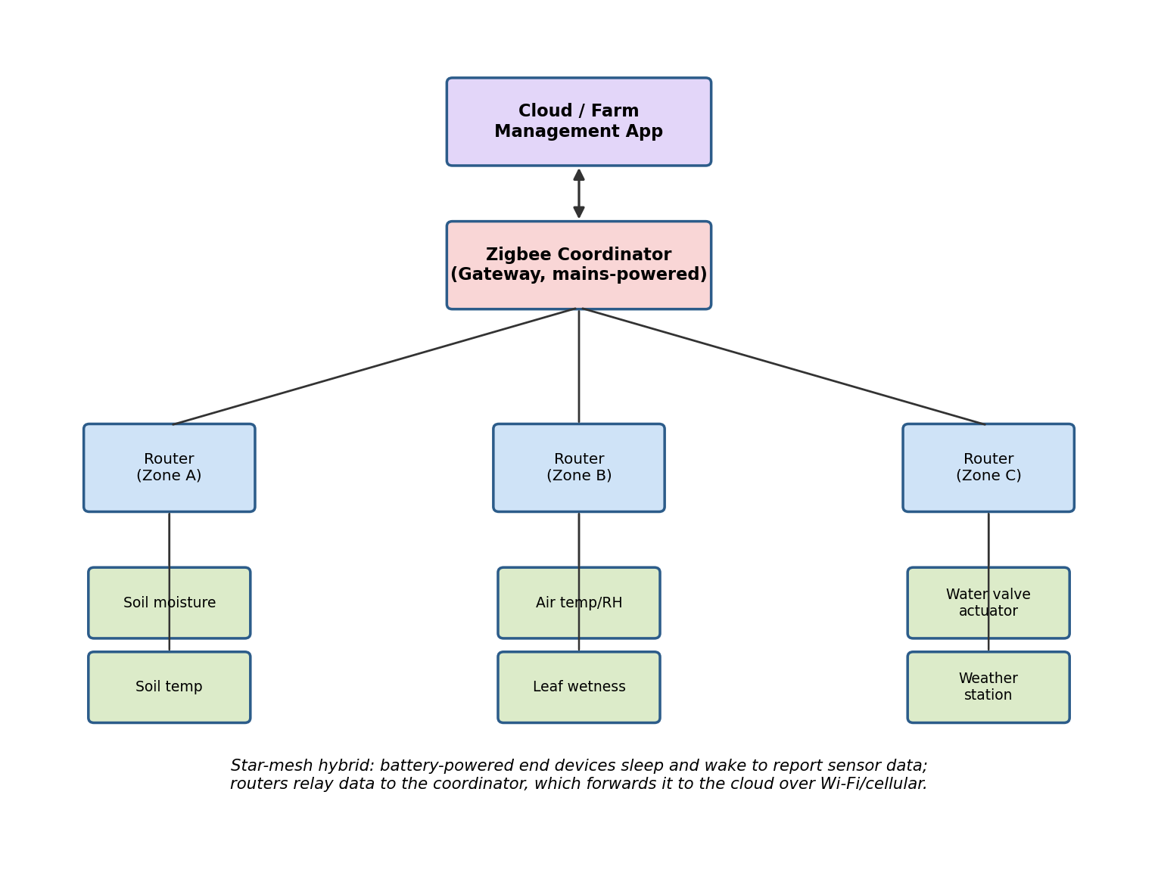
Figure 5: Zigbee smart agriculture network layout
- Coordinator: one mains-powered gateway device, placed at the farmhouse or a central shed. It forms and manages the Zigbee PAN, collects data from every router, and forwards it to a cloud application over Wi-Fi or a cellular modem.
- Routers: mains- or solar-powered devices placed at the edge of each field zone, spaced so their radio ranges overlap and self-heal the mesh if one link drops. Each router relays data from the end devices in its zone back toward the coordinator.
- End devices: battery-powered sensor and actuator nodes — soil moisture and temperature probes, air temperature/humidity sensors, leaf-wetness sensors, a weather station, and motorised valve actuators for drip irrigation. These sleep most of the time and wake briefly on a schedule (or on an event, like a moisture threshold) to report data or receive a command, which is what lets them run for months on a battery.
- Application logic: the cloud platform aggregates sensor readings, triggers irrigation valves automatically when soil moisture drops below a threshold, and gives the farmer alerts and a dashboard on a phone app.
This star-mesh hybrid topology is a good fit for agriculture specifically because fields are large and irregularly shaped — a single-hop star network would leave dead zones, while Zigbee's mesh routing lets the network extend across the whole farm by adding more routers, without every node needing to reach the gateway directly. The low data rate is not a limitation here, since sensor readings are small and infrequent, and Zigbee's very low power draw is what makes unattended, battery-powered field sensors practical in the first place.

Q14. Limitations of RFID and How NFC/UWB Address Them
CO3, CO4
RFID's limitations:
- Its read range can work against it: a passive tag can sometimes be read from farther away than intended, which raises the risk of unauthorised scanning or cloning.
- Read reliability depends heavily on tag orientation, and on interference from metal or liquid in the environment.
- It tells a reader that a tag is present, but not precisely how far away or in which direction — RFID gives proximity, not accurate position.
- Reading many tags at once requires anti-collision protocols, which slows things down as tag density increases.
- Cheaper tags often carry weak or no encryption, making them relatively easy to clone or eavesdrop on.
NFC addresses the security concern directly by cutting range down to a few centimetres. That is a deliberate design choice: it forces the user to deliberately bring two devices close together, which is what makes NFC workable for payments and secure pairing — you cannot skim an NFC tag from across a room the way you sometimes can an RFID tag.
UWB addresses the positioning gap. It transmits very short pulses across a wide bandwidth, which allows precise time-of-flight measurement between devices — centimetre-level ranging and angle-of-arrival direction-finding that ordinary RFID cannot provide. That precision is also why UWB resists relay and spoofing attacks better than standard RFID: an attacker cannot easily fake the timing a UWB system relies on. It is the basis for applications like secure passive car entry and precise indoor item-finding, where knowing exactly how far away and in which direction something is matters as much as knowing it is nearby.

Q15. Bluetooth Low Energy (BLE) in Health Monitoring Systems
CO4
BLE's defining trait — very low power draw compared with classic Bluetooth — is exactly what health wearables need. A fitness band, smartwatch, continuous glucose monitor, or ECG patch built on BLE can run for days or weeks on a battery small enough to be worn comfortably, because the radio only wakes briefly to advertise or exchange data instead of holding a continuous connection.
Most health devices expose their data through BLE's GATT (Generic Attribute Profile) using standardised services — a Heart Rate Service, Health Thermometer Service, or Glucose Service, for example — which means any BLE-capable phone or hub can read the data without needing a proprietary app built by the device manufacturer. In practice, a paired phone app maintains a background connection, receives readings in near real time, and can raise an alert immediately if something like heart rate moves outside a normal range.
From there, the phone (or a bedside hub) typically relays the data on to a cloud service or electronic health record, which is what enables remote patient monitoring — a clinician can review trends without the patient visiting in person. BLE's adaptive frequency hopping also helps it coexist with the many other wireless devices found in a hospital or clinic.
The trade-off is throughput: BLE's data rate is far too low for continuous video or imaging, and in a crowded 2.4 GHz environment with many BLE devices nearby, connection reliability can suffer. It works well for the intermittent, low-volume readings typical of vital-sign monitoring, but it is not the right choice for data-heavy medical streams.

Q16. RFID vs Barcode
CO1, CO3
Parameter | RFID | Barcode
Line of sight | Not required | Required — the scanner must see the pattern directly
Read range | A few cm to several metres, depending on tag type | A few cm up to roughly a metre
Read speed | Can read many tags at once | One at a time, scanned sequentially
Data storage | Can hold more data; many tags are rewritable | Fixed at print time, read-only
Durability | More rugged — tags can be embedded or sealed inside packaging | Easily damaged by smudges, tears, or dirt
Cost | Higher per unit, especially for active tags | Very cheap — just printed ink
Security | Can be encrypted, harder to counterfeit | Easy to photocopy or duplicate
Power source | Passive tags are powered by the reader's field; active tags carry a battery | None needed — it is just a printed pattern

