**Name: Alekhya Tejomurtula**

**Class: TY A**

**Roll No: 58**

**Srn: 201900449**

**Problem Statement:**

Design a Lexical analyzer for the subset of Java Language. Read input from the file. Also create symbol table. Detect any one lexical error. Output in 4 columns Line No, Lexeme, Token and Token Value. Upload single file containing input, output and source code.

**Input Code: (C code)**

int main ( )

{

int a ;

a = 10 ;

}

**Output:**

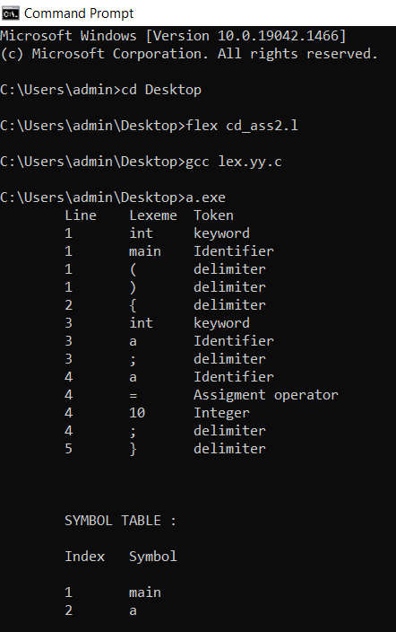

**Source Code: (lex code)**

%{

#include <stdio.h>

#include <string.h>

int LN=1;

int count=0;

char symbols[100][20];

int symbolPos [100];

char temp[20];

%}

digit [0-9]

letter [A-Za-z_]

%%

"while"|"if"|"else if"|"else"|"for"|"case"|"return"|"int"|"char"|"float"|"double"|"do"|"void"|"break"|"long" {fprintf(yyout,"\t%d\t%s\tkeyword\n",LN,yytext);}

{letter}({letter}|{digit})* {fprintf(yyout,"\t%d\t%s\tIdentifier\n",LN,yytext);

strcpy(symbols[count],yytext);

count++;

}

"{"|"}"|"("|")"|";"|"," {fprintf(yyout,"\t%d\t%s\tdelimiter\n",LN,yytext);}

{digit}+ {fprintf(yyout,"\t%d\t%s\tInteger\n",LN,yytext);}

{digit}+\.{digit}+ {fprintf(yyout,"\t%d\t%s\tDecimal\n",LN,yytext);}

"=" {fprintf(yyout,"\t%d\t%s\tAssigment operator\n",LN,yytext);}

"&&"|"||" {fprintf(yyout,"\t%d\t%s\tLogical operator\n",LN,yytext);}

"=="|"<="|">="|"!="|"<"|">" {fprintf(yyout,"\t%d\t%s\tRelational operator\n",LN,yytext);}

"+"|"-"|"*"|"/"|"++"|"--" {fprintf(yyout,"\t%d\t%s\tArithmetic operator\n",LN,yytext);}

"\n" {LN++;}

%%

int yywrap()

{

return 1;

}

char remove_dups(int count, char array[100][20])

{

int k, r, h, i, printCount = count;

char ob[100][20];

strcpy(ob[0],array[0]); h= 1;

for(r= 0 ; r<count ; r++)

{

k= 0;

while (k< h)

{

if (strcmp(array[r], ob[k]) == 0){

printCount--;

break;

}

k++;

}

if (k==h) {

strcpy(ob[h],array[r]);

h++;

}

}

for(i = 0;i<printCount+1;i++)

printf("\t%d\t%s\n",(i+1),ob[i]);

}

int main(int argc,char* argv[])

{

int i,j;

char* str[20];

char final[20];

yyin = fopen("cd_ass2.c", "r");

/*yyout = fopen("output.txt","w");*/

///symout = fopen("symbol.txt","w");

printf("\tLine\tLexeme\tToken\n");

yylex();

//printf("%d\n",count);

for(j = 0;j<count;j++)

str[count] = symbols[count];

printf("\n\n\n\tSYMBOL TABLE : \n\n");

printf("\tIndex\tSymbol\n\n");

remove_dups(count,symbols);

/*fclose(yyout);*/

fclose(yyin);

}