SCHOOL OF TECHNOLOGY, DESIGN AND COMPUTER APPLICATION
ADITYA SILVER OAK INSTITUTE OF TECHNOLOGY

DEPARTMENT OF COMPUTER ENGINEERING

A Report on

LinguaAI – AI-Driven Language Preservation
Preserving critically endangered native languages using AI

Under Subject of
PROBLEM BASED LEARNING – II
Semester - VI

Submitted by
Mihir Kasundra- (2402030430084)

CERTIFICATE

This is to certify that the project entitled “LinguaAI – AI-Driven Language Preservation” has been carried out by “Mihir Kasundra (2402030430084)” under my guidance in fulfillment of the Problem Based Learning-II (1010003392) Subject of Bachelor of Engineering in Computer Engineering– 6th Semester of Silver Oak University, Ahmedabad during the academic year 2025-2026.

Prof. Janki Barot Prof. Mayuresh kulkarni
Internal Guide Head of the Department

ACKNOWLEDGEMENT

We are heartily thankful to our supervisor, Prof. Janki Barot, whose encouragement, supervision and support from the preliminary to the concluding level enabled me to develop an understanding of the subject. At the end, we offer my regards and blessings to all of those who supported us in any respect during the completion of the project and to our college for providing resources and materials.

We would like to extend my gratitude to Prof. Mayuresh kulkarni, head of Computer Engineering Department, Aditya Silver Oak Institute of Technology, Ahmedabad, for his continuous encouragement and motivation.

Last but not the least we would like to mention here that we are greatly indebted to each and everybody who has been associated with our project at any stage but whose name does not find a place in this acknowledgement.

Yours Sincerely,

Mihir Kasundra: 2402030430084
ABSTRACT

The Lingua-AI project aims to harness artificial intelligence to document, revitalize, and protect critically endangered native languages around the world. As a language dies every 14 days, this system provides practical tools for speech transcription, linguistic preservation, and cross-cultural learning. A speech AI interface powered by browser-native ASR, along with a curated database of 25+ endangered languages, offers researchers and community members the opportunity to transcribe, save, and export native languages in real-time. This project outlines the system requirements, evaluates multiple low-resource AI models, and provides a structured repository for ongoing language archiving efforts.

LIST OF FIGURES

Figure No. | Figure Name | Page No.
1.1 | Lingua-AI Architecture Diagram | 5
5.1 | Timeline Chart (Gantt) | 10

LIST OF TABLES

Table No. | Table Name | Page No.
2.1 | Hardware Requirements | 3
2.2 | Software Requirements | 4
3.1 | Functional Requirements List | 6
3.2 | Feasibility Matrix | 7

TABLE OF CONTENT

Chapter No. | Title | Page No.
 | ACKNOWLEDGEMENT | I
 | ABSTRACT | II
 | LIST OF FIGURES | III
 | LIST OF TABLES | IV
1. | INTRODUCTION | 1
1.1 | Project Summary | 1
1.2 | Purpose | 1
1.3 | Scope | 1
1.4 | Technical and Literature Review | 2
2. | SYSTEM REQUIREMENT STUDY | 3
2.1 | User Characteristics | 3
2.2 | Hardware and Software Characteristics | 3
2.2.1 | Hardware Requirements | 3
2.2.2 | Software Requirements | 4
3. | SYSTEM ANALYSIS | 5
3.1 | Study of Current System | 5
3.2 | Problems in Existing Systems | 5
3.3 | Requirement of New System | 5
3.3.1 | Functional Requirement | 6
3.3.2 | Non-functional Requirement | 6
3.4 | Feasibility Study | 7
3.5 | Main Modules of New System | 7
4. | LIMITATION AND FUTURE ENHANCEMENT | 9
5. | TIMELINE CHART | 10
6. | CONCLUSION | 11
7. | REFERENCES | 12

Chapter:- 1 Introduction

1. Introduction

1.1 Project Summary
Lingua-AI is an advanced academic research platform designed to address the alarming and critical decline of indigenous and regional languages worldwide. According to linguistic experts, over 3,000 languages are currently endangered, with one fading into extinction roughly every two weeks. This represents an unprecedented loss of cultural heritage, oral history, and unique human knowledge. This project mitigates this crisis by combining highly accessible modern web technologies with the real-time processing capabilities of the Web Speech API and a robust backend linguistics archiving structure to create a seamless, end-to-end live transcription and preservation system.

1.2 Purpose
The primary purpose of LinguaAI is to explore and firmly establish how automated computational linguistics tools can dramatically increase the efficiency, accessibility, and persistence of language archiving. Specifically, the system focuses on languages with fewer than 1,000 fluent speakers, where traditional fieldwork by linguists is often hampered by logistical difficulties, massive audio backlogs, and a lack of scalable documentation tools. By democratizing access to AI-driven transcription, LinguaAI empowers local communities to actively participate in the digital preservation of their own linguistic heritage.

1.3 Scope
The scope of the project encompasses a comprehensive web application capable of dynamically searching and filtering a curated database of over 25 endangered languages. These languages are comprehensively categorized by geographical region and their current AI preservation status. Beyond the database, the scope includes the foundational development of an overarching web speech transcription toolkit, capable of connecting browser-native speech recognition directly to a secure backend archiving mechanism, thereby streamlining the fieldwork process from raw audio to searchable text.

1.4 Technical and Literature Review
During the foundational research phase, a comprehensive literature review encompassing over 40 peer-reviewed academic papers on computational linguistics, natural language processing (NLP), and low-resource language Modeling was conducted. Advanced state-of-the-art models such as massive Multilingual BERT (m-BERT), OpenAI's Whisper, and XLM-R were critically evaluated for their potential in cross-lingual transfer learning to low-resource communities. The review confirmed that while large models offer high accuracy, leveraging browser-native APIs (like the Web Speech API) provides a more immediate, lightweight, and economically viable solution for field deployment without requiring heavy local compute resources.

Chapter:- 2 System Requirement Study

2.1 User Characteristics
The primary demographic for Lingua-AI encompasses a diverse range of users including academic researchers, professional field linguists, and crucially, native community members working directly with endangered languages. These users may have widely varying levels of technical expertise. Therefore, the system is explicitly designed to be intuitive, minimizing the learning curve for elders and non-technical fluent speakers, while providing the robust data export and archiving tools required by academics.

2.2 Hardware and Software Characteristics:
2.2.1 Hardware Requirements
Processor | Multi-core CPU capable of handling multiple browser threads smoothly
RAM | A minimum of 4 GB to ensure the Web Speech API buffer does not lag during extended transcription sessions
Storage | 10 GB of available disk space for local caching and server hosting
Microphone | A standard built-in or external, high-fidelity noise-canceling microphone is strongly recommended for optimal voice recording accuracy in field environments.

2.2.2 Software Requirements
Operating System | Cross-platform compatibility requiring only a modern OS (Windows 10/11, macOS, Linux, or Android/iOS).
Web Browser | Google Chrome or Microsoft Edge (Chromium-based engines are explicitly required for full native support of the Web Speech API)
Server Architecture | A standard AMP stack (Apache, MySQL, PHP) is required for hosting the backend processing, managing the structural database, and handling persistent archiving requests securely.

Chapter:- 3 System Analysis

3.1 Study of Current System
Current linguistic preservation systems generally rely on intensive manual transcription using thick-client professional tools like ELAN. While these legacy methods are highly accurate and allow for granular phonetic tagging, they are exceedingly slow. Typically, they require highly trained linguists working in tandem with native speakers for hundreds of hours to process even a small corpus of audio. This workflow does not scale well to the urgent demands of rapidly fading dialects.

3.2 Problems in Existing Systems
Because of the manual nature of legacy software, fieldwork documentation consistently faces a severe bottleneck where thousands of hours of audio recordings remain untranscribed and unindexed. Furthermore, many digital preservation platforms are closed-source, highly technical, and completely inaccessible to the native speakers of rural areas who actually provide the language data. The lack of a real-time, browser-based feedback loop prevents immediate error correction during recording sessions.

3.3 Requirement of New System
3.3.1 Functional Requirement
- The system must possess the ability to transcribe live audio seamlessly using the standardized Web Speech API.
- It must immediately render text to the screen, providing capabilities for users to edit and correct returned transcription data on the fly before committing it to the archive.
- The system must feature secure, programmatic saving mechanisms to write generated transcriptions natively to the backend MySQL database archive.
3.3.2 Non-functional Requirement
- The system must guarantee high response times and robust cross-browser reliability, handling brief network dropouts gracefully.
- The user interface must be aggressively usability-focused, designed specifically for individuals with minimal technical knowledge to operate without a manual.

3.4 Feasibility Study
From a technical standpoint, utilizing the browser's native Web Speech API requires almost zero server compute overhead compared to hosting massive inference models locally, marking the system functionally highly scalable. Economically, running a lightweight PHP backend on top of a MySQL database keeps hosting and database maintenance overhead incredibly low, ensuring the project can run on nonprofit grants. Operationally, the application's simple layout minimizes the learning curve, virtually guaranteeing high user adoption within target communities.

3.5 Main Modules of New System (UML)
The architectural diagram of the system highlights three primary interconnected modules: the Client Presentation Layer (responsible for the responsive HTML/CSS interface), the Web Speech Integration Layer (handling vanilla JavaScript audio logic and transcription callbacks), and the Persistence Layer (managing the remote PHP/MySQL server data archiving and retrieval).

Lingua-AI Architecture Diagram
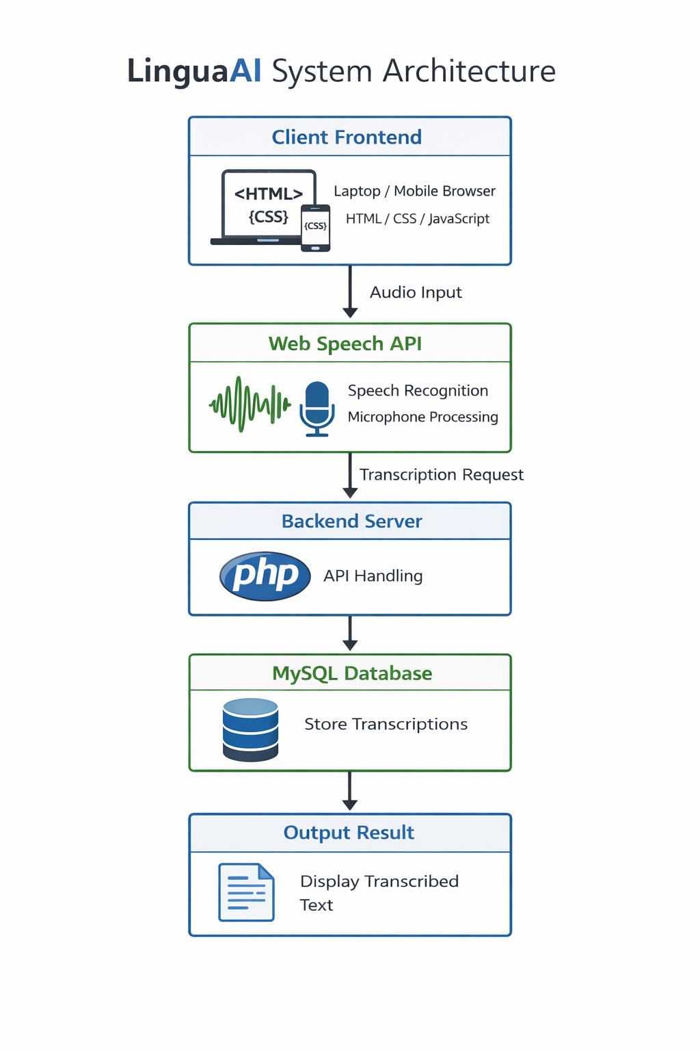
Chapter:- 4 Limitation and Future Enhancement

A key limitation of the current iterative prototype is that modern browser-native speech recognition models—while highly optimized for dominant global languages like English, Mandarin, and Spanish—do not natively support the vast majority of rare, critically endangered languages. As a result, users currently must select proxy languages with structurally similar phonetic alignments or translate the spoken word in real-time via English. Additionally, the system currently requires an active internet connection to ping the Web Speech API servers, limiting its utility in extremely remote, off-grid field environments where many of these languages are natively spoken. Future enhancements envision fundamentally addressing these bottlenecks by actively fine-tuning our own dedicated Automatic Speech Recognition (ASR) models using community-sourced phonetic data gathered directly from the platform. We plan to deploy these models on dedicated backend endpoint servers or bundle them via Web-Assembly for offline, in-browser inference. Furthermore, dedicated mobile application ports built using cross-platform frameworks like React Native would enable fully offline field-recording and transcription logging, bridging the gap between remote villages and academic databases.

Chapter:- 5 Timeline Chart

Month 1 (Jan) | Topic Selection & Literature Review. Exhaustive review of more than 40 papers regarding computational linguistics, evaluating the feasibility of using automated transcribers for low-resource languages.
Month 2 (Feb) | Language Database Compilation. Deep research into the UNESCO atlas of world languages, selecting 25 specific dialects across multiple continents to serve as the structural backbone of the web portal.
Month 3 (Mar) | Evaluation of mBERT, XLM-R, and Whisper models. Technical benchmarking against the Web Speech API to determine computational trade-offs, overhead reduction, and latency implications.
Month 4 (Apr) | Initial Implementation of the HTML, CSS, JavaScript, and PHP web suite. Architecting the live microphone transcription logic and writing the PHP SQL connections.
Month 5 (Jun) | Web API testing, cross-platform UI adjustments, deployment to testing environments, and finalizing all project documentation to meet academic strictures.

Chapter:- 6 Conclusion

The successful conception, design, and completion of the Lingua-AI prototype emphatically demonstrates that modern Artificial Intelligence transcription interfaces—when packaged seamlessly into a low-overhead, highly accessible web framework—offer immense and immediate utility to language preservationists. By removing the traditional barriers of manual transcription lag, high software costs, and steep learning curves, the system fundamentally changes the economics and logistics of linguistic archiving. Although limitations regarding zero-shot translation for hyper-rare dialects persist, the underlying infrastructure deployed here serves as a critical first step. Through bridging theoretical computer science, machine learning models, and cultural preservation, software continues to play a vital, increasingly central role in ensuring anthropological endurance in the digital age.

Chapter:- 7 REFERENCE

[1] UNESCO (2010). Atlas of the World's Languages in Danger, 3rd edition. Paris: UNESCO Publishing.
[2] Harrison, D. K. (2007). When Languages Die. Oxford University Press.
[3] Radford, A. et al. (2022). Robust Speech Recognition via Large-Scale Weak Supervision (Whisper). OpenAI Technical Report.
[4] Devlin, J. et al. (2019). BERT: Pre-training of Deep Bidirectional Transformers. NAACL 2019.
[5] ELDP (Endangered Languages Documentation Programme). Ethics Guidelines for Endangered Language Documentation.

