IOT based Water Flow Meter Project Report
Mihir Patil#, Sanat Pareek*, Akash Bharti#
#Computer science department, NMIMS University
Shirpur

Abstract— The IoT-based water flow meter project aimed to develop a smart water flow meter system that can measure the water flow rate and send the data to the cloud platform for real-time monitoring and analysis. The system was designed to be accurate, reliable, and efficient, using waterflow sensors to measure the water flow rate and NodeMCU board to connect the sensor to the internet. The data was transmitted using the MQTT protocol to a cloud platform, where it was processed and analyzed using various data analytics tools.

- Introduction
The Internet of Things (IoT) is revolutionizing the way we live and work. One of the areas where it has significant impact is in the management of resources such as water. In this project, we will design an IoT based water flow meter to monitor the water flow rate and volume in a pipeline. The project involves the use of various sensors, microcontrollers, and wireless communication technologies.
Water Management System is an important part of City Management. Water management involves supplying water according to the real requirement & without wasting Water. Therefore it is very important to measure water flow rate and volume. Without measuring these parameters, Water Management is almost impossible. Also monitoring the Water Volume, Flow Rate & Water Quality remotely using Internet Connectivity has become very essential. Therefore there is a need for Monitoring Water Management System Online..
- Project overview
  - Definition of IOT based water flow meter
An IoT flowmeter is a device that not only measures flow in a pipeline but intelligently transmits measurement data via an IoT enabled method like Bluetooth, GSM, Wi-Fi and/or ethernet to an endpoint like a web server or mail server.
  - Components and Modules
    - WIFI module NodeMCU ESP8266
The NodeMCU (Node Microcontroller Unit) is an open-source software and hardware development environment built around an inexpensive System-on-a-Chip (SoC) called the ESP8266. The ESP8266, designed and manufactured by
Espressif Systems, contains the crucial elements of a computer.
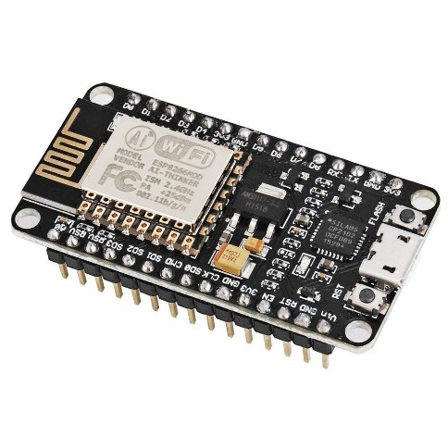
Figure 1 NodeMCU Esp8266
    - YF-S201 Hall-Effect Water Flow Sensor
In the water flow sensor, a rotor is placed in the path of liquid to utilize the Hall Effect. The shaft of the rotor is connected to the Hall Effect sensor. When the liquid flows through the water flow sensor, it rotates the rotor. As it is an arrangement of a current flowing coil and a magnet connected to the shaft of the rotor, a voltage/pulse is generated. The number of pulses per second or minute is used to measure the flow rate and total amount of water passed through the sensor.
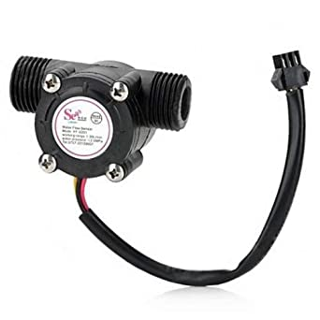
Figure 2 Hall-effect Water Flow sensor
    - 0.96" I2C OLED Display
This 0.96″ OLED Display Module offers 128×64 pixel resolution. They are featuring much less thickness than LCD displays with good brightness and also produce better and true colors.
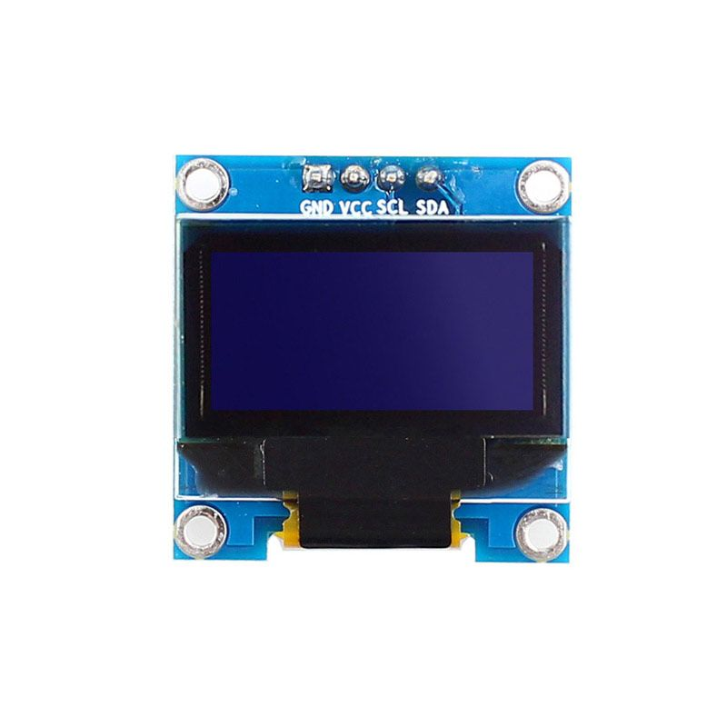
Figure 3 0.96" I2C OLED Display
    - Breadboard
A breadboard, solderless breadboard, or protoboard is a construction base used to build semi-permanent prototypes of electronic circuits. Unlike a perfboard or stripboard, breadboards do not require soldering or destruction of tracks and are hence reusable. For this reason, breadboard is chosen for this project.
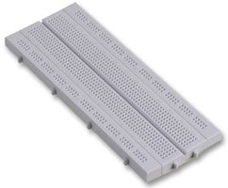
Figure 4 Breadboard

    - Jumping connecting wires
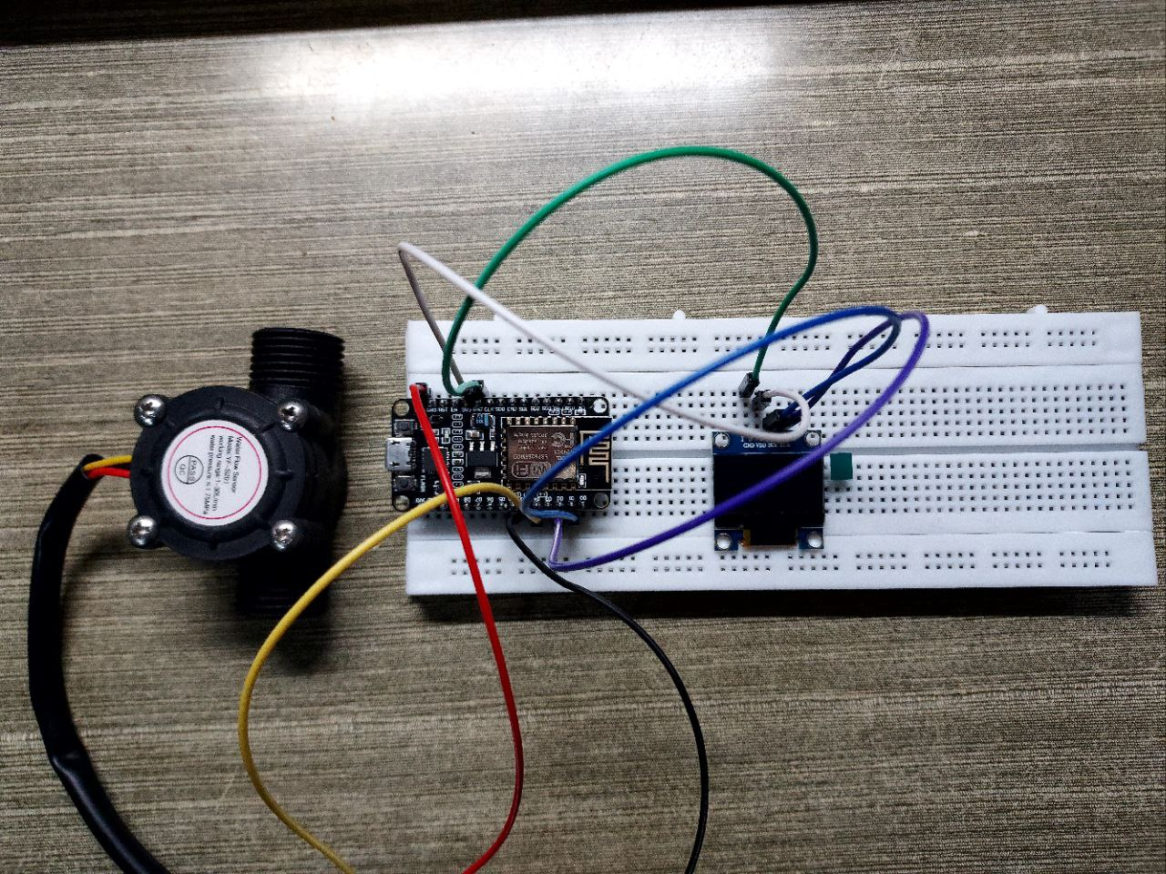
Jumper wires are simply wires that have connector pins at each end, allowing them to be used to connect two points to each other without soldering.
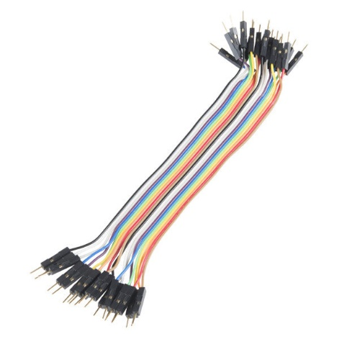
Figure 5 male to male connectors
  - Circuit description and working
Water Flow Sensor is a digital Sensor, so we can connect its output pin to any of the digital pins of ESP8266. In my case, I connected to GPIO2, i.e D4. The sensor works at 5V & can be connected to Vin of ESP8266. Similarly, I2C OLED Display SDA & SCL pins are connected to D2 & D1 of ESP8266 respectively. The OLED Display works at 3.3V so it can be connected to 3.3V pin of Nodemcu.
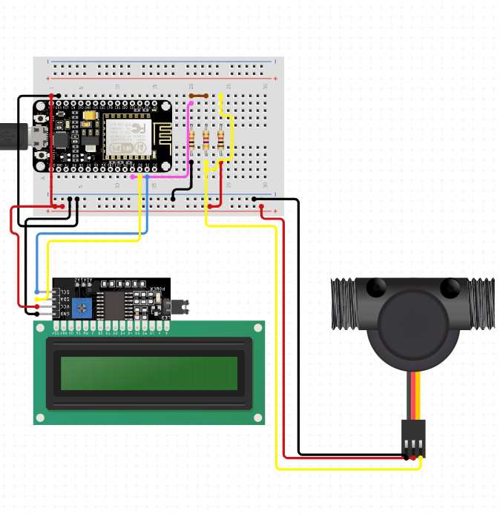
Figure 6 circuit diagram
The OLED Display will show Water Flow Rate & Total Volume of Water passed through the pipe. The same Flow Rate & Volume data can be sent to Thingspeak Server after an interval of 15 seconds regularly.

- Algorithms Flow chart and working
3.1 Algorithm
STEP 1: START THE PROCESS
STEP 2: CONNECT WIFI
STEP 3: READ WATER FLOW RATE AND VOLUME
(The water velocity depends on the pressure that forces the through pipelines. The cross-sectional area of the pipe is known and remains constant, thus we calculate the average velocity that indicates the flow rate.
Let us consider Q is the flow rate/total flow of water through the pipe, V is the average velocity & A is the cross-sectional area of the pipe. In such a case the basis relationship for determining the liquid’s flow rate in such cases is Q=VxA.
Sensor Frequency (Hz) = 7.5 * Q (Liters/min)
Litres = Q * time elapsed (seconds) / 60 (seconds/minute)
Litres = (Frequency (Pulses/second) / 7.5) * time elapsed (seconds) / 60
Litres = Pulses / (7.5 * 60)).
STEP 4: SEND DATA TO THINGSPEAK API.
STEP 5: DELAY TO 15 SECONDS.
STEP 6: REPEAT STEPS 3,4,5 UNTIL THE PROCESS ENDS.
STEP 7: END

3.2 Flowchart

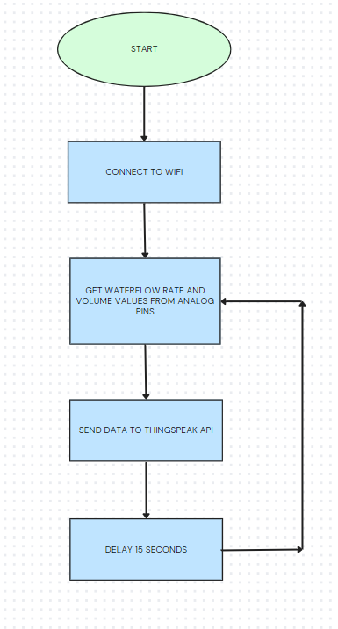
Figure 7 flowchart

3.4 Monitoring water flow and volume rate
Once the Code is uploaded the OLED Display will strat working and will show the flow rate and volume. Initially the flow rate will be 0 liter/minute(L/M). Also Total Volume shown will be 0 Liter(L).
Once the motor is turned ON & Water Starts flowing, you can see in figure(8) the OLED Display displaying the Flow Rate (F) & Volume(V).
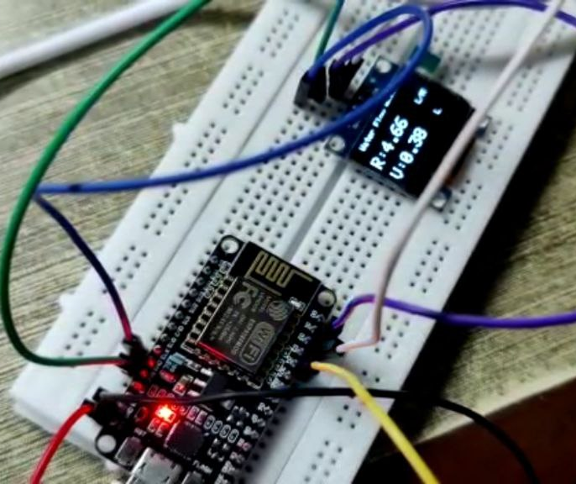
Figure 8 readings

you can monitor the Water Flow Rate & Volume Data on Thingspeak Server as well.

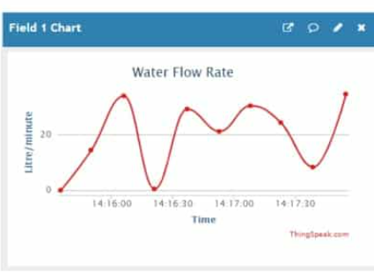
Figure 9 water flow rate graph

- Conclusions
The IoT based water flow meter system provides an efficient way to monitor water usage and detect leaks in real-time. It can be used in various applications such as home water management, irrigation systems, and industrial processes. The system is cost-effective, easy to install, and requires minimal maintenance. It can help in conserving water resources and reducing water wastage.
In conclusion, the IoT-based water flow meter system is a useful tool for water management, and its integration with the cloud platform can provide real-time monitoring and analysis of water usage. The project can be extended further by adding additional sensors and analytics tools to provide more insights into the water management system.

References
- Adeel Javed, Building Arduino Projects for the Internet of Things, Apress.
- Thingspeak.com
- https://github.com/mathworks/thingspeak-arduino
- https://randomnerdtutorials.com/esp8266-nodemcu-thingspeak-publish-arduino/
- https://docs.espressif.com/projects/esptool/en/latest/esp32/troubleshooting.html
- https://github.com/espressif/esptool/issues/586
- https://arduino-esp8266.readthedocs.io/en/latest/
- https://learn.sparkfun.com/tutorials/esp8266-thing-hookup-guide/installing-the-esp8266-arduino-addon
- https://iotdesignpro.com/projects/iot-based-water-flow-meter

