NAME : GONDALIYA MIHIR DILIPBHAI
ID NO : 25IT027

PRACTICAL = 1.2
Problem Definition : A small library wants to
digitize its system to manage its collection of
books. Each in the library has the following
attributes:
• Book ID
• Title
• Author
• Number of available copies
The system must allow:

• Adding new books to the library
• Issuing a book to a student (only if copies
are available)
• Returning issued books
• Displaying total books in the library

The library committee wants students to
implement the system using both procedural
programming and object-oriented
programming, and then compare both
approaches in terms of code reusability and
complexity.

CPP_CODE:
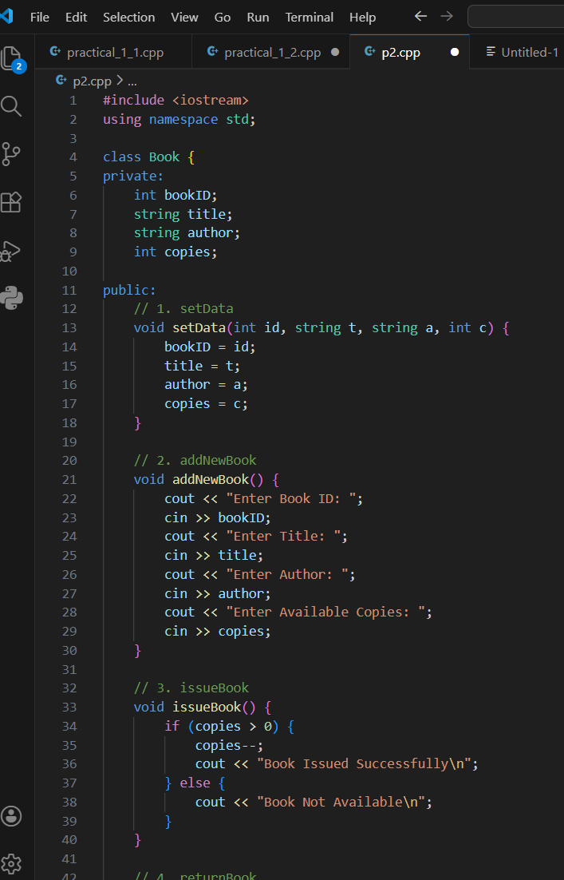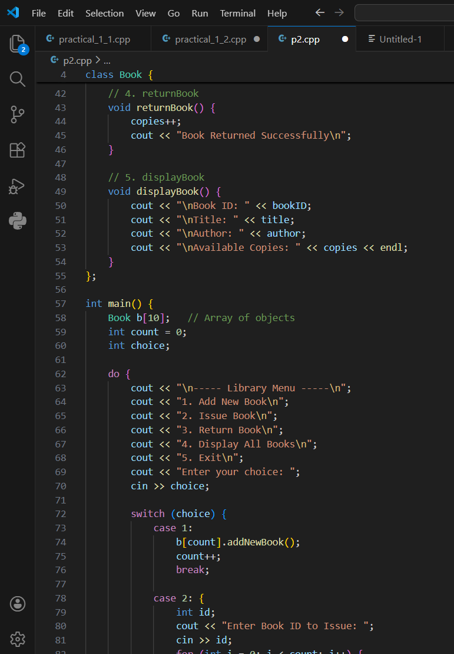
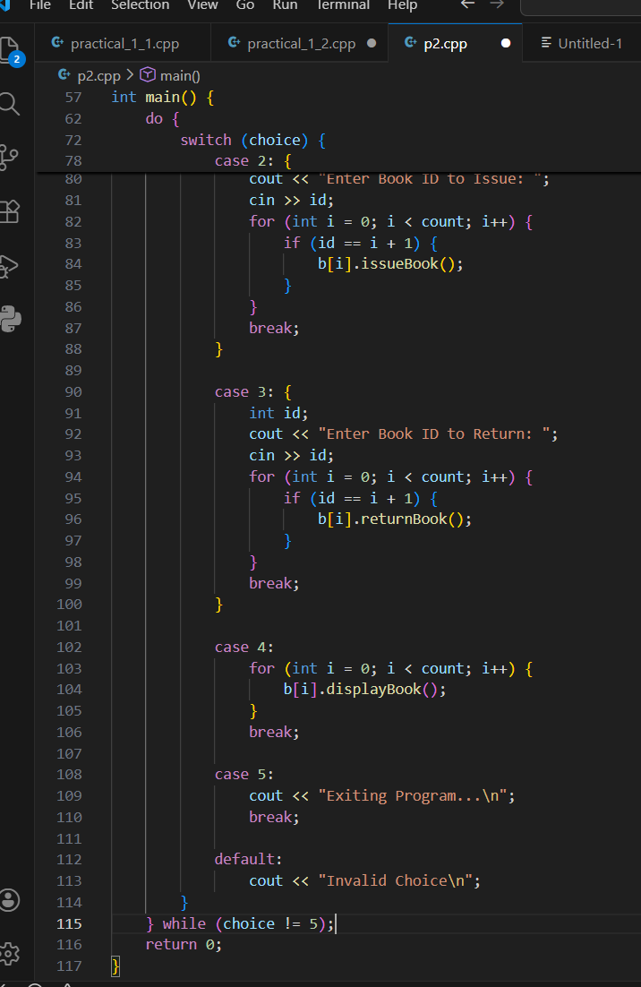

OUTPUT:
